Arnside and Chilworth Street alleyway
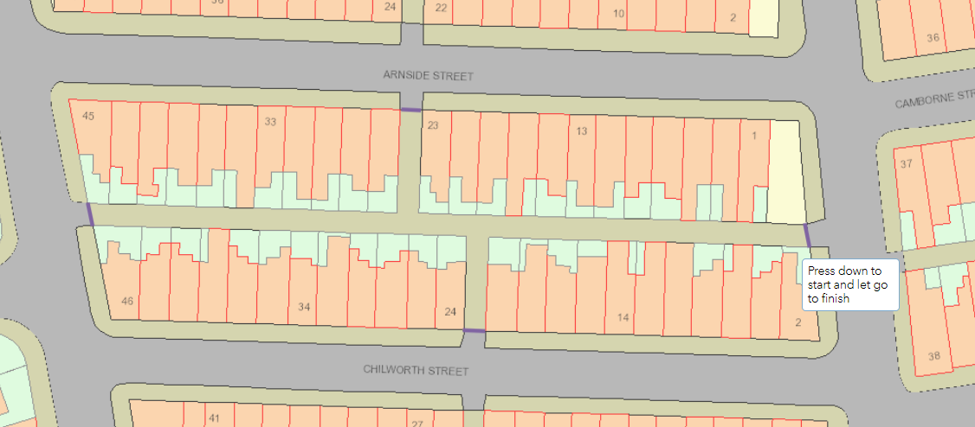
Chilworth and Newlyn Street alleyway
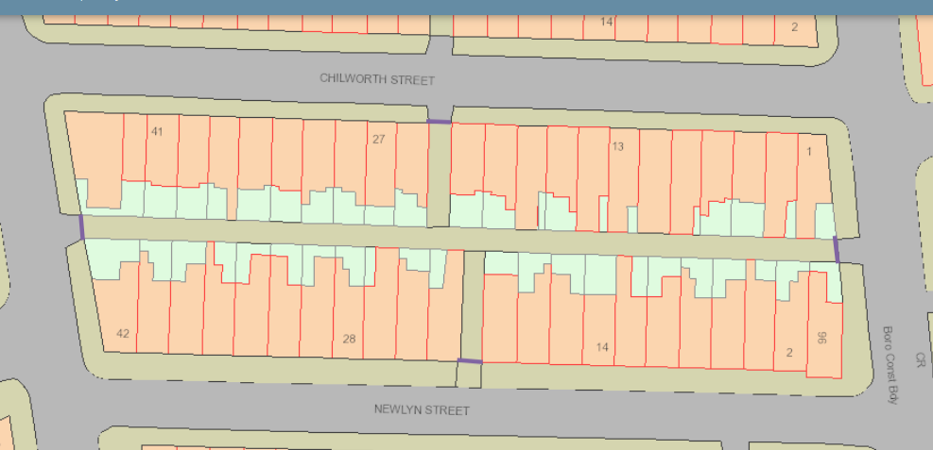
Newlyn and Boscombe Street alleyway
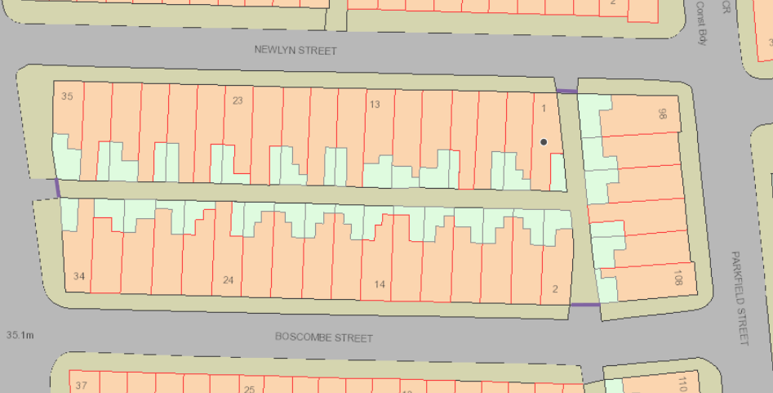

Camborne and Wincombe Street alleyway
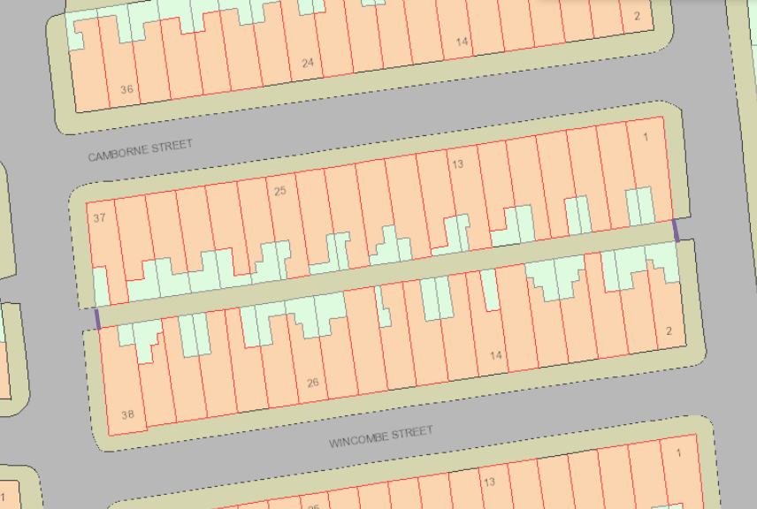
Wincombe and Lowestoft Street alleyway
