Jonathan Mumby
16 Old Market Place
Altrincham
WA14 4DF
Manchester City Council
Planning Department
PO Box 532
Town Hall
Albert Square
Manchester
M60 2LA

Dear Sir/Madam,

Re: Request for confirmation of compliance of condition 8 (Demolition Method Statement) attached to planning permission 127971/FO/2020.

We are pleased to submit the application to approve details reserved by Condition 8 – Method Statement, on behalf of MPH Ancoats Limited.

The conditions were reserved on consent ref: 127971/FO/2020 for:

Erection of a 6 storey building to form 90 residential apartments (Use Class c3a) following demolition of existing structures with associated access, car parking, amenity space, landscaping and other associated works.

The requisite planning application fee (£116) has been paid online via the planning portal (PP-12437916).

The application is supported by the following plans and documents:

- Covering Letter (this document); and
- Demolition Plan of Works, prepared by Collins Demolition Ltd (Ref: CDL167MS).

The application is accompanied by the above plan submitted to facilitate the review and subsequent discharge of Condition 8 of planning permission 127971/FO/2020 which is detailed below:

Condition 8 – No demolition works or vegetation clearance shall take place during the optimum period for bird nesting (March – September inclusive) unless nesting birds have been shown to be absent, or, a method statement for demolition including for the protection of any nesting birds is agreed in writing by the City Council, Local Planning Authority. Any method statement shall then be implemented for the duration of the demolition works.

-

The submitted Demolition Plan document details the mechanical demolition of the former hand car wash on site with the reclamation work undertaken in accordance with key legislation and approved codes of practise detailed in Appendix 1 – 1.1 of the document.

In line with the wording of condition 8 of the previous permission, the Demolition Plan includes details regarding the protection of any nesting birds within Appendix 3 – 3.10 of the submitted document.

We would also like to highlight that the condition states that works should not take place during nesting season and that this runs until the end of September, however, we have been advised by the project ecologist, Rachel Hacking, that nesting bird surveys are being undertaken from 1st March until 31st August as recommended within the Bird Census Techniques, and that from 1st September it is not required to have the site checked for nesting birds (please see the copy of the email from the ecologists included within section 3.10 of the statement).

On the basis of the above information and submitted plan, we trust that you have all the information required to validate the approval of details reserved by condition application. Should you have any queries or require any further information, please do not hesitate to contact me.

Yours faithfully,

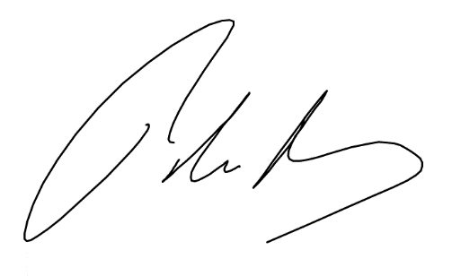

Jonathan Mumby
Enabl

