25 St Brannocks Road,
Manchester,
M21 0UP.

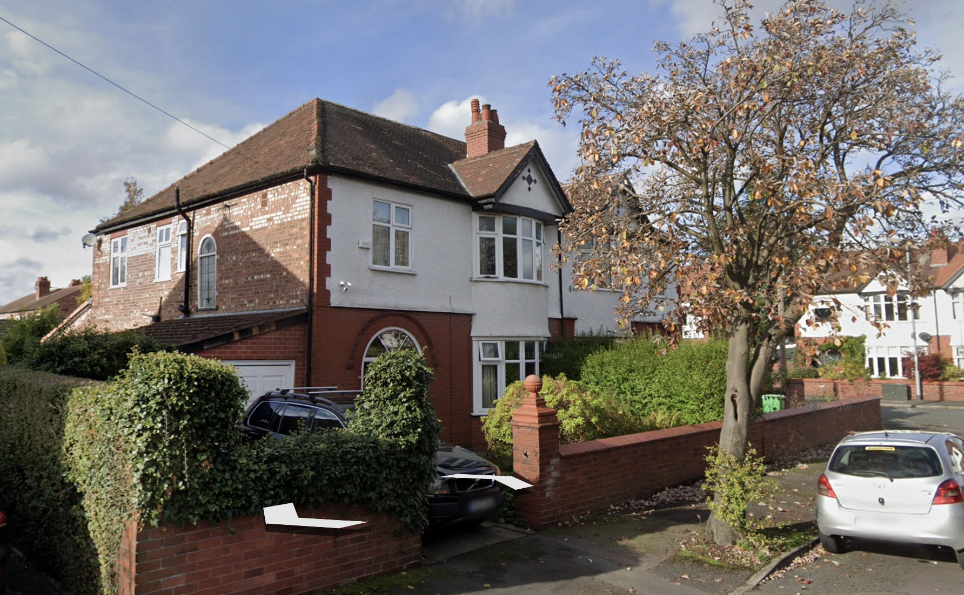

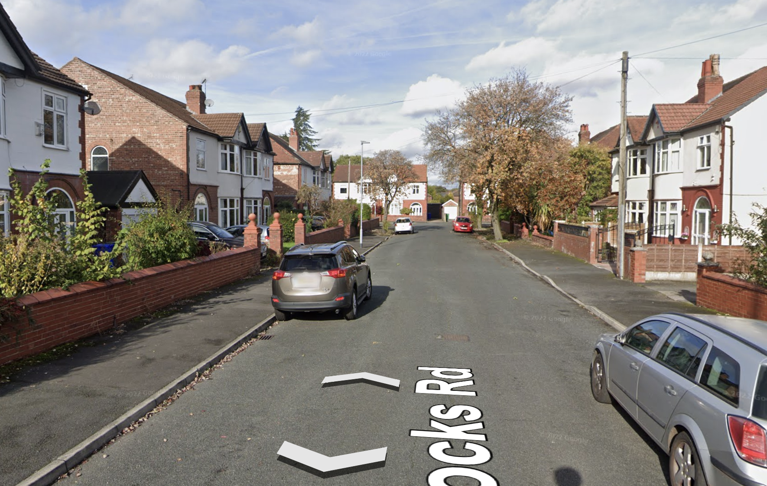

nnn

