HERITAGE IMPACT STATEMENT FOR INTERNAL REFURBISHMENT TO A LISTED BUILDING AT 1-5 ST ANN`S SQUARE MANCHESTER

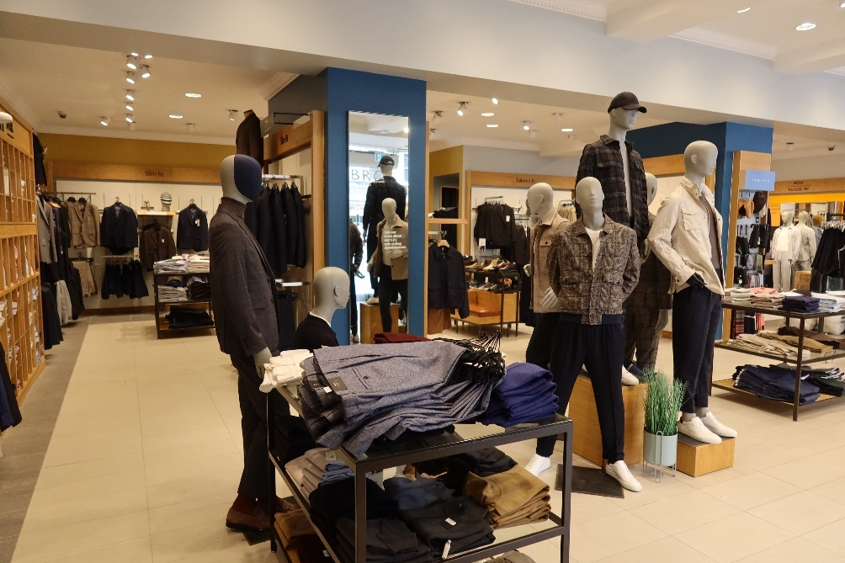
Existing Internal Photo 1
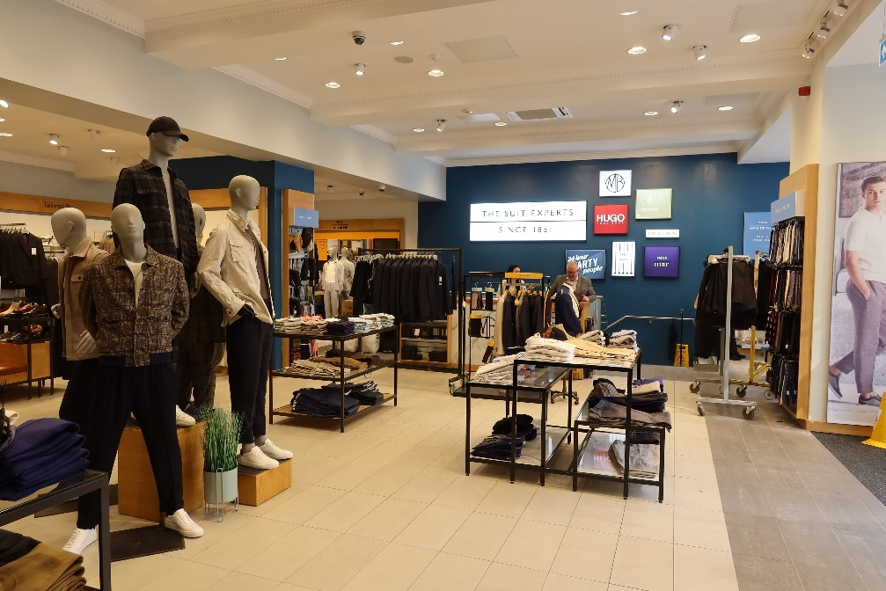
Existing Internal Photo 2

SPECIAL HISTORIC AND ARCHITECTURAL IMPORTANCE OF LISTED BUILDINGS
This heritage, design & access statement has been prepared in support of an application for internal refurbishment. The property is a Grade II listed

List Entry Number 1200826

1. PROPERTY
The building is an existing retail unit on 1 St Ann`s Square Manchester, M2 7EF, trading as Moss Bros. The ground floor and part of the Basement is used for Retail to the general public, with staff accommodation to the Basement.

2. HERITAGE
SJ8398SE 698-1/27/124 MANCHESTER EXCHANGE STREET (East side) Nos.1 to 13 (Odd) Royal Exchange 03/10/74
GV II Includes: Nos.4 to 20 ROYAL EXCHANGE ARCADE. Includes: Nos.1 to 19 ROYAL EXCHANGE ARCADE. Includes: Nos.1 to 17 OLD BANK STREET. Includes: Nos.1 to 7 Former Royal Exchange ST ANN'S SQUARE. Includes: Nos.2 to 20 Former Royal Exchange MARKET STREET. Includes: Nos.2 to 20 Former Royal Exchange CROSS STREET. Commercial exchange, now shops, theatre, etc. Rebuilt and enlarged (for the fourth time on this site) in 1914-21, by Bradshaw, Gass and Hope. Darley stone, slate roof with three glazed domes.
Very large approximately rectangular plan on island site penetrated by east-west arcade at ground floor and enclosing central atrium at first floor. Classical style. Four storeys with two attic storeys; ground floor treated as rustic, with channelled rusticated piers, giant Corinthian order to first, second and third floors with massive entablature and modillioned cornice; first attic storey with cornice and balustraded parapet, second attic storey in mansard roof, Baroque turret at north-west corner, domes over other corners. Giant round-headed entrance arch in west side with wide steps up; first and second floor windows set in giant round-headed arches; mullioned windows to third floor and first attic storey. NEW STREET 1. 5113 (West Side) No 28 SE 1416 SW 1/942 II 2. C18. Stucco. 3 storeys. Modillion eaves cornice. Blocking course. Rusticated quoins. 3 ranges of C19 windows in plain raised surrounds, except for the south range (originally the centre range), which has moulded surrounds, and entablature to 1st floor windows. Modern shopfront.
Listing NGR: SE1443216592

3. SETTING & EXTERNAL ELEVATIONS
1-5 St Ann’s Square forms part of the ground floor of the St Ann’s Square elevation of the Manchester Royal Exchange building and it directly fronts and is accessed from the pedestrianised street. The classically detailed Manchester Royal Exchange comprises five floors to parapet level, with two attic storeys above, and basement levels. The central arcade running east-west through the building at ground floor level forms the northern boundary of the shop premises and Moss Bros maintain shop windows into the arcade. The primary elevation of 1-5 St Ann’s Square faces west onto St Ann’s Square and only the ground floor level of the shop premises is visible from the exterior. The shop occupied by Moss Bros forms the southern boundary of the store. The St Ann’s Square façade comprises rusticated sandstone piers either side of original-sized openings. The original shop windows and doors have long ago been replaced and currently comprise modern flat glazed windows and doors with signage across the top of each opening. There are glass block pavement lights set in front of each opening over the basement lightwells. The arcade elevation comprises varnished wooden pilasters and architraves with modern flat glass shop windows and signage across the top of the openings.

Ground Floor
The ground floor area of the existing store comprises the original shops known as 1-3 and 5 St Anns Square.
The ground floor area of 1-3 St Anns Square appears to have been designed as an open, flexible retail space with glazed entrances on both the St Anns Square and arcade elevations and 5 St Anns Square was originally a separate shop accessed from ST Anns Square only.
The current use of the ground floor is for sales and fitting rooms. The original wall between 1-3 and 5 St Anns square was opened up after 1953 and the shop doorway was replaced with a shop window at some point between 1922 and 1953.
The current appearance of 1-5 St Anns Square is due to internal fitout upgrades and general alteration over the decades, including new ceilings and detailing, suggesting significant previous alteration and repair throughout and as would be expected in a property of this age and use where typical, changes would have been carried out on a fairly regular basis.

4. ASSESSMENT OF SIGNIFICANCE
Introduction
The Manchester Royal Exchange is currently recognised as a Grade II listed property on the National Heritage List for England. As of March 2015, there were approximately 376,099 listed buildings in England. Grade II listed buildings are classified as nationally important and of special interest and 92% of all listed buildings are in this class. It is important as part of an assessment of significance, to assess the site or building as a whole and not elements in isolation. This is to enable an overall appreciation of the importance of a place upon which an assessment of the potential positive or negative aspects of any proposals can be made in the longer term. The following significance assessment is based upon heritage values recognised by Historic England.
Evidential Value
The potential of a place to yield evidence about past human activity. The Manchester Royal Exchange is important as a former key centre of commerce within the UK, particularly for the cotton and textile trade and its related industries. 1-5 St Ann’s Square provides strong evidence of ongoing original use by the retail clothing sector. Retail shops, such as 1-5 St Ann’s Square were a key part of the ancillary, yet related, use of the Manchester Royal Exchange as an overall entity and they demonstrate the typical evolution of retail premises over the decades. 1-3 St Ann’s Square in particular has always been associated with men’s tailoring and outfitting, from Pope & Bradley tailors as first tenants to the iconic Moss Bros brand today, who have occupied 5 St Ann’s Square since 1939 and expanded into 1-3 St Ann’s Square in the 1940s. The shops, as part of the overall construction of the Exchange were built using steel frame and reinforced concrete construction. The Manchester Royal Exchange construction is typical of a large-scale building requiring large spans built using a trusted method that became popular from the 1880s. Overall, 1-5 St Ann’s Square is of moderate significance in terms of its evidential value, set within a nationally important building of high significance.

Historical Value
The ways in which past people, events and aspects of life can be connected through a place to the present. The Manchester Royal Exchange is an iconic building in the centre of Manchester that was historically a key centre of trade and today, a hub for retail and the arts. At the time of the opening of the Royal Exchange in 1921, Manchester was described as the centre of the largest industrial area in the British Empire, with the city as the gathering ground of a huge industrial population of over 9 million people of the surrounding area. The Royal Exchange overall (and subsequently the retail shops as integral elements) is key in demonstrating the historical importance of trade to Manchester and to Britain as a whole, particularly following the 19th century boom in textiles and cotton and their related industries. The building reflects the rise and fall of industry throughout the years until the final closure of the exchange in 1968. The building and its predecessors are a reflection of how they were key to the trade activities that made Manchester the successful commercial city it is today. The retail shopfronts that have been maintained since the original design was laid out are also key elements in outwardly expressing the use of the building as a trade hub at the heart of the city. The current building is also a reflection of the perceived importance of the site to trade in Britain at the beginning of the 20th century. The building of the large extension to the Exchange was permitted by the Government under special licence despite the outbreak of the First World War and the subsequent demands on labour and materials that would normally have been reserved for the war effort.
The site has historical associations with Queen Victoria who gave the Exchange Royal status in 1851, and the name was maintained through to the current built incarnation, which maintains its own historical Royal associations being officially opened by King George V and Queen Mary in October 1921. The property is located within the central shopping area of Manchester city centre and the Royal Exchange building is testament to the importance of the building to the retail sector as well as wider trade and industry and it continues this function today. Overall, 1-5 St Ann’s Square is of high significance in terms of its historical value, set within a nationally important building of high significance.
Aesthetic Value
The ways in which people draw sensory and intellectual stimulation from a place. The Manchester Royal Exchange is an architectural icon within the city centre of Manchester built originally in the late 19th century and significantly enlarged in the same style in 1914-21. Built in the Italianate style popular in the second half of the 19th century for large scale urban buildings and dominated by classical detailing in Darley Dale sandstone, the Exchange occupied 1.7 acres and the Exchange Hall itself was lit by six glazed domes. It was considered at the time to be the largest trading room in Britain. The building overall is a key element of the historic character of the streetscape, the city centre and the conservation area. On the western elevation of the building, 1-5 St Ann’s Square directly contributes to the composition of the external elevation of the Royal Exchange, making its own contribution to the significance of the streetscape by helping to maintain original elements as well as the consistent and uniform street frontage of this important building. The St Ann’s Square entrance to the Exchange Hall was described upon its opening in 1921 as the more important of the two main entrances. As well as its neighbours, the store is a key element within the setting of this main entrance (both historically and for the theatre today) and the retained original and early features of the shopfronts (including rusticated piers, opening sizes and pavement lights) make an important contribution towards the appreciation of both the individual shopfronts and the overall historic character of the Royal Exchange. Changes to the premises in terms of layout and regular upgrading of shop fitouts are consistent with this type of use and also provides evidence of regular change to meet changing fashion and retail expectations throughout the decades since the building was opened in 1921. Overall, 1-5 St Ann’s Square is of high significance in terms of its architectural and aesthetic value, set within a nationally important building. The interior of the building retains some of its original layout and fabric. However, the key elements of its significance relate to its contribution to the external character and appearance of the historic Royal Exchange of which it is an integral part.
Communal value
The meanings of a place for the people who relate to it, or for whom it figures in their collective experience or memory. The communal, or social value, of the place is not simply of a historical nature and it does have relevance today in terms of its significance as a retail shop and as part of the Manchester Royal Exchange overall. As a purpose-built retail venue and with its long-term association with an iconic British brand and retailer, 1-5 St Ann’s Square maintains its original use today as a prominent shopfront at the heart of a prime retail district in central Manchester. Part of a nationally important building historically associated with trade and now a centre for commercial activities and the arts, the shop is well visited and makes an important contribution to the vitality of Manchester’s central shopping district and specifically, the historically important St Ann’s Square. Overall, 1-5 St Ann’s Square is of moderate significance in terms of its communal value, set within a building of high importance.

5. HERITAGE IMPACT ASSESSMENT
Amount of development
The existing staircase to the basement is to be infilled and the store is to be split into 2 stores and a staff area, with plasterboard and stud walls all joints to be taped and filled to give 30-minute fire rating.
The staircase was installed in 2016 (Application 112490/LO/2016).
We have had approval to remove the existing glazing to the right-hand shopfront installed in 2016. Planning approval 135178/FO/2022 and listed Building Approval 135183/LO/2022.
The existing retail fitout is of neutral significance and therefore its removal and replacement with an upgraded fitout, including freestanding and built-in furniture would have a positive impact on the appearance of the interior.
The shop floor layout will have new division walls to form the proposed new layout. The existing ceiling, beams and cornices are to be retained all as existing, with electrical and fire services upgraded and contained within/ behind new fitout fabric. Upgrade of services within new fabric will have a positive impact in the protection of the Historic building and neutral impact on Historic fabric or layout within the shops themselves.
It is proposed to infill the staircase to create an open shop floor, the staircase was installed in 2016.
The basement will not be used and will be retained all as existing, with access from the Landlords rear corridor, all fire services will be upgraded to conform to current regulations.
Retail premises have always required flexibility in their design and layout. Overall, the proposed alterations will allow the continued original use of the property in a modern, competitive, retail environment and therefore maintain optimum viable use for the Grade II listed Royal Exchange and its shops.

Signed applicant.

…Paul Turner…………………………….. Date 05 May 2023

