SITE SPECIFIC SUPPLEMENTARY INFORMATION

- Site Details

Site Name: | Lockton Court | Site Address: | Lockton Court  Lockton Close  Manchester  M1 7JP
NGR: | E: 384719 N: 397386 | Site Address: | Lockton Court  Lockton Close  Manchester  M1 7JP
Site Ref Number: | 74835 | Site Type: Macro | Rooftop – NTQ (Notice to Quit)

- Pre-Application Check List

Site Selection

Was an LPA mast register used to check for suitable sites by the operator or the LPA? |  | No
If no explain why:

After a phone call to the LPA it was felt that the industry database was a more up to date source of information.

Was the industry site database checked for suitable sites by the operator: | Yes
If no explain why:

N/A

Pre-application consultation with LPA

Date of written offer of pre-application consultation: | 13th March 2023
Was there pre-application contact: |  | No
Date of pre-application contact: | N/A
Name of contact: | The Director of Planning
Summary of outcome/Main issues raised:

At the time of preparing this submission, and despite our attempt to engage in pre-application dialogue with the LPA, no comments had been received in respect to the proposals.

Ten Commitments Consultation

Rating of Site under Traffic Light Model: | Green
Prior to the submission of this application the applicant initiates pre-consultation discussions with the local planning authority. This provides an opportunity for the LPA to discuss development proposals and identify site specific issues.

Summary of outcome/Main issues raised:

No responses had been received at the time of submission.

School/College

Location of site in relation to school/college:

There are no schools in close proximity to the site.

Outline of consultation carried out with school/college:

N/A

Summary of outcome/Main issues raised:

N/A

Civil Aviation Authority/Secretary of State for Defence/Aerodrome Operator consultation (only required for an application for prior approval)

Will the structure be within 3km of an aerodrome or airfield? |  | Yes
Has the Civil Aviation Authority/Secretary of State for Defence/Aerodrome Operator been notified? |  | Yes
Details of response:

N/A

Developer’s Notice

Copy of Developer’s Notice enclosed? |  | Yes
Date served: | 26th October 2023

- Proposed Development

The proposed site:
This application follows the approval of application referenced 117478/FO/2017. The proposal in this application is required to replace the previous consent.

It is imperative to consider that this proposal is to replace an existing installation and is not a new additional mast. The need for this new mast stems from MBNL having been issued with an NTQ (Notice to Quit). The DSA (Designated Search Area) covers Piccadilly in Manchester. Piccadilly is an urban area with high density; high rise buildings meaning rooftop options are preferred. The NTQ (Notice to Quit) site is 93530, MSS Building which belongs to the University of Manchester who have confirmed that the building is due to be bulldozed and the immediate surrounding area is to undergo redevelopment. Any new site will need to provide replica or improved coverage.

The proposed site is located off Lockton Close situated on the rooftop of Lockton Court. The proposed site is close to the heart of Manchester surrounded by both commercial and residential uses. Views of the proposal from Streetview will be limited.

Figure 1:
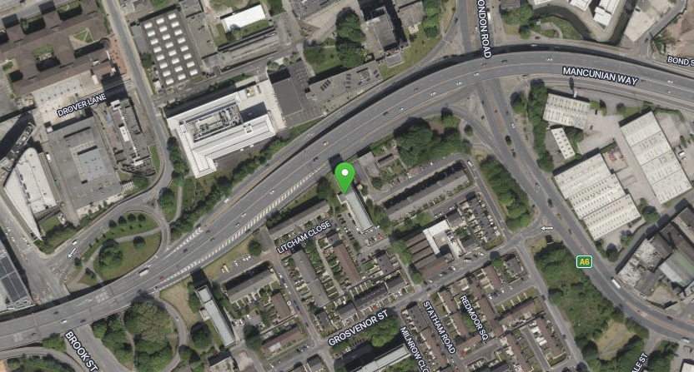

Figure 2:
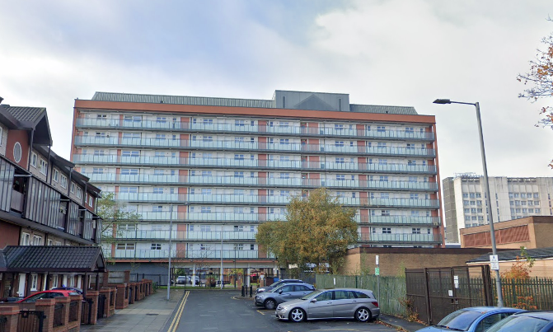
Figure 3:
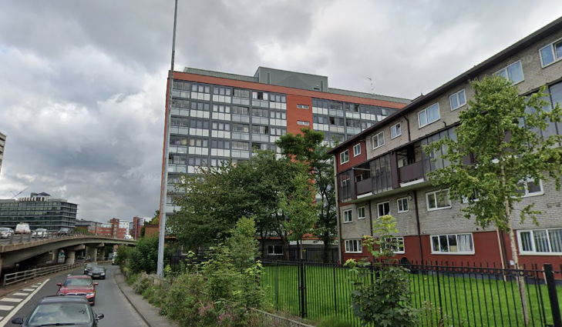

The proposal is for the installation of a new 7.5m high fli stub tower that will provide new coverage for EE and has the potential for H3G LTE.
The site has been carefully selected in a position that limits impact upon the streetview to provide the required new coverage to the area whilst minimising visual intrusion for residential properties.
Local Planning Authority: Manchester City Council

Development Plan: Manchester City Council LDF Core Strategy DPD (2012) / Extant UDP Policies
Fig.1 – Local Plan Map (extract – reference only)

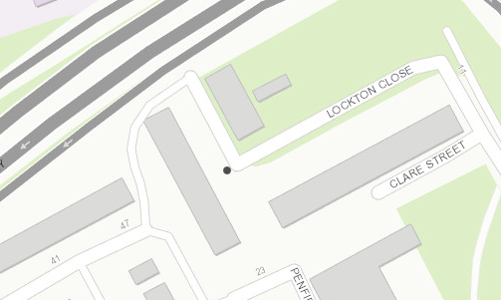

Site and its surrounds

Policy Relevant to the Development Site:

The site is designated as being within the settlement boundary, with urban / industrial uses to the north, east, south and west. The land designation is not a material consideration.

Manchester City Council does have a specific telecoms policy. This, together with the NPPF is of relevance. The National Planning Policy section of this supporting statement goes into detailed analysis of why this site is in compliance with the NPPF.

Policy Analysis:

Policy DC17 states:

Applications for telecommunications developments will normally be approved if the Council can be satisfied that the development has been sited and designed to minimise its impact on residential amenity and in environmentally sensitive areas. Wherever possible, the Council will expect the potential of existing buildings and masts, including the sharing of such facilities, to be fully explored before agreeing to additional separate development.

The proposed development would not appear alien in this urban setting and although visible from publicly accessible vantage points, it would be suitably distant to ensure minimal visual disruption and would not constitute a distraction and would maintain the character of the area (with minimal visual change to the building or wider location). In addition the development would provide opportunities for site sharing, ensuring accordance with the policy.

The proposal fully accords with the requirements of the NPPF.

The sharing of base stations between multiple operators is one of the key strategic policy principles contained within the NPPF. H3G and EE and ESN (Emergency Services Network) have a network sharing agreement and thus these installations are fully compliant with the NPPF.
Central Government attaches great importance to the design of the built environment and outlines this within Section 12 (para. 124) of the National Planning Policy Framework. It states:

“Good design is a key aspect of sustainable development, creates better places in which to live and work and helps make development acceptable to communities.”

In keeping with the National Planning Policy Framework (NPPF). guidelines of using: “high quality communications” (Section 10), the proposed design has been selected to minimise visual impact upon the street scene by integrating with the existing built environment and the existing street furniture, having similar vertical lines and overall appearance to the street lighting columns that are common feature in the built environment. As stated above the National Planning Policy Framework advocates site sharing, and as such we believe that there are no sequentially preferable locations within the defined site search area.
The design of the proposed equipment is considered to be the least visually intrusive option available.

RADIO PLANNING AND PROPAGATION

When planning cellular telecommunications networks it is important for engineers to predict, with a high degree of confidence, the behaviour of cellular transmissions. This then enables the operator to calculate how many cell sites are needed to provide the level of coverage required by the services they offer under the terms of their licence.
The strength of radio signals detected at a receiving device naturally reduces the further away it is from the transmitter. In general the reduction (or decay) in signal power is affected by a number of variables. The main factors are

- frequency,
- distance (from transmitter),
- terrain (such as hills),
- clutter (such as buildings, foliage, vehicles, and water)
- and atmospheric conditions (such as rain).

A reduction in the strength of the radio signal increases the likelihood of dropped calls and reduced data rates for internet browsing, for example.
Clutter
Any physical object obstructing the propagation of radio signals causes a reduction in signal strength reaching a customer’s device. A common term for these objects is ‘clutter’. The more obvious examples are buildings and geographical terrain such as hills and trees.
Buildings cause a varying amount of signal reduction depending on their height, construction, thickness of walls, amount of windows etc. Glass causes a lower reduction in signal than brick/concrete walls.
Customers will inadvertently be aware of this by finding that sometimes they need to go near windows, a higher floor of a building or even outside in order to achieve a stronger signal for their mobile devices.
Tree Clutter
The effects of trees on signal degradation should never be underestimated. Signal absorption and shadowing effects vary according to vegetation and density, and are caused by the main tree trunk, branches and leaves.
Cell sites located in or near trees will have signals significantly reduced. As a result a number of extra sites may need to be built locally in order to counter-effect this.
Signal variation throughout the seasons is also a practical concern. Leaves on trees in the spring and summer can cause shadowing and reduce radio voice quality and increase the number of dropped calls.
As a result the bottom of an antenna should be a) above the top level of the trees, b) allow greater height due to the antenna downtilt at build or for future requirements and c) allow some room for future growth of the trees.
In the case where the cell site utilises point-to-point microwave backhaul transmission the microwave dish should not be obscured at all.
Propagation Models
In essence these are mathematical formulae used to characterise radio wave propagation, in order to determine the received signal strength at a receiving device.
The most well-known propagation model used for mobile telecommunications is ‘Okamura-Hata’. More specific studies have been performed to investigate specific clutter and terrain such as dense-urban and urban environments. Resulting from these are propagation models for specific clutter types.
Coverage Planning Tools
Radio planning engineers plan cellular networks using highly sophisticated computer programs that incorporate the above propagation models. Armed with data on cell site location, cell site configuration, maps, terrain etc they are used to predict areas of coverage deficiency (so called ‘coverage holes’), new site requirements and configurations.
Network Changes
Over time the topography and clutter in an area is subject to change. For example, building developments, housing and tree growth can all change. As a consequence the signals received from local phone masts can degrade, as they are dependent on these factors. These reasons along with customer complaints, network consolidation (mast sharing) and new technologies (4G) require a re-evaluation of a network operator’s telecommunications infrastructure.
Mast sharing can result in some masts no longer being needed. As a result they are decommissioned and physically removed.
Technical surveys undertaken for reasons above may highlight that antenna height increases are required – this is more likely for sites with low antenna heights around 15m AGL, particularly street furniture sites. More details on these reasons below.
While thus far this document is generic to mobile telephony masts it should be noted that each mast has to be dealt with on a case-by-case basis.
Site Height increases
There are a number of reasons why an operator may request a height increase on existing structures. The main ones are described below.
Maintaining existing coverage
The antennas inside, for example, street furniture sites are generally of 2 physical build designs – ‘Single Stack’ and ‘Dual Stack’. The former describes when the set of antennas are all at the same height. The latter describes a site with 2 sets of antennas one above the other.
The ‘Dual Stack’ is by far the preferred option. This is due to a number of factors including greater flexibility & control for different technologies and providing optimum service performance to customers.
Network Consolidation between H3G LTE and EE and new 4G technologies facilitate a Single Stack structure being upgraded to a Dual Stack structure. In a straight swap scenario at equal height the new lower aperture antennas would be lower than they were originally - resulting in significantly reduced coverage. To ensure existing coverage is maintained the whole structure needs to be increased in height.
Clutter changes
A more extreme example is when the local clutter or tree lines have changed, or are such that the mobile signals are blocked, resulting in lower quality calls and downloads for mobile device users. To provide sufficient services to customers height increases on existing masts or additional new masts are required. The former is the preferred option in many cases.
ICNIRP Compliance
The addition of new technologies and mast sharing affects ICNIRP compliance – a higher minimum mast height is required in some case.

Enclose map showing the cell centre and adjoining cells:
This can be emailed to the LPA upon request.

Type of Structure
Description:

PROPOSED EE/H3G 7.5m HIGH FLI STUB TOWER ON STEEL GRILLAGE ON PLINTHS FIXED TO R.C. ROOF SLAB OVER R.C. DOWNSTAND BEAMS WITH 6No. ANTENNA APERTURES AT 350°/120°/240° & 4No. 600Ø DISHES. GRILLAGE C/W ACCESS PLATFORM, SHIPS LADDER, SELF-CLOSING GATES, HANDRAIL, OPEN MESH FLOORING & KICK PLATE.
PROPOSED EE/H3G OUTDOOR CABINETS ON STEEL GRILLAGE.
PROPOSED 'BILCO' ROOF HATCH IN PROFILED METAL ROOF SHEET (TRIMMING STEEL REQUIRED).

Overall Height: 38.20m AGL
Height of existing building |  | N/A
Equipment Housing:
Length:
Width:
Height:
Materials
Tower/mast etc – type of material and external colour: | Galvanised
Equipment housing – type of material and external colour: | Grey – Steel

Reasons for choice of design:
The proposed installation is an EE Ltd and H3G LTE 7.5m high fli stub tower which will house both EE and H3G LTE. The sharing of base stations between multiple operators is one of the key strategic policy principles contained within the NPPF.

In keeping with the National Planning Policy Framework (NPPF July 2021). guidelines of using high quality communications infrastructure the proposed design has been selected to minimise visual impact upon the street scene by integrating with the existing street furniture, having similar vertical lines and overall appearance to the numerous street lighting columns.

- Technical Information

ICNIRP Declaration attached  ICNIRP public compliance is determined by mathematical calculation and implemented by careful location of antennas, access restrictions and/or barriers and signage as necessary. Members of the public cannot unknowingly enter areas close to the antennas where exposure may exceed the relevant guidelines.  When determining compliance the emissions from all mobile phone network operators on the site are taken into account. | Yes

- Technical Justification

Reason(s) why site required
The National Planning Policy Framework clearly states that authorities should not question the need for the service, nor seek to prevent competition between operators. Notwithstanding this fact, the Applicant considers it to be important to explain the technical justification for the site and how the facility fits into the overall network.

Notwithstanding this fact, the Applicant considers it to be important to explain the technical justification for the site and how the facility fits into the overall network.

Further detail regarding the general operation of the network can be found in the accompanying document entitled ‘General Background Information on Radio Network Development for Planning Applications’. This information is provided to assist the local planning authority in understanding any technical constraints on the location of the proposed development.

- Site Selection Process – alternative sites considered and not chosen

Discounted Options
In accordance with the sequential approach outlined in the National Planning Policy Framework (NPPF) following search criteria have been utilised. Firstly, consideration is always given to sharing any existing telecommunication structures in the area, secondly consideration is then given to utilising any suitable existing structures or buildings and thirdly sites for freestanding ground-based installations are investigated.

This sequential approach is outlined below:

- Mast and Site Sharing
- Existing Buildings Structures
- Ground Bases Installations

In compliance with its licence and the sequential approach outlined in the NPPF all attempts to utilise any existing telecommunication structures where they represent the optimum environmental solution have been employed. The Ofcom Site Finder mast register is always examined prior to the submission of an application.

D1 – Morton Laboratory – RT – NGR: E 384772 N 397601 -
Site discounted due to building being too small to house our equipment due to taller surrounding buildings.

D2 – Vision Centre – RT – NGR: E 384742 N 397666
Site discounted due to building being too small to house our equipment due to taller surrounding buildings.

D3 – Ferranti Building – RT – NGR: E 384731 N 397486
Site discounted due to building being too small to house our equipment due to taller surrounding buildings.

D4 – Pariser Building - RT – NGR: E 384664 N 397522
Site discounted due to building being too small to house our equipment due to taller surrounding buildings. Building is also next door to existing ‘3’ UMTS site (M0115).

D5 – Wright Robinson Halls - RT – NGR: E 384711 N 397633 -
Site discounted due to no response from SP so assume not interested. Building also looks like it is to be redeveloped along with the NTQ site.

D6 – Manchester Meeting Place – RT – NGR: E 384643 N 397587
Site discounted due to building being too small to house our equipment due to taller surrounding buildings. Building is also next door to existing ‘3’ UMTS site (M0115).

D7 – The University of Manchester Conferences and Venues – RT – NGR: E 384695 N 397573
Site discounted due to no response from SP so assume not interested.

D8 – MacDonald Hotel & Spa – RT – NGR: E 384849 N 397635
Site was originally progressed, but SP withdrew due to redevelopment plans.

If no alternative site options have been investigated, please explain why:

N/A

- Additional Relevant Information

Background to the Proposal
This specific proposal forms part of an integral requirement for EE Ltd, ESN and H3G LTE to expand their respective telecommunications network across Manchester specifically in this instance to enhance coverage levels and network capacity within the M1 area.

This partnership has resulted in the development and production of an array of “dual user” structures and cabinets, which have the ability to accommodate both operator’s antenna systems and radio equipment.

Mobile phone base stations operate on a low power and accordingly base stations therefore need to be located in the areas they are required to serve. Increasingly, people are also using their mobiles in their homes, and this means we need to position base stations in, or close to, residential areas.

A further limiting factor is that the position has to be one that fits in with the existing network. Sites have to form a patchwork of coverage cells with each cell overlapping to a limited degree with the surrounding base stations to provide continuous network cover as users move from one cell to the other. However, if this overlap is too great unacceptable interference is created between the two cells.

DEVELOPMENT PLAN POLICY.

Development plan considerations have a special significance in law. Section 54A of the Town and Country Planning Act 1990 (The Act), and re-iterated in Section 38 of the Planning and Compensation Act 2004, it is stated that:

“Where in making any determination under the Planning Acts regard is to be had to the Development Plan, determination shall be made in accordance with the Development Plan unless material considerations indicate otherwise.”

NATIONAL PLANNING POLICY

The Government remain committed to promoting telecommunications and place emphasis on the importance of telecommunications to the wider economy. The National Planning Policy Framework (NPPF July 2021) sets out the Government’s planning policies for England and how these are expected to be applied at the Local level. It provides a framework within which local people and their accountable Councils can produce their own distinctive local and neighbourhood plans, which reflect the needs and priorities of their communities.

The purpose of the planning system is to contribute to the achievement of sustainable development. There are three dimensions of sustainable development, each of which give rise to the need for the planning systems to perform a number of roles including: -

- Economic Role – contributing to building strong, responsive and competitive economy;
- Social Role – Supporting strong vibrant and healthy communities; and
- Environmental Role – Contributing to protecting and enhancing our natural, built and historic environment.
The NPPF contains at its core a presumption in favour of sustainable development which runs through both plan-making and decision-making processes. The NPPF recognises the vital importance of high-quality telecommunications and dedicates a whole chapter to this. Chapter 10 of the NPPF outlines the Governments support for high quality communications. The paragraphs below clearly outline the overarching support from Central Government for telecommunications and how Local Planning Authorities should embrace this vital infrastructure:

NPPF Paragraph 114 states:

“Advanced, high quality and reliable communications infrastructure is essential for economic growth and social well-being. Planning policies and decisions should support the expansion of electronic communications networks, including next generation mobile technology (such as 5G) and full fibre broadband connections. Policies should set out how high-quality digital infrastructure, providing access to services from a range of providers, is expected to be delivered and upgraded over time; and should prioritise full fibre connections to existing and new developments (as these connections will, in almost all cases, provide the optimum solution).”

It continues in Paragraph 115:

“The number of radio and electronic communications masts, and the sites for such installations, should be kept to a minimum consistent with the needs of consumers, the efficient operation of the network and providing reasonable capacity for future expansion. Use of existing masts, buildings and other structures for new electronic communications capability (including wireless) should be encouraged. Where new sites are required (such as for new 5G networks, or for connected transport and smart city applications), equipment should be sympathetically designed and camouflaged where appropriate.”

Operators always follow the sequential site selection process. Where an existing site can be shared or upgraded this will always be adhered to before a new proposal is put forward for consideration.

The support for telecoms and the need not to constrain Operators is laid out in Paragraph 118:

“Local planning authorities must determine applications on planning grounds only. They should not seek to prevent competition between different operators, question the need for an electronic communications system, or set health safeguards different from the International Commission guidelines for public exposure.”

Conclusion

We consider that the development is complaint with the council’s policy and that in accordance with Section 38 (6) of the Planning and Compensation Act 2004 permission should be granted for the installation.

We consider the development complies with both central government and local planning policy guidance where the underlying aim is to provide an efficient and competitive telecommunication system for the benefit of the community while minimising visual impact.

Taking into account the factors of technical constraints, available sites and planning constraints we consider that this site and design clearly represents the optimum environmental solution.

On the basis of a recognised need to expand and promote telecommunications networks across the region, it is considered that the proposal fully accords with the requirements of the National Planning Policy Framework and Council’s Local Plan Policies.

Ryan Marshall
Planning Manager
Email: r.marshall@whptelecoms.com

Contact Details

Name: (Agent) | Ryan Marshall | Telephone:
Operator: | EE and H3G LTE | Fax no: | N/A
Address: | WHP Telecoms Ltd  1a Station Court Station Road  Guiseley  Leeds  LS20 8EY | Email Address: | r.marshall@whptelecoms.com
Signed: | 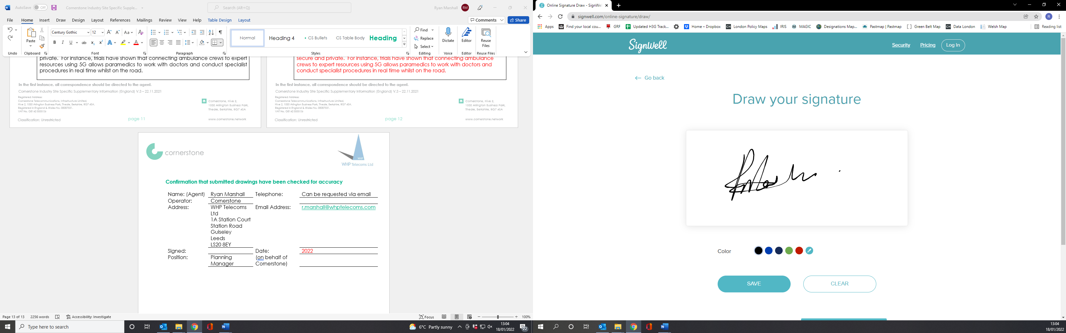 | Date: | 28th October 2023
Position: | Planning Manager | Company:  (on behalf of above operator) | WHP

