Construction Management Plan | St James, Protected Fire Corridor

Contents
1.0 - Introduction 3
1.1 – Site Location Plan 3
2.0 – Site Establishments & Logistics 4
2.1 – Site Operating Hours 4
2.2 – Site Establishment Plan 4
2.3 – Site Parking Arrangements 6
2.4 – Materials Deliveries 6
2.5 – Storage of Materials 6
2.6 – Construction 6
2.7 – The Erection & Maintenance of Security Hoarding 7
2.8 – Traffic Management & Road Closures 7
2.9 – Access 7
2.10 – Temporary Lighting 8
2.11 – Access to Existing Properties & Businesses 8
3.0 Environmental Restrictions and Existing Risks 9
3.1 - Site Waste Management Plan 9
3.2 – Recycling of Waste & Demolition Materials 9
3.3 – Control of Dust & Dirt 9
3.4 – Control of Noise & Vibration 10
3.5 – Human Impact 11
4.0 – Programme 12
4.1 – Construction Programme 12
5.0 - Complaints Handling Procedure 12

1.0 - Introduction

1.1 – Site Location Plan
St James Buildings is a high-rise, Grade II listed building on Oxford Street, Manchester, England. Located on Oxford Road, surrounded by Portland Street and adjacent to the Palace Theatre.
The building consists of 9 storeys excluding ground and basement and is split into 6 blocks from Block A-E. See location plan below:
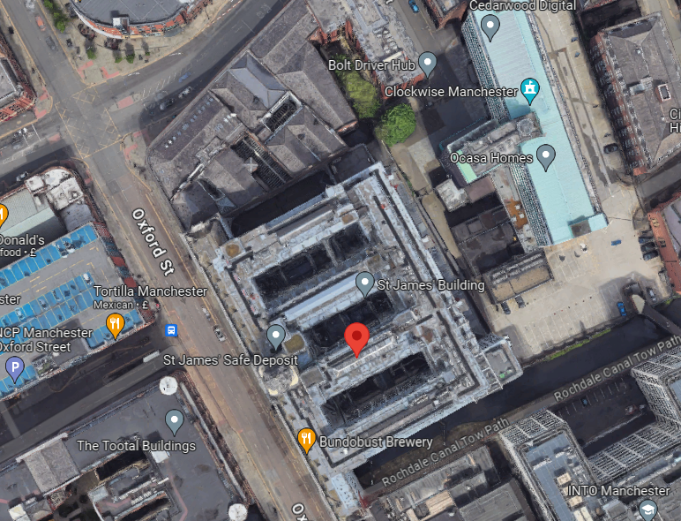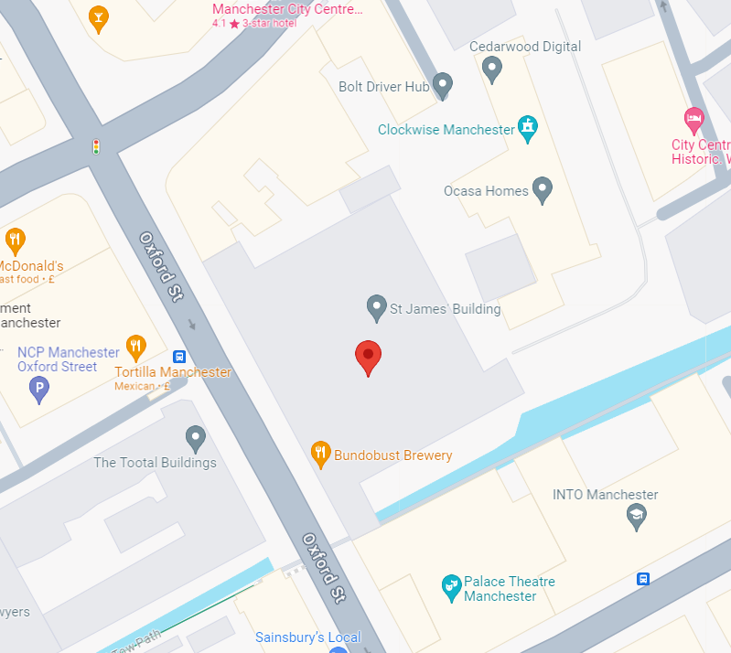

2.0 – Site Establishments & Logistics

2.1 – Site Operating Hours
The site will be operated and managed by Cubic Works Limited, in their capacity as Principal Contractor under the CDM Regulation 2015.

The works will be completed between Monday - Friday with weekend working reserved for specific tasks and operations such as noisy works due to occupants remaining present throughout the building during the works.

Official site working hours will typically be:
Mon – Fri: 7:00am – 6:00 pm,
Sat: 7:00am – 4:00pm (as required)
Sunday/Bank Holidays: 8:00am - 4:00pm (as required)

The above site working hours details the typical operating hours of the site where, for the most part, non noisy internal fit out works will be being undertaken. Any works which are noisy will be completed in line with Manchester City Council’s prescribed timeframes of:

Mon - Fri: 7.30am to 6:00 pm
Saturday: 8.30am to 2:00 pm
No noisy works on Sundays

If for whatever reason noisy works need to be completed outside of the above prescribed timeframes, for example for health & safety reasons, then Cubic Works Ltd will apply for consent using the online application form. It will not be assumed consent will be provided and it is understood that assessment will be based on the hours applied for, nature of the work and justification for working out of hours.

2.2 – Site Establishment Plan
Access for contractor vehicles, as well as for deliveries and the removal of waste materials will be via Portland Street.

Access from the front elevation off Oxford Road is also not available due to the busy nature of this road, as well as no vehicular access to deliver and remove materials due to parking bays, bike lanes and loading bays all being within close proximity to one another.

The project office and site welfare will be located on the first floor of the building. The first floor includes subdivided office rooms to enable contractor and client meetings, dining facilities, a functioning kitchen with hot water and toilet facilities, all in accordance with Schedule 2 of the CDM Regulations 2015.

2.3 – Site Parking Arrangements
There are contractor parking provisions on site. There is a small amount of off street car parking dotted around the site, as well as a number of other Bruntwood properties within close proximity. Cubic Works site management team will use the basement car park as well as the project’s main subcontractors. The remainder of the project team will be required to utilise public / street parking as required.

2.4 – Materials Deliveries
All loading and unloading of materials will be undertaken within the building carpark. There will be no forklift truck on site, therefore all delivery vehicles where required will have their own plant (hiab or similar) for removal of materials. All deliveries will be coordinated by a banksman and a weekly delivery booking schedule will be utilised.

2.5 – Storage of Materials
All materials and waste will be stored within the building carpark.

2.6 – Construction
Before any construction works begin, site boundaries will be established by means of solid hoardings to secure the site within the building carpark.

The general construction sequence will be as follows:

- Site set up
- Installation of gantry structure
- Installation of lightweight partition systeming
- Installation of fire shutters
- Installation of fire doors, etc
- Decoration and making good works
- Installation of flooring where required
- Clean
- Decant from site

There are no excavation works being completed or works which would lead to significant dirt / debris contaminating vehicle tyres. There is therefore no specific requirement to provide wheel washing facilities however water will be available throughout the site should the requirement for sporadic cleaning arise.

HSE guidance dictates sheeting of "tipper" vehicles. It is not anticipated that tipper vehicles will be utilised on this project due to the nature of works and therefore a specific methodology for sheeting has not been included within this CMP. Should the need arise for this at a later stage in the project, Cubic Works will ensure that this is managed and the risk reduced as far as reasonably practicable in line with their duties as Principal Contractor under the CDM Regulations 2015.

2.7 – The Erection & Maintenance of Security Hoarding
The site will be secured by means of a security hoarding in the form of heras fencing within the building car park. No hoarding will be completed outside of the building footprint or on public land.

The site is covered by the existing building lighting and remote monitored CCTV outside of normal working hours.

2.8 – Traffic Management & Road Closures
Traffic management and road closures are not applicable to this project.

2.10 – Temporary Lighting

Lighting will be provided within the building, in the form of tripod task lighting as well as temporary bulkhead lighting where necessary.

2.11 – Access to Existing Properties & Businesses
It is anticipated that there will be little to no significant impact as a result of the works to surrounding properties and businesses.

3.0 Environmental Restrictions and Existing Risks

3.1 - Site Waste Management Plan
The principal wastes predicted to be generated by the construction work include mixed construction and demolition wastes, packaging, timber and catering wastes (i.e. general waste). Hazardous waste in the form of asbestos is present within the building and will be remediated prior to commencement of any construction works.
3.2 – Recycling of Waste & Demolition Materials
All waste streams will be segregated, where possible, prior to being removed from the sites by a licensed carrier. All mixed waste is to be transported to a licensed transfer station where the waste is segregated and waste to landfill reduced whenever possible.

3.3 – Control of Dust & Dirt
Guidance from the BRE (Building Research Establishment) states that the most effective mitigation technique for dust control is to prevent dust from becoming airborne, since it is difficult to suppress after this stage.

Cubic Works, as standard, implements procedures to control the emission of dust including, but not limited to, all tools being fitted with dust extraction equipment, misting/watering areas before sweeping and segregating joinery cutting zones to ensure dust which is released is contained to specified areas.

Further details will be included in each individual subcontractor's site specific risk assessments and method statements (RAMS) with Cubic Works managing this in their capacity as Principal Contractor under the CDM Regulations 2015.

3.4 – Control of Noise & Vibration
The majority of the works entail internal fit out works. Protection against this noise for both operatives and the public will be managed through individual site specific risk assessments and method statements for each activity and activities will only take place during agreed Manchester City Council working hours.

BS5228-1 (Noise) provides practical information on construction noise reduction measures and promotes a ‘Best Practicable Means’ approach to noise control. The calculation method provided in BS 5228-1 is based on the number and types of equipment operating, their associated sound levels, operational times, and the distance to receptors, together with the effects of any screening.

The site manager will have ultimate responsibility for reducing noise and vibration levels from the site.

Mitigation measures that will be implemented to control noise, as detailed in Section 8 of BS 5228-1:2009+A1:2014, are as follows:

- Turning equipment off when not in use
- Ensuring that all plant and equipment is well maintained
- Minimise drop heights of materials
- Start plant up sequentially rather than simultaneously

There is no proposed piling or excavation work and it is therefore likely that vibration will not be a concern for this site.

3.5 – Human Impact
Construction works can have an impact upon the local environment and the residents of local communities. As such, the following processes and procedures will be implemented, in addition to the above controls to minimise the effect that the redevelopment will have on the local community.

4.0 – Programme

4.1 – Construction Programme
Subject to planning approval, targeted for February 2024, the works are to commence on site immediately with a target completion date of June 2024.

It must be appreciated that these dates are subject to change depending on approvals from Manchester City Council and appointment of all of the subcontractor supply chain.

5.0 - Complaints Handling Procedure
The site will be registered under the Considerate Contractors Scheme and the Code of Considerate Practice will be followed. A project organogram will be made public for the chain of command for complaints to be made. When a complaint is registered, Cubic Works will take appropriate remedial action including issuing an acknowledgement to the complainant within a maximum of 12 hours, aiming to conclude the concerns around the complaint within five working days. Ultimately, Cubic Works will be responsible for handling the complaint.

