
Ark deakin

Construction Phase Health and Safety Plan

Project: SONA
July 2023 Rev 13

Construction Phase H&S Plan Sign Off
Prepared in accordance with the requirements of the Construction (Design and Management) Regulations 2015 (CDM) – Appendix 3
Prior to implementation of this CPHSP, the plan should be reviewed and signed off below as reflects the construction works being undertaken.
The Client’s representative (or Principal Designer) must sign below to signify acceptance of the plan
Project Construction Phase Plan Sign Off
Position: | Project Manager | Name: |  | Jordan Stent
Signature: |  | Date: |  | 01/10/2021
This CPHSP has been developed for project implementation and is fit for purpose as ready for review by the Client’s representative to confirm acceptance for the construction works to commence
Contracts Manager / Project Manger |  | Jordan Stent | Project Manager |  | 01/10/2021
The Client is aware of their duties under the Construction (Design & Management) Regulations: 2015 and is satisfied with the content of this plan for the construction works to commence
Clients Representative / Principal Designer |  | Dave Aspey | Project 4 Safety Solutions |  | 01/10/2021
The Client (or his representative) has reviewed the welfare facilities on the site and satisfied they are suitable for the works to commence
Clients Representative / Principal Designer |  | Dave Aspey | Project 4 Safety Solutions |  | 01/10/2021

CPHSP Review & Update
The Environment Health and Safety Plan must be reviewed and updated at least monthly, or when there is significant change to risks or risk control measures (including legal or regulatory requirements).
Relevant sections or requirements of the plan must be communicated to all relevant staff and shared with third parties.
Details of the review will be recorded below to demonstrate the project review process and status

Monthly Plan Review
Date | Section No | Summary of revisions / updates | Review By
21 Oct 21 |  | Comments by Safer Sphere | KT
02 Nov 21 | 3.4 | Working Hours | LD
02 Nov 21 | 4.12 | Site Set-up | LD
02 Nov 21 | 5.3 | Delivery & Removal of Materials/Waste | LD
02 Nov 21 | 5.15 | Dust Control | LD
02 Nov 21 | 5.16 | Temporary Works | LD
02 Dec 21 |  | No Amendments Required | LD
02 Jan 22 |  | No Amendments Required | LD
14 Feb 22 | 4.1 | Management Structure & Responsibilities | LD
16th March 22 |  | No Amendments Required | LD
7th April 22 |  | No Amendments Required | LD
19th May 22 |  | Amendment to First Aid & Fire Marshall Personnel | LD
27th June 22 |  | No Amendments Required | LD
14th Sep 22 |  | No Amendments Required | LD
9th November 22 |  | No Amendments Required | LD
05 January 23 | 4.1 | Change of appointments | LD
 | 4.1 | Change of appointments | JL
06.09.23 | 3.10 | Wheel Wash Facilities | CDW
06.09.23 | 3.10 | Delivery of Materials/ Sheeting | CDW
06.09.23 | 3.10 | Dust suppression | CDW
06.09.23 | 3.10 | Compound | CDW
06.09.23 | 3.14 | Emergency Contact Details | CDW

Description of Project

Project Description
Describe in sufficient detail the scope of the project, which should include but not be limited to:  - The key environment, health & safety elements of the works, the proposed programme, phasing and any specific high risk, unique or unusual aspects of the project. | Project Action by:  J. Stent/ C.Watkin  Contracts / Project Manager / Admin

Project Classification (tick those that apply)
PFI | Private Finance Initiative |  |  | GMP | Guaranteed Maximum Price
PM | Project Management |  |  | DMC | Design, Manage and Construct
CM | Construction Management |  |  | LST | Lump Sum Tender
MC | Management Contracting |  |  | Other | # Specify #
DB | Design & Build
Project Programme:
Start on Site Date: |  | 04/10/2021 |  | Contract Period (weeks) |  | 58
Project F10 to be issued by client. |  |  |  |  |  | Date: 26/10/22
Project Description
The project consists of the following:
- Scope of works concerning the new build project includes but is not limited to;
- Re-configure existing drainage
- New incoming services to building
- Carry out remedial works to existing structure
- Continuation of build progress to 41 residential flats as per the Architects specification
- Installation of M&E
- Installation and commission of new lift
- Make good/cast new slabs and balcony walkways
- Installation of new windows, cladding and brickwork
- Alterations & adaptations of existing scaffold in line with project timeline

Project Duty Holders & Contacts
Insert the contact details of the organisations / individuals listed on the F10 rev. Notification as defined as Duty Holders within the CDM Regulations 2015  Insert other key project contacts (i.e. emergency services and enforcing authorities etc.) | Project Action by:  J. Stent/ C.Watkin  Contracts / Project Manager / Admin

Duty Holders (defined by CDM Regulations 2015)
Title | Contact Name (s) | Company Name | Contact Details (Address, E-Mail & Telephone)
Client / Employer | James Quinn | GGC Polygon Manchester Limited | 15 Esplanade, St Helier, Jersey, JE1 1RB Channel Islands
Main Contractor | J. Stent C.Watkin | RECOM Solutions | RECOM Solutions Ltd, The Schoolhouse, Unit 6 Second Ave, Trafford Park, Stretford, Manchester M17 1DZ
Building Control Officer | TBC
Principle Designer | Dave Aspey | Project Four Safety Solutions | Blackfriars House, St Mary's Parsonage, Manchester M3 2JA

Emergency Services Contact Details
Title | Name | Contact Details (Address, E-Mail & Telephone) | Notified of Project?
Police | Manchester Police | Talbot Rd, Old Trafford, Stretford, Manchester, M32 0UX | N/A
Ambulance | Northwest Ambulance Service | Wheel Forge Way, Trafford Park, Stretford, M41 7RR | N/A
Fire & Emergency | Stretford Fire Station | 246-246 Park Road, Trafford Park, Stretford, M32 8RJ | N/A

Enforcing Authorities Contact Details
Title | Name / Contact Details (Address, E-Mail & Telephone) | Notified of Project
Health & Safety Executive | Merseyside HSE Merton Rd, Bootle L20 7HS
Building Control | Carl Williams – Building Consents, 17c Church Street, Frodsham, Cheshire, WA6 6PN | Yes
Environment Agency | N/A | N/A
Highways Agency | National Highways | N/A
Drainage (Foul & Storm) | United Utilities | N/A
Electricity | Electricity North West | N/A
Gas | National Grid | N/A
Telephones | N/A | N/A
Considerate Constructor Scheme | N/A – Not registering project on scheme | N/A
Other (Specify)

Pre-Construction Information
Record below all surveys, reports and other information that it is anticipated will be needed for the effective planning and management of the works.  Request such information from the client or Principal Designer if not automatically issued, and record as appropriate request and received dates.  File large or bulky documents in the project safety management filing system, and clearly identify their location in the table below. | Project Action by:  Contracts / Project Manager  J. Stent
Description  (Amend list as appropriate) | Applicable (Y/N) | Date Received | Report Reference No. | Location / File Reference
Pre-Construction Information Pack | Yes | To be issued | Online Dropbox system | Online J. Stent Login details
Asbestos survey / report(s) / Clean Air Cert | N/A
Planning conditions / constraints | Yes
Geotechnical survey | Yes
Structural survey | Yes
Schedule of conditions | No
Party wall survey / agreements | No
Noise survey | No
Archaeological survey | No
Retained structures / elements | No
Listed building status | No
Environmental issues | No
Underground Services | Yes |  |  | Site file
UXO (Unexploded Ordnance) | No

Constraints & Restrictions
From project documentation, including pre-construction information, determine and record below, any constraints or restrictions which may affect the execution of this project. | Project Action by:  J.Stent/ C.Watkin  Contracts / Project Manager

Item | Constraint or Restriction | Description or Reference to Further Information / Detailed Report | Action or Control Measures Required
1 | Adjacent Premises e.g. Housing, Offices, Shops, etc | Existing shops, accommodation and public buildings in close proximity of site. | All site operatives to be inducted by RECOM and run through fire and emergency procedures, including safe lifting. All operatives have been reminded that we have obligations to local neighbourhood to keep it clean and tidy
2 | Adjacent Transport Undertaking e.g. Bus Stops, Taxi Ranks, Underground or Train stations, Live overhead lines / rails | N/A
4 | Asbestos e.g. Asbestos surveys, asbestos management plans | N/A
5 | Client Activities e.g. Operational Areas, Sensitive or restricted areas | N/A | Close liaison with key stakeholders (Cert Property) of the project. Weekly look ahead meetings with notes to be issued to identify what areas may be affected. Inductions by RECOM.
6 | Energy Supply e.g. Limitations, Type (generator or mains) | Yes | Temp feed for site works initially to be fully mains fed.
7 | Environment e.g. Discharge Consent(s), SSSI, Adjacent canals, rivers, watercourses | N/A
8 | Existing Structures e.g. Demolition, Temporary Support, Fragile Materials | Yes | Existing structure part built, careful planning for all works until site is made 100% safe.
9 | Ground Conditions e.g. Soil Surveys, ‘Brownfield’ Sites, Gradients, Wells, Mine Workings, Shafts, Basements | Yes | See original site survey of existing
10 | Noise Control e.g. Environnemental noise limits Section 60 / 61 agreement | N/A | No constraints at present.
11 | Working Hour Restrictions | Planning Permission Document | Weekdays 7:30-18 :00  Saturdays 8 :30-14 :00  Sunday – No Working

Management of the Work

Management Structure & Responsibilities
Complete the project structure chart by discipline at the start of the project. Amend the chart as project personnel change  Ensure that each member of staff working on the project reads and understand their personal roles & responsibilities, as indicated in the company Policy Arrangements SS-SMS-01-02 and sign to acknowledge this. All identified staff are to read the summary of general H&S duties below. | Project Action by:  R.Taylor

Health and Safety Duties and Responsibilities of all Project Personnel
- Set a personal example to lead in safety and health promotion.
- Understand the company H&S policy, CPHSP Plan and appreciate the responsibility allocated to each team member
- Attend the project Safety Induction
- Attend any health & safety training identified by the company, the Project training plan and personally maintain professional competencies.
- Liaise with other managers to clarify responsibilities at physical or organisational interfaces between packages or sections of the project, so that full coordination is maintained
Wheel Wash Facilities
- Due to the nature of this development there is no requirement for wheel wash as there is no risk of mud on the public highway. Should there be at any stage Recom will in the first instance brush and was down using jet was. Road sweeper will be deployed if this is not resolving the situation.
Dust Suppression
- All activities involving dust will include the use of dust suppression.
- All cutting of sheet materials will be done outside using suitable dust extraction and operatives will be required to wear FFP3 dust masks
- Any cutting of concrete and or brick will include dust suppression (water bottles) and damping down
- Vacuum will be used to ensure clear work areas after cutting has taken place
- All attempts will be made to ensure dust particles are collected at source and prevented from becoming airborne
Compound
- Due to the location of the site there is no requirement and no location for a compound. Materials will be brought in on a as and when required basis.
Skips
- Skips are generally 8yrd skips for general waste
- We have waste segregation and plasterboard skips
Site Parking
- Off-site parking will be in car park adjacent to Apolo theatre.
Deliveries
- Any open back delivery vehicles will be sheeted include muck off site
Name (Print) | Role / Title | Signature | Date
Carl Watkin | Operations Manager |  | 06/09/2023
Ryan Taylor | Construction Manager
Joe Elliot | Assistant Cons Manager

Health & Safety Resources
Adequate safety resources to complete the project, including personnel, time and cost allowance will have been assessed prior to commencement on site.  Responsibility for Health & Safety on the project remains with the Contracts / Project Manager and the rest of the project team.  To provide assistance, advice and monitoring of compliance within the project a H&S Advisor resource should be allocated to the project as below.  At all times works are taking place, RECOM will maintain an adequate level of Operations Management on site to manage the contractors undertaking the works.  Each sub-contractor will allocate to the project their own H&S Advisor / Manager and Supervisors who together with RECOM management will plan, manage, supervise and monitor the health & safety aspects of their works.  Minimum resource level for contractors H&S Advisor and Supervisors will be agreed as part of the tender process and based on the package risk rating. | Project Action by:  R.Taylor

H&S Advisor / Manager Allocation & Contractor | Number of Visits / Month | From  Project Week & Date | To  Project Week & Date
RECOM | 2 | 04/10/2021 | TBC

Project H&S Goals
Client specific Environment, Health & Safety Standards or Goals that have been stipulated as part of the contract are to be included within this H&S Plan and included within any induction, site rules etc. | Project Action by:  J. Stent

The following Client’s H&S Goals and Performance Standards have been provided and are to form part of the specific site rules / standards for this project:
No detail provided but will be expected to include
- No prosecutions or enforcement notices for Health & Safety issues
- No reportable injuries, diseases or dangerous occurrences
- No falls from height of personnel, materials, plant or equipment
- No personnel injured by the movement of plant or vehicles especially during reversing operations
- No slips, trips & falls
- No fires, environmental incidents or cases of public nuisance.
- No cases of occupational dermatitis, ‘Hand Arm Vibration Syndrome’ (HAVS) or occupational ‘Noise Induced Hearing Loss’.
- No cases of occupational injury from manual handling.

Liaison between parties on site
Develop a schedule of key meetings through which H&S risk and compliance can be discussed and managed between the main stakeholders involved with the project  Populate the table below and review at regular intervals. | Project Action by:  J. Stent

Meeting | Objective | Attendees | Frequency
Project H&S Coordination Meeting | Consultation at project level will be via regular Safety Forum meetings on site (minimum Weekly) involving all RECOM and sub-contract site personnel. The meeting will be attended by the site management team and be structured to enable pre-planning of forthcoming site activities and ensuring that all people working on the project are aware of the interface with other trades. Meeting minutes should be posted on the notice boards within the site facilities. | - Contracts / Project Manager  - Site Manager  - RECOM Supervisors  - Sub-Contractor Supervisors  - Others | Weekly
Other Specific Meetings Required. | Weekly Look Ahead Meeting / Notes – To be issued by RECOM Solutions.

Consultation with the Workforce
Develop a schedule of methods to facilitate workforce consultation with all the people on site, in respect of their health and safety.  The object is to ensure that all personnel working on the project are provided with a suitable forum to be consulted on relevant H&S issues.  Monitor outputs and facilitate communication to the entire workforce. | Project Action by:  J. Stent
Engagement with the site workforce will be actively pursued at all opportunities, and achieved at 3 levels on site via:-
 | Consultation Methodology
Project | Safety Forum | Trade Union Representatives | Through one or more Workforce Representative | Site Project Meeting
Work-gang | Toolbox Talks | Safety Task Analysis | Through elected representatives | Method Statement Briefings
Individual | Feedback/  suggestion boxes | Directly with each employee | Whistle blowing procedures | Open door policy

Managing Design
CDM Design Management is a systematic approach to the organisation, evaluation and direction of the design process to achieve a project that delivers life cycle safety free from ill-health.  Depending on the nature of the project and procurement method the client may already have a design in place or may require RECOM to assist in its preparation and as such RECOM has a CDM Design Risk Management process to meet compliance with the CDM Regulations 2015. | Project Action by:  J. Stent
Where RECOM has design responsibility or a design management function, the Hazard And Risk Management (HARM) review process shall be undertaken during design and planning to positively influence safety during the construction, operation, maintenance and demolition of buildings. Where RECOM cannot influence design due to the stage of its development and/or our role, reviews of 3rd party design residual risks will be carried out to highlight and eliminate environment, health and safety risks in construction, fit-out, operation and maintenance.
The above process is outlined in RECOM CDM Design Management Guide.
Any ongoing designs and or design changes will be reviewed against the HARM register and process for any effect on H&S or opportunity for mitigations. Site safety control measures will then be established where necessary.

Selection of Contractors / Consultants / Suppliers
The procurement of contractors and suppliers is to be undertaken in accordance with the requirements of the RECOM Procedures on Subcontract Procurement. This covers all aspects of supply chain competence from pre-qualification through to SSIP accreditation.  Refer to SS-SMS-03.1 for the safety management system process on supply chain selections:  Pre-qualification and Accreditation will be evaluated by means of ‘Building Confidence’ or SSIP Standards. | Project Action by:  J. Stent
To ensure compliance with the legal standards and RECOM standards, the following must be met:
- All contractors / consultants / suppliers formally engaged to provide design, development, construction, management or maintenance services must be go through a pre-qualification process which includes an assessment of the organisation’s ability to meet any relevant legislative requirements, including adequate insurance cover.
- The environment, health and safety responsibilities of key contractors / suppliers, and the significant risks associated with their works, must be clearly defined for each engagement. The relevant GMRs (and associated Means and Methods where applicable) and any other H&S requirements must be provided to these organisations to adequately plan and price the work. The quality and accuracy of the contractor / consultant / supplier’s documentation should be a key factor in selection.
- Contractors / consultants / suppliers must employ adequate numbers of competent supervisors, provide proof of competence for key workers, particularly those carrying out high risk activities or undertaking work where proof of competence is required by law.
- Where it is assessed that a contractor, consultant or supplier may not be able to meet legal requirements in full they must not be engaged unless the operation has no other feasible option available. In this situation a Mitigation Plan must be prepared and approved before any contract can be awarded.
Contractor / Consultant / Supplier | Internal Competence Assessment? (Yes / No, date undertaken) | Accreditations (CHAS, Safe Contractor, Construction Line, Building Confidence, etc)
RECOM Solutions | YES | Construction Line
Farley Electrical | YES | ECS
Cheshire Scaffolding | YES | CISRS

Site Safety Inductions
Project teams must ensure that site inductions are provided for all persons working on or visiting our sites to communicate key risks, emergency procedures, site rules and safety precautions to them. | Project Action by:  J. Stent
Ensure all persons who will work on the project for more than one day receive a project specific induction before they start work on site. The induction shall include:
- senior management commitment to health and safety;
- the outline of the project;
- the individual's immediate line manager and any other key personnel;
- any site-specific health and safety risks, for example in relation to access, transport, site contamination, hazardous substances and manual handling;
- control measures on the site, including:
- any site rules,
- any permit-to-work systems,
- traffic routes,
- security arrangements,
- hearing protection zones,
- arrangements for personal protective equipment, including what is needed, where to find it and how to use it,
- arrangements for housekeeping and materials storage,
- facilities available, including welfare facilities,
- emergency procedures, including fire precautions, the action to take in the event of a fire, escape routes, assembly points, responsible people and the safe use of any fire-fighting equipment;
- arrangements for first aid;
- arrangements for reporting accidents and other incidents;
- details of any planned training, such as 'toolbox' talks;
- arrangements for consulting and involving workers in health and safety, including the identity and role of any:
- appointed trade union safety representatives,
- representatives of employee safety,
- safety committees;
- information about the individual's responsibilities for health and safety.

Contractor Training & Competence
All contractor personnel will be trained to the standards set out in relevant H&S legislation.  Project specific training requirements and certificate type are identified below | Project Action by:  J. Stent

*Add / omit from the list below as applicable

Specific training requirement | Certification Scheme
Contractors Managers (General) | SMSTS certificate (Site Managers Safety Training Scheme) + Relevant trade qualifications / experience.
Contractors Supervisors (General) | SSSTS (Site Supervisors Safety Training Scheme) or SMSTS certificate
Scaffolding Supervisors | N/A
Demolition Supervisor | N/A
General Construction Trades & Labourers. | CSCS card (with relevant endorsements)
Plant Operators (General). | Relevant CPCS card+ machine specific familiarisation training.
Compact Crane Operator. | CPCS card+ machine specific familiarisation training.
Signaller / Slingers. | CPCS card
MEWP operator | IPAF card (with relevant endorsements) + machine specific familiarisation training.
Light weight scaffold tower erection | PASMA card (with relevant endorsements) + equipment specific familiarisation training.
Scaffolder | CISRS card + manufactures training if system scaffold is to be used. (CSCS affiliated)
Electricians | ECS card (CSCS affiliated)
Plumbers | JIB-PMES card (CSCS affiliated)
Utility Services | EUSR card (CSCS affiliated)
Demolition | CCDO Card (CSCS affiliated)
Safety Net rigging | FASET
Independent Rope Access & Personal Suspension | IRATA

Site Security
Ensure the site has adequate security by providing fencing to the perimeter and lockable access gates.  Ensure that visitors sign a visitor’s register and are accompanied by a member of the RECOM team or by an authorised member of a trade contractor's site personnel.  Where projects are not manned by security staff outside site operating hours ensure that a prominent notice is displayed at each site entry point indicating appropriate emergency call out contact numbers.  Ensure that signage is located at each entrance noting that unauthorised persons are not to enter, and giving clear directions to pedestrian entrances.  The following security measures will be provided on this project to provide protection to the perimeter of the site and control of personnel access. | Project Action by:  J. Stent
*Add / omit from the list below as applicable

Physical Means
Describe how the perimeter will be secured by physical means (i.e. hoardings, existing structure etc). Include height and construction of hoardings and any temporary measures if relocation is required during the programme of works
- Full perimeter hoarding will be in place to prevent unauthorised access into the RECOM Construction Site.
- Sign In book on Site.
- Perimeter CCTV
- On-site Security
- Facial Recognition Entrance
Scaffolding
Describe what security measures to scaffolds or other structural elements founded on the footpath or road will be taken to prevent their use for unauthorised access
Ladders will be secured with ladder locks at ground level or removed at night time to prevent persons climbing up if they get over the site boundary fence.

Vehicle Access Points
Describe how vehicle access points will be controlled to prevent access by unauthorised vehicles or pedestrians. Describe any gates / movable barriers and gate control personnel, etc.
Coordination will be required with site security/gateman.
Perimeter Alarms, Lighting & CCTV
Describe any additional perimeter protection alarms, CCTV etc to assist the security of the site
CCTV to be fitted in various locations around site perimeter.

Security Guard Provision
Describe any static security guard locations or patrols including outside site hours (i.e. 24-hour provision)
Client to supply 24 hour manned security.
Personnel Access
Describe the physical means of preventing unauthorised persons entering at designated personnel access points (i.e. security guards, biometric / swipe card activated turnstiles etc)
RECOM operatives/sub-contractors will attend the site induction prior to accessing the site- signage to be installed displaying this. A Physical Coded Gate, followed by a facial recognition access point shall be put in place to ensure there is no unauthorised access into the site.

Welfare Facilities
Welfare facilities commensurate with the number of people on site must be available at the start of the project, where all adequate facilities can be used. RECOM will provide hand sanitizer and welfare provisions throughout the works. | Project Action by:  J. Stent
- The quantity and location of the welfare facilities needed on commencement of the project and the anticipated facilities required for the peak numbers of the project are to be provided in the table below
- All welfare facilities are to be provided in full accordance with the CDM Regulations 2015 Schedule 2.
Welfare Facilities / Details | Start of Project |  |  |  | Peak of Project
Anticipated number of Males on the Project | 10-20 |  |  |  | 50
Anticipated number of Females on the Project | 2 |  |  |  | 0
No of Urinals / Male WCs / Female WCs to be provided | 0 | 3 |  | 0 | 0 | 3 |  | 0
No of Wash Hand Basins / Showers to be provided | 1 |  | 0 |  | 2 |  | 0
Hot / Cold running water supplied from | Welfare – Canteen as per attached plan
Location of Drinking Water Provision | Welfare – Canteen as per attached plan
Method for supplying Drinking Water | Mains
Individual Storage Facilities provided (lockers etc) | No
Specific Changing Facilities for Male Personnel | No
Specific Changing Facilities for Female Personnel | No
Provision of Drying Facilities | Yes
Provision and Location of Rest Room | Yes
Provision for Boiling Water for Drinks | Yes
Provision for Heating / Cooking Food | Yes
Person / Contractor Responsible for Maintenance of Facilities | RECOM Solutions
Person / Contractor Responsible for Cleaning the Facilities | RECOM Solutions
Consumables provided by: | RECOM Solutions

Site Set-up
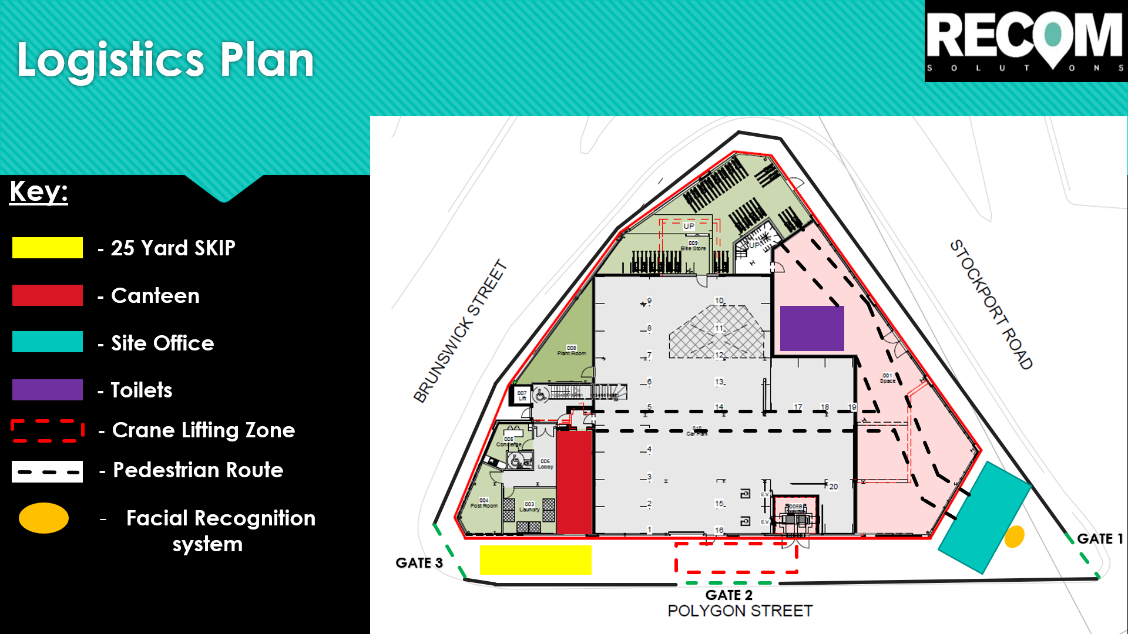

First Aid Arrangements
The names of qualified first aiders from RECOM and contractors is provided below with contact details and qualifications in first aid and use of defibrillators.  The locations of first aid room (if applicable) and first aid kits and are provided in the table below. | Project Action by:  J. Stent

Category of risk |  |  | Nº employed at location |  | Minimum number of first-aid personnel
High  e.g. construction sites and depots with workshops, manufacturing or processing facilities. |  |  | Fewer than 30  5 – 50  More than 50  Where there are hazards for which additional first-aid skills are necessary |  | At least one appointed person  At least one first aider  One additional first aider for every 50 employed  In addition, at least one first aider trained in the specific emergency action
 | First Aiders |  |  |  |  |  | Expiry of First- Aid Qualification
 | Name | Employer |  | Work Area |  | Contact Number | Expiry of First- Aid Qualification
 | Jordan Stent | RECOM Solutions |  | Site |  | 07772400052 | October 2022
 | Carl Watkin | RECOM Solutions |  | Site
 | Ryan Taylor | RECOM Solutions |  | Site

Location of First Aid Rooms (if applicable)
1. | Site Office inside front gate
2.

Location of First Aid Kits
1. | Site Office
2. | Site Canteen
3. | Security Office and on every floor/ Landing

Fire & Emergency Arrangements
The names of trained Fire Marshals from RECOM and contractors are provided below with contact details and qualifications in fire and emergency action.  A project specific fire plan is to be developed and maintained throughout project. | Project Action by:  J. Stent
A site fire & emergency plan will be prepared in accordance with RECOM process SS-SMS-15.1. An emergency and environmental incident response plan will be completed for this project, posted on site in the office and welfare facilities with specific arrangements communicated at induction.
The likelihood of an incident can be minimised by effective planning through the development of site Emergency and Environmental Incident Response Plan.

Specific Plan Provided? (Y/N) | Y N | Plan Provided in Appendix No. | To be developed prior to starting on site
SMS Requirement for Specific Plan (Y/N) | Y N | SMS Plan Reference: | SONA Fire Safety Plan
Fire Marshals / Wardens |  |  |  | Expiry of Fire & Emergency Training
Name | Employer | Work Area | Contact Number | Expiry of Fire & Emergency Training
Carl Watkin | Recom Solutions | Site Office | 07938601674 | 24/02/2025
Ryan Taylor | Recom Solutions | Site Office | 07935757364 | 22/02/2025

Reporting & Investigation of Incidents
All incidents must be reported to the site manager and senior management team and will be investigated according to the RECOM investigation procedures.  The timely and accurate investigation of ALL incidents (relative to severity) is crucial to identify why they occurred and how to prevent similar incidents in the future. Failure to implement the effective investigation procedures can result in prosecution, difficulty with insurance claims and financial loss to the company. | Project Action by:  Director / Manager / H&S Provider.  All personnel on site.  J. Stent
The purpose of incident investigation is to:
- Fully understand the immediate and underlying causes of incidents;
- Institute corrective actions to eliminate the re-occurrence of the identified immediate and / or underlying causes;
- To share lessons learnt to prevent similar incidents occurring elsewhere within the business; and
- To minimise the impact of incidents both in terms of human suffering and economic loss.
Once the immediate emergency response to an incident has been implemented, the injured has been treated and the situation made safe, the investigation process should begin. This root cause(s) investigation process involves the collection of evidence, identification of immediate causes, critical factors, underlying causes, corrective actions and lessons learnt.
Fatal and other major incidents will be investigated by an independent investigation team from our H&S service provider.
All accidents including those to subcontractor workers must be reported immediately to the site management and a record entered in the site accident book. This includes all cases where first aid is provided, regardless of how minor the injury is considered. Where an investigation is carried out, the site manager and contracts manager will ensure that any follow up action required or recommended is carried out promptly and that information is relayed to all on site who may be affected by findings.
‘near miss’ incidents, those categorised as dangerous occurrences under statute, and those causing major damage whether or not injuries occur will be reported, investigated and recorded.

Production & Approval of Risk Assessments and Safe Systems of Work
All contractors will be required to detail the safe systems of work they will adopt for works involving any significant risk in Method Statements.  The Method Statement must describe nature and sequence of the works together with the control measures necessary to carry out the works in a safe manner, detail key responsibilities and how it will be communicated to their workers.  Where changes impact on the agreed method of work, the Method Statement must be revised accordingly and accepted by all parties. | Project Action by:  J. Stent/J. Lincoln
Method Statements & Risk Assessments
Ensure that contractors submit their Method Statement to RECOM, a minimum of 2 weeks, and preferably 30 days, before they are due to start work on site.
Check and agree the Method Statement before permitting the contractor to commence work on site.
Record this process on the Method Statement Review form.
RECOM ‘accepted’ method statements will be given a ‘CAT A’ status Non-acceptable method statements will be given a ‘CAT B’ status.
A copy of the completed review form is to be returned to the contractor confirming the Method Statement status.
Maintain a log of all Package Method Statements with their current status using the Method Statement Schedule Form.
Permits to Work
Permit to Work procedures will be implemented to ensure that regularly encountered high risks works are effectively controlled on a day to day basis.
Outlined below are the standard RECOM permits to work that may be applicable to particular construction activities:-
- Permit to Dig
- Permit to Enter (Confined Space)
- Hot Work Permit
- General work permit (High risk)
- Permit to demolish
- Permit to Lift
- Permit to work on live electrical apparatus (Commissioning & Testing)
- Out of Hours Work Permit (Working without [Company] Supervision)

Site Rules
Individual
- All personnel working on this project will attend an induction.
- All site personnel, for their own safety and for the safety of others, are required to fully comply with their employer’s task safe working method statement
- All personnel are required to wear a safety helmet, high visibility vest, safety footwear, gloves and appropriate eye protection as identified by risk assessment and method statement. Additional PPE, e.g. hearing protection, will be worn where appropriate.
- Transistor radios, personal stereos / Walkman’s / iPods or similar, are not to be used.
- The consumption of alcohol and drugs is prohibited.
- Smoking will only be permitted in designated areas.
- Covid-19 risk assessment and MS to be followed at all times whilst on site – All operatives to sign up to procedures during induction process.
- No personnel shall indulge in fighting, horseplay or practical jokes within the site perimeter.
Collective
- Any person found to be interfering or misusing fixtures, fittings or equipment provided in the interest of health, safety or welfare will be excluded from the site.
- Visitors must report to RECOM Solutions site offices, and will be allowed entry at their discretion. Whilst on site visitors are to wear appropriate PPE.
- Vehicle drivers must wear a safety helmet, hi-vis jacket or vest and safety footwear at all times when at risk. Vehicles are not to be reversed in construction areas unless under the control of an authorised traffic marshal / banksmen.
- Every incident (injury or near miss) event must be reported to RECOM Solutions.
- No person may operate any mechanical plant or equipment unless they have been trained, have been certificated as competent and are authorised to do so.
- Any mechanical plant or equipment found to be defective is not to be used and should be reported.
- All safety signs and notices must be followed.
- Site fire and emergency alarms, equipment and instructions are designed to protect life. They must be followed.
- Ladders are only to be used as work platforms for tasks of short duration and only if no alternative means of access is readily available. Ladders must always be secured to a structure or securely ‘footed’ by another person whilst in use.
- Only designated & qualified electricians may make an electrical connection / disconnection, other than at approved plug & socket points, or make alteration to the temporary electrical supply.

Arrangements for Control of Significant Risks

Project H&S Management
During the Pre-construction (identification) and Construction (control) stages of a project it is important to undertake regular reviews to establish if all of the risks have been identified and the correct control measures applied.
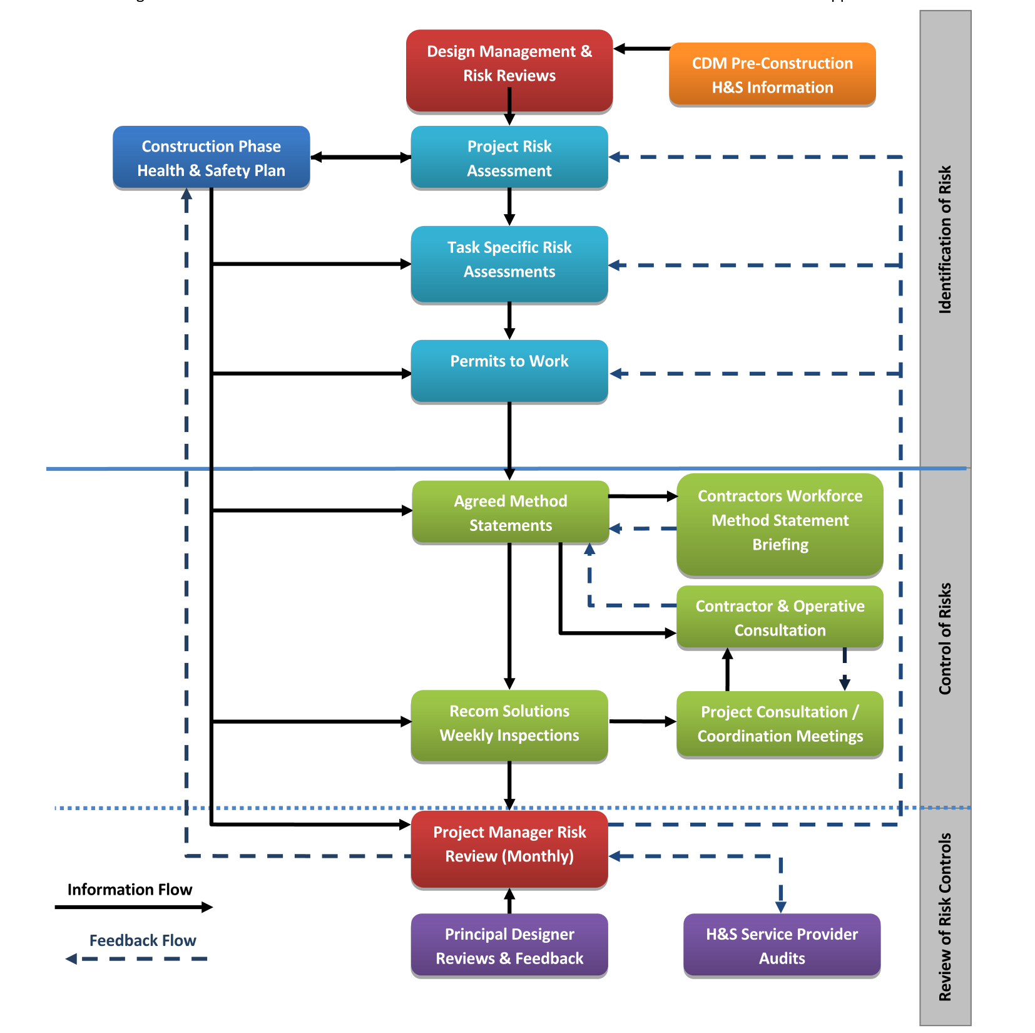

Project Risk Review
The following Project Risk Assessment shall be undertaken in order to identify the significant risks to the project requiring specific controls to meet the requirements of the CDM Regulations 2015 and H&S Legislation. Where the risks are applicable further supporting detail shall be provided in the sections following. | Project Action by:  J. Stent  J. Lincoln
Significant Risks | Applicable (Y/N)
Delivery and removal of materials (including waste) and work equipment taking account of any risks to the public, for example during access to or egress from the site | Y N
Dealing with services - water, electricity and gas, including overhead power lines and temporary electrical installations, | Y N
Accommodating adjacent land use | Y N
Stability of structures, including temporary structures and existing unstable structures | Y N
Preventing falls | Y N
Work with or near fragile materials | Y N
Control of lifting operations | Y N
Maintenance of plant and equipment | Y N
Excavations and work where there are poor ground conditions | Y N
Wells, underground earthworks and tunnels | Y N
Work on or near water where there is a risk of drowning | Y N
Work involving diving | Y N
Caisson or compressed air working | Y N
Work involving explosives | Y N
Traffic routes and segregation of vehicles and pedestrians | Y N
Storage of materials (particularly hazardous materials) and work equipment | Y N
Asbestos | Y N
Contaminated Land | Y N
Manual Handling | Y N
Hazardous substances, particularly where there is a need for health monitoring | Y N
Noise and vibration | Y N
Work with ionising radiation | Y N
Exposure to UV radiation (from the sun) | Y N

*Add / omit from the list below as applicable

Delivery & Removal of Materials
Risk Detail | Risk of interaction with Public / Pedestrians as site skip / unloading areas will be outside the project.
Overview of Proposed Mitigations | 800L bins transported onto site via a LOLER Certified Bin Cage & On-site crane to loading bays to avoid build-up of waste on floors.  Bin emptying procedures are controlled by allowing the Waste Collection Vehicle to park within the site perimeter through Gate 2.  Skip is stored within site boundary and as such presents no risk to the public.
Specific Plan Provided? (Y/N) | YN | Plan Provided in Appendix No.
SMS Requirement for Specific Plan (Y/N) | Y N | SMS Plan Reference: | Access & Egress Plan/Traffic Management Plan
SMS Standards | SS-SMS-02.2.1 Logistics and Storage Process Guide

Dealing with Services
Risk Detail | Ensure all permits are in place before works commence
Overview of Proposed Mitigations | RECOM to issue permit to dig in accordance with SMS.
Specific Plan Provided? (Y/N) |  | Plan Provided in Appendix No.
SMS Requirement for Specific Plan (Y/N) | Y N | SMS Plan Reference: | N/A
SMS Standards | SS-SMS-06.1.1 – Risk Assessment Guide  SS-SMS-08.1. – Permit to Work Process

Preventing Falls
Risk Detail | Working at height- work above ceilings
Overview of Proposed Mitigations | PASMA trained operatives to install alloy towers and inspect weekly.
Specific Plan Provided? (Y/N) | Y N | Plan Provided in Appendix No.
SMS Requirement for Specific Plan (Y/N) | Y N | SMS Plan Reference: | N/A
SMS Standards | SS-SMS-14.1 – Work at Height Process

Fragile Materials
Risk Detail | N/A
Overview of Proposed Mitigations | Work in accordance to specified RAMS
Specific Plan Provided? (Y/N) | Y N | Plan Provided in Appendix No.
SMS Requirement for Specific Plan (Y/N) | Y N | SMS Plan Reference: | N/A
SMS Standards | SS-SMS-14.1 – Work at Height Process

Maintenance of Plant & Equipment
Risk Detail | Hand Tools – TO be maintained / tested
Overview of Proposed Mitigations | Register of PAT tested tools to be held. LOLER cert to be provided for all lifting equipment including crane.
Specific Plan Provided? (Y/N) | Y N | Plan Provided in Appendix No.
SMS Requirement for Specific Plan (Y/N) | Y N | SMS Plan Reference: | N/A
SMS Standards | SS-SMS-09.1 – Statutory Inspections & Records Process

Storage of Materials
Risk Detail | Ensuring all materials stored within site boundary/Segregated from the public
Overview of Proposed Mitigations | As per logistics plan
Specific Plan Provided? (Y/N) | Y N | Plan Provided in Appendix No.
SMS Requirement for Specific Plan (Y/N) | Y N | SMS Plan Reference: | To be provided by RECOM Solutions prior to on site start date.
SMS Standards | SS-SMS-02.2.1 Logistics and Storage Process Guide

Traffic Routes and Segregation of Vehicles & Pedestrians
Risk Detail | Ensuring works do not impact the flow of traffic, pedestrians and passing public
Overview of Proposed Mitigations | Induction to detail how works are managed. All deliveries booked in with site manager.
Specific Plan Provided? (Y/N) | Y N | Plan Provided in Appendix No.
SMS Requirement for Specific Plan (Y/N) | Y N | SMS Plan Reference: | To be provided by RECOM Solutions prior to on site start date.
SMS Standards | SS-SMS-02.2.1 Logistics and Storage Process Guide

Asbestos
Risk Detail | Asbestos Removal Works
Overview of Proposed Mitigations | There will be no asbestos removal works on this project as there is no asbestos in the building.
Specific Plan Provided? (Y/N) | Y N | Plan Provided in Appendix No.
SMS Requirement for Specific Plan (Y/N) | Y N | SMS Plan Reference:
SMS Standards | SS-SMS-19.1 – Asbestos Process Guide

Manual Handling
Risk Detail | Manual Handling - General
Overview of Proposed Mitigations | Review in site induction and review individual capabilities.
Specific Plan Provided? (Y/N) | Y N | Plan Provided in Appendix No.
SMS Requirement for Specific Plan (Y/N) | Y N | SMS Plan Reference: | N/A
SMS Standards | SS-SMS-06.1.1 – Risk Assessment Guide

Hazardous Substances
Risk Detail | Storage of materials
Overview of Proposed Mitigations | COSSH assessment to be provided for Cement, and any silicone works internally
Specific Plan Provided? (Y/N) | Y N | Plan Provided in Appendix No.
SMS Requirement for Specific Plan (Y/N) | Y N | SMS Plan Reference: | N/A
SMS Standards | SS-SMS-16.1. – COSHH Assessment Guide  SS-SMS-18.1. – Occupational Health Guide

Noise and Vibration
Risk Detail | Noise / Vibration. – Not expected to exceed DB ratings, if so plan to be updated
Overview of Proposed Mitigations | Review on site during activity. If an issue is identified, implement an action plan / working out of hours.
Specific Plan Provided? (Y/N) | Y N | Plan Provided in Appendix No.
SMS Requirement for Specific Plan (Y/N) | Y N | SMS Plan Reference: | N/A
SMS Standards | SS-SMS-10.1. – Noise & HAV’s Process

5.14 Lifting
Risk Detail | Lifting
Overview of Proposed Mitigations | Crane lifts to be planned in advance with slot times given to crane operator and slinger.
Specific Plan Provided? (Y/N) | Y N | Plan Provided in Appendix No. | Lift Plan to be provided by Falcon Cranes Ltd to cover use of tower crane.
SMS Requirement for Specific Plan (Y/N) | Y N | SMS Plan Reference: | Specific rescue plan for TC driver to be developed by Falcon and included in Fire Safety Plan.
SMS Standards | SS-SMS-10.5. – Lifting

5.15 Dust Suppression
Risk Detail | Dust Suppression
Overview of Proposed Mitigations | Dust Suppression methods must be stated within Sub-contractor RAMS.  All operatives undertaking dust producing activities must always wear a FFP3 Mask – Inventory located within site office.  If on-tool dust extracting methods aren’t possible (Such as with the Quantity x 2 110v Vacuums), then operatives must be in a large, well-ventilated space and assess the risk prior to starting to identify other control methods such as water suppression.  Regular toolbox talks to be undertaken with site operatives to refresh understanding of the risks associated with different types of dust & safe working methods.  All on-site cleaning of dust is to be undertaken with the on-site 110v vacuums, not brushes.
Specific Plan Provided? (Y/N) | Y N | Plan Provided in Appendix No. | N/A
SMS Requirement for Specific Plan (Y/N) | Y N | SMS Plan Reference: | N/A
SMS Standards | HSE Construction Information Sheet No 36

5.16 Temporary Works
8.37 Temporary Works “Temporary Works” is a widely used expression in the construction industry for an “engineered solution” used to support or protect an existing structure or the permanent works during construction, or to support an item of plant or equipment, or the vertical sides or side-slopes of an excavation, or to provide access. The construction of most types of permanent works will require the use of some form of temporary works. As a responsible Company we have interpreted BS 5975:2019 and will ensure that Temporary Works Coordinators (TWC) is formally appointed for each project. RECOM will ensure compliance with BS 5975:2008+A1:2011 - BS 5975:2019 by ensuring all employees have the required competencies and have been briefed on company procedures and documents relating to Temporary Works. (See Temporary Works Procedures File). Examples of Temporary Works include, but are not limited to: • Earthworks - trenches, excavations, temporary slopes and stockpiles • Structures - formwork, falsework, propping, facade retention, needling, shoring, edge protection, scaffolding, temporary bridges, site hoarding and signage, site fencing, cofferdams • Equipment / plant foundations - tower crane bases, supports, anchors and ties for construction hoists and mast climbing work platforms (MCWP’s), groundworks to provide suitable locations for plant erection, e.g., mobile cranes and piling rigs.

The Health & Safety File
All information required for the health & safety file is collated in a timely manner for the conclusion of the works.  The Project Manager must liaise with the Principal Designer to agree the format that will be used to gather information for the H&S File, including numbers of copies (hard and soft) and agreed format. | Project Action by:  J. Stent/J. Lincoln
- The principal contractor has a duty to obtain relevant information for the health & safety file as required by the Principal Designer. It is important that this information is provided promptly and the principal contractor must ensure that contractors are aware of what is expected from them and when to deliver it.
- A typical copy of the index for the Health & Safety File follows indicating the information to be provided by the various parties to the principal contractor for forwarding to the Principal Designer. This is subject to change and is to be agreed with the Client and Project Manager.
- Sections not deemed relevant to this package of works have been greyed out.
No. | Contents | Typical Details | Info Supplier
1.0 | Introduction | General principles behind the H&S File | Principal Designer
2.0 | Project Details
2.1 | Project Description | Description of the project, including scope of works and locations | Principle Designer
2.2 | Project Directory | Duty Holders / parties involved in the project | Principal Designer
2.3 | Package Contractors | Sub-Contractors & Designers involved in the project. | Principal Contractor
3.0 | Construction Statement
3.1 | Construction Methodology | Construction statement with details of the process along with photographs of key stages | Principal Contractor
4.0 | Building & Fabric Design
4.1 | Design Philosophy | Overview of design basis, methodology and standards/ legislation used in design. | Architect
4.2 | Safe Access for Maintenance | Provision of a full cleaning & maintenance access strategy identifying the methodology for safe access during operation, maintenance and cleaning. | Architect
5.0 | Civil & Structural Design
5.1 | Design Philosophy | Overview of design basis, methodology and standards/ legislation used in design. | Civil & Structural Engineer
5.2 | Loadings | Details of the characteristic and wind loadings derived in the design, defining the actual loads applied. | Civil & Structural Engineer
6.0 | Services Design
6.1 | Principles of Services Design | General philosophy behind the design including details of incoming services and isolation points | M&E Designer
6.2 | Safe Access for Maintenance | Provision of a full cleaning & maintenance access strategy identifying the methodology for safe access during operation, maintenance and cleaning of services and plant. | M&E Designer / M&E Contractor(s)
6.3 | Plant Replacement Strategy | Details of strategy as to how items of plant (M&E) are to be replaced, including any temporary works | M&E Designer / M&E Contractor(s)
6.4 | Incoming Services | Provide details and / or drawings of incoming services with routes and isolation points | M&E Contractor(s)
7.0 | Fire Design
7.1 | Emergency & Fire Fighting Systems | Description of the emergency and firefighting systems installed within the area of works | M&E Designer / Fire Consultant / M&E Contractor(s)
8.0 | Residual Hazards
8.1 | Residual Risks | Residual risks remaining after completion that should be considered during any future operation, construction, maintenance, cleaning and ultimately demolition works. List of unusual materials (if any) used in the construction giving rise to residual risks. | Principal Contractor / Principal Designer / Designers
8.2 | Buried Services | Details, location, depth and type of buried services existing and installed within the boundary of the site. | Principal Contractor
9.0 | As Built Information
9.1 | Schedule of O&M Manuals | Complete list of all the Operation and Maintenance Manuals provided | Principal Contractor
9.2 | As-Built Drawings | All drawings to be referenced within a schedule and must be annotated at ‘As-Built’ status. | RECOM/Contractors
9.3 | Schedule of Surveys & Reports | Any other surveys or reports applicable to these works that include specific health & safety information | RECOM/Contractors
10.0 | Additional Client Information | The Bolster Recording System will be the H&S File for this project.

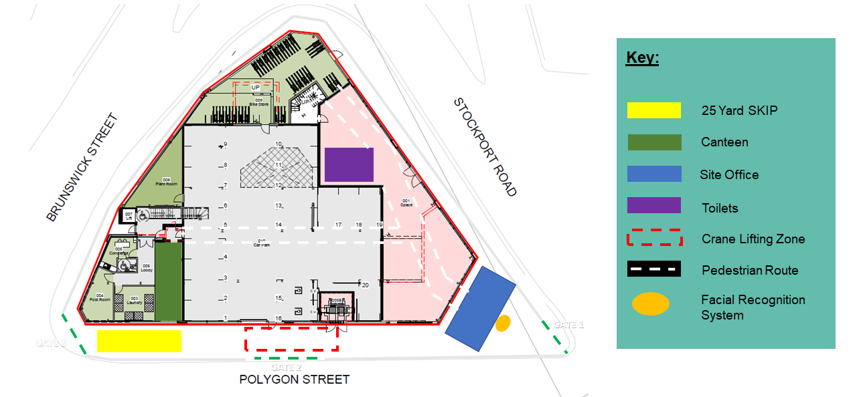
Appendix One – Logistics Plan

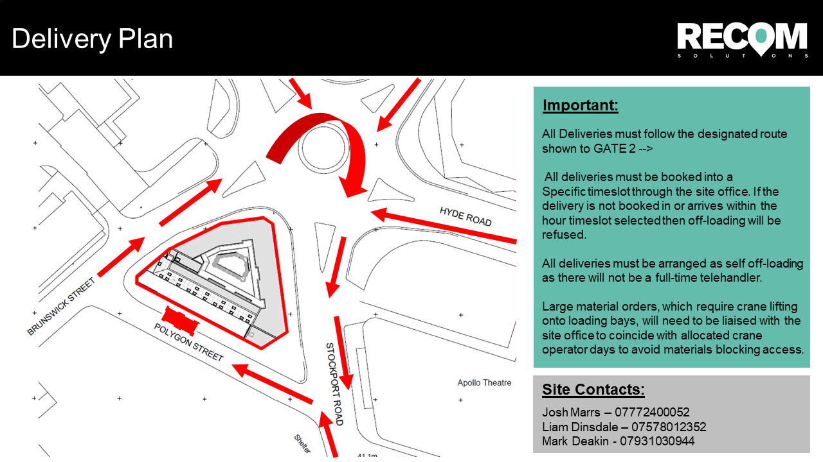
Appendix Two – Delivery Plan

