
PAH Drainage Maintenance

Attenuation Tanks – Versa void Modula Geo-Void

Maintenance
ESS Geo-void modular tank system provides total all round access with clear access point and channels in all directions.

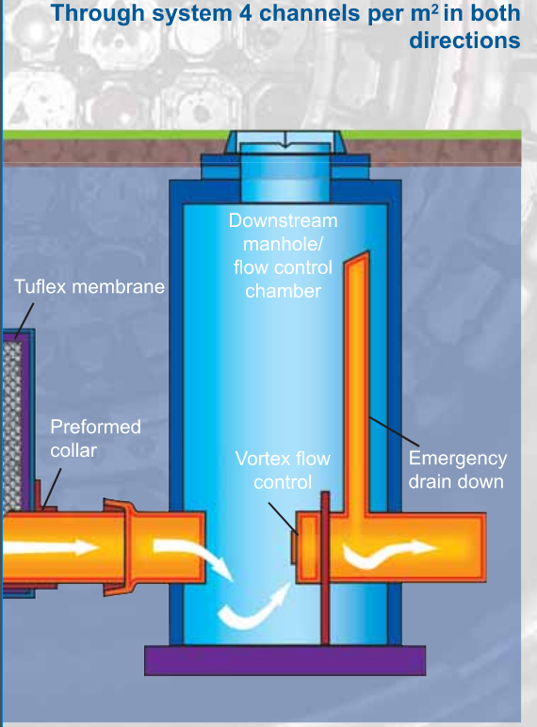

Pumping chamber – Kingspan

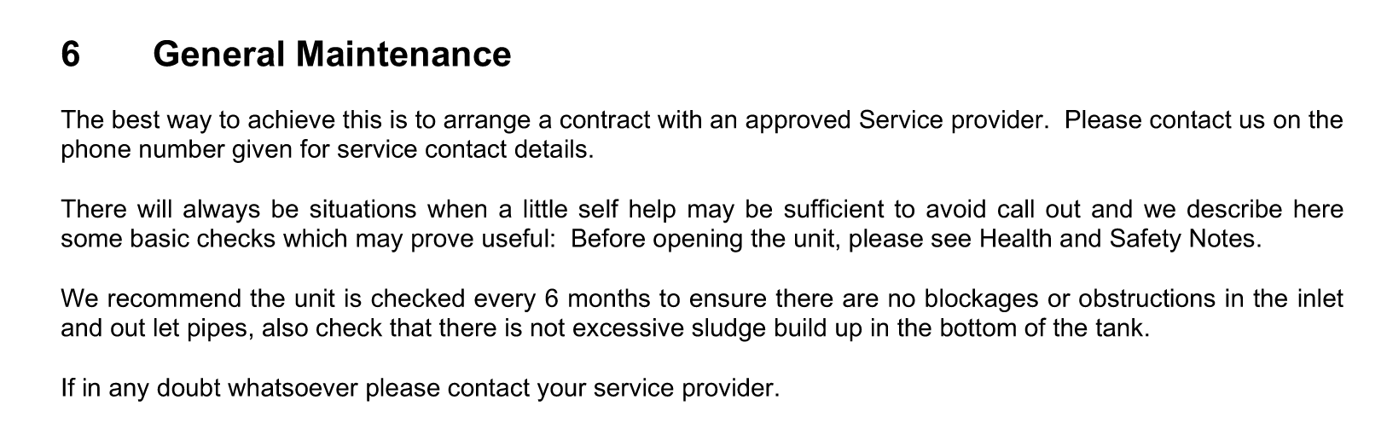

Foul/rainwater & Grey water drainage including manholes

All drainage for the scheme is internal either at ground floor or at basement level. No external drainage is connected to the waste. The scheme is design to utilise a combined outlet manhole which is existing with all drainage internal of this being split. To maintain this drainage, it requires a 12 monthly flush with clean water and any blockages can get cleared from internal manholes. The basement foul drainage is connected to the pumping station above to prior to entering the combined manhole (follow maintenance strategy above for this).

