Materials Schedule

PROPOSED RESIDENTAIL DEVELOPMENT
Greenwood / Gladeside Road
Wythenshawe

Project Details
Client:
Challenger Building Services Ltd
Postal address:
140 Lee Lane,
Horwich,
Bolton,
BL6 7AF

Application reference: 125993/FO/2020

Brief description of the works:
Redevelopment of the site to provide 40 no. one and two bedroom affordable apartments, together with associated parking, amenity space and site infrastructure.

List of the Proposed Materials
Brickwork
Type –Heywood Red Multi
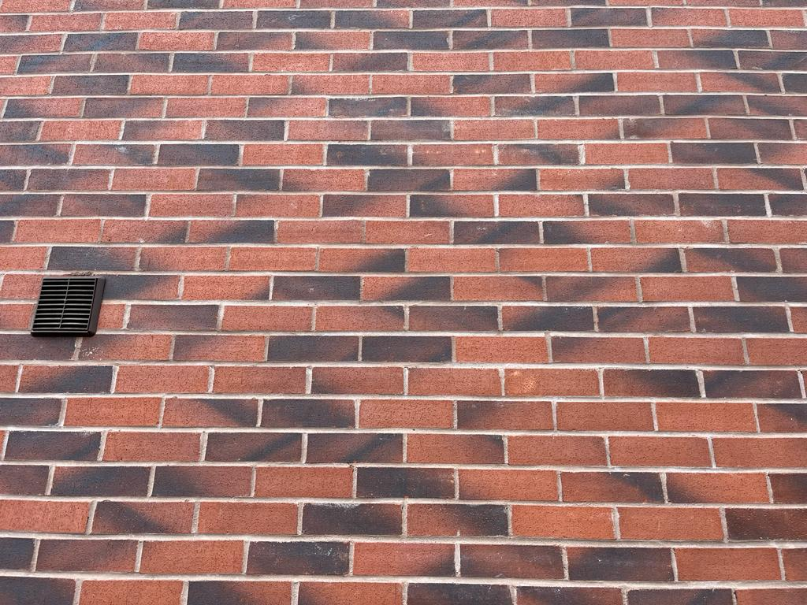

Parapet Roof Coping
Type – wall coping

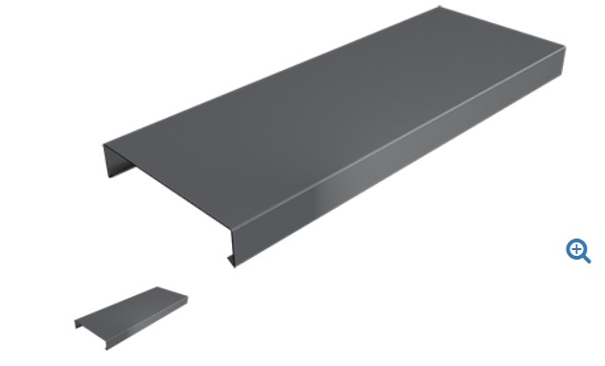

Windows
Type –UPVC – Grey
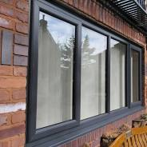

External Doors (Apartments – Courtyard)
Type – Composite Door – Colour Grey to Match Windows.

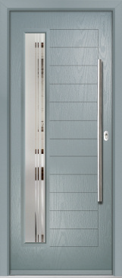

French doors
Type – UPVc French Door – (Grey)
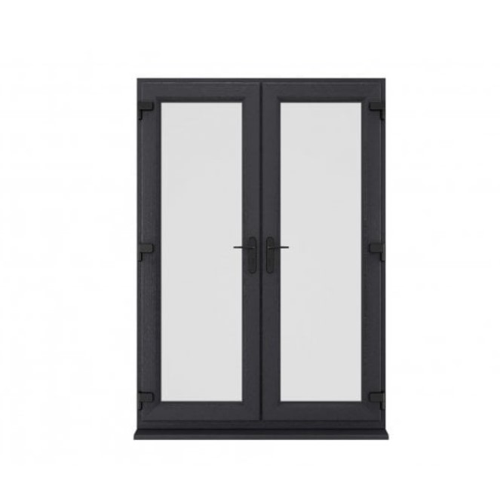

Juliette Balconies – Colour Black

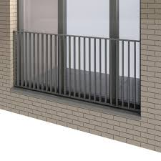

Rainwater Goods
Gutter detail within single ply roofing system
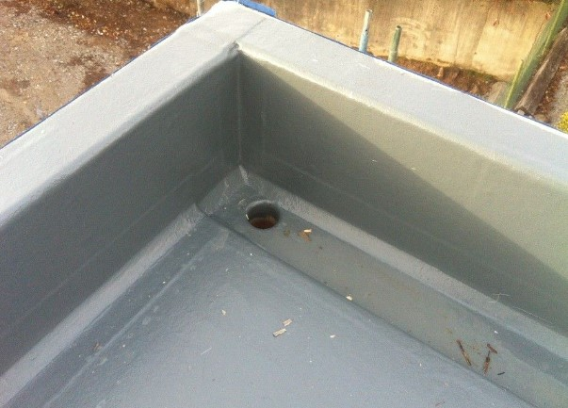

Marley anti vandal RWP and hopper

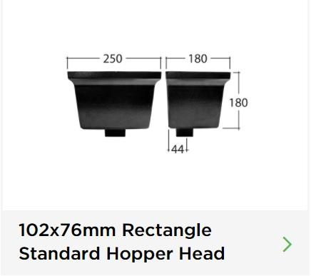
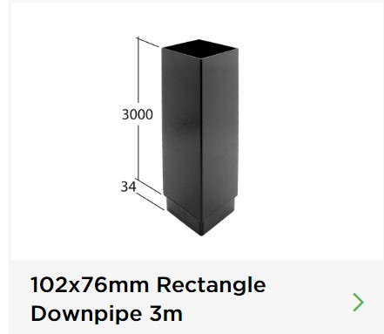

Paving for Paths around Building
Marshalls Regent Concrete paving

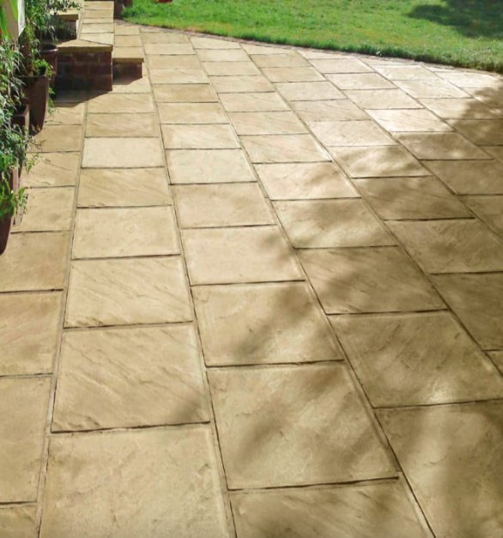

Paving
Saxon Paving 450 x 450mm

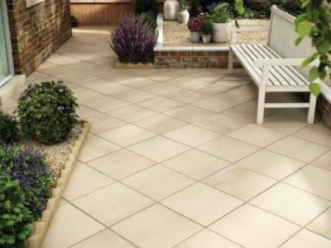
Block Paving
A&G Country Cobble – (Colour Cashel)

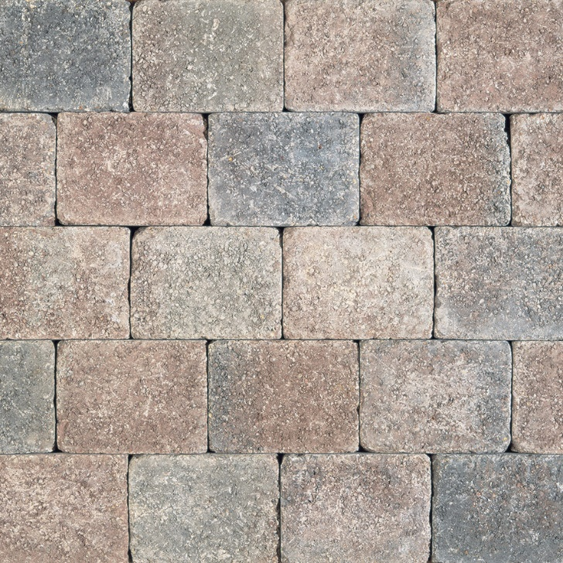

Access Road – Tarmac SMA

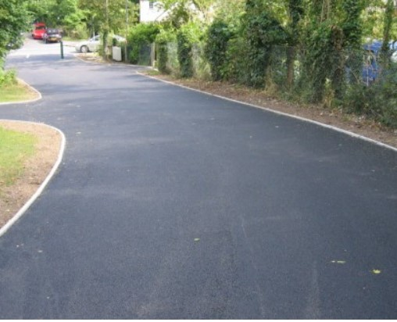

Hooped top railings to front

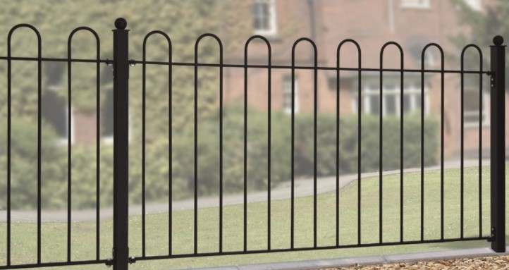

Colour Black

