Oxford Road Congestion Relief – Network Rail / Northern CCTV
LBC co-ordination meeting
Date
22/11/23
Attendees
James Donnelly (Chair) – Scheme Project Manager, Network Rail
Jonathan Mooney - Project Manager, Northern
Richard Brindley – Designated Project Engineer, Network Rail
Mathew Harvey – Telecoms Engineer, Northern
Toan To – Design Engineer, Arcadis
Stephen Shenton – Telecoms Engineer, Network Rail
Jason Todhunter – Engineer, ASP
Gaynor Quinn – Sponsor, Network Rail
Luke Cowap – Project Manager, Story

Minutes
The scope was presented from both scheme’s, the Congestion Relief project by Network Rail (Appendix 1) and Northern’s CCTV renewal scheme (appendix 2) and the overlap of scope was discussed.
After the review of the two proposals, it was decided that camera 12 from Northern’s scope (appendix 2) was not required and therefore will be removed from the discussion.

Appendix 1 – Extract from Telecoms form B

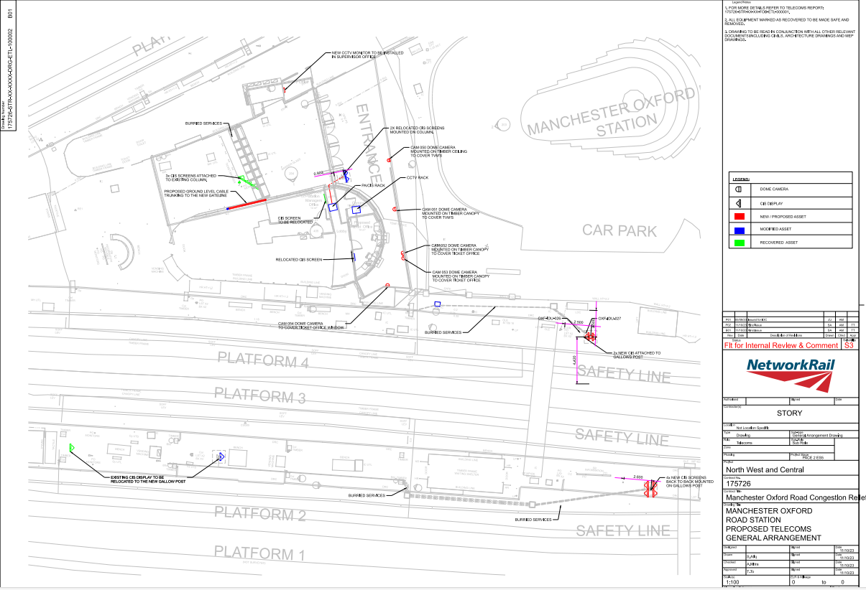

Appendix 2 – Northern’s proposed CCTV layout
