PROPOSED EXTENSION AT 27 DANESMOOR ROAD
DIDSBURY, MANCHESTER

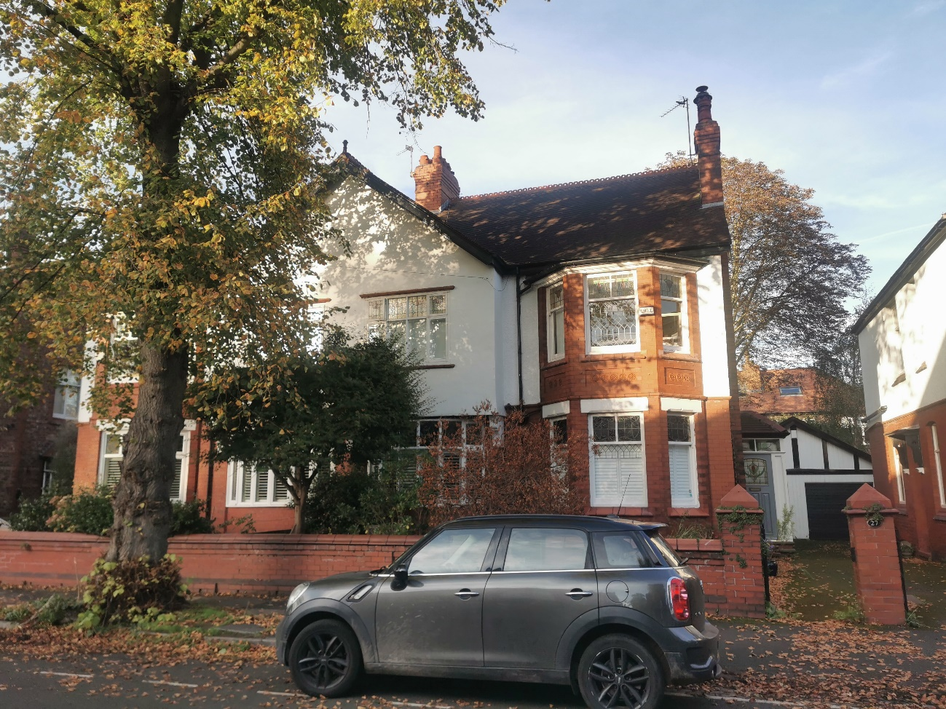

HERITAGE ASSESSMENT
October 2023

CONTENTS
1: Executive Summary 4
2: The Site 5
3: The Proposal/Scope of this Report 7
4: The Conservation Area 9
5: The Application Property 12
6: Summary of Significance 13
7: Planning Policy Context 14
8: Impact of the Proposal 16

1: EXECUTIVE SUMMARY
This report supports proposed works at number 27 Danesmoor Road, Didsbury, in the City of Manchester. The application building is an undesignated Edwardian semi- detached property located within Ballbrook Conservation Area.

Proposals are being submitted to Manchester City Council for a loft conversion. The heritage issue arising is their impact upon the significance (i.e. heritage interest and value) of the conservation area, The purpose of this report is to identify this significance and assess how it will be affected.

The significance of Ballbrook Conservation Area derives from its character and appearance as a late 19th century residential suburb on the outer fringe of the city. The core of the conservation area is formed by the Edwardian middle-class houses of the Radcliffe Estate, a notable development by architect George Westcott that remains virtually intact. Its houses display the typical townscape qualities of their period. The significance of the conservation area is therefore embodied in these houses and their relationship to each other along the original pattern of tree-lined avenues.

27 Danesmoor Road possesses the typical character and features of this development. As such its significance derives more from its value as part of the group rather than its individual qualities. This significance is illustrated in the public views of the building obtained from Danesmoor Road, which encompass the front and side elevations only. The private rear of the building is entirely hidden from view and therefore does not contribute to the views that establish the character and appearance of the conservation area.

The works have a purpose of adapting the building to modern family living. Only the external alterations have a bearing upon the conservation area, and they comprise:

- Rear dormer window to light the converted loft space
- Roof lights on the front elevation

The works to the rear would be entirely hidden from the public views that illustrate the property’s contribution to the conservation area. In terms of scale, the dormer are clearly subservient to the host building, and owing to their contemporary design will be clearly distinguishable from it. The front rooflights, in the context of the conservation area as a whole, are a minor and acceptable alteration that will not detract from the original building. Approximately 75% of properties on the road have converted loft space/dormer so it is presumed the planning process did not judge their introduction to be detrimental.

For these reasons, no adverse effect will result from the works and therefore the character, appearance and significance of the conservation area will essentially be preserved. The proposal thus satisfies the requirements of both national planning guidance and the local development plan and should be approved without delay.

2: THE SITE

The application site is number 27 Danesmoor Road, Didsbury, one of the communities within the City of Manchester. The application building is a semi-detached property located on the north side of the road amid an early 20th century residential setting
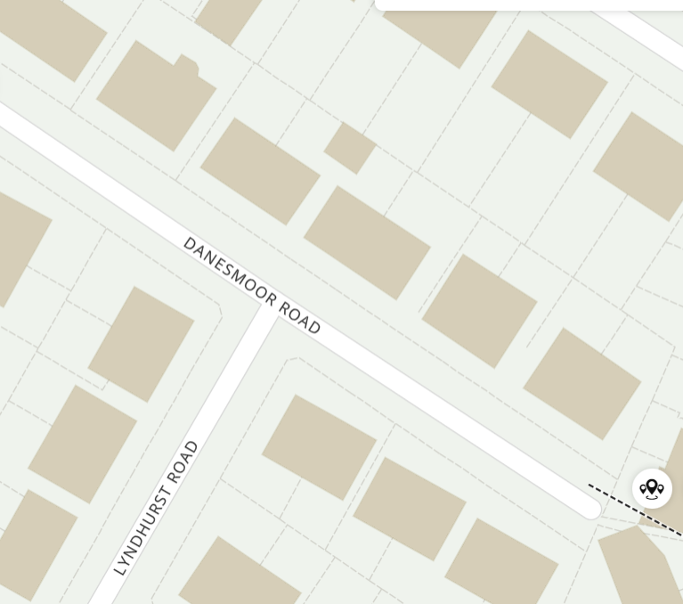

Map 1.The application property

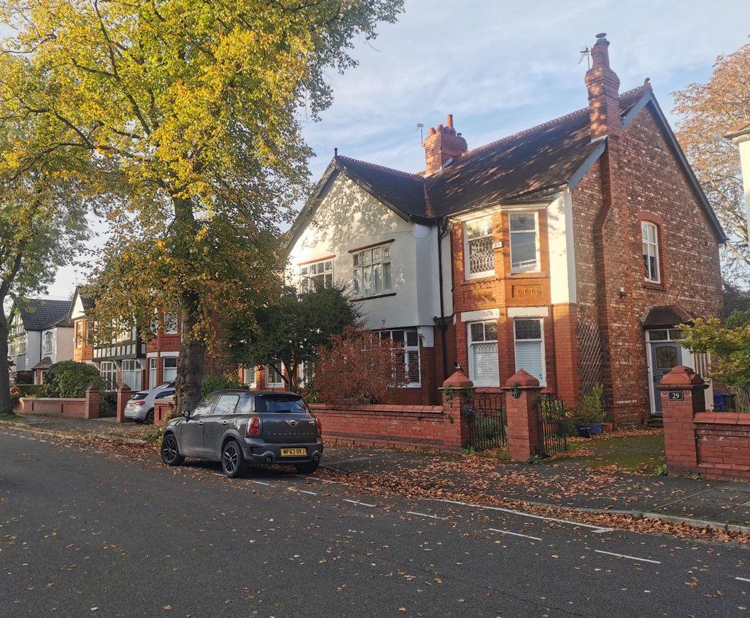33 Danesmoor Road (indicated), part of a mirrored pair of semi-detached houses

- The property forms part of an early 20th century streetscene on Danesmoor Road and its environs

3: THE PROPOSAL/SCOPE OF THIS REPORT

Proposed development

Proposals are being submitted to Manchester City Council for a loft conversion.

Designations

The application building is itself undesignated, but stands within Ballbrook Conservation Area.

Heritage impact

The heritage issue arising is therefore the proposal’s impact upon the significance (i.e. heritage interest and value) of the conservation area.

Scope and purpose of this report

Paragraph 189 of Chapter 16 (Conserving and Enhancing the Historic Environment) of the Revised National Planning Policy Framework (as revised July 2018 and February 2019) states local planning authorities should require an applicant to describe the significance of the heritage assets affected, including the contribution made by their setting. The scope and purpose of this report is to describe the significance of the conservation area and to assess the proposal’s impact in the context of relevant heritage planning policies. It is considered the level of detail employed is, in accordance with paragraph 189, proportionate to the importance of the heritage assets and no more than is necessary to understand the proposal’s impact. The report is to be read in conjunction with other documentation supporting the application.

Report structure

This is as follows:

    - Analysis of the conservation area (Section 4) and the contribution made by the application property (Section 5)

    - Evaluation of the significance of the conservation area and application property (Section 6)

    - A review of the relevant planning policies against which the application will be assessed (Section 7)

    - Evaluation within this policy context of the impact of the proposal upon the conservation area (Section 8).

4: THE CONSERVATION AREA

Overview

Ballbrook Conservation Area was first designated in November 1991 and is located four miles south of Manchester City Centre. It covers a late 19th/early 20th century residential area of around ten hectares that is bounded by Wilmslow Road to the east, Lapwing Lane to the southwest, Palatine Road to the northwest and Sandileigh Avenue to the north.

Character and appearance

A character appraisal, which would guide development within the conservation area and form a material consideration in determining planning applications affecting it, has not been produced by Manchester City Council. However the qualities of the conservation area that form the basis of its special interest are described in the city council’s internet pages as follows:

        - The area was still rural in the mid-19th century, with the Ball Brook forming part of the boundary between Didsbury and Withington
        - Development began in the late 19th century, with large houses built along Palatine Road from 1897 to 1902, while Wilmslow Road and Lapwing Lane were developed with mostly three-storey Victorian villas
        - Withington and Didsbury were annexed by Manchester in 1904, and the brook was culverted prior to the next phase of development
        - The core of the conservation area was built thereafter, comprising Sandileigh Avenue, Danesmoor Road, Holmwood Road, Lyndhurst Road, St. Aldwyn's Road and Redclyffe Road. This comprises housing built between 1910 and 1914
        - Most were by developers Booth and Britten, using architect George Westcott
        - When constructed, this was known as the Radcliffe Estate. Its group of houses remains virtually intact and displays all the townscape qualities of an Edwardian suburban housing estate
        - The tree-lined avenues are fronted by smooth brick garden walls and the houses are similar, many with rendered or pebbledash at first floor and some with half- timbered gables
        - Front elevations are varied, punctuated with projecting bays, oriel windows and porches, Much of the original stained glass remains
        - There are no listed buildings in the conservation area
        - Post-war development is represented by the bank, post office and telephone exchange group buildings fronting Lapwing Lane, and also includes houses along Palatine Road and Ballbrook Avenue

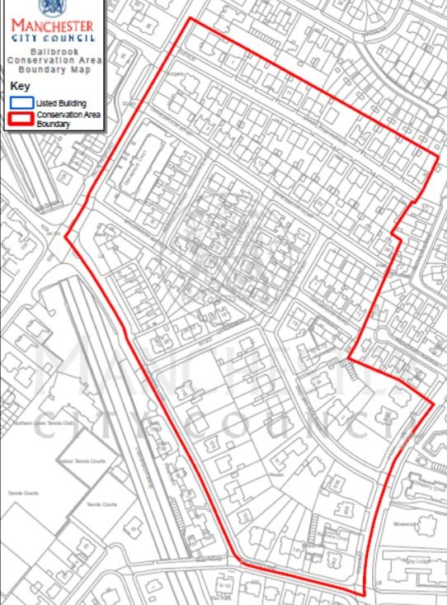

Map 2. Conservation area boundary with the application building indicated

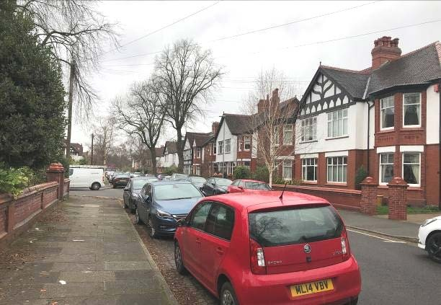

- The former Radcliffe estate represents the core of the conservation area
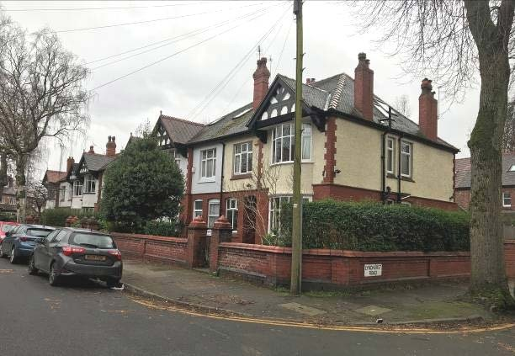

- Its houses display the typical characteristics of the period

5: THE APPLICATION PROPERTY

Number 27 Danesmoor Road is one of the Edwardian houses which characterise the Radcliffe Estate development of 1910-1914. It is part of a mirrored pair of semis that display the area’s typical architectural palette of bay windows, brickwork, render and timber-framed decoration. As such, rather than its individual qualities the property’s contribution derives more from its group value with the remainder of the development. This contribution is evident via the public streetscene views that are obtained from Danesmoor Road, which encompass the front and side elevations only. The rear of the property, facing a garden, is totally private and hidden from public view.

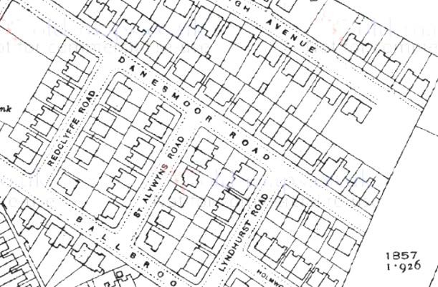

Map 3. The 25-inch OS mapping of 1922 shows the application property amid the then-new Radcliffe Estate

6: SUMMARY OF SIGNIFICANCE

Rationale

Paragraph 190 of the National Planning Policy Framework states local planning authorities should identify and assess the particular significance of a heritage asset, including its setting, and take this into account when considering the impact of a proposal in order to avoid or minimize conflict between the asset’s conservation and any aspect of the proposal. Significance is defined in the NPPF Glossary as:

‘The value of a heritage asset to this and future generations because of its heritage interest. That interest may be archaeological, architectural, artistic or historic. Significance derives not only from a heritage asset's physical presence, but also from its setting.’

The conservation area

The significance of Ballbrook Conservation Area derives from its character and appearance as a late 19th century residential suburb developed on the outer fringe of the expanding city. The core of the conservation area is formed by the Edwardian middle- class houses of the Radcliffe Estate, a notable development by architect George Westcott that remains virtually intact. Its houses display the typical the townscape qualities of their period, with a mixed architectural palette including smooth brick and rendered elevations, bay windows and timber-framed details. The significance of the conservation area is therefore embodied in these houses and their relationship to each other along the original pattern of tree-lined avenues.

The application property

27 Danesmoor Road is an original component of the Radcliffe Estate, an Edwardian semi-detached middle class house that possesses the typical character and features of the development and its era. As such, its significance derives more from its value as part of the group rather than its individual qualities. This significance is illustrated in the public views of the building obtained from Danesmoor Road, which are of the front and side elevations only. The private rear of the building is entirely hidden from view and therefore does not contribute to the views that establish the character and appearance of the conservation area.

7: PLANNING POLICY CONTEXT

Statutory duty

Section 72 (1) of the Planning (Listed Buildings and Conservation Areas) Act 1990 requires local planning authorities to pay special attention to the desirability of preserving or enhancing their character.

Relevant polices

Section 16 of the Revised National Planning Policy Framework provides the guidance on how the statutory duty is to be put into practice. Paragraph 192 states that in determining applications, local planning authorities should take account of:

    - The desirability of sustaining and enhancing the significance of heritage assets, and putting them to viable uses consistent with their conservation
    - The positive contribution that conservation of heritage assets can make to sustainable communities including their economic vitality, and
    - The desirability of new development making a positive contribution to local character and distinctiveness

Regarding designated heritage assets, paragraph 193 states that ‘great weight’ should be given to their conservation and the more important the asset, the greater that weight should be; and that significance can be lost through development within its setting. This is irrespective of whether any potential harm amounts to substantial harm, total loss or less than substantial harm to its significance. Paragraph 194 states that as heritage assets are irreplaceable, any harm or loss should require clear and convincing justification.

In the local planning context, the following policies relate to the proposal:

    - Policy EN3 of the City Council’s Local Development Framework Core Strategy, adopted July 2012. This states:

Throughout the City, the Council will encourage development that complements and takes advantage of the distinct historic and heritage features of its districts and neighbourhoods, including those of the City Centre.
New developments must be designed so as to support the council in preserving, or where possible, enhancing the historic environment, the character, setting and accessibility of areas and buildings of acknowledged importance, including scheduled ancient monuments, listed buildings, registered parks and gardens, conservation areas and archaeological remains.

Proposals which enable the re-use of heritage assets will be encouraged where they are considered consistent with the significance of the heritage asset.

    - Saved policy DC18 of the Unitary Development Plan (Conservation Areas), states:

The Council will give particularly careful consideration to development proposals within Conservation Areas.
      - The Council will seek to preserve and enhance the character of its designated conservation areas by carefully considering the following issues:
        - the relationship of new structures to neighbouring buildings and spaces;
        - the effect of major changes to the appearance of existing buildings;
        - the desirability of retaining existing features, such as boundary walls, gardens, trees, (including street trees);
        - the effect of signs and advertisements;
        - any further guidance on specific areas which has been approved by the Council.
      - The Council will not normally grant outline planning permission for development within Conservation Areas.
      - Consent to demolish a building in a conservation area will be granted only where it can be shown that it is wholly beyond repair, incapable of reasonably beneficial use, or where its removal or replacement would benefit the appearance of character of the area.
      - Where demolition is to be followed by redevelopment, demolition will be permitted only where there are approved detailed plans for that redevelopment and where the Council has been furnished with evidence that the development will be undertaken.
      - Development proposals adjacent to Conservation Areas will be granted only where it can be shown that they will not harm the appearance or character of the area. This will include the protection of views into and out of Conservation Areas.

The council’s web pages on Ballbrook also include the following development guidance:
Development control in Ballbrook is aimed at encouraging development which enhances the prosperity of the area whilst paying attention to its special architectural and visual qualities. Property owners in the area are encouraged to retain the original character and detail of their houses. This should include the details, colour and materials of window frames, doors and other elements of the buildings.
It is envisaged that small-scale development and refurbishment will take place from time to time. The main aim of designation is to ensure that the character and quality of both the buildings and the spaces between them is retained. As with all conservation areas, attention must be paid to maintaining harmony with regard to building heights, the type and the colour of materials.

8: IMPACT OF THE PROPOSAL

Summary of the works
The works seek the alterations with the purpose of adapting the building to modern family living. Only the external alterations have a bearing upon the conservation area; the internal works are unseen and therefore entail no impact. The external works comprise:

    - Rear dormer window to light the converted loft space
    - Roof lights on the front elevation
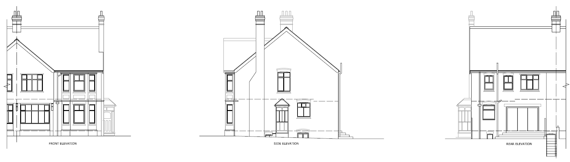
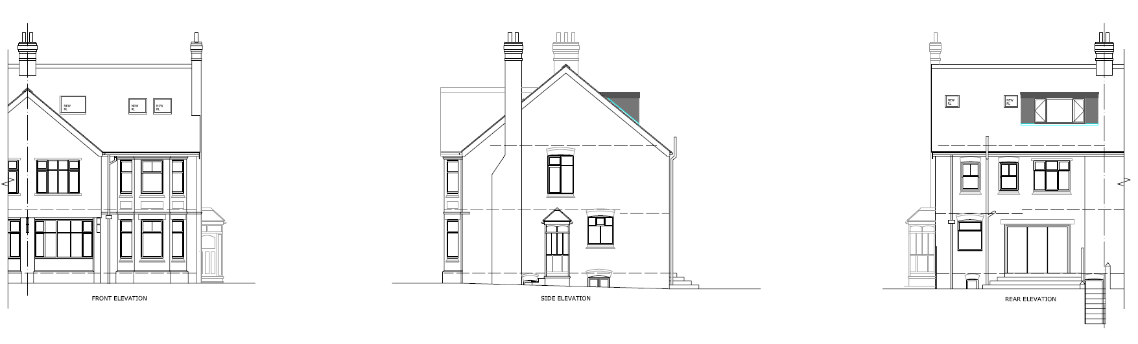
Figure 1. External works as proposed (Knight Pyatt Architects)

Their impact

- Rear dormer/rear rooflight. These works would be entirely hidden from the public views that illustrate the property’s contribution to the conservation area. In terms of the relationship to the host building, the loft conversion and dormer are clearly subservient in scale and owing to their contemporary design will be clearly distinguishable from the original structure.

- Front elevation rooflights. In the context of the conservation area as a whole, these represent a minor and acceptable alteration that will not detract from the character and contribution made by the host building. Number 29 also has front elevation rooflights, and hence it is assumed the planning process did not consider their introduction to be detrimental also. The proposed rooflights will therefore create a sense of uniformity to the pair.

Conclusion

For the reasons stated above, it is considered the proposed works will have no adverse effect and will therefore essentially preserve the character, appearance and significance of the application building and therefore that of the conservation area. The proposal thus satisfies the requirements of both national planning guidance as stated in paragraphs 192 and 193 of the NPPF, along with those of the local development plan, and therefore approval should be awarded without delay.

