SITE SPECIFIC SUPPLEMENTARY INFORMATION

- Site Details

Site Name: | 1 Wilmott Street Temp | Site Address: | 1 Wilmott Street Temp  Manchester  M15 6BD
NGR: | E: 383901, N: 397267 | Site Address: | 1 Wilmott Street Temp  Manchester  M15 6BD
Site Ref Number: | 37904 | Site Type: Macro | Temporary consent for 12 months – mast is already on site via Emergency Powers and then Application number: 136484/FO/2023 – A further 12 months are needed while a permanent solution is addressed.

- Pre-Application Check List

Site Selection

Was an LPA mast register used to check for suitable sites by the operator or the LPA? |  | No
If no explain why:

After a phone call to the LPA, it was felt that the industry database was a more up to date source of information.

Was the industry site database checked for suitable sites by the operator: | Yes
If no explain why: N/A

Pre-application consultation with LPA

Date of written offer of pre-application consultation: | 8th March 2023
Was there pre-application contact: |  | No
Date of pre-application contact: | N/A
Name of contact: | The Director of Planning
Summary of outcome/Main issues raised: At the time of preparing this submission, no comments had been received in respect to the proposals.

Ten Commitments Consultation

Rating of Site under Traffic Light Model: | Amber
Prior to the submission of this application the applicant initiates pre-consultation discussions with the local planning authority. This provides an opportunity for the LPA to discuss development proposals and identify site specific issues. Further consultation has also been carried out with the Ward Councillors.

Summary of outcome/Main issues raised:

No responses had been received at the time of submission.

School/College

Location of site in relation to school/college:

Bright Horizons Manchester Day Nursery and Preschool is in close proximity to the site.

Outline of consultation carried out with school/college:

Bright Horizons Manchester Day Nursery and Preschool have been notified prior to submission.

Summary of outcome/Main issues raised:

N/A

Civil Aviation Authority/Secretary of State for Defence/Aerodrome Operator consultation

Will the structure be within 3km of an aerodrome or airfield? |  | Yes
Has the Civil Aviation Authority/Secretary of State for Defence/Aerodrome Operator been notified? |  | Yes
Details of response:

N/A

Site Provider Letter

Site Provider Letter enclosed? | Yes
Date served: | 29th February 2024

- Proposed Development

The proposed site:
The need for this temporary mast stems from MBNL having been issued with an NTQ (Notice to Quit) on their previous permanent solution. A new replacement permanent solution is being sought but there is still an urgent need in this area for replacement coverage or EE, 3UK and the Emergency Services. This temporary full planning application is seeking an extension on site for a further 12 months. This submission follows the previously approved application referenced 136484/FO/2023.

The proposed site at 1 Wilmott Street Temp, Manchester, M15 6BD is situated to the left of Manchester Hulme Street Car Park. The existing site is situated within the heart of Manchester, providing essential coverage. The extension proposed in this application ensures the area will be provided with continued coverage, whilst a permanent solution is identified. The existing site and its surroundings can be seen below in Figure 1-3.
The proposal is for the installation of a new 30.00m Temp Mast that will provide replacement coverage for EE, for H3G LTE and the Emergency Services. The proposed new facility will require the installation of a limited number of equipment cabinet housing radio equipment at ground level and in close proximity to the base of the pole. The cabinet equipment are however, permitted development (without Prior Approval) and thus do not form part of this application. The site has been carefully selected in a position that benefits from some screening effects so as to provide the required new coverage to the area whilst minimising visual intrusion for residential properties. The monopole style design has been specified in order to allow the proposal to merge with the numerous vertical features distributed around the vicinity of the site.
Figure 1:

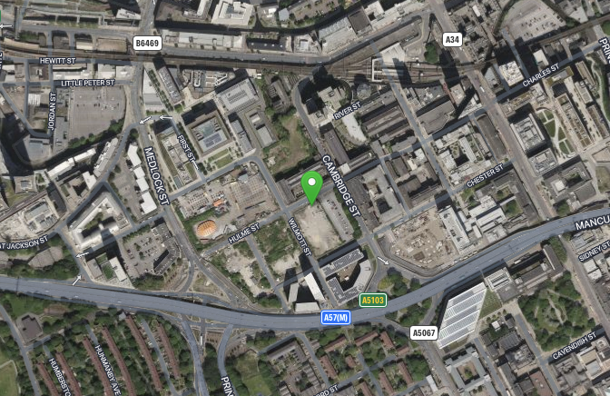
Figure 2:
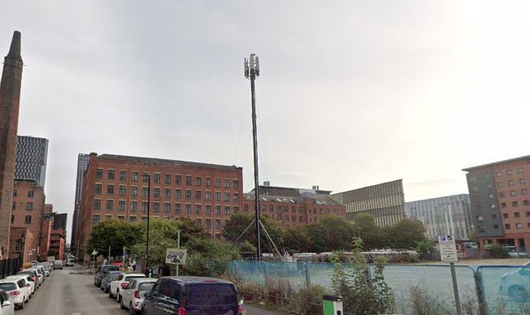
Figure 3:
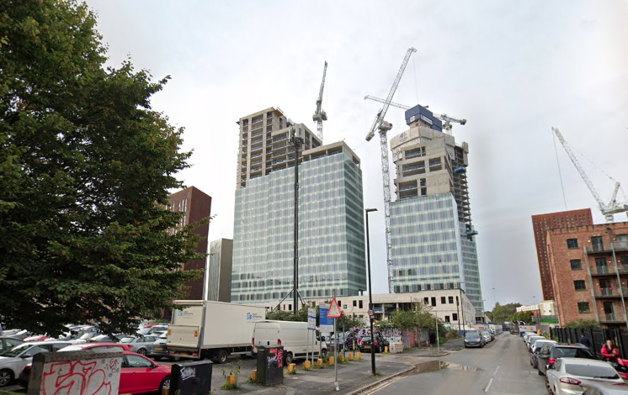

Site Ref: | 37904 | Site Address: | 1 Wilmott Street, Manchester, M1 5BD

Local Planning Authority: Manchester City Council

Development Plan: Manchester Core Strategy (2012) / Manchester UDP (saved policies)
Fig.1: LP Plan Extract (Reference Only):
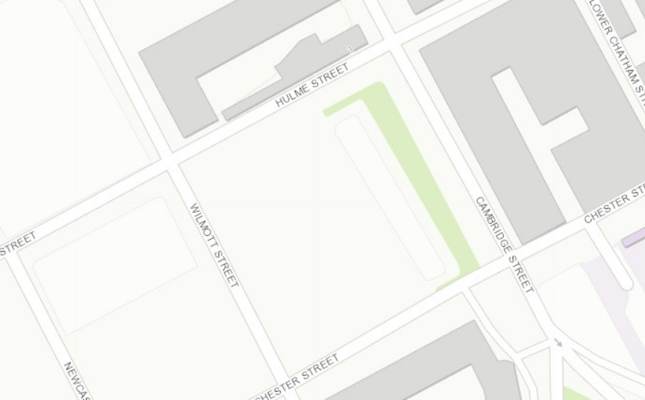

Site and its surrounds

Policy Relevant to the Development Site:

The site is designated as being within the settlement boundary, with urban uses to the north, east, south, and west. The site designation is not a material consideration.

This is an existing, temporary, telecommunications site and the proposal seeks planning permission for 12 months.

Manchester Council does have a specific telecoms policy. This, together with the NPPF is of relevance. The National Planning Policy section of this supporting statement goes into detailed analysis of why this site is in compliance with the NPPF.

Policy Analysis:

Policy DC17.1 states:

“Applications for telecommunications developments will normally be approved if the
Council can be satisfied that the development has been sited and designed to minimise its impact on residential amenity and in environmentally sensitive areas. Wherever possible, the Council will expect the potential of existing buildings and masts, including the sharing of such facilities, to be fully explored before agreeing to additional separate development.”

The proposed development at this site is required to continue to deliver the requisite level of electronic communication service on a single installation that is to be adapted to accommodate multiple users (so enable future site sharing opportunities), yet seeks to minimise its impact or change to the character of this location (being utilitarian in appearance in an area of historically industrial character). The form and design of the proposed configuration would not appear out of context in this location, so according with wider Development Plan policy and would ensure the appearance and character of the area is fully maintained.

The public benefits of a greatly enhanced communications network for businesses, residents and visitors alike in this location would qualify as a substantial benefit with near benign change or impact on amenity (with the nearest residential properties remaining the same distance from that of the existing site).

The enhanced digital service would very much accord with the objectives of the Development Plan policy. The proposal fully accords with the requirements of the NPPF

The sharing of base stations between multiple operators is one of the key strategic policy principles contained within the NPPF. H3G and EE and ESN (Emergency Services Network) have a network sharing agreement and thus these installations are fully compliant with the NPPF. Central Government attaches great importance to the design of the built environment and outlines this within Section 12 (para. 124) of the National Planning Policy Framework. It states:
“Good design is a key aspect of sustainable development, creates better places in which to live and work and helps make development acceptable to communities.”

In keeping with the National Planning Policy Framework (NPPF). guidelines of using: “high quality communications” (Section 10), the proposed design has been selected to minimise visual impact upon the street scene by integrating with the existing built environment and the existing street furniture, having similar vertical lines and overall appearance to the street lighting columns that are common feature in the built environment. As stated above the National Planning Policy Framework advocates site sharing, and as such we believe that there are no sequentially preferable locations within the defined site search area.
The design of the proposed equipment is considered to be the least visually intrusive option available.

RADIO PLANNING AND PROPAGATION
When planning cellular telecommunications networks it is important for engineers to predict, with a high degree of confidence, the behaviour of cellular transmissions. This then enables the operator to calculate how many cell sites are needed to provide the level of coverage required by the services they offer under the terms of their licence.
The strength of radio signals detected at a receiving device naturally reduces the further away it is from the transmitter. In general the reduction (or decay) in signal power is affected by a number of variables. The main factors are

- frequency,
- distance (from transmitter),
- terrain (such as hills),
- clutter (such as buildings, foliage, vehicles, and water)
- and atmospheric conditions (such as rain).

A reduction in the strength of the radio signal increases the likelihood of dropped calls and reduced data rates for internet browsing, for example.
Clutter
Any physical object obstructing the propagation of radio signals causes a reduction in signal strength reaching a customer’s device. A common term for these objects is ‘clutter’. The more obvious examples are buildings and geographical terrain such as hills and trees.
Buildings cause a varying amount of signal reduction depending on their height, construction, thickness of walls, amount of windows etc. Glass causes a lower reduction in signal than brick/concrete walls.
Customers will inadvertently be aware of this by finding that sometimes they need to go near windows, a higher floor of a building or even outside in order to achieve a stronger signal for their mobile devices.
Tree Clutter
The effects of trees on signal degradation should never be underestimated. Signal absorption and shadowing effects vary according to vegetation and density, and are caused by the main tree trunk, branches and leaves.
Cell sites located in or near trees will have signals significantly reduced. As a result a number of extra sites may need to be built locally in order to counter-effect this.
Signal variation throughout the seasons is also a practical concern. Leaves on trees in the spring and summer can cause shadowing and reduce radio voice quality and increase the number of dropped calls.
As a result the bottom of an antenna should be a) above the top level of the trees, b) allow greater height due to the antenna downtilt at build or for future requirements and c) allow some room for future growth of the trees.
In the case where the cell site utilises point-to-point microwave backhaul transmission the microwave dish should not be obscured at all.
Propagation Models
In essence these are mathematical formulae used to characterise radio wave propagation, in order to determine the received signal strength at a receiving device.
The most well-known propagation model used for mobile telecommunications is ‘Okamura-Hata’. More specific studies have been performed to investigate specific clutter and terrain such as dense-urban and urban environments. Resulting from these are propagation models for specific clutter types.
Coverage Planning Tools
Radio planning engineers plan cellular networks using highly sophisticated computer programs that incorporate the above propagation models. Armed with data on cell site location, cell site configuration, maps, terrain etc they are used to predict areas of coverage deficiency (so called ‘coverage holes’), new site requirements and configurations.
Network Changes
Over time the topography and clutter in an area is subject to change. For example, building developments, housing and tree growth can all change. As a consequence the signals received from local phone masts can degrade, as they are dependent on these factors. These reasons along with customer complaints, network consolidation (mast sharing) and new technologies (4G) require a re-evaluation of a network operator’s telecommunications infrastructure.
Mast sharing can result in some masts no longer being needed. As a result they are decommissioned and physically removed.
Technical surveys undertaken for reasons above may highlight that antenna height increases are required – this is more likely for sites with low antenna heights around 15m AGL, particularly street furniture sites. More details on these reasons below.

While thus far this document is generic to mobile telephony masts it should be noted that each mast has to be dealt with on a case-by-case basis.
Site Height increases
There are a number of reasons why an operator may request a height increase on existing structures. The main ones are described below.
Maintaining existing coverage
The antennas inside, for example, street furniture sites are generally of 2 physical build designs – ‘Single Stack’ and ‘Dual Stack’. The former describes when the set of antennas are all at the same height. The latter describes a site with 2 sets of antennas one above the other.
The ‘Dual Stack’ is by far the preferred option. This is due to a number of factors including greater flexibility & control for different technologies and providing optimum service performance to customers.
Network Consolidation between H3G LTE and EE and new 4G technologies facilitate a Single Stack structure being upgraded to a Dual Stack structure. In a straight swap scenario at equal height the new lower aperture antennas would be lower than they were originally - resulting in significantly reduced coverage. To ensure existing coverage is maintained the whole structure needs to be increased in height.
Clutter changes
A more extreme example is when the local clutter or tree lines have changed, or are such that the mobile signals are blocked, resulting in lower quality calls and downloads for mobile device users. To provide sufficient services to customers height increases on existing masts or additional new masts are required. The former is the preferred option in many cases.
ICNIRP Compliance
The addition of new technologies and mast sharing affects ICNIRP compliance – a higher minimum mast height is required in some cases.

Enclose map showing the cell centre and adjoining cells:
This can be emailed to the LPA upon request.

Type of Structure
Description:

C/L of Dish +30.50m AGL
Top of Mast +30.00m AGL
C/L of Antennas +28.90m AGL
PROPOSED MBNL 30.00m HIGH TEMP MAST ON STEEL FRAME C/W CONCRETE BALLAST BLOCKS. 6No. MBNL ANTENNAS MOUNTED ON HEADFRAME AND 1No. LEG MOUNTED 300Ø DISH
PROPOSED EE APM5930 CABINET MOUNTED ON PROPOSED TIMBER SLEEPERS
PROPOSED EE BTS3900A STACKED CABINETS & APM5930 CABINET MOUNTED ON PROPOSED TIMBER SLEEPERS
PROPOSED H3G BOWLER CABINET MOUNTED ON PROPOSED TIMBER SLEEPERS
PROPOSED MBNL FCOA CABINET MOUNTED ON PROPOSED TIMBER SLEEPERS
PROPOSED MBNL 2.10m HIGH PALISADE FENCING C/W 1.50m WIDE ACCESS GATE TO FORM PERIMETER OF 15.00x15.00m COMPOUND C/W ACOUSTIC PANELLING TO THE INSIDE
PROPOSED MBNL Mk5 LINK A/C CABINET MOUNTED ON PROPOSED TIMBER SLEEPERS

Overall Height: 30.00m AGL
Height of existing building |  | N/A
Equipment Housing:
Length: |  | See drawings
Width: |  | See drawings
Height: |  | See drawings
Materials
Tower/mast etc – type of material and external colour: | Grey
Equipment housing – type of material and external colour: | Grey RAL 7035

Reasons for choice of design:
The proposed installation is an EE Ltd and H3G LTE 30.00m High Temp Mast which will house both EE and H3G LTE. The sharing of base stations between multiple operators is one of the key strategic policy principles contained within the NPPF.
In keeping with the National Planning Policy Framework (NPPF July 2021). guidelines of using high quality communications infrastructure the proposed design has been selected to minimise visual impact upon the street scene by integrating with the existing street furniture, having similar vertical lines and overall appearance to the numerous street lighting columns.

- Technical Information

ICNIRP Declaration attached  ICNIRP public compliance is determined by mathematical calculation and implemented by careful location of antennas, access restrictions and/or barriers and signage as necessary. Members of the public cannot unknowingly enter areas close to the antennas where exposure may exceed the relevant guidelines.  When determining compliance the emissions from all mobile phone network operators on the site are taken into account. | Yes

- Technical Justification

Reason(s) why site required
The National Planning Policy Framework clearly states that authorities should not question the need for the service, nor seek to prevent competition between operators. Notwithstanding this fact, the Applicant considers it to be important to explain the technical justification for the site and how the facility fits into the overall network.

Notwithstanding this fact, the Applicant considers it to be important to explain the technical justification for the site and how the facility fits into the overall network.

The site is required to provide new 5G coverage for EE Ltd in order to improve coverage in the M15 area of Manchester. The cell search areas for 5G are extremely constrained with a typical cell radius of approximately 250m meaning that it would not be feasible to site the column outside of this locale.

Further detail regarding the general operation of the network can be found in the accompanying document entitled ‘General Background Information on Radio Network Development for Planning Applications’. This information is provided to assist the local planning authority in understanding any technical constraints on the location of the proposed development.

- Site Selection Process – alternative sites considered and not chosen

Discounted Options
In accordance with the sequential approach outlined in the National Planning Policy Framework (NPPF) following search criteria have been utilised. Firstly, consideration is always given to sharing any existing telecommunication structures in the area, secondly consideration is then given to utilising any suitable existing structures or buildings and thirdly sites for freestanding ground-based installations are investigated.

This sequential approach is outlined below:

- Mast and Site Sharing
- Existing Buildings Structures
- Ground Bases Installations

In compliance with its licence and the sequential approach outlined in the NPPF all attempts to utilise any existing telecommunication structures where they represent the optimum environmental solution have been employed. The Ofcom Site Finder mast register is always examined prior to the submission of an application.

If no alternative site options have been investigated, please explain why:

This is a temporary mast that will be replaced by a permanent solution. This proposal is for a temporary 12 month period only, no other discounted options have been investigated due to the temporary nature of this proposal.
- Additional Relevant Information

Background to the Proposal
This specific proposal forms part of an integral requirement for EE Ltd, ESN and H3G LTE to expand their respective 5G telecommunications network across Manchester specifically in this instance to enhance 5G coverage levels and network capacity within the M15 area.

This partnership has resulted in the development and production of an array of “dual user” structures and cabinets, which have the ability to accommodate both operator’s antenna systems and radio equipment.

Mobile phone base stations operate on a low power and accordingly base stations therefore need to be located in the areas they are required to serve. Increasingly, people are also using their mobiles in their homes, and this means we need to position base stations in, or close to, residential areas.

A further limiting factor is that the position has to be one that fits in with the existing network. Sites have to form a patchwork of coverage cells with each cell overlapping to a limited degree with the surrounding base stations to provide continuous network cover as users move from one cell to the other. However, if this overlap is too great unacceptable interference is created between the two cells.

DEVELOPMENT PLAN POLICY.

Development plan considerations have a special significance in law. Section 54A of the Town and Country Planning Act 1990 (The Act), and re-iterated in Section 38 of the Planning and Compensation Act 2004, it is stated that:

“Where in making any determination under the Planning Acts regard is to be had to the Development Plan, determination shall be made in accordance with the Development Plan unless material considerations indicate otherwise.”

NATIONAL PLANNING POLICY

The Government remain committed to promoting telecommunications and place emphasis on the importance of telecommunications to the wider economy. The National Planning Policy Framework (NPPF July 2021) sets out the Government’s planning policies for England and how these are expected to be applied at the Local level. It provides a framework within which local people and their accountable Councils can produce their own distinctive local and neighbourhood plans, which reflect the needs and priorities of their communities.

The purpose of the planning system is to contribute to the achievement of sustainable development. There are three dimensions of sustainable development, each of which give rise to the need for the planning systems to perform a number of roles including: -

- Economic Role – contributing to building strong, responsive and competitive economy;
- Social Role – Supporting strong vibrant and healthy communities; and
- Environmental Role – Contributing to protecting and enhancing our natural, built and historic environment.
The NPPF contains at its core a presumption in favour of sustainable development which runs through both plan-making and decision-making processes. The NPPF recognises the vital importance of high-quality telecommunications and dedicates a whole chapter to this. Chapter 10 of the NPPF outlines the Governments support for high quality communications. The paragraphs below clearly outline the overarching support from Central Government for telecommunications and how Local Planning Authorities should embrace this vital infrastructure:

NPPF Paragraph 114 states:

“Advanced, high quality and reliable communications infrastructure is essential for economic growth and social well-being. Planning policies and decisions should support the expansion of electronic communications networks, including next generation mobile technology (such as 5G) and full fibre broadband connections. Policies should set out how high-quality digital infrastructure, providing access to services from a range of providers, is expected to be delivered and upgraded over time; and should prioritise full fibre connections to existing and new developments (as these connections will, in almost all cases, provide the optimum solution).”

It continues in Paragraph 115:

“The number of radio and electronic communications masts, and the sites for such installations, should be kept to a minimum consistent with the needs of consumers, the efficient operation of the network and providing reasonable capacity for future expansion. Use of existing masts, buildings and other structures for new electronic communications capability (including wireless) should be encouraged. Where new sites are required (such as for new 5G networks, or for connected transport and smart city applications), equipment should be sympathetically designed and camouflaged where appropriate.”

Operators always follow the sequential site selection process. Where an existing site can be shared or upgraded this will always be adhered to before a new proposal is put forward for consideration.

The support for telecoms and the need not to constrain Operators is laid out in Paragraph 118:

“Local planning authorities must determine applications on planning grounds only. They should not seek to prevent competition between different operators, question the need for an electronic communications system, or set health safeguards different from the International Commission guidelines for public exposure.”

Conclusion

We consider that the development is complaint with the council’s policy and that in accordance with Section 38 (6) of the Planning and Compensation Act 2004 permission should be granted for the installation.

We consider the development complies with both central government and local planning policy guidance where the underlying aim is to provide an efficient and competitive telecommunication system for the benefit of the community while minimising visual impact.

Taking into account the factors of technical constraints, available sites and planning constraints we consider that this site and design clearly represents the optimum environmental solution.

On the basis of a recognised need to expand and promote telecommunications networks across the region, it is considered that the proposal fully accords with the requirements of the National Planning Policy Framework and Council’s Local Plan Policies.

Ryan Marshall
Planning Manager
Email: r.marshall@whptelecoms.com

Contact Details

Name: (Agent) | Ryan Marshall | Telephone: | Emailed on request
Operator: | EE and H3G LTE | Fax no: | N/A
Address: | WHP Telecoms Ltd  1a Station Court  Station Road  Guiseley  LS20 8EY | Email Address: | r.marshall@whptelecoms.com
Signed: | 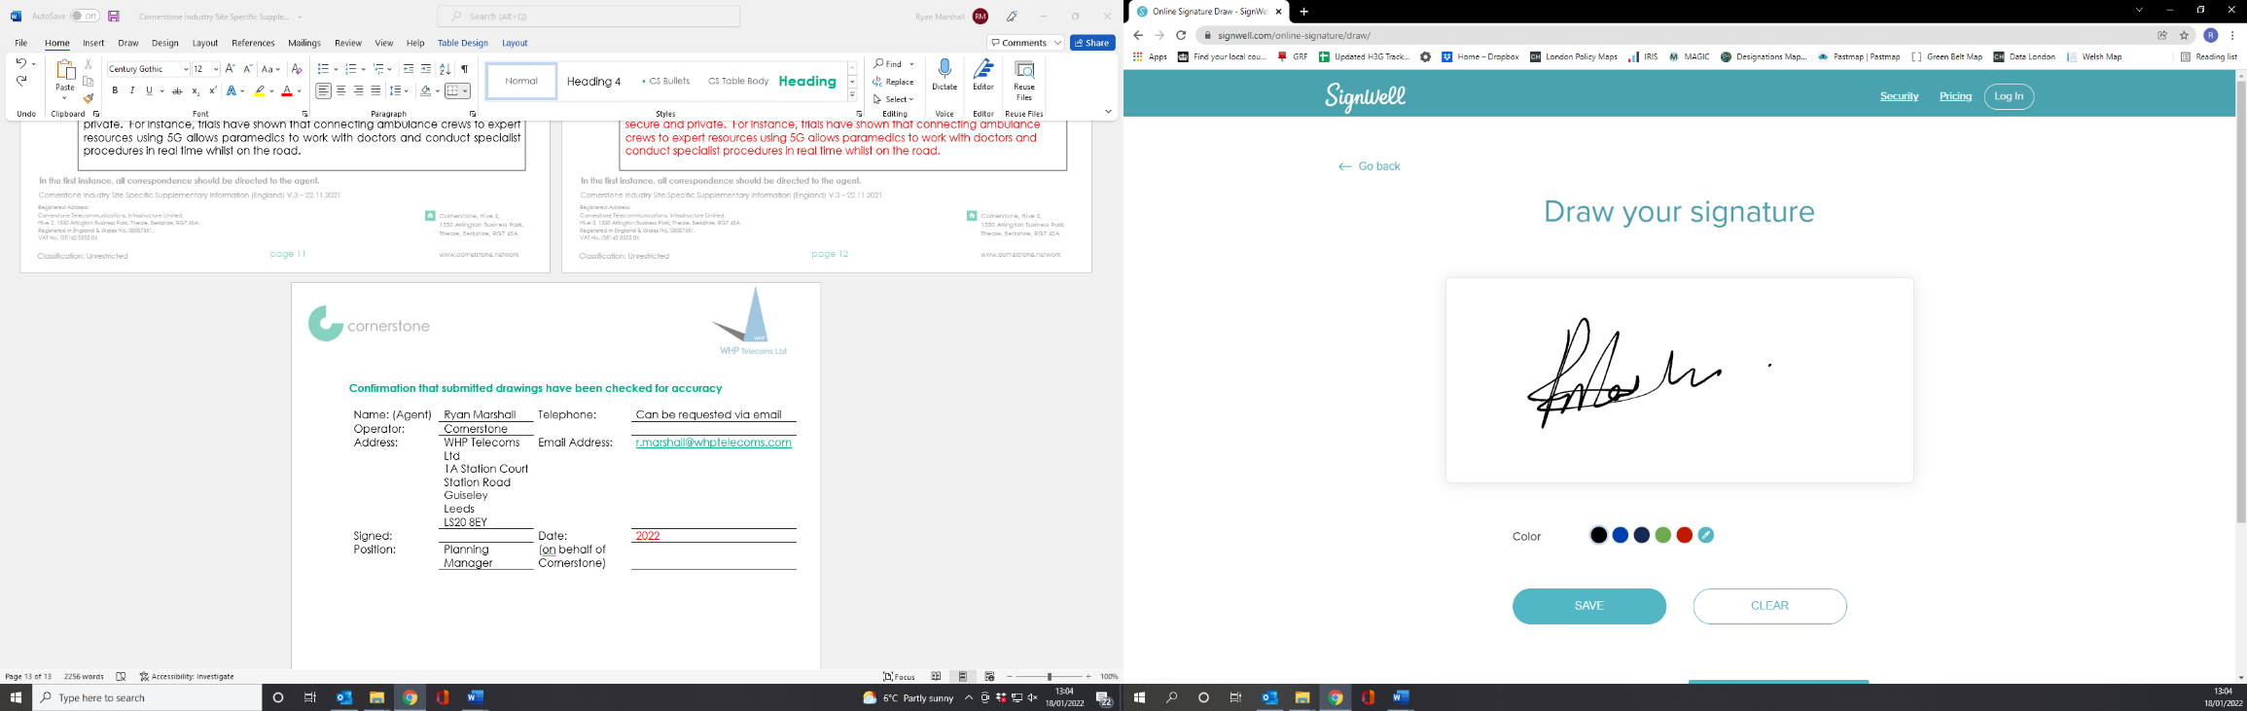 | Date: | 1st March 2024
Position: | Planning Manager | Company:  (on behalf of above operator) | WHP

