5.0 Environmental Standards Statement

5.1 Energy Efficiency

The building has been designed to increase energy efficiencies wherever possible by selecting materials and components which have high thermal efficiencies which reduces CO2 emissions by at least 25% more than the requirements of Building Regulations: Approved Document L2B 2006 as Part 1 Policy E1.5 and Guide to Development in Manchester - Supplementary Planning Document and Planning Guidance (SPD). This has been achieved by implementing the following design principles:
The performance of the building fabric and fixed building services will achieve the below overall standards of energy efficiency:
Fabric Element | U-Value
Walls | 0.19 W/(m²K)
Floors | 0.17 W/(m²K)
Pitched Roofs | 0.16 W/(m²K)
Flat Roofs | 0.18 W/(m²K)
Windows | 1.5 W/(m²K)
High Usage Entrance Doors | 2.82 W/(m²K)

In addition to the above building fabric design principles, energy efficient building services have been chosen both mechanically and electrically to heat and power the building along with energy generation from solar panels located on the roof of the building. The buildings primary source of heat generation will be from air source heat pumps located externally within a fenced enclosure, high efficiency fan convectors have been selected for heat emission within the building to improve thermal convection and in-turn thermal efficiencies of the building.

High efficiency LED lighting with absence detection, daylight sensors and dimming controls will be installed to ensure that energy usage will be kept to a minimum within the building wherever possible.
The site layout has been included within the design principles to maximise the use of natural light, as indicated on the sun calculations below, three elevations will receive natural daylight at all times with windows positioned strategically to maximise natural light.
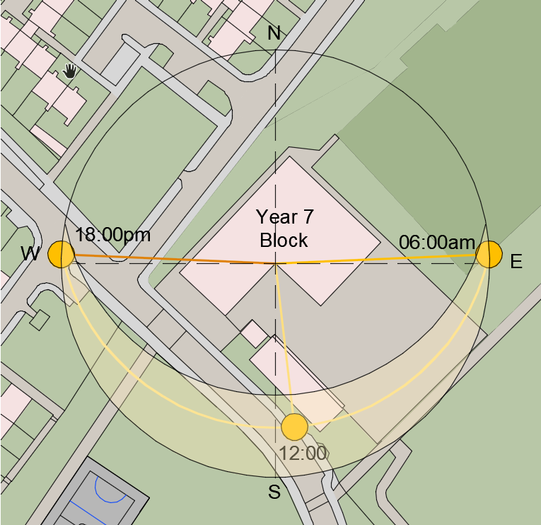
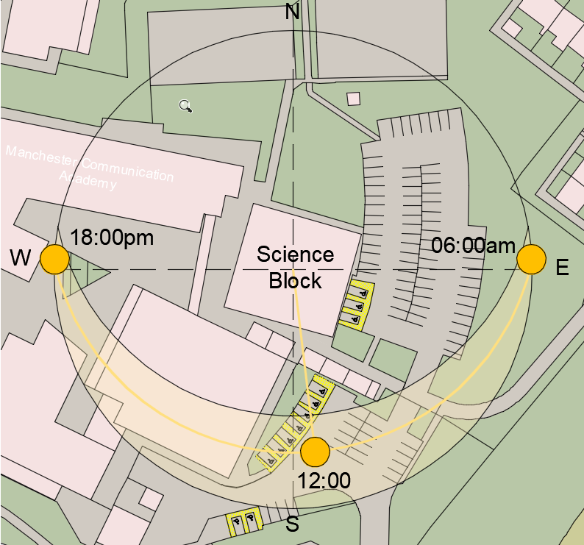

5.2 Renewable Energy
As previously mentioned solar arrays will be incorporated into both buildings to generate power for air source heat pumps which will in-turn generate heat for the buildings. In addition to the new installations, the main block of the school is heated via air source heat pumps which are also powered by a solar array with battery storage which can be used as a backup should exceptionally adverse weather conditions occur. The final site energy demand for the school utilise renewable energy sources which equates to 60% of the site energy demand being generated by sources on-site.
5.3 Environmental Design
When selecting materials for the projects, wherever reasonably practical materials must achieve a BRE Green Guide Rating of A+ which represents the best environmental performance / least environmental impact. The primary materials of the building have been specified from recycled sources with high content of future recyclable opportunities.
5.4 Water Management
The water management plan has been submitted with this planning application, a revised drainage solution has been included to ensure that surface water run off if kept to a minimum to protect waterways and local sewer systems. Calculations have been undertaken which have determined that attenuation tanks are not required with permeable solutions being used where hardstanding has been introduced to promote natural filtration to soakaways.
5.5 Waste & Construction Management
The Principal Contractor will setup recycling centres within the construction site with a waste management strategy which allows for separation of materials into categories for recycling at waste collection sites. A target has been set for this project to achieve at least 60% recycling of waste materials used as part of the construction process. The waste collection area will be located within the contractor’s compound which will be accessible from a temporary roadway for recycling vehicles to collect waste.

5.6 Biodiversity
In line with UDP Part 1 Policies E2.3 and E2.4 an ecological appraisal and Biodiversity Assessment has been completed by an ecologist which has been appended to this document. The results determined that the existing habitat opportunities on-site are poor with most areas being poorly moderated grassland and developed land with sealed surfaces. It is proposed that as part of this development habitats are created including:
- Urban – Developed Land; Sealed Surface
- Grassland – Modified Grassland
- Hedgerows
- Trees
The above habitats will create a bio-diversity net gain of 0.22 habitat units (10.81%) which meets the requirements of planning policy and legislation.

