Aruba 5 series APs and mounts
WLAN Transformation at the University of Manchester involves the installation of new wireless access points. The devices to be used are Aruba 5 series, AP-515 and AP-535. Data sheets which include all features, dimensions and specifications can be found at the below hyperlinks:

Aruba 510 Series Campus Access Points Data Sheet (arubanetworks.com)
Aruba 530 Series Campus Access Points Data Sheet (arubanetworks.com)

Ceiling mounting - Below is an image of the mount used when the APs are mounted to the ceiling:
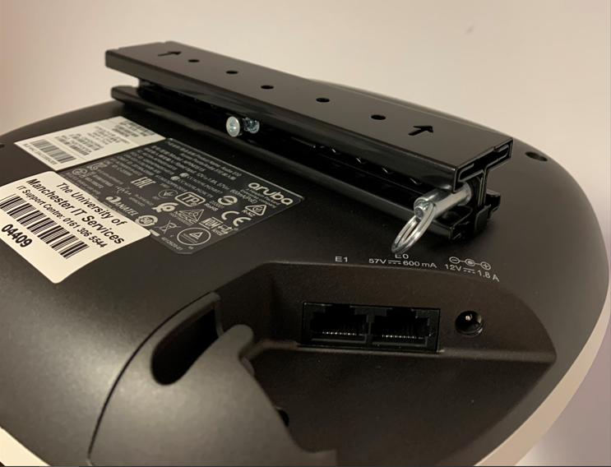

Wall mounting - Below is an image of how the APs are to be mounted to the wall in the event that the ceiling is too high for the AP to be serviced, or the ceiling is not suitable:
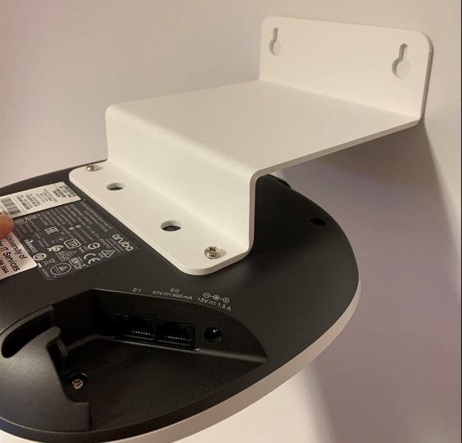
Aesthetic concealment - Slip on covers are available, which cover the visible white exterior of the AP. These come in white but can be painted with heat proof paint to match a ceiling colour. An example of where these have been deployed is at the John Rylands Library Deansgate, main library area, where a dark brown colour has been used to make the APs less visible when mounted on the ceiling.
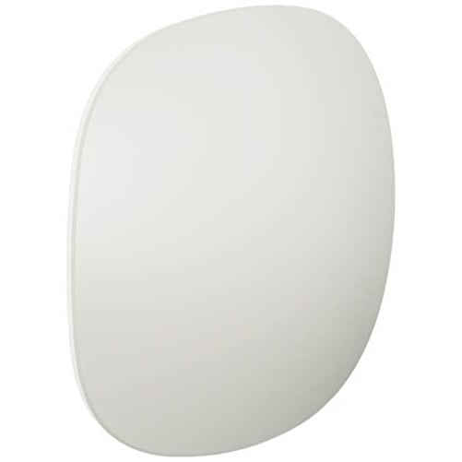

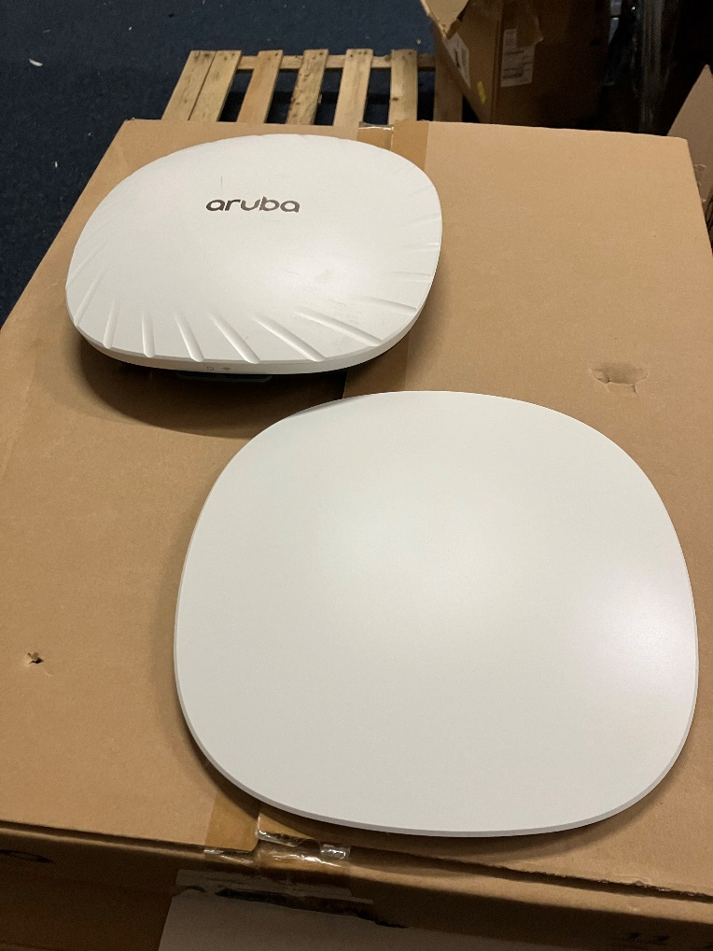
Once painted these simply snap on in place.

Examples of materials to be used:

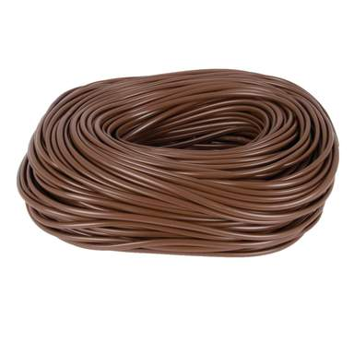
Brown data cable (alternative for costs plastic sleeving)

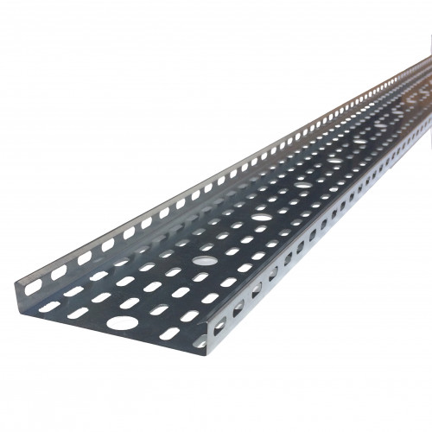
Cable tray

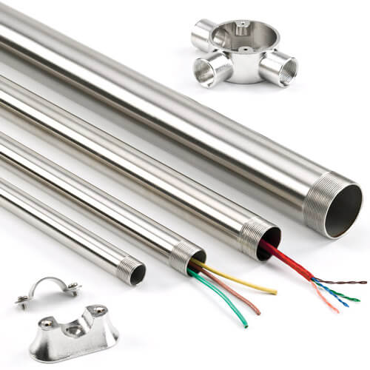

Conduit (in galvanised/black/white)

