
Midland Hotel Granite Repair Methodology – Proposed.

- Site Investigation.
Several trial holes were undertaken to the periphery of the granite surround. These were to understand in greater detail the build up of the existing granite and its thickness over all. This was quite a key principle to understand, as different repair strategies would have to be enacted, depending on whether the granite was ‘clad on’ to a deeper super structure, or whether the granite was full thickness, itself a load bearing façade. Please see figure 1 and 2 for the locations of the core drill holes. There are two types of granite within the doorway. Details of the both are included within the accompanying materials.

- Findings.
Please see Fig, 3, 4 and 5 for images of the granite core drill holes.

The investigations revealed that the granite was full thickness, i.e. it is as thick as it appears on the surface, the quoins etc are not ‘L’ shaped on plan and the ashlar units, which could have been assumed to be 100mm thick cladding or similar are as thick as the quoins they sit behind. There is no evidence of any cavity at the rear of the granite. In each location we found brick infill, bearing immediately onto the back of the granite. The width varies slightly, 390mm thick in the reveal to the door and thicker still in the arch, going up to close to 500mm thickness.

In each location there was little to suggest that the heat damage to the surface of the granite was anything other than surface deep. Once the core drill passed the outer crust of flame damaged granite to the exterior, the granite internally was consistent and incredibly hard.

- Recommendations
As the granite is full depth, it would be logistically difficult to remove whole pieces and replace them without disturbing the structure above. Additionally it would also be incredibly expensive to buy the raw material in the quantity required to replace every damaged piece of granite. It is therefore suggested that the repair is carried out using face part indents. This will minimize the volume of old stone to cut out, new stone to buy and can be enacted without undermining the rest of the structure above.

Please see fig 6 for an illustration of a sample indent.

We would suggest that the thickness of the indents are 100mm wide. Once the original damaged stone is cut out, the 100mm thickness will allow the contractor to insert whole units in a traditional fashion, securing each piece back with stainless steel anchors in the rear of the unit. Also the ‘L’ shaped units (of which there will be many on this door surround) will have an amount of strength in the corner at the meeting of the converging faces. If a thinner veneer or cladding type unit were to be considered, a fixing system would need to be designed to bear the weight of the units above, adequately restrain the units from falling away and adequately resist movement into the building in the event of an impact.

The surface of the granite could not be readily filled or repaired by using a mortar repair or similar. The grainy nature of the granite would be almost impossible to replicate. The granite has a honed/ polished finish. Which would need to be replicated to a high degree of accuracy to remain in keeping with remainder of the façade.

It is recommended that the new units are fixed with stainless steel fixings and lime mortar. Lime Mortar to be matched to the existing mortar in both colour and consistency. The stainless steel fixings are to be resin bonded into holes drilled into the original granite and counterpart holes drilled into the new granite indent. The exact number of fixings would have to be designed by the Project engineer. It is envisaged that 2 nr stainless steel fixings per units would be adequate. Stainless steel fixings by Ancon Ltd or similar. Ancon YPB ties with loose dowel, to suit the width of the indent.

Before commencing with the replacement of the granite, it is highly recommended that the surround, the steps, the walls in front of the steps and the terracotta to the balcony above are TORC cleaned to agree the extent of replacement.

- Sequence
It is suggested that the order of the works is as follows;

- Erect scaffolding to the full height of the façade, to a width of approximately 6m. (There is a down pipe each of the fire damaged door surround. Suggest this is the extremity of the width of the scaffolding. )
- Inspect the façade and record the existing condition.
- TORC clean the scaffolded areas
- Inspect the wall areas from the scaffolding jointly with the Architect.
- Survey the steps, door surround and the balcony terracotta
- Produce a set of full working details for the masonry replacement
- Forward to the project team for approval
- On confirmation that the details are accepted, order the granite from the sources identified within the accompanying documentation
- If any terracotta is to be replaced, place an order of the units required with Darwen Terracotta, or equal approved.
- Once the granite procurement is comprehensively underway, start onsite, breaking out the flame damaged granite.
- Install the new granite sequentially.
- Include for an arch former to the underside of the arch
- On completion of the installation re- clean the area between the downpipes at ground floor area and the Balcony with the DOFF steam system.
- Dismantle the scaffolding before carrying out tread and riser indents to the steps
- Clear site

- Extent of Replacement
Please see fig 7 for pictures demonstrating extent of the replacement.

We are recommending that all granite to the interior of the door way and each stone that quoins around onto the main front elevation is replaced. There are very small number of stones in this category that appear to be very modestly damaged and may not require replacement. This would be subject to hammer testing insitu (under item 4 above) to ensure that the heat damage hasn’t delaminated the main face.

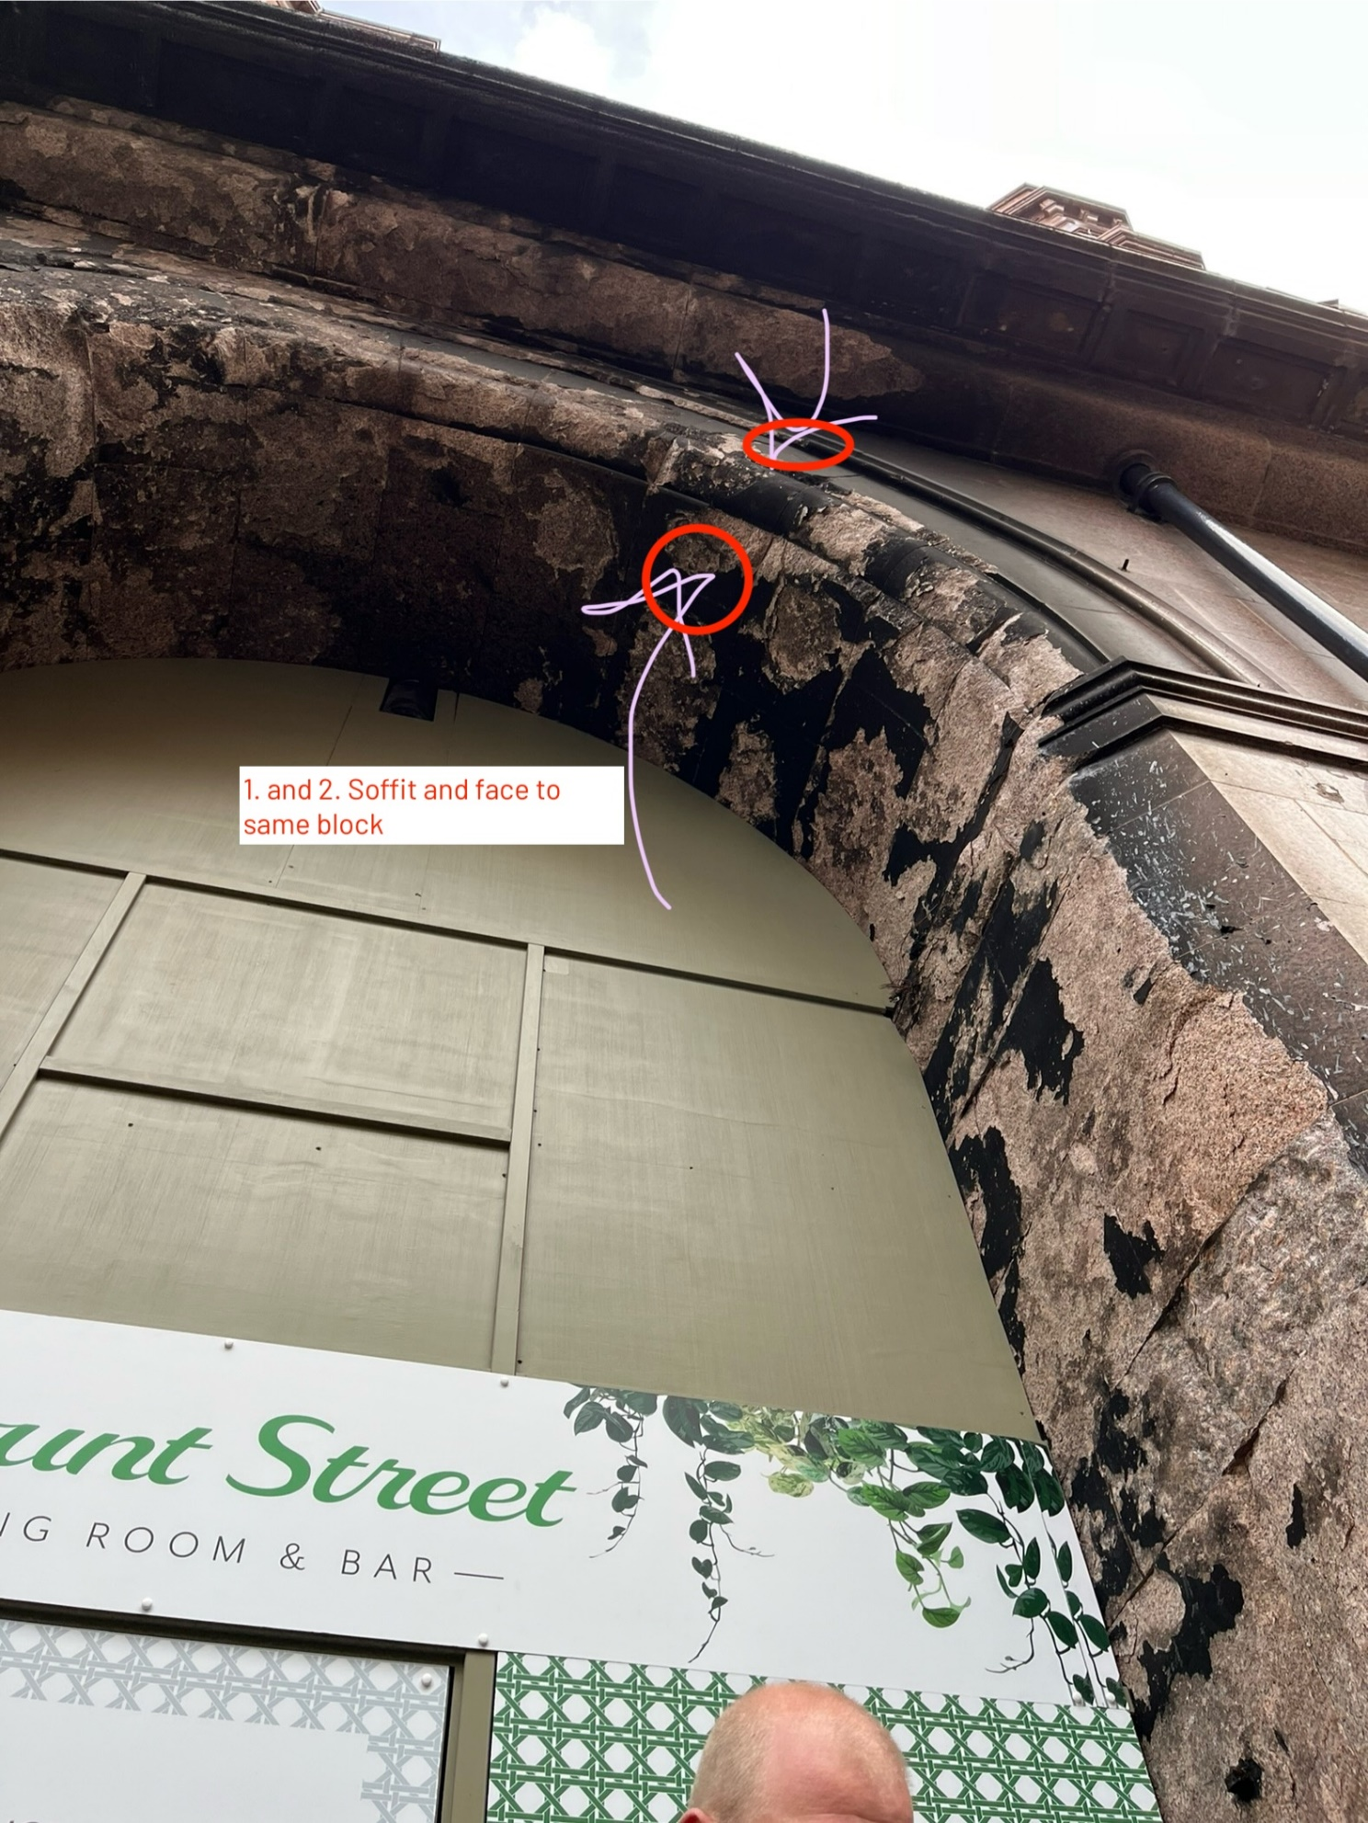

Fig 1. Core dill holes to the Arch.

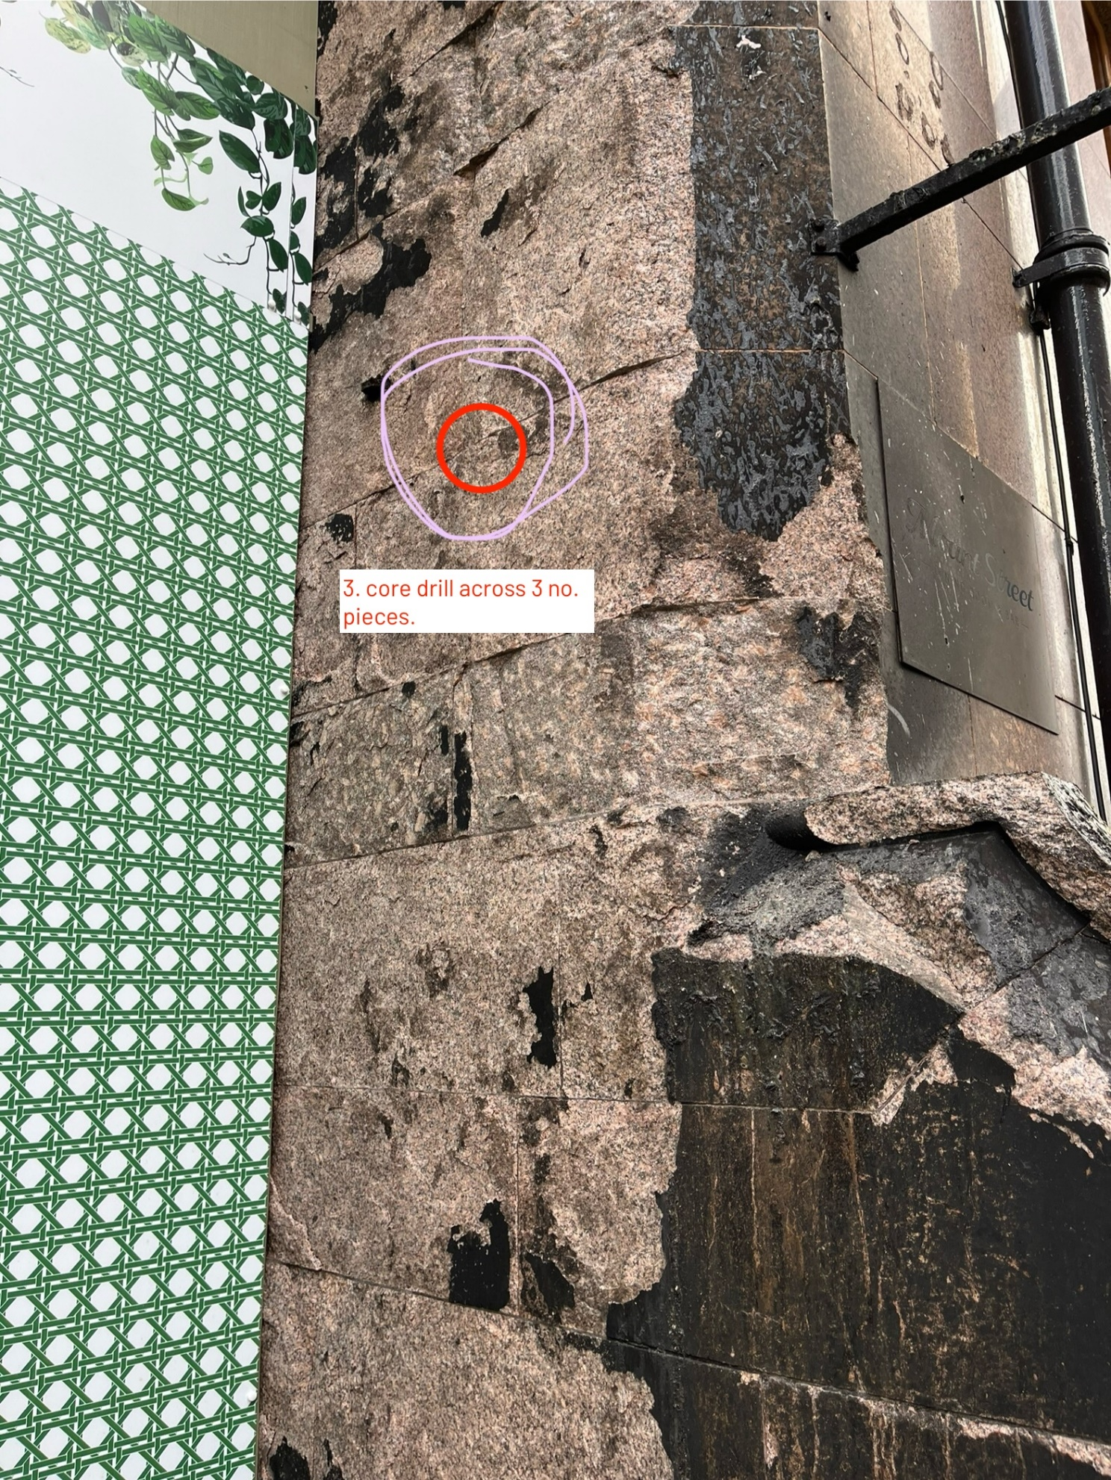

Fig 2. Core drill hole to the reveal of the door.

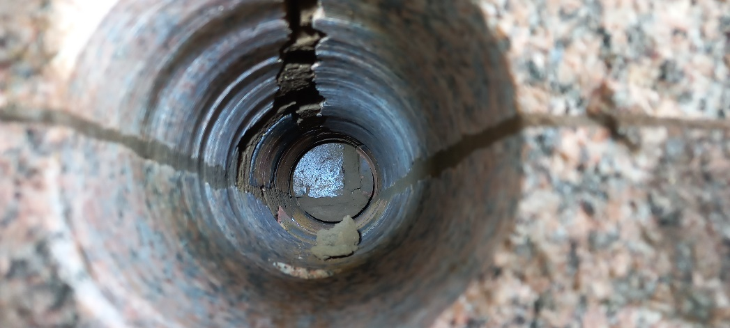
Fig 3. Core drill location 3. Door Reveal.

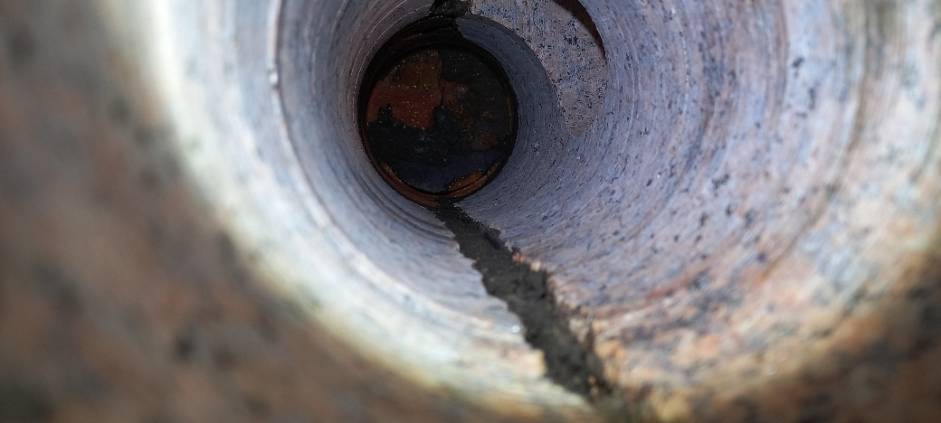
Fig 4. Core drill location 1. Arch Soffit.

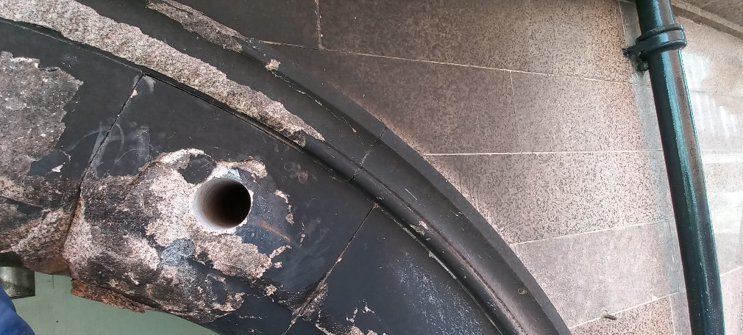
Fig 5. Core Drill location 2. Arch face

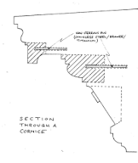
Fig 6. A sample illustration of a stone indent.

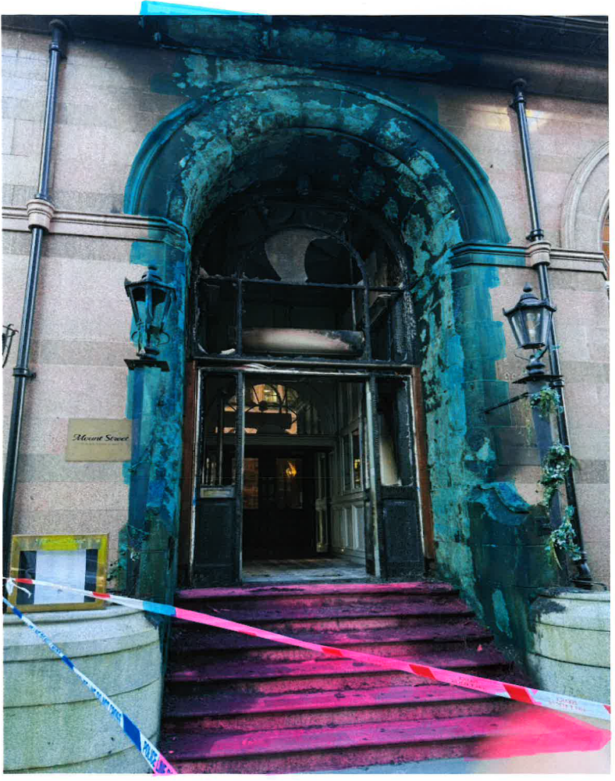
Figure 7 – Extent of Granite that requires indent repairs.
Blue indicates a 100mm thick face replacement.
Pink indicates a 50mm cladding tread and riser indent replacement to the top and front of each step.

