
VOX Travel Plan

Travel Plan Coordinator: James Murphy & Megan Cosgrove
The Vox Main entrance is located on Trentham Street, which is one-way within the vicinity of the site in the northbound direction. A designated on-street cycle lane is provided on the Southern side of the building, marked for cyclists travelling eastbound towards Manchester City Centre. Footways and street lighting are provided on both sides. The road serves a number of local amenities, commercial and residential units.
Travel Plans for residents/Travel Information Leaflet
Vox is located a two-minute walk away from Cornbrook Metrolink station, an interchange station connecting residents to all tram routes within the city, and surrounding zones of Greater Manchester. The City Centre is also within 25-minute walking distance, greatly diminishing the need for a car. With a large majority of current residents being young professionals, we continually aim to promote an environmentally friendly, modern way of living that reduces the need for car ownership; if not an option, we hope to residents engage and work together to lower car usage and promote other travel options.
Please find information on all of Manchester’s available transport methods:

Buses & Free Bus
Vox is conveniently located within walking distance of all major bus & metro links, far reaching to the outskirts of Greater Manchester.

The nearest bus stops are located on the A56 Chester Road, 65m from the Vox main entrance immediately to the east of the Chester Road/Bridgewater Way junction. There are continuous footways linking the site to the stop, which operates the 255, 720 and X50 Services.

Manchester is also the first city to offer free buses that interlinks all main routes within the City Centre. This economic and cost-efficient alternative offers our residents free inner-city transport (see route map below) across two routes whilst operating some of the most innovative and environmentally friendly bus models on the market to date.
The buses run from 7am to 11:30pm Monday to Saturday, and, from 10am to 6pm on Sundays and public holidays with the closest stop to Vox being Deansgate on route one.
Visual announcements relating to various aspects of the journey are displayed and audio described on interactive boards.
Please visit the TGFM website by for further information by clicking here.
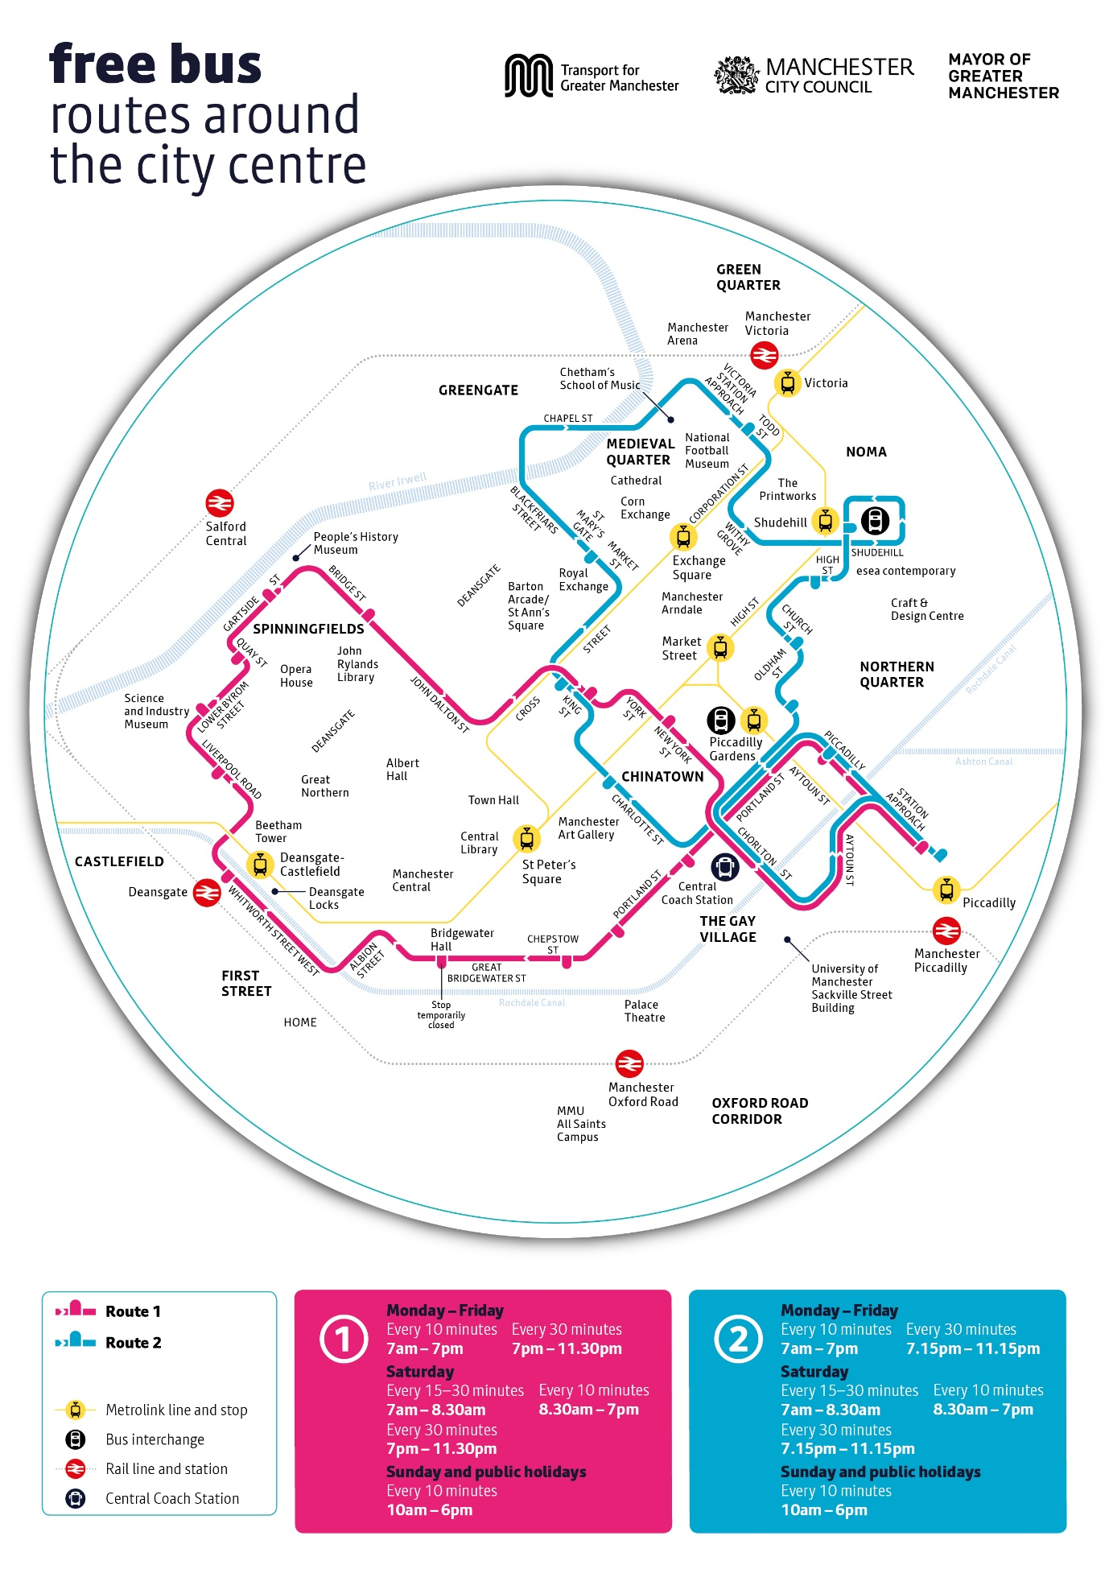

Metrolink
Cornbrook Metrolink Station is the nearest station to the site located approximately 300m (2-minute walk) to the north-west of the site off Cornbrook Road. The Station is one of only three that connect every single Metrolink line in Manchester and Greater Manchester with the exception of the Yellow Line (Bury to Piccadilly).

Trains
If you commute to work outside of Manchester city centre or enjoy a city break on weekends, you will be pleased to know your nearest station is Deansgate, conveniently located approximately 1.2km to the east of the site on Whitworth Street West. The Station provides services to Liverpool, Preston, Southport, and other local destinations. National routes are available through connections from local stations, namely Manchester Piccadilly, Victoria, and Oxford road station. The journey time from Manchester Piccadilly to London is just over two hours. Both Piccadilly and Victoria can be reached directly from Cornbrook Metrolink station in under twelve minutes. Railcards are available to purchase online or at any station with an information desk. You can benefit from saving up to a third of your railway cost on each journey and in addition to the 16-25 railcards there is also an aged 26-30 railcard to help make train travel more affordable.

Walking and Cycling
The site benefits from good pedestrian and cycle links. The majority of local roads are well-lit and have a maximum speed restriction of 30mph. Cycle lanes are available on both Ellesmere Street and Chester Road connecting to upgraded cycle routes around Manchester city centre. The majority of pedestrian crossing points have dropped kerbs with tactile paving.

Vox has 280 individual bike storage slots located in the secure under-croft car park which equates to one slot per apartment. We plan to further promote cycling via a building cycling group aimed to encourage residents to communicate with each other to arrange organised cycles around the city, which will help the resident health and wellbeing.

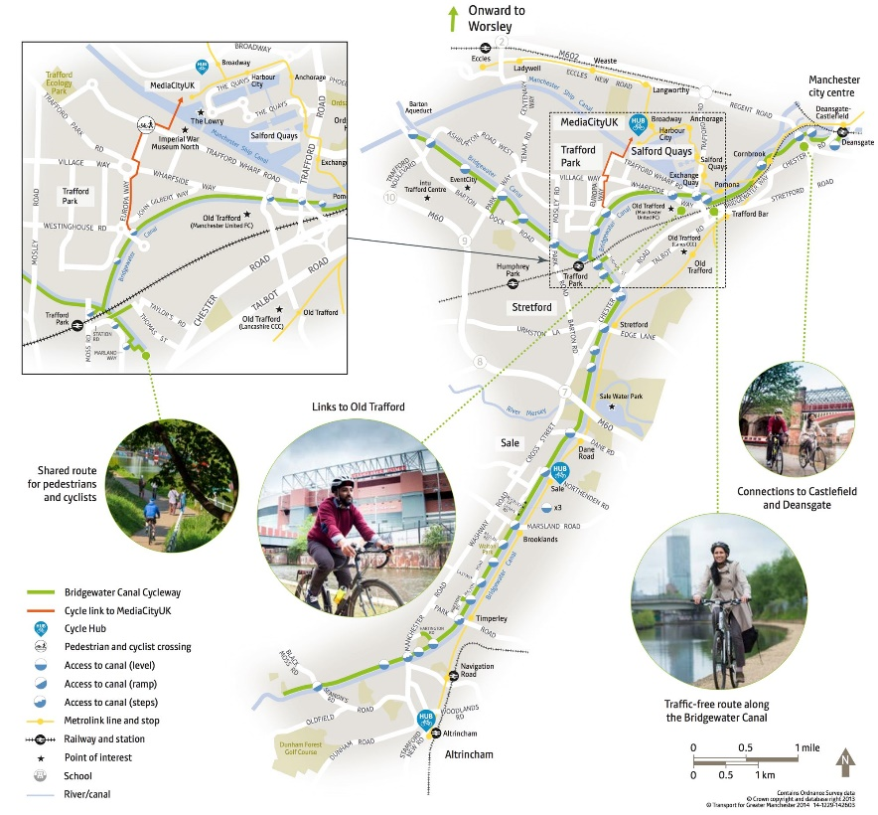

Car Sharing
We understand you may still need or even just want your own car, which is why Vox has 50 secure car parking spaces which are available to residents for an additional monthly charge.
Electric vehicle owners can benefit from 6 designated EV parking bays with individual chargers, the cost of which is inclusive of the additional monthly car parking charge.
The Car Park is on Ground level and the entrance is located on Dinton Street at the rear of the building with secure access. There will also be a permit issued to all residents that have purchased a space which will be monitored by our on-site management team.
As residents of Vox you are surrounded by a large, varied group of individuals and neighbours which is why we would encourage you to explore any additional car sharing needs via your Vox Manchester App. We have a large demographic of residents who have relocated from neighbouring cities, this could be a great opportunity to meet your neighbours and split travel expenses I.E petrol or parking costs. If you are interested in car sharing whether you are the car owner or the commuter, please do not hesitate to utilise your Vox App to communicate to one and other. This will be organised amongst yourselves and will not be the responsibility of the on site team to set up, implement or enforce*
*Note: This option must be voluntarily offered by the resident willing to host a car share opportunity and mutually agreed between all parties involved. Any exchange of monies will be at the discretion and agreement of the residents involved and will not be determined by The Vox team. Car sharing times or opportunities will not be for the team at The Vox to enforce or hold anyone accountable to. It will be solely on the resident at their discretion to decide as to who/when they accept. No responsibility or obligation will be held by either the resident or The Vox team and can be discontinued by the resident at any given time without consequence or reason.

The information contained within this document is accurate as at the time of writing and is publicly available. The Vox Team will endeavour to keep the document updated by cannot be held responsible or liable for any loss or liability that may be suffered as a result of information herein.

Do not forget to use your Vox Manchester App for up-to-date information, news, and timetables on Manchester’s public transport!

