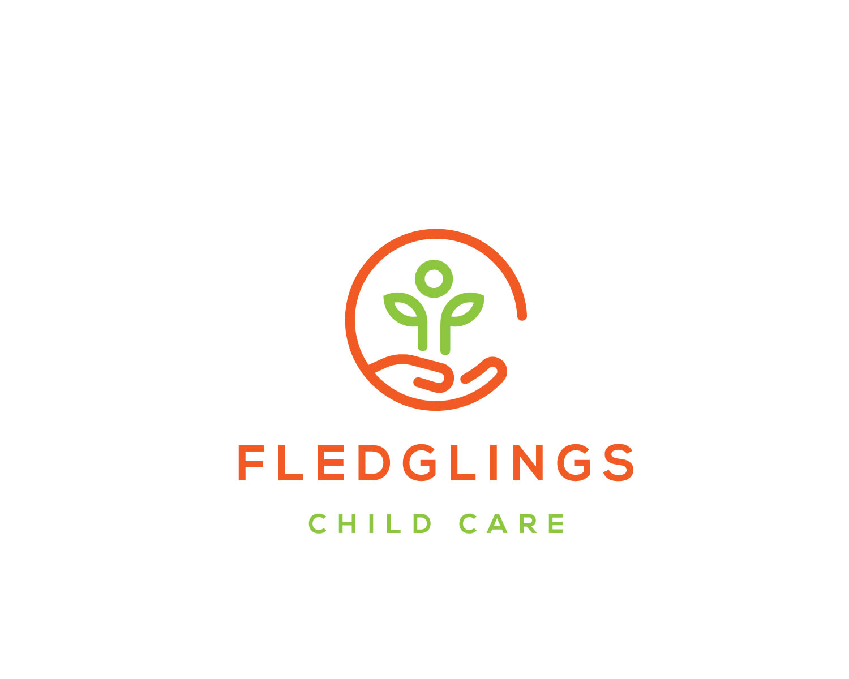  POLICY 1010 GOOD NEIGHBOUR POLICY  October 2023 | At Fledglings Child Care a positive relationship with neighbours and the surrounding community are our paramount concern. We have a good neighbour policy to ensure positive relationships within the community.

Table of Contents
OUR VISION AND COMMITMENT 2
Whistleblowing policy 3
1.1 Duty and Responsibility 3
Impact of the home within the community 4
1.2 Building Presentation 4
1.3 Presentation of staff and Fledglings representatives 4
1.4 Care for how children/young people present themselves 5
1.5 React quickly and properly when incidents occur 5
1.6 Address on-going practices 5
1.7 Address training issues 6
Maintaining community links following an incident 6
1.8 Matters affecting local community 6
Incident 6
1.9 Stage 1 6
1.10 Stage 2 6
1.11 Stage 3 7
1.12 Stage 4 7
1.13 Stage 5 7
1.14 Complaints and representations 7
Useful contacts for neighbours and residents 8
Regulatory Body Contact details 8
Cross Reference 8
Document Review Table 8

OUR VISION AND COMMITMENT

Fledglings Child Care offers young people a family oriented residential living experience where they can be healthy, safe from harm and able to develop confidence and well-being leading to fulfilling their potential.

Our three pillars are based on delivering
care, education and independence.

Each young person will be respected, valued and nurtured to allow their individual talents, strengths and self-worth to develop during their time living in the home.

The staff team will promote positive relationships with young people through activities and shared daily life in a well maintained, safe and stimulating environment.

Whistleblowing policy

Duty and Responsibility
It is the duty of local authorities to ‘look after’ certain children who are assessed as being ‘in need or at risk of significant harm’ for a variety of reasons. Where appropriate, that duty of care is delegated to specialist bodies such as Fledglings Child Care. Whilst children/young people are ‘looked after’ their care should be of the highest standard and they will be returned to their families whenever it is practicable and safe to do so. In following this duty, we will ensure that children/young people ‘looked after’ are given the opportunity to reach their full potential in respect of education, health, and social attainment. Every aspect of this service is governed by the Children’s Home Regulations 2015, which regulates the way staff look after children/young people.

In respect of children/young people living in the home, the objective will be to ensure that the home is part of the community rather than separate from it. Children/young people and staff should enjoy the same opportunities, choices, and access to facilities as their neighbours but should also try to make a positive contribution to the local community.

Fledglings Child Care is committed to ensuring that whilst children are in our care, as well as protecting their welfare, we will do all in our power to encourage and teach them how to be responsible members of the community.

All members of the local community, including children/young people and staff, have rights, but these rights are equally matched by responsibilities to others. Staff responsible for the care of the children/young people must act as good parents and present positive role models. Our aim is to promote the safety and welfare of the children/young people in our care. To achieve this, we appreciate support and observations from members of the local community.

Above all else it is essential that staff listen to and respond to the concerns of neighbours in the spirit of being a good neighbour themselves. This should not be done in a way which takes away from the staff responsibility to the children /young people in our care. In managing the home Fledglings Child Care and its staff are committed to the following standards.

We will:

- Establish positive links with the local community.
- Staff will be expected to help the children/young people accept and respect the rights of others and the immediate neighbours and local community.

Staff should:

- Know the local community
- Obtain information on local facilities
- Present good images in the local community
- Have good and appropriate communication systems, such as greetings cards, point of contact and follow-up process. This must be evidenced, so managers should develop a community file for their home.
- Work with the young people to get involved in the local community and encourage them to make a positive contribution to it.

Impact of the home within the community

Building Presentation
The look of the building needs to reflect a positive, cared for image.
Staff will:
- Be mindful of how the home and grounds look, keep rubbish under control.
- Be mindful where young people, visitors are at all times.
- Maintain good boundaries and fences.
- Keep noise to a minimum (e.g., by installation of double glazing, controlling stereos, T.V. and computer games and advising visitors to the home)
- Keep gardens maintained.
- Draw curtains as appropriate.
- Put lights on or off as appropriate.
- Ensure visible supervision of children/young people’s activities.
- Be proactive in showing that staff are with the children/young people.
- Ensure appropriate parking.
- Ensure that they, where possible, get involved in community events and celebrate with the young people them being park of the local community.

Presentation of staff and Fledglings representatives

It is vital that staff and others accept the importance of their role in relation to the children’s home and the community within which it is situated.

Staff will:

- Present as good role models for the children and young people.
- Be ambassadors for the home and company, this includes both during working times and outside working times.
- Be accountable for the children/young people’s behaviour outside the home in the grounds, in the locality and in community facilities.
- Be careful of combinations of children/young people going out together and congregating in the neighbourhood.
- Be mindful of the number of children/young people out together this includes discouraging local youths from hanging around outside the home with or without the children/young in our care.
- Use and support local facilities.
- Respond to complaints appropriately and in accordance with the complaints policy and within timescales.
- Act as corporate parents by being consistent and offering appropriate structures and boundaries.
- Help children/young people accept and respect themselves and others.
- Have staff ID on them available if requested. However, this does not need to be visible.

Care for how children/young people present themselves

To assist with their feeling of self-worth, children and young people should:

- Wear good clothing and where appropriate school uniform.
- Appear well cared for and wear clothes suited to the weather conditions.
- Present acceptable behaviour.
- Accept that they are accountable for their behaviour outside the house.

React quickly and properly when incidents occur

To respond quickly to concerns and complaints, accepting that each situation is unique.

Staff will:
- Receive training to deal effectively with incidents as part of a core programme of training – this includes Behaviour Management Training and Complaints training.
- Receive clear guidance to enable them to respond effectively.
- Identify a person who will take responsibility and co-ordinate action.
- Respond as immediately as possible thereby preventing an issue becoming bigger.
- Advise the manager who will respond personally or follow up on actions.
- The manager to be proactive in speaking personally to neighbours if there has been an incident.
- Ensure more senior managers are made aware of any concerns highlighted by the neighbours.
- Inform the community and or individual of action taken as appropriate.
- Advise neighbours of the use of the complaint’s procedure where appropriate.
- Check whether the neighbours satisfied with outcome/action taken.

Address on-going practices

Maintaining good relations with the community is a never-ending process.
Staff and managers should:
- Keep practices in relation to public relations as agenda item for staff and supervision meetings.
- Keep in touch with local neighbours.
- Check on their views and wellbeing.
- Keep them informed of developments that may affect them.
- Be a good neighbour.
- Consider becoming involved in neighbourhood watch schemes etc.
- Assist in times of crisis.
- Encourage liaison groups.
- Be aware of local community issues.
- Involve staff, children and young people in local community events and resources.

Address training issues

To improve staff confidence and attitudes when tackling the issues presented to them. Managers will provide training which:

- Deals with incidents/complaints.
- Enables positive working with the local community.
- tackles behaviour management in relation to the local community.
- promotes the role of the corporate parent.

Maintaining community links following an incident

Matters affecting local community
The following is staff guidance to enable staff to deal effectively with matters which may affect the local community. The most senior person on duty will be responsible for ensuring that the following guidance is implemented.

Incident

Stage 1

  - Immediately assess situation (depending on the seriousness it may be necessary to contact the manager if not on site or The Responsible Individual)
  - Consider any aspects that may cause adverse reaction from the community.
  - Take details to assist with the matter being dealt with effectively.
  - Inform those involved of the complaint procedure.
  - Identify person to co-ordinate - (within 30 minutes)
  - Take positive action.
  - Liaise with neighbours.
  - Demonstrate that you are in control and acting on it.
  - Take a balanced approach, avoid taking an aggressive or defensive stance.
  - Manage your own feelings.

Stage 2

  - Inform of action taken (as soon as appropriate, but by end of shift)
  - if young person has been abusive or caused damage - be proactive.
  - Inform neighbour of the consequence to be imposed.
  - Use restorative justice methods to minimise police involvement i.e. get young person to apologise / make amends (put yourself in their place, how would you feel?)
  - Do not pass the child/ young person’s name to anyone who requests this unless the request is made by the police.
  - Ensure that where necessary social workers and parents (if appropriate) are informed of any incidents involving their child/children.

Stage 3

  - Inform manager at earliest opportunity
  - Depending on the seriousness it may be necessary to contact them in their ‘off’ time.

Stage 4

  - Manager to follow up (within 7 days)
  - The manager or senior member of staff should visit in person to ensure the neighbour is satisfied with the way that the situation was handled.
  - This should be followed up again at a point in the future.
  - Remind those involved of the complaint procedure.

Stage 5

  - Advise senior management.
  - If the nature of the incident is particularly serious; ensure that senior management are briefed at the earliest opportunity.
  - Neighbours are entitled to contact senior management directly.

Complaints and representations

Where a neighbour is unhappy with the response/outcome, they should again be advised of the complaint procedure.

In addition, they should be informed of how to access senior management.

Useful contacts for neighbours and residents

Fledglings Child Care Head Office
Colonnade House,
163 Kingsway,
Manchester,
M19 2ND

Regulatory Body Contact details

Ofsted
Piccadilly Gate
Store Street
Manchester
M1 2WD

Contact Number: 0300 1234 666

Email: enquiries@ofsted.gov.uk

Website: http://www.ofsted.gov.uk

Cross Reference

- Complaints Policy

Document Review Table

Reason for update | Date of review | Reviewed by
Created | February 2022 | Jeremy Farrar
Reviewed | October 2023 | Jeremy Farrar

