


Date: 9th March 2023

Traffic Management Plan V.2
17 Quay Street
Manchester
M3 3HN
Table of Contents
1 Introduction 2
2 Traffic Management Plan 3
3 Site Administration 4
4 Pedestrian Route Checklist 5
5 Pedestrian Route Actions to be Taken 6
6 Vehicle Routes 7
7 Vehicle Routes Actions to be Taken 8
8 Vehicle Movements 9
9 Vehicle Movements Actions to be Taken 10
10 Hierarchy of Control Measures for Reversing Operations 11
11 Drivers Safe Work Practices Checklist 12
12 Signallers / Banksman Checklist 14
13 Safe Use of Site Dumpsters Checklist 15
14 Central Control Register 17
15 Route Map 18
16 Site Logistics Plan 19

1 Introduction

The Traffic Management Strategy for the project is one of minimising the interface wherever possible between Public and Site traffic, and reducing the number of deliveries were practicable, including the staging of deliveries, such that the volume of traffic is kept as even as possible avoiding peaks, and controlling vehicular movements on the project.

Every year around 70 people are killed or injured by vehicles at work. This document provides practical guidance on the planning of these issues, the control measures that will be implemented and highlights the points for consideration and necessary actions.

Avoiding hazards and controlling the risks arising from the use of the vehicles in construction work is essential. The Health and Safety Executive (H.S.E) expect to see traffic management plans that include:

- Planning and managing both vehicles and pedestrian routes

- The elimination of reversing where possible

- Safe driving and working practices

- Protection of the public

- Adequate vision and lines of sight

- The provision of signs and barriers

- Adequate parking and off-loading/storage areas

If you require further information, please contact Spacescape Ltd.’s Health and Safety Advisor.

2 Traffic Management Plan

Route maps (clause 15) shows the proposed routes that all site deliveries will be directed along to gain access to the site. They also highlight the routes to be taken when leaving the site to avoid potential collisions with site vehicles and road vehicles at the site entrance on Artilary Street.

Immediately upon commencement, all deliveries, operatives and visitors to the Project will report to the site manager’s office. This will be communicated to all contractors at their Pre-start meeting.

They will be inducted by Spacescape’s Site Manager Darren Lodge,and be informed of Emergency procedures, assembly points, first Aid, site rules, location of welfare facilities, etc. at this time. They will be instructed to sign in and out at the security gate each day, until the full access control system is in operation. PPE appropriate to the tasks being undertaken will be checked upon signing in.

Contractors, visitors and staff will use existing pedestrian pathways until such time as the sites are enclosed and access control is operational.

The attached logistics plan (Appendix 2) highlights the access point for the project, loading bay, pedestrian / vehicular segregation, welfare, storage, security & material handling that will be enforced following the full Site establishment.

An integral part to the progress meetings held with all trade contractors is the delivery schedule pro-forma. All contractors are required to give details of proposed timing of material deliveries to the site. At this stage they will be given a specific area for delivery

The Traffic Management Plan and the control measures therein are included within all trade contractor tender enquiries to ensure early understanding and acceptance / compliance with the rules that will be enforced on this project.

Under no circumstance will lorries be allowed to lay-up in surrounding roads.

Delivery Vehicles / Laying up:

Prevention Steps

1. Delivery hours will be limited to working hours. This condition forms part of subcontract documentation, and subcontractors are reminded of this at pre-start meetings.

2. Deliveries are scheduled with our Site Manager and logged within the daily site diary (F03.02a).

3. Contrctors will be in position half an hour before start of work and before their earliest delivery time- if not in attendance the delivery will be refused, Spacescape are not responsible for any extra costs or charges occurred.

4. Persistent offenders will be reported to the Managing Director, who will action with the directors of the offending company.

3 Site Administration

Responsibility for Construction Traffic movement is that of the Site Manager who together with the site team will:

3.1 Ensure that subcontractors and suppliers adhere to procedures set out in the Pre-site conditions by booking in deliveries giving the required notices.

3.2 Prevent unauthorised contractors parking and the congestion of traffic. All personnel in the team will be in contact with each other and site management who in turn will have mobile and telephone contact with the subcontractors.

3.3 Provide security at the access shutter and the loading bay.

3.4 Maintain roads in a clean and safe condition.

It is recognised that all deliveries are not notified to ourselves; such deliveries are usually smaller, deliveries by third parties and on occasion simply not booked in. Deliveries from overseas often have difficulty in providing accurate arrival times. The Project Manager will then manage the delivery situation with the priority to get the vehicle off the public road system and within the site. Other options open to the team are to send deliveries away (persistent offenders) or temporarily send deliveries to a lorry park with a return time. We reiterate that lorries will not be allowed to lay-up along or adjacent to public roads.

4 Pedestrian Route Checklist

No. | Question | YES | NO | N/A
1. | Are pedestrian routes clearly separated from vehicle routes by fending and/or a kerb, or other suitable means?  If “no”, see Action No. 1 below | 
2. | Are pedestrian routes wide enough to safely accommodate the number of people likely to use them at peak times?  If “no”, see Action No. 2 below | 
3. | Do pedestrian routes allow easy access to work areas?  If “no”, see Action No. 3 below | 
4. | Pedestrian routes are kept free of obstructions?  If “no”, see Action No. 4 below | 
5. | Pedestrian routes are clearly and suitably signed?  If “no”, see Action No. 5 below | 
6. | Can pedestrians safely cross the main vehicle routes?  If “no”, see Action No. 6 below | 
7. | Do pedestrians have a clear view of traffic movements at crossings and at gates which lead onto traffic routes?  If “no”, see Action No. 7 below | 
8. | Do pedestrians have clearly marked, separate access for use at loading bays and site gates?  If “no”, see Action No. 8 below | 
9. | Do pedestrian routes provide safe access to welfare facilities?  If “no”, see Action No. 9 below | 

5 Pedestrian Route Actions to be Taken

No. | Action | Action Taken
1. | Ensure routes are clearly designated and protected. | Pedestrian routes are shown on current site drawing displayed in induction room. This is reviewed daily in accordance with risk assessments and updated if required. Pedestrian routes are explained during induction.  NB: Plan requires update to accommodation of drop kerb
2. | Base plan on peak numbers | 
3. | Plan routes to allow safe access |  Routes reviewed daily
4. | Ensure plan includes need to keep access routes clear | Routes to be checked daily via supervisor’s inspections
5. | Ensure sufficient signage |  Part of inspection
6. | Ensure sufficient crossing points are planned for | 
7. | Ensure that blind spots are eradicated during the planning process | 
8. | Consider separate access to loading bays and gates | N/A
9. | Provide safe routes at parking areas. Plan site set up to avoid need to pedestrians to cross routes | N/A

6 Vehicle Routes

No. | Question | YES | NO | N/A
1. | Are routes clearly separated from pedestrian routes by fending and/or a kerb, or other suitable means?  If “no”, see Action No. 1 below | 
2. | Are routes wide enough to safely accommodate the number of vehicles likely to use them at peak times?  If “no”, see Action No. 2 below | 
3. | Do routes allow easy access to delivery areas?  If “no”, see Action No. 3 below | 
4. | Are routes are kept free of obstructions?  If “no”, see Action No. 4 below | 
5. | Are routes are clearly and suitably signed?  If “no”, see Action No. 5 below | 
6. | Can pedestrians safely cross the main vehicle route?  If “no”, see Action No. 6 below | 
7. | Do pedestrians have a clear view of traffic movements at crossings and at gates which lead onto traffic routes?  If “no”, see Action No. 7 below | 
8. | Do routes eliminate or reduce the need for reversing?  If “no”, see Action No. 8 below | 
9. | At the final point of exit can the driver see pedestrians on the pavement?  If “no”, see Action No. 9 below | 
10 | Are temporary structures protected from vehicle impact?  If “no”, see Action No. 10 below | 
11 | Will parking areas be required?  If “no”, see Action No. 11 below | 

7 Vehicle Routes Actions to be Taken

No. | Action | Action Taken
1. | Ensure routes are clearly designated and pedestrians protected. | 
2. | Ensure the plan assumes peak number, Consider one-way system. | 
3. | Plan routes to allow safe access | 
4. | Ensure plan includes need to keep access routes clear | To be checked via supervisor’s inspections.
5. | Ensure sufficient signage | 
6. | Ensure sufficient crossing points are planned for. Ensure drivers are told of crossing points. | 
7. | Ensure that blind spots are eradicated during the planning process | 
8. | Plan routes to reduce or eliminate reversing | 
9. | Ensure adequate sight lines or mirrors to assist driver. Angle hoarding line to assist vision | 
10 | Ensure scaffolds, false work or other structures (LPG stores) are protected from impact | 
11 | Ensure sufficient parking areas exist. If necessary, provide Banksman to ensure vehicles are parked safely. Ensure adequate lighting exists. | 

8 Vehicle Movements

No. | Question | YES | NO | N/A
1. | Are routes planned to reduce the need for excessive vehicle movement?  If “no”, see Action No. 1 below | 
2. | Are vehicles fitted with reversing aids?  If “no”, see Action No. 2 & Clause 10 below | 
3. | Will vehicles reverse without reversing aids?  If “yes”, see Action No. 3 & Clause 10 below | 
4. | Will vehicles reverse to excavations?  If “yes”, see Action No. 4 & Clause 10 below |  | 
5. | Are routes kept free of obstructions?  If “no”, see Action No. 5 below | 
6. | Are routes clearly and suitably signed  If “no”, see Action No. 6 below | 
7. | Can pedestrians safely cross the main vehicle routes?  If “no”, see Action No. 7 below | 
8. | Do pedestrians have a clear view of traffic movements at crossings and at gates which lead onto traffic routes?  If “no”, see Action No. 8 below | 
9. | Do drivers have a clear view?  If “no”, see Action No. 9 below | 
10 | Will vehicles run a risk of depositing mud on the road?  If “yes”, see Action No. 10 below |  |  | 
11 | Will vehicles need sheeting up?  If “yes”, see Action No. 11 below | 

9 Vehicle Movements Actions to be Taken

No. | Action | Action Taken
1. | Ensure routes provide sufficient space to turn. Keep routes to a minimum. | 
2. | Request they are fitted. | 
3. | Vehicles not fitted with reversing aids must be banked when reversing. | All reversing vehicles to be banked.
4. | Ensure banksman present or adequate stop block. | 
5. | Ensure plan includes need to keep access routes clear. Include an induction. | 
6. | Ensure sufficient signage. | 
7. | Ensure sufficient crossing points are planned for. Ensure drivers are told of crossing points. | 
8. | Ensure that blind spots are eradicated during the planning process. | 
9. | Plan routes to reduce or eliminate reversing and blind spots. | 
10 | Consider wheel wash facilities or other suitable alternative. | 
11 | Ensure provision of sheeting area, if required. | Vehicles to be sheeted.

10 Hierarchy of Control Measures for Reversing Operations

No. | Action | Action Taken
1. | Eliminate the need to reverse. | Implement one-way systems around the site and in loading and unloading areas. Provide designated turning areas.
2. | Reduce reversing operations. | Reduce the number of vehicle movements as far as possible. Instruct drivers not to reverse, unless absolutely necessary.
3. | Ensure adequate visibility for drivers. | Fit CCTV, convex mirrors, Fresnel lens, etc. to overcome restrictions to visibility from the driver’s seat, particularly at the sides and rear of vehicle.
4. | Ensure safe systems of work are followed. | Design vehicle reversing areas which:  - Allow adequate space for vehicles to manoeuvre safely.  - Exclude pedestrians; and  - Are clearly signed and have physical stops or buffers to warn drivers that they have reached the limit of the safe reversing area.  Fit radar proximity devices to vehicles to indicate to drivers when there are objects near the vehicle.  Ensure everyone on site understands site rules on vehicle safety.  Drivers and signallers need to be in constant communication during reversing operations.  Signallers should not be put at risk from vehicle movement, eg by standing directly behind by standing directly behind reversing vehicles.  Ensure all vehicles on site are fitted with appropriate warning devices.
5. | Provide warnings when vehicles are reversing. | Ensure reversing warning lights and alarms are in good working order and instruct workers to keep clear of moving vehicles.

11 Drivers Safe Work Practices Checklist

No. | Action
1. | Only operate vehicles if you are competent and authorised to drive them
2. | Do not drive when your abilities are impaired by ill health, poor vision, prescribed/illegal drugs or alcohol
3. | Make sure you fully understand the operating procedures of the vehicles you control
4. | Know the site routes and follow them. Take care at pedestrian cross-overs.
5. | Understand the system of signals used on site
6. | Visiting drivers: seek appropriate authority to enter the site and operate vehicles
7. | Know the safe operating limitations of your vehicles, particularly relating to safe maximum loads and gradients
8. | Carry out daily checks on your vehicles and report all defects immediately to supervisors
9. | Follow site procedures and comply with all site rules
10. | Do not drive at excessive speeds
11. | Wear appropriate PPE when out of the cab
12. | Ensure that windows and mirrors are kept clean and clear
13. | Keep the vehicle tidy and free from items which may hinder the operation of vehicle controls
14. | Do not allow passengers to ride on vehicles unless safe seating is provided
15. | Park vehicles on flat ground wherever possible, with the engine switched off, the handbrake and trailer brake applied and where necessary use wheel chocks
16. | Do not reverse without reversing aid or banksman assistance
17. | Where visibility from the driving position is restricted, use visibility aids or a signaller. Stop if you lose site of the signaller or the visibility aids become defective.
18. | Do not remain on vehicles during loading operations, unless the driver’s position is adequately protected
19. | Ensure loads are safe to transport
20. | Do not attempt to get on or off moving vehicles
21. | Do not make adjustments with the engine running and guards removed
22. | Do not smoke during refuelling operations
23. | Do not use a mobile phone whilst driving on site
24. | Sign below to acknowledge receipt of the above information:  Signature: ………………………………………… Date: ………………………..

12 Signallers / Banksman Checklist

No. | Action
1. | Use relevant safety procedures and correct signalling systems
2. | Ensure drivers understand the correct signalling systems
3. | Signal instructions clearly
4. | Ensure you are visible to the driver and the driver is visible to you; if not, stop the vehicle moving
5. | Stand in a safe location at all times
6. | Warn pedestrians and make sure they are kept away from vehicle operations.
7. | Wear appropriate protective clothing, including high-visibility clothing
8. | Report work hazards to supervisors
9. | Make sure you can get to and from your work location safely
10. | Do not ride on the vehicle you are directing unless you are in a designated safe position
11. | Do not direct vehicles if your ability is affected by alcohol or drugs
12. | Do not use a mobile phone whilst directing vehicles
13. | Sign below to acknowledge receipt of the above rules:  Signature: ………………………………………… Date: ………………………..

13 Safe Use of Site Dumpsters Checklist

No. | Action
1. | Allow only competent people to drive site dumpers
2. | Provide stop blocks at the edges of excavations, pits, spoil heaps, etc. to prevent dumpers falling when tipping. The blocks need to be positioned a sufficient distance away from any unsupported edges and slopes to prevent the weight of the vehicle causing collapse
3. | Do not operate the site dumper’s controls unless seated on the driving seat
4. | Do not carry passengers unless purpose-built seats are provided
5. | Do not drive on gradients in excess of those safe for the dumper (see manufacturer’s instructions)
6. | Avoid manoeuvring on sloping ground
7. | Drive at appropriate speeds for site conditions
8. | Load on flat ground with brakes applied
9. | Get off dumper when it is being loaded
10. | Ensure loads are distributed evenly and do not let them obscure your vision
11. | Securely fix loads which may cause danger if they move
12. | Stop the vehicle, take out of gear and apply parking brake, before tipping loads
13. | Do not drive around with the skip in the vertical discharge position
14. | Use the appropriate towing pins (not bent pieces of reinforcement bars)
15. | Do not leave the engine running when you leave the vehicle
16. | Be aware of the differences in performance of site dumpers when loaded and unloaded, particularly speed, braking and stability on slopes
17. | Be aware of the different handling and braking characteristics of the vehicle in wet or icy conditions
18. | Do not alter tyre pressures outside the manufacturer’s specifications.
19. | When using a starting handle ensure  - Neutral gear is selected, and the handbrake is firmly applied, and the area is clear of obstructions  - The starting-handle is the correct type and in good condition with a handle grip which rotates freely  Your thumb is kept on top of the grip of the handle to prevent injury in case of kickback
20. | Do not use a mobile phone whilst driving a dumper
21. | Sign below to acknowledge receipt of the above rules:  Signature: ………………………………………… Date: ………………………..

14 Central Control Register

Week Commencing:

Day | Delivery Details | Contractor | Contact No.

15 Route Map

Directions:

By Road, the site is approached from Quay Street into Byrom Street and reverse onto Artilary Street via a Banksman.

Please note that contractor parking and drop off points are restricted as detailed on the Site Compound below

Contractors and deliveries will not at any point interfere with the surrounding buildings.

When the site is occupied, vigilance must be taken at all times to ensure the health and safety of employees and member of the public

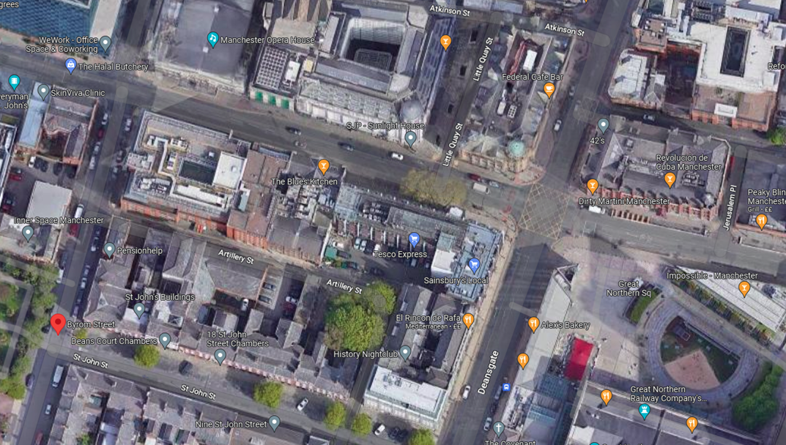

16 Site Logistics Plan


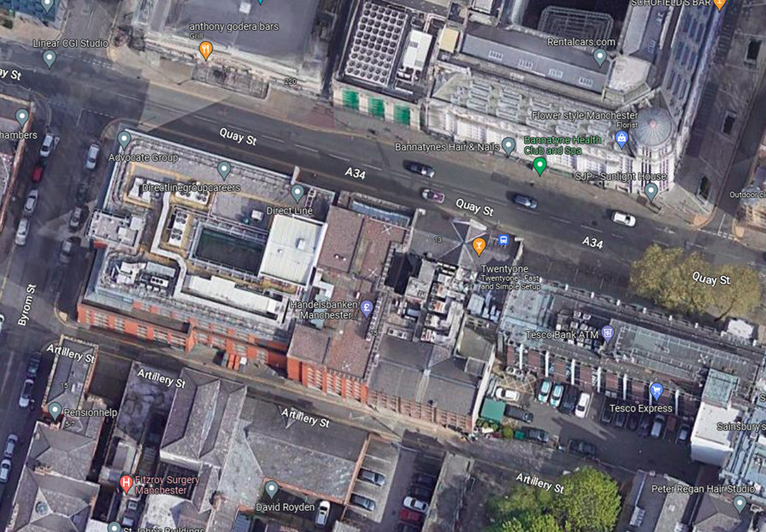

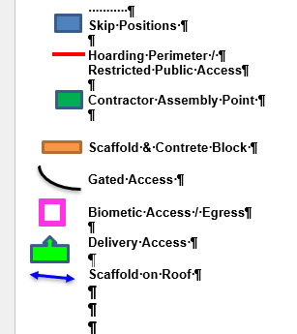

Further versions of this plan will be issued as site conditions change.

