PLANNING STATEMENT

- Site Details

Site Name: | Co-op Whalley Range | Site Address: | Co-op Food  135-141 Withington Road  Whalley Range  Manchester  M16 8EE
NGR: | E: 383021, N: 395066 | Site Address:
Site Ref Number: | NTQ 92781 | Site Type: Macro | NTQ (Notice to Quit) – Replacement

- Pre-Application Check List

Site Selection

Was an LPA mast register used to check for suitable sites by the operator or the LPA? |  | No
If no explain why:

After a phone call to the LPA it was felt that the industry database was a more up to date source of information.

Was the industry site database checked for suitable sites by the operator: | Yes
If no explain why:

N/A

Pre-application consultation with LPA

Date of written offer of pre-application consultation: | 17th April 2024
Was there pre-application contact: |  | No
Date of pre-application contact: | N/A
Name of contact: | The Director of Planning
Summary of outcome/Main issues raised:

An email was received from the LPA (Rob Griffin) requesting a tour of options prior to any application submission. The meeting took place on 22nd May 2024.

Ten Commitments Consultation

Rating of Site under Traffic Light Model: |  | Amber
Prior to the submission of this application the applicant initiates pre-consultation discussions with the local planning authority. This provides an opportunity for the LPA to discuss development proposals and identify site specific issues.

Summary of outcome/Main issues raised:

There has been one objection to the proposal at the pre-application stage. It is vital to consider that this is a replacement site and not a new additional one in the area.

School/College

Location of site in relation to school/college:

St Bede’s College and Prep School is in close proximity to the site.

Outline of consultation carried out with school/college:

St Bede’s College and Prep School have been notified prior to submission.

Summary of outcome/Main issues raised:

There has been no response from St Bede’s College and Prep School at the time of submission.

Civil Aviation Authority/Secretary of State for Defence/Aerodrome Operator consultation

Will the structure be within 3km of an aerodrome or airfield? |  | Yes
Has the Civil Aviation Authority/Secretary of State for Defence/Aerodrome Operator been notified? |  | Yes
Details of response:

N/A

Developer’s Notice

Copy of Developer’s Notice enclosed? | Yes
Date served: | 23rd May 2024

- Proposed Development

The proposed site:
It is imperative to consider that this proposal is to replace an existing installation and is not a new additional mast. The need for this new mast stems from MBNL having been issued with an NTQ (Notice to Quit).

The existing NTQ site is at 133, Withington Road, Whalley Range, Manchester, Greater Manchester, England, M16 8EE. This existing installation would therefore be decommissioned and removed.
The proposed site at Co-op Whalley Range, Co-op Food, 135-141 Withington Road, Whalley Range, Manchester, M16 8EE.
The proposal is for the installation of a new 20m monopole that will provide continued and improved coverage for EE and H3G LTE for this area of Manchester when the existing installation is decommissioned. The proposed new facility will require the installation of a limited number of equipment cabinet housing radio equipment at ground level and in close proximity to the base of the pole.

The proposal is within a mixed residential and commercial zone. To mitigate potential residential amenity concerns, the mast and associated equipment has been situated around commercial entities such as Co-op & Toyota. Furthermore, the proposal incorporates a screening backdrop comprised of mature tree planting, serving to enhance both aesthetic appeal and reduce visual impact.

It is extremely important for the functionality of the local businesses for a robust and reliable telecommunication infrastructure, with a wide range of telecommunication services. It is also extremely important for Local residents to have a reliable telecommunication infrastructure, with many more people working from home this is increasingly important. The proposed installation will ensure this infrastructure is upheld.

The site has been carefully selected in a position that benefits from some screening effects so as to provide the required new coverage to the area whilst minimising visual intrusion for residential properties.

The area already hosts a telecommunications mast, thereby establishing a precedent for the integration of telecom infrastructure within this vicinity. This existing infrastructure underscores the suitability of the area for telecommunications operations, reinforcing the proposal's compatibility with the surrounding environment.

As previously stated, this is not a new additional installation but is a replacement for an existing installation that is to be removed. The proposed replacement installation is necessary for the continued and improved wireless connectivity and capacity for local businesses and residents to this busy area of Manchester.
Figure 1:
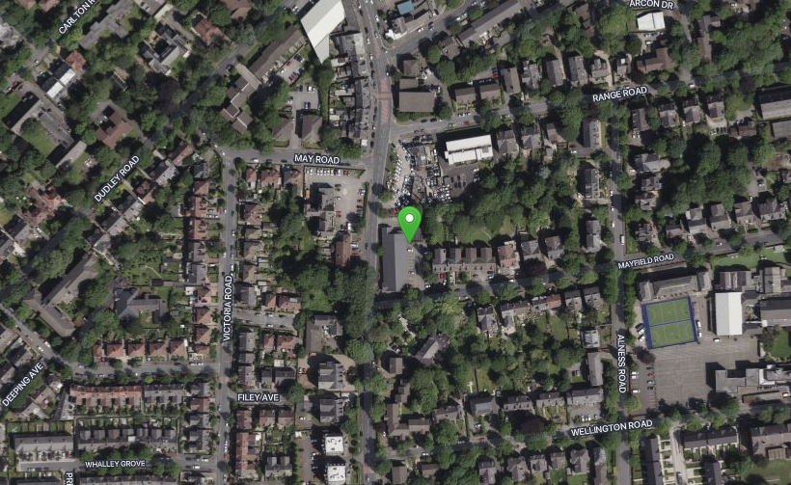

Figure 2:

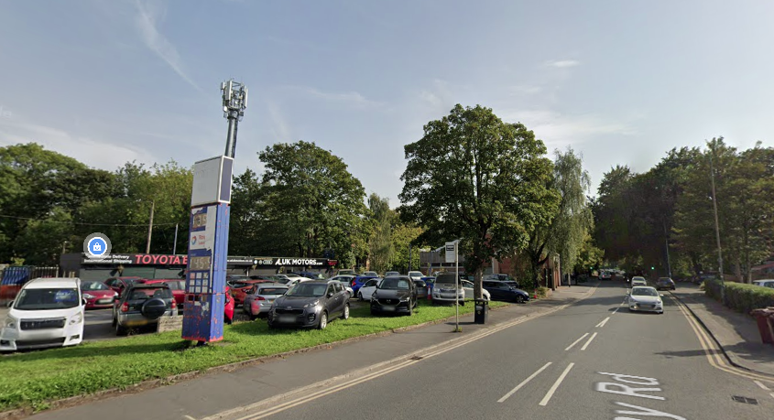

Figure 3:

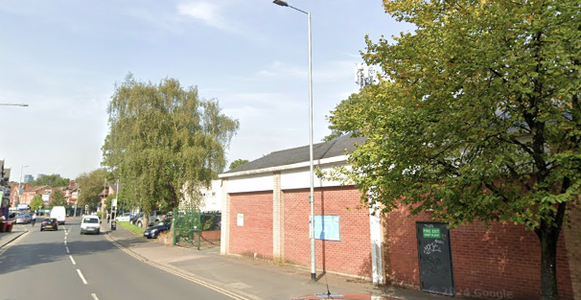

Site Ref: | 92781 | Site Address: | Car Park of Co-op, 135-141 Withington Road, Whalley Range, Manchester, M16 8EE

Local Planning Authority: Manchester City Council

Development Plan: Manchester Core Strategy (2012) / Manchester UDP (saved policies) / Places for Everyone Joint DPD (2024)

Fig.1: LP Plan Extract (Reference Only):

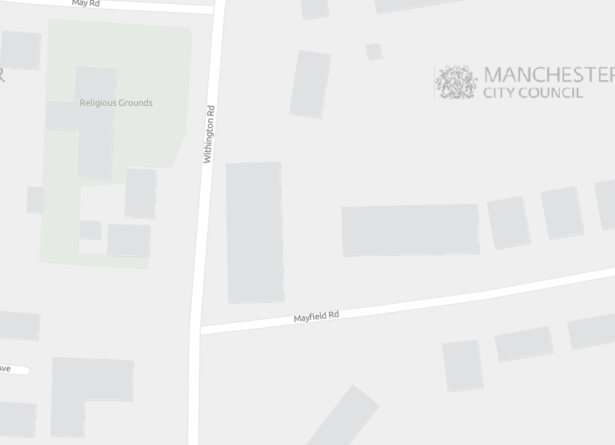

Site and its surrounds

Policy Relevant to the Development Site:

The site is designated as being within the settlement boundary, with urban uses to the north, east, south, and west. The site is in the Whalley Grange Conservation Area and the designation is a material consideration.

This is an existing telecommunications installation.

Manchester Council does have a specific telecoms policy. This, together with the NPPF is of relevance. The National Planning Policy section of this supporting statement goes into detailed analysis of why this site is in compliance with the NPPF.

Policy Analysis:

Policy DC17.1 states:

“Applications for telecommunications developments will normally be approved if the Council can be satisfied that the development has been sited and designed to minimise its impact on residential amenity and in environmentally sensitive areas. Wherever possible, the Council will expect the potential of existing buildings and masts, including the sharing of such facilities, to be fully explored before agreeing to additional separate development.”

Policy JP-P2 reads:

“Heritage

We will proactively manage and work with partners to positively conserve, sustain and enhance our historic environment and heritage assets and their settings.
Opportunities will be pursued to aid the promotion, enjoyment, understanding and interpretation of heritage assets, as a means of maximising wider public benefits and reinforcing Greater Manchester's distinct character, identity and sense of place.

Local Plans will set out the key elements which contribute to the district's identity, character and distinctiveness and which should be the priority for conserving and enhancing in the future and demonstrate a clear understanding of the historic environment and the heritage values of sites, buildings or areas and their relationship with their surroundings.

This knowledge should be used to inform the positive management and integration of our heritage by:

1. Setting out a clear vision that recognises and embeds the role of heritage in place-making;

2. Ensuring that the heritage significance of a site or area is considered in accordance with national planning policy in the planning and design process and opportunities for interpretation and local engagement are optimised;

3. Integrating the conservation and enhancement of heritage assets and their settings, with creative contextual architectural responses that contribute to their significance and sense of place;

4. Delivering positive benefits that sustain and enhance the historic environment, as well as contributing to the economic viability, accessibility and environmental quality of a place, and to social wellbeing; and

5. Exploring opportunities to reduce greenhouse gas emissions that restoration of historic buildings offer.

Particular consideration will be given to ensure that the significance of key elements of the historic environment which contribute to Greater Manchester's distinctive identity and sense of place are protected from harm. These include historic town centres, places of worship, historic transport routes including the canal network, industrial buildings and structures including textile mills, farmsteads and other sites, buildings, and areas of identified archaeological, architectural, artistic and/or historic value. Development proposals affecting designated and non-designated heritage assets and/or their settings will be considered having regard to national planning policy. Where heritage assets have been identified as being at risk, Local Plans should identify specific opportunities for them to contribute to regeneration and placemaking, and they should set out strategies for their repair and re-use.

Development proposals which will help safeguard the significance of and secure a sustainable future for Greater Manchester’s heritage at risk will be supported in principle, provided they are not contrary to national policy or other policies in the development plan.

Proposals should be informed, as necessary, by the findings and recommendations of the appropriate heritage assessment(s) in the development plan evidence base and/or any updated heritage assessment submitted as part of the planning application process.”

In addition, the following objective is important:

“Objective 9: Ensure access to physical and social infrastructure. We will:

• Improve the capacity and network coverage of digital, energy, telecoms, transport and water in key growth locations.”

The proposed development at this site is required to deliver the requisite level of electronic communication service on a single installation that is to be adapted to accommodate multiple users (so enable future site sharing opportunities), yet seeks to minimise its impact or change to the character of this location (being utilitarian in appearance, of a scale and height similar to that being replaced). The form and design of the proposed configuration would not appear out of context in this location, so according with wider Development Plan policy and would ensure the appearance and character of the area is fully maintained.

In addition to the above, Paragraph 118 of the NPPF (December 2023) states:

18. Advanced, high quality and reliable communications infrastructure is essential for economic growth and social well-being. Planning policies and decisions should support the expansion of electronic communications networks, including next generation mobile technology (such as 5G) and full fibre broadband connections. Policies should set out how high-quality digital infrastructure, providing access to services from a range of providers, is expected to be delivered and upgraded over time; and should prioritise full fibre connections to existing and new developments (as these connections will, in almost all cases, provide the optimum solution).

The LPA should look to support this proposal as the equipment will bring “reliable communications” to the area.

Paragraph 121 states that

“for a new mast or base station, evidence that the applicant has explored the possibility of erecting antennas on an existing building, mast or other structure and a statement that self-certifies that, when operational, International Commission guidelines will be met.”

The discounted options section of this planning statement fully illustrates that all other potential masts, roof tops and other locations have been investigated. The proposed site is the optimum location from a planning and coverage perspective.

The public benefits of a greatly enhanced communications network for businesses, residents and visitors alike in this location would qualify as a substantial benefit with near benign change or impact on amenity (with the nearest residential properties remaining the same distance from that of the existing site).

The level of harm to the wider heritage asset would be less than substantial, and would be materially outweighed by the tangible public benefits the enhanced infrastructure would deliver in terms of improved digital ser ice and connectivity.

The enhanced digital service would very much accord with the objectives of the Development Plan policy.

The proposal fully accords with the requirements of the NPPF
The sharing of base stations between multiple operators is one of the key strategic policy principles contained within the NPPF. H3G and EE and ESN (Emergency Services Network) have a network sharing agreement and thus these installations are fully compliant with the NPPF.
Central Government attaches great importance to the design of the built environment and outlines this within Section 12 (para. 124) of the National Planning Policy Framework. It states:

“Good design is a key aspect of sustainable development, creates better places in which to live and work and helps make development acceptable to communities.”

In keeping with the National Planning Policy Framework (NPPF). guidelines of using: “high quality communications” (Section 10), the proposed design has been selected to minimise visual impact upon the street scene by integrating with the existing built environment and the existing street furniture, having similar vertical lines and overall appearance to the street lighting columns that are common feature in the built environment. As stated above the National Planning Policy Framework advocates site sharing, and as such we believe that there are no sequentially preferable locations within the defined site search area.
The design of the proposed equipment is considered to be the least visually intrusive option available.
RADIO PLANNING AND PROPAGATION
When planning cellular telecommunications networks it is important for engineers to predict, with a high degree of confidence, the behaviour of cellular transmissions. This then enables the operator to calculate how many cell sites are needed to provide the level of coverage required by the services they offer under the terms of their licence.
The strength of radio signals detected at a receiving device naturally reduces the further away it is from the transmitter. In general the reduction (or decay) in signal power is affected by a number of variables. The main factors are

- frequency,
- distance (from transmitter),
- terrain (such as hills),
- clutter (such as buildings, foliage, vehicles, and water)
- and atmospheric conditions (such as rain).

A reduction in the strength of the radio signal increases the likelihood of dropped calls and reduced data rates for internet browsing, for example.
Clutter
Any physical object obstructing the propagation of radio signals causes a reduction in signal strength reaching a customer’s device. A common term for these objects is ‘clutter’. The more obvious examples are buildings and geographical terrain such as hills and trees.
Buildings cause a varying amount of signal reduction depending on their height, construction, thickness of walls, amount of windows etc. Glass causes a lower reduction in signal than brick/concrete walls.
Customers will inadvertently be aware of this by finding that sometimes they need to go near windows, a higher floor of a building or even outside in order to achieve a stronger signal for their mobile devices.
Tree Clutter
The effects of trees on signal degradation should never be underestimated. Signal absorption and shadowing effects vary according to vegetation and density, and are caused by the main tree trunk, branches and leaves.
Cell sites located in or near trees will have signals significantly reduced. As a result a number of extra sites may need to be built locally in order to counter-effect this.
Signal variation throughout the seasons is also a practical concern. Leaves on trees in the spring and summer can cause shadowing and reduce radio voice quality and increase the number of dropped calls.
As a result the bottom of an antenna should be a) above the top level of the trees, b) allow greater height due to the antenna downtilt at build or for future requirements and c) allow some room for future growth of the trees.
In the case where the cell site utilises point-to-point microwave backhaul transmission the microwave dish should not be obscured at all.
Propagation Models
In essence these are mathematical formulae used to characterise radio wave propagation, in order to determine the received signal strength at a receiving device.
The most well-known propagation model used for mobile telecommunications is ‘Okamura-Hata’. More specific studies have been performed to investigate specific clutter and terrain such as dense-urban and urban environments. Resulting from these are propagation models for specific clutter types.
Coverage Planning Tools
Radio planning engineers plan cellular networks using highly sophisticated computer programs that incorporate the above propagation models. Armed with data on cell site location, cell site configuration, maps, terrain etc they are used to predict areas of coverage deficiency (so called ‘coverage holes’), new site requirements and configurations.
Network Changes
Over time the topography and clutter in an area is subject to change. For example, building developments, housing and tree growth can all change. As a consequence the signals received from local phone masts can degrade, as they are dependent on these factors. These reasons along with customer complaints, network consolidation (mast sharing) and new technologies (4G) require a re-evaluation of a network operator’s telecommunications infrastructure.
Mast sharing can result in some masts no longer being needed. As a result they are decommissioned and physically removed.
Technical surveys undertaken for reasons above may highlight that antenna height increases are required – this is more likely for sites with low antenna heights around 15m AGL, particularly street furniture sites. More details on these reasons below.
While thus far this document is generic to mobile telephony masts it should be noted that each mast has to be dealt with on a case-by-case basis.
Site Height increases
There are a number of reasons why an operator may request a height increase on existing structures. The main ones are described below.
Maintaining existing coverage
The antennas inside, for example, street furniture sites are generally of 2 physical build designs – ‘Single Stack’ and ‘Dual Stack’. The former describes when the set of antennas are all at the same height. The latter describes a site with 2 sets of antennas one above the other.
The ‘Dual Stack’ is by far the preferred option. This is due to a number of factors including greater flexibility & control for different technologies and providing optimum service performance to customers.

Network Consolidation between H3G LTE and EE and new 4G technologies facilitate a Single Stack structure being upgraded to a Dual Stack structure. In a straight swap scenario at equal height the new lower aperture antennas would be lower than they were originally - resulting in significantly reduced coverage. To ensure existing coverage is maintained the whole structure needs to be increased in height.
Clutter changes
A more extreme example is when the local clutter or tree lines have changed, or are such that the mobile signals are blocked, resulting in lower quality calls and downloads for mobile device users. To provide sufficient services to customers height increases on existing masts or additional new masts are required. The former is the preferred option in many cases.
ICNIRP Compliance
The addition of new technologies and mast sharing affects ICNIRP compliance – a higher minimum mast height is required in some cases.

Enclose map showing the cell centre and adjoining cells:
This can be emailed to the LPA upon request.

Type of Structure
Description:

TOP OF TOWER +20.00m AGL
C/L OF APERTURES +18.65m AGL
C/L OF DISHES +15.75m AGL

PROPOSED 20m HIGH VALMONT CLIMBABLE MONOPOLE ON 5.2x5.2x1.4m DEEP CONCRETE BASE WITH CONFIG 2 CIRCULAR HEADFRAME FOR 6No. ANTENNA APERTURES AT 0°/120°/240° & 4No. 600Ø DISHES. BOB'S, MHA'S AND ACTIVE ROUTERS TO BE FIXED TO HEADFRAME BEHIND ANTENNAS

PROPOSED 2.4m HIGH MESH PANEL FENCE TOPPED WITH SHARK TOOTH SPIKES (CLEARVU 22) TO 3 SIDES OF COMPOUND C/W 3m WIDE DOUBLE GATES

PROPOSED EE/H3G MK5B LINK A/C CABINET ON MONOPOLE BASE

PROPOSED EE 2No. UNILATERAL CABINETS ON MONOPOLE BASE (BEHIND)

PROPOSED H3G 2No. UNILATERAL CABINETS ON MONOPOLE BASE

SECTION OF FOOTPATH TO BE REMOVED

PROPOSED 1 OF 6No. 1100 HIGH CONCRETE FILLED 114.3Ø STEEL BOLLARDS PAINTED YELLOW

Overall Height: 20m AGL
Height of existing building |  | N/A
Equipment Housing:
Length: |  | See drawings
Width: |  | See drawings
Height: |  | See drawings
Materials
Tower/mast etc – type of material and external colour: | See drawings
Equipment housing – type of material and external colour: | See drawings

Reasons for choice of design:
The proposed installation is an EE Ltd and H3G LTE 20m Monopole which will house both EE and H3G LTE. The sharing of base stations between multiple operators is one of the key strategic policy principles contained within the NPPF.

Central Government attaches great importance to the design of the built environment and outlines this within Section 12 (para. 131) of the 2023 National Planning Policy Framework. It states:

“Good design is a key aspect of sustainable development, creates better places in which to live and work and helps make development acceptable to communities.”.

In keeping with the National Planning Policy Framework guidelines of using high quality communications infrastructure the design of the proposed equipment is considered to be the least visually intrusive option available and would not detract from the character of the area in which the proposal sits.
Our client appreciates that the proposed site lies within The Whalley Grange Conservation Area (Article 2 (3) land), and proposed Monopole design has been selected to minimise visual impact as much as possible. The monopole style design has been specified in order to allow the proposal to merge with the numerous street lighting columns distributed around the vicinity of the site. The siting and appearance has been driven by the requirement to preserve and enhance the conservation area, whilst continuing to provide the required coverage for the area.
Physical objects such as the tall surrounding trees can obstruct radio signals causing a reduction in signal strength and coverage. The height of the proposed monopole is therefore necessary for this installation to enable the continued and improved coverage and capacity to be achieved and delivered to the residents and businesses in the area. The height of the proposed new installation is the same as the existing NTQ installation to the rear of ALUK Motors, whilst the design of the new installation is in keeping and would not look out of place within this setting with the existing skyline presence.

- Technical Information

ICNIRP Declaration attached  ICNIRP public compliance is determined by mathematical calculation and implemented by careful location of antennas, access restrictions and/or barriers and signage as necessary. Members of the public cannot unknowingly enter areas close to the antennas where exposure may exceed the relevant guidelines.  When determining compliance the emissions from all mobile phone network operators on the site are taken into account. | Yes

- Technical Justification

Reason(s) why site required
The National Planning Policy Framework clearly states that authorities should not question the need for the service, nor seek to prevent competition between operators. Notwithstanding this fact, the Applicant considers it to be important to explain the technical justification for the site and how the facility fits into the overall network.

Notwithstanding this fact, the Applicant considers it to be important to explain the technical justification for the site and how the facility fits into the overall network.

The site is required to provide new 5G coverage for EE Ltd in order to improve coverage in the M16 area of Manchester. The cell search areas for 5G are extremely constrained with a typical cell radius of approximately 250m meaning that it would not be feasible to site the column outside of this locale.

Further detail regarding the general operation of the network can be found in the accompanying document entitled ‘General Background Information on Radio Network Development for Planning Applications’. This information is provided to assist the local planning authority in understanding any technical constraints on the location of the proposed development.

The installation of this replacement telecommunications Monopole within this area of Manchester, is essential to ensure continued provision and to meet the growing demand for reliable and high-speed communication services. The proposed mast will also enhance mobile network coverage, ensuring that residents have continued and improved access to seamless and efficient communication services. This connectivity is not only crucial for personal communication but also plays a vital role in supporting businesses, education, and emergency services within the community.

- Site Selection Process – alternative sites considered and not chosen

Discounted Options
In accordance with the sequential approach outlined in the National Planning Policy Framework (NPPF) following search criteria have been utilised. Firstly, consideration is always given to sharing any existing telecommunication structures in the area, secondly consideration is then given to utilising any suitable existing structures or buildings and thirdly sites for freestanding ground-based installations are investigated.

This sequential approach is outlined below:

- Mast and Site Sharing
- Existing Buildings Structures
- Ground Bases Installations

In compliance with its licence and the sequential approach outlined in the NPPF all attempts to utilise any existing telecommunication structures where they represent the optimum environmental solution have been employed. The Ofcom Site Finder mast register is always examined prior to the submission of an application.

Site Type | Site Name and Address | NGR | Reason for not choosing
D1 - GF - Greenfield | Alexandra Park | E: 383451, N: 394998 | Historic park and garden located to the East of the search ring. We would not get planning here for any sort of mast
D2 - GF - Greenfield | Minhaj-ul-Quran International | E: 382955, N: 395115 | Building used as place of worship accompanied by a small car park. Car park looks to be used throughout the day leaving very limited space for equipment. No rooftop solution available either. LPA also made us aware there is a planning application to turn the building into flats/apartments.
D3 - RT - Rooftop | Range Road Apartments | E: 383061, N: 395133 | 3 storey block off apartments located close to the NTQ. Site discounted due to rooftop being unsuitable for telecom equipment. Site would also struggle to replicate existing height.
D4 - RT - Rooftop | T A Centre | E: 382197, N: 394955 | Site located outside the search area so would not provide required coverage. Also limited space for equipment.
D5 - RT - Rooftop | St Bedes College | E: 383316, N: 395014 | Building is listed and within Conservation Area. LPA suggests unlikely to gain planning.
D6 - SW - Streetworks | Alness Road SW | E: 383176, N: 395000 | Streetwork site to the rear of St Bedes College & School. Site discounted due to proximity to School and residential. Site also within CA. LPA suggests unlikely to gain planning. Pavement also offers limited space.
D7 - SW - Streetworks | Manly Road SW | E: 383197, N: 394554 | Streetwork site on the junction of Alness Road & Manly Road. Site discounted due to proximity to residential. Site also within CA. LPA suggests unlikely to gain planning. Pavement also offers limited space.
D8 - GF - Greenfield | Tesco Whalley Range | E: 382945, N: 395247 | Small car park which serves Tesco. Very limited space for equipment therefore discounted.
D9 - GF - Greenfield | Army Reserve Centre | E: 382143, N: 394955 | Site discounted as the centre confirm it is used by Special Forces so wouldn't be able to provide 24 hour access. Space available is also limited.
D10 - SW - Streetworks | Withington Road SW | E: 383011, N: 395027 | Site discounted due to underground services.
GF- Greenfield  D11 | 131 / 133 Withington Road  Whalley Range  Manchester  M16 8EE | E:383031 N:395098 | This is the location of the NTQ. This location has therefore been discounted.

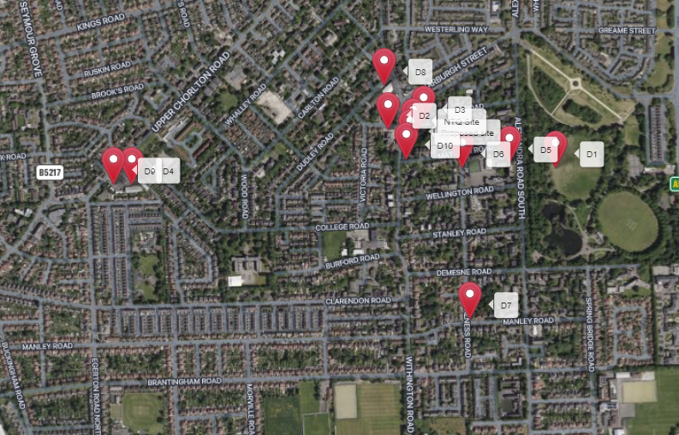

https://gridreferencefinder.com?gr=SJ8302195066|Proposed_s_site|1,SJ8303195098|NTQ_s_Site|1,SJ8345194998|D1|1,SJ8295595115|D2|1,SJ8306195133|D3|1,SJ8219794955|D4|1,SJ8331695014|D5|1,SJ8317695000|D6|1,SJ8319794554|D7|1,SJ8294595247|D8|1,SJ8214394955|D9|1,SJ8301195027|D10|1&v=r&labels=1

If no alternative site options have been investigated, please explain why:

N/A

- Additional Relevant Information

Background to the Proposal
This specific proposal forms part of an integral requirement for EE Ltd, ESN and H3G LTE to expand their respective 5G telecommunications network across Manchester specifically in this instance to enhance 5G coverage levels and network capacity within the M16 area.

This partnership has resulted in the development and production of an array of “dual user” structures and cabinets, which have the ability to accommodate both operator’s antenna systems and radio equipment.

Mobile phone base stations operate on a low power and accordingly base stations therefore need to be located in the areas they are required to serve. Increasingly, people are also using their mobiles in their homes, and this means we need to position base stations in, or close to, residential areas.

A further limiting factor is that the position has to be one that fits in with the existing network. Sites have to form a patchwork of coverage cells with each cell overlapping to a limited degree with the surrounding base stations to provide continuous network cover as users move from one cell to the other. However, if this overlap is too great unacceptable interference is created between the two cells.

DEVELOPMENT PLAN POLICY.

Development plan considerations have a special significance in law. Section 54A of the Town and Country Planning Act 1990 (The Act), and re-iterated in Section 38 of the Planning and Compensation Act 2004, it is stated that:

“Where in making any determination under the Planning Acts regard is to be had to the Development Plan, determination shall be made in accordance with the Development Plan unless material considerations indicate otherwise.”

NATIONAL PLANNING POLICY

The Government remain committed to promoting telecommunications and place emphasis on the importance of telecommunications to the wider economy. The National Planning Policy Framework (NPPF July 2021) sets out the Government’s planning policies for England and how these are expected to be applied at the Local level. It provides a framework within which local people and their accountable Councils can produce their own distinctive local and neighbourhood plans, which reflect the needs and priorities of their communities.

The purpose of the planning system is to contribute to the achievement of sustainable development. There are three dimensions of sustainable development, each of which give rise to the need for the planning systems to perform a number of roles including: -

- Economic Role – contributing to building strong, responsive and competitive economy;
- Social Role – Supporting strong vibrant and healthy communities; and
- Environmental Role – Contributing to protecting and enhancing our natural, built and historic environment.
The NPPF contains at its core a presumption in favour of sustainable development which runs through both plan-making and decision-making processes. The NPPF recognises the vital importance of high-quality telecommunications and dedicates a whole chapter to this. Chapter 10 of the NPPF outlines the Governments support for high quality communications. The paragraphs below clearly outline the overarching support from Central Government for telecommunications and how Local Planning Authorities should embrace this vital infrastructure:

NPPF Paragraph 114 states:

“Advanced, high quality and reliable communications infrastructure is essential for economic growth and social well-being. Planning policies and decisions should support the expansion of electronic communications networks, including next generation mobile technology (such as 5G) and full fibre broadband connections. Policies should set out how high-quality digital infrastructure, providing access to services from a range of providers, is expected to be delivered and upgraded over time; and should prioritise full fibre connections to existing and new developments (as these connections will, in almost all cases, provide the optimum solution).”

It continues in Paragraph 115:

“The number of radio and electronic communications masts, and the sites for such installations, should be kept to a minimum consistent with the needs of consumers, the efficient operation of the network and providing reasonable capacity for future expansion. Use of existing masts, buildings and other structures for new electronic communications capability (including wireless) should be encouraged. Where new sites are required (such as for new 5G networks, or for connected transport and smart city applications), equipment should be sympathetically designed and camouflaged where appropriate.”

Operators always follow the sequential site selection process. Where an existing site can be shared or upgraded this will always adhered to before a new proposal is put forward for consideration.

The support for telecoms and the need not to constrain Operators is laid out in Paragraph 118:

“Local planning authorities must determine applications on planning grounds only. They should not seek to prevent competition between different operators, question the need for an electronic communications system, or set health safeguards different from the International Commission guidelines for public exposure.”

Conclusion

We consider that the development is complaint with the council’s policy and that in accordance with Section 38 (6) of the Planning and Compensation Act 2004 permission should be granted for the installation.

We consider the development complies with both central government and local planning policy guidance where the underlying aim is to provide an efficient and competitive telecommunication system for the benefit of the community while minimising visual impact.

Taking into account the factors of technical constraints, available sites and planning constraints we consider that this site and design clearly represents the optimum environmental solution.

On the basis of a recognised need to expand and promote telecommunications networks across the region, it is considered that the proposal fully accords with the requirements of the National Planning Policy Framework and Council’s Local Plan Policies.

Julia Marshall
Planning Manager
Email: j.marshall@whptelecoms.com

Contact Details

Name: (Agent) | Julia Marshall | Telephone:
Operator: | EE and H3G LTE | Fax no: | N/A
Address: | WHP Telecoms Ltd  1a Station Court Station Road  Guiseley  Leeds  LS20 8EY | Email Address: | j.marshall@whptelecoms.com
Signed: |  | Date: | 25th May 2024
Position: | Planning Manager | Company:  (on behalf of above operator) | WHP

