Design and Access Statement Rev A
Basement Level,
24 Lever Street, Manchester, M1 1DZ

Introduction
The property is currently empty, the previous use as office and retail has been ceased for a number of months. This proposal is to fit out the basement level to create a new Public Bar with music and games. The bar would be accessed via the existing entrance to Lever Street, utilising the existing stair, with exit routes to the rear through existing spiral stair and alternative communal exit corridor.
The building is a Grade II property, located on the South East side of Lever Street at the junction of the corner of Bunsen Street, with the existing entrance located to the Lever Street Elevation.
The building consists of a basement level, 4 storeys and attic floor, previously Watts Bros Hardware and Furniture Warehouse, now offices.
The building is dated 1898 at 3rd Floor, it is a red brick building in Flemish bond with red sandstone dressings and slate roof in the Free Elizabeth style.
The ground floor has a large round-headed doorway to the left, with convex jambs, moulded head and keystone cartouche lettered "24", and a prominent cornice on elongated consoles; a mullioned 2-light window to the right over a basement doorway and 2 altered windows further right. On the upper floors the 2 centre bays have 3-storey elliptical-headed arches with 3-light windows to all floors, the outer bays have vertical-rectangular windows, with panelled aprons at 2nd floor and large carved aprons at 3rd floor lettered respectively "18" and "98".
The attic has 3-light mullioned windows in the centre bays and vertical windows in the gables with ornamental architraves including oculi in steeply-swept gables finished with small segmental pediments. The right-hand return wall has 2 bays in matching style, continued with an 8-window range of white glazed brick, carried down to 2 storeys at the rear, which has a parallel loading bay.
For this application we are only concerned with the basement level.

Proposal:
The proposal for the Basement level of 24 Lever Street is to change the use of this floor from Class A1 Retail to Sui Generis (Public Houses, Wine Bar, Drinking Establishment). Fitting out the existing basement level with new bar and back of house areas (Toilets, cellar, office) along with seating areas.
Externally it is proposed to utilise the existing entrance and exits, with no external changes to the front or rear elevations.
A new louvre through an existing window opening is to be introduced to the side elevation (Bunsen Street) to allow for cellar cooling and fresh air into the unit.
Existing plasterboard partitions internally are to be removed where required to make way for the new layout. The existing rear spiral stair is to be retained and utilised for exit routes.
The existing elevation is to be retained as is with discreet signage to be installed in line with the local framework. Existing window frames to be redecorated only.
Entrance into the property will remain the same with a rear stair remaining as existing.
Design
Shopfront to remain as existing, minor repairs to be made and decoration required. A new signage scheme will be proposed to advertise the bar to encourage patrons to visit. Signage design to be submitted for planning separately.
Internally we proposed to introduce new plasterboard walls to form back of house area/ toilets/ cellar/ office etc.
Existing features such as columns and sliding metal door to the rear are to be retained with proposal to decorate only.

Access
The current access into the building is from Lever Street, using an existing staircase down to the basement level. The existing door opens directly onto the stair with a minimum landing space of 400mm, onto which the doors fold back. There is currently no disabled access into the unit and following investigation we have concluded that this will not be possible to achieve for a number of reasons as outlined below;
Option 1: Provide a platform lift.
We investigated installing a platform lift, however as the site is a basement site with other businesses to the floor above head height restrictions internally does not allow this. In addition there would be substantial changes required to the façade to accommodate this method, something which we feel would not be acceptable. The existing entrance stair is also unfeasible as there is insufficient width within the existing entrance to allow for this.
Option 2: Install a stair lift.
The installation of a stair lift with a drop down seat was investigated however there are existing restrictions which will not allow this option. Firstly the entrance doors open inwards onto the existing stair, as there is no landing at the top of the stair, there is no position to allow a chair lift to be fitted and provide a safe platform to embark. Secondly due to the restricted width of the stair, this was dismissed as not being viable as it would impede the exit route width which is limited.

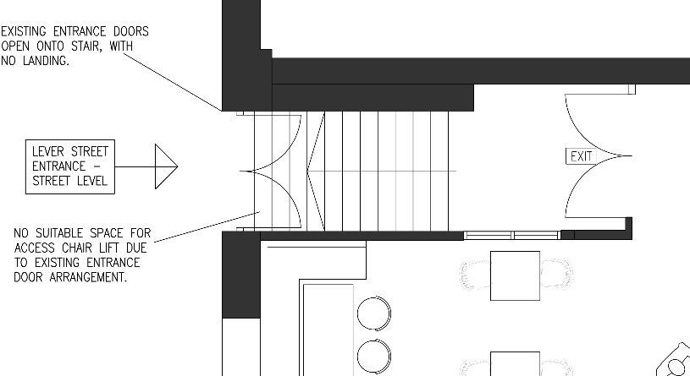
Image A: Entrance Layout from street level. (Lever Street)

In addition to the restrictions and issues with providing disabled access, there are complications with providing egress from the site should there be an emergency situation. The existing exits which are to be retained are located to the rear of the site. The first is a spiral staircase which opens into a shared exit route at ground floor level and exits to street level. This stair would not be suitable for DDA route due to the steps and the existing enclosure is not large enough for a refuge to be positioned within the space.
The second exit is through the rear left side of the site, which joins a shared exit route with other units. This exit is also stepped and does not have a space suitable for a refuge as it is currently.

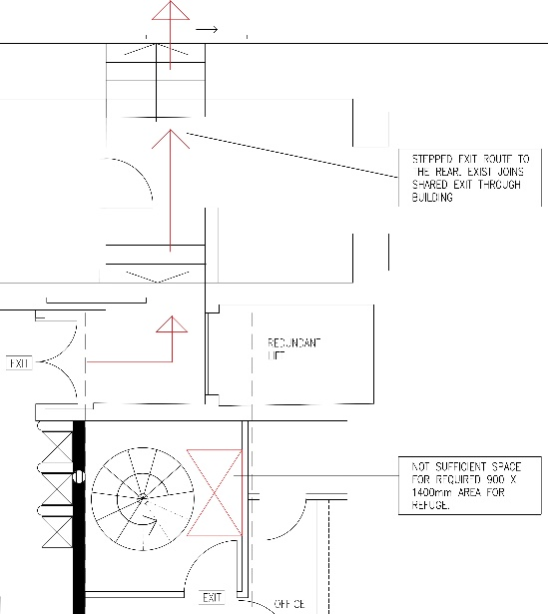
Image B: Existing exit route with steps and spiral stair lobby space.
As exits from the building are not satisfactory for disabled use, we feel that the building will not be able to be accessible and in doing so would present a risk.
In conclusion we do not think the site will be able to provide a suitable safe access option due to the restrictions of the existing building and it’s heritage status. Due to this we propose that the entrance stair is retained as existing.

Conclusion
The proposed changes to the property are necessary to allow the building to be repurposed and occupied.
Where the new louvre is to be installed to Bunsen Street elevation we proposed to powder coat this to match existing grilles and screens in existence to this elevation, utilising the existing openings to ensure the building in maintained in its original form, with no additional demolitions.
In terms of the building, we intend to retain and enhance any existing features, being sympathetic to the existing design.
In regard to access and egress from the building, following investigation into alternative options we have concluded that the site cannot provide suitable access to comply with DDA requirements. Therefore we propose to retain the existing entrance stairs and exit routes as noted above.

