Contractor | Name:  NFS Flooring UK  Ltd | Address:  83 Ducie Street  Manchester  M1 2JQ |  |  | Tel: 0161 945 8475
Contractor | Name:  NFS Flooring UK  Ltd |  |  |  | E-mail:  info@naturalflooringsolutions.co.uk
Project Name | Fourways Manchester
Description of the Task/Activity | Timber flooring repair light sand & oil
Site  Address/Location: | Fourways  57 Hilton Street  Manchester  M1 2EJ |  | Start  Date/Time: | 16/07/2024 @ 18:00
Site  Address/Location: |  |  | Finish  Date/Time | 01/08/2024 @ 06:00
Personnel  Involved | Name |  | Role/Trade
Personnel  Involved | Michael Richardson |  | Site Supervisor
Personnel  Involved | Said Benbrahim |  | Floor sander
Personnel  Involved | Ayuub Benbrahim |  | Floor sander
Personnel  Involved | Rachid Benjabour |  | Floor sander
Personnel  Involved | Richard Meddani |  | Site Supervisor
Personnel  Involved | Kieran Coackley |  | Floor sander
Site Supervisor: | Richard Meddani |  | Tel: | 07796 652432
Safety Officer | Richard Meddani |  | Tel:
Key Plant & Tools | Kunzle and Tazin Taurus belt sander x 5 Kunzle and Tazin Silverback edge sander x 3 Kunzle and Tazin Golia x 1
Key Materials | Osmo Polyx-Oil Raw & Osmo Polyx clear
Other Essential Equipment: | Festool RDA sanders x 3 / Festool dust extractors x3 / festool Kapex chop saw / Festool plunge saw & table saw / Fein multi tool x 5 / Dewalt cordless drills
Specific Identified  Residual Hazards: (or refer to the task specific risk assessment(s)) | Bags of dust may combust Inhalation of dust.  Noise emissions from sanding machines  Machinery cable  Wet lacquered floors  Blocking emergency exit/doorways/hallways  Lifting and transporting  Dust Emissions  Hand-arm vibration  Fire  Electrical  Eye injury

Conservation statement

Sanding will take place as per approved sample as advised by the conservation team. We aim to remove the top layer of existing lacquer ONLY and maintain the grain to the original floorboards. We will aim to remove no more that 1mm throughout, taking care to do the sanding works gradually and methodically in an attempt to avoid over sanding.

Please refer to method statement for further information and grit ratings.

Method Statement

- We will arrive at site and park in a designated safe area.

- We will undergo a full site induction by the Principal Contractor.

- Our Site Supervisor will walk around the site and carry out a Point of Work Risk Assessment to identify any specific hazards and controls not originally identified. The Site Supervisor is responsible for any amendments to the RAMS during the project.

- Our Site Supervisor will deliver the contents of the RAMS to the workforce using a toolbox talk method.

- All tools and equipment will be visually inspected prior to use and defects reported to the Site Supervisor immediately.

- Doors and windows will be opened to ensure adequate ventilation and through flow of air and operatives will wear P3 respirators. All nonessential personnel will be removed from the area.

- We will assess the damaged boards and replace using reclaimed pine floor boards to match existing.

- Replacement floor boards will be fixed down using a face nail method to match existing.

- All replacement boards with be cut to start and finish on existing joists.

- The sanding process will commence using a Kunzle and Tasin belt sander and a Kunzle and Tasin edge sander.

- This will be rotated amongst the workforce to minimize exposure to hand arm vibration.

- All none essential personnel will be removed from the working area.

- Signs will be posted on doors warning of the noise hazard present.

- Running through the following abrasives:

  - 40 grit
  - 60 grit
  - 80 grit

 | 60 grit
Sequence of Operations: (include sketches if required) | 80 grit  All edges will be finished with a 40 grit then a 80-grit using a Festool Rotex sander
All sanding equipment has dust extraction allowing us to sand at 95% dust free
Once sanding is complete, we will use a wet mop or ‘M’ Class vacuum to clear any dust deposits, we will NOT use a dry brush.
we will apply 2 coats of Osmo Raw Oil/\Osmo clear hardwax oil using an Osmo brush applicator with a light buff between each coat.

Doors and windows will be opened to ensure adequate ventilation and through flow of air and operatives will wear P3 respirators. All none essential personnel will be removed from the area.

All dust bags will be removed from site at the end of each working day and disposed of properly.
Single use overalls to be used and disposed of at the end of shift to prevent dust to be taken home.
All wet areas will have signs and barrier tape making clear that no foot traffic is allow for the duration whilst products are drying

Temporary  Supports and Props needed to facilitate the works: | None
Method of Access and Egress to the work area: | Access to site is via the main entrance  Sign in on arrival and sign out on departure.  All equipment and materials will be off loaded and loaded at the main entrance.
Fall Protection Measures:  (Where work at height cannot be eliminated – consider both Personnel &  Materials) | N/A
Storage  Arrangements: | None
SWL’s: | N/A

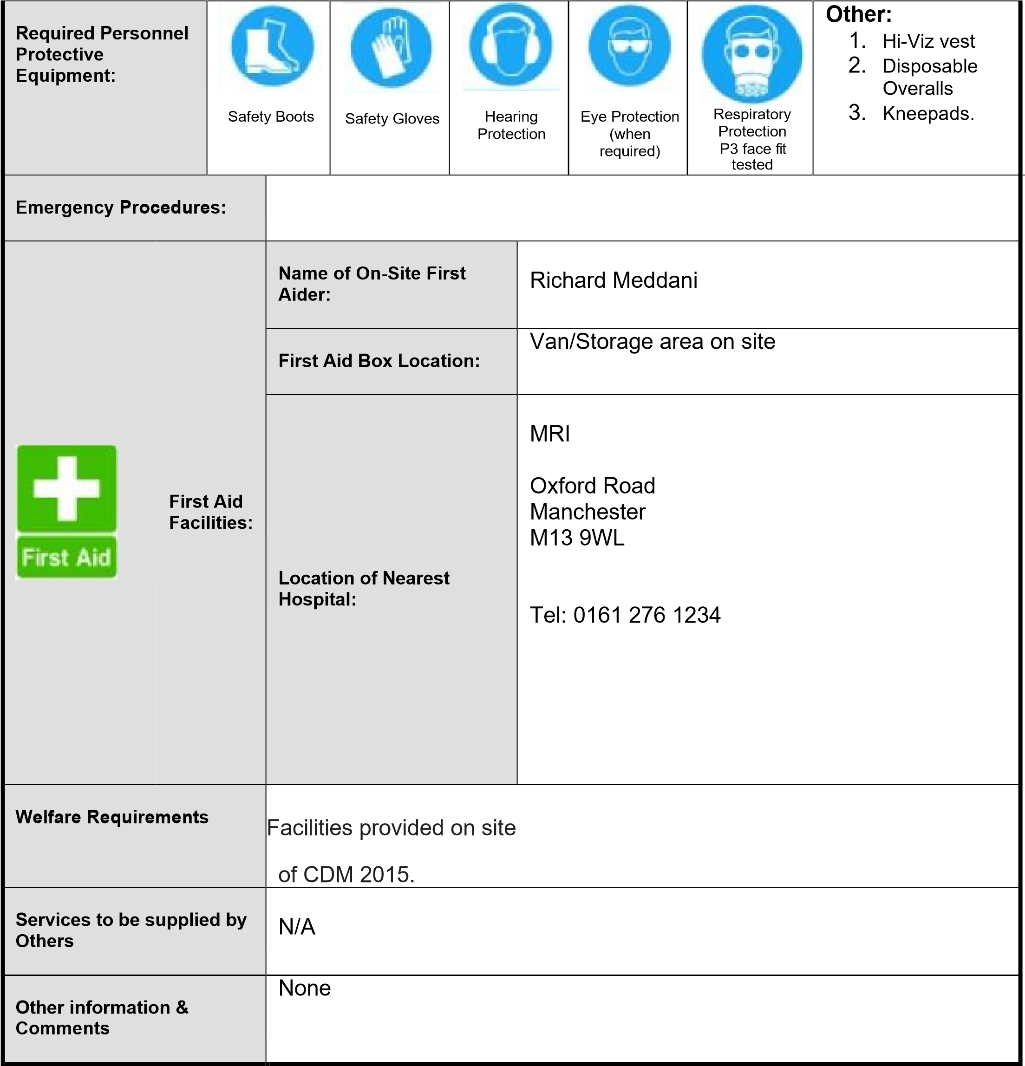

All work will be undertaken by qualified competent persons with experience of the type of work described above, and in all cases in full accordance with safety procedures specified in the company’s Health and Safety Policy.

Prepared by:

Kathryn Foran
Position:

Reviewed by:

Position:

Secretary
Date: 11/07/2024

Richard Meddani

Manager
Date: 11/07/2024

Items Attached: | Yes | No
Sketches | □ | 
Program of Work | □ | 
Risk Assessments |  | □

