Heritage Statement

This statement has been done in the preparation of heritage statements required to support planning and listed building consent applications.
About this heritage statement
This heritage statement identifies all heritage assets and their settings which may be affected. It is therefore being produced early in the design process and demonstrates how an understanding of a heritage asset’s significance has informed proposals. The following is included:
1) Assessment of heritage significance
2) Details of the proposed works
3) Assessment of Impact

- Site Address
103 Crumpsall Lane, Manchester, M8 5SR

- The application site (identify all that are applicable):

Heritage Asset | Yes
A listed building (Grade II, Grade II* or Grade I) | ☐
Within a conservation area | ☒
A scheduled ancient monument | ☐
Within the Westminster World Heritage Site | ☐
A registered park or garden | ☐
In the setting of or adjacent to one of the above? | ☐
Within an archaeological priority area | ☐
A non-designated heritage asset | ☐

- In each case where you have answered yes in 2 above, please identify the asset and its heritage designation (i.e. the grade of listed building, conservation area name etc)

The location of the site is within Crumpsall Green Conservation Area.

- The significance of the heritage asset(s)
What makes the heritage asset(s) special? Please describe each asset, including its age, architectural style, materials, features of interest, history etc and how these contribute to significance. If the building is listed, this may include both internal and external features. Where appropriate, you should also identify contribution of setting to significance. Photographs, archival materials (such as historic plans) may assist with this and should be appended, where relevant.

The site is located at 103 Crumpsall Lane, Manchester, M8 5SR, and is adjacent to No. 1 Delaunays Road. The building itself is 3-storey.

The site is located within the Crumpsall Green conservation area.

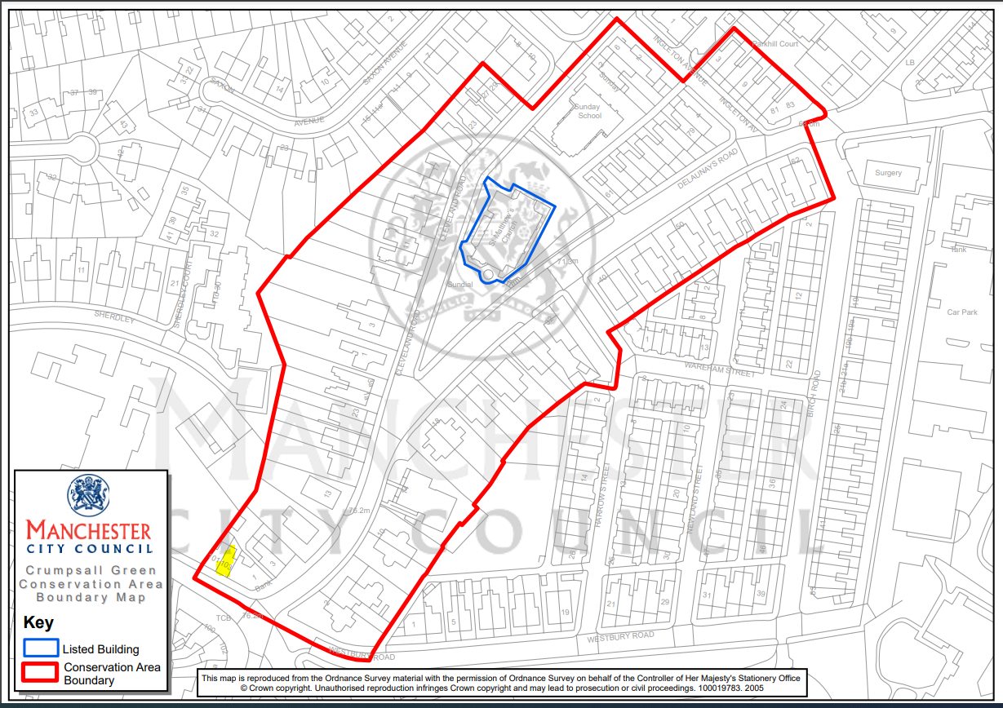

The Crumpsall Green Conservation Area is broadly centred on the area around Delaunays Road and Cleveland Road. The conservation area is partly bounded to the north by Ingleton Avenue, with Westbury Road at the south right of the conservation area.

The conservation area includes The Church of St Matthews with St Mary which is designated Grade II Listed building.

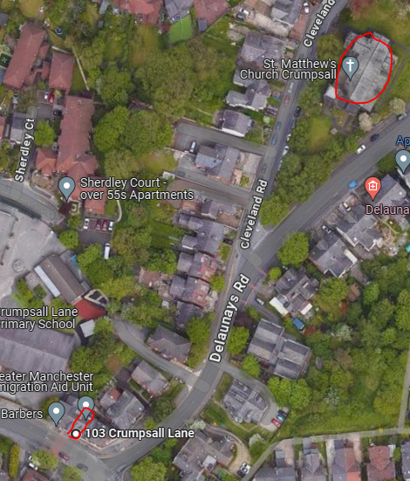
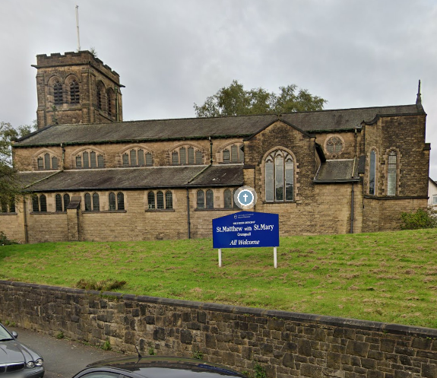

View of Church of St Matthews with St Mary 103 Crumpsall Lane outlined red with the proximity of 0.1 miles to the church

The Church of St Matthews with St Mary is located at the junction of Cleveland Road and Delaunays Road within its own defined boundaries. The building is constructed in facing stonework with slate roof coverings.

“Church. 1908-10. By Isaac Taylor. Rock-faced ashlar with ashlar dressings to exterior and buff brick with ashlar dressings to interior. Late Perpendicular style. Chancel, chancel transepts, north vestry, nave with aisles, west baptistery and entrance and north west tower. Short chancel has 5-light east window and a lancet to either side with another in the canted corner joining it to the transepts. 3-light window to south transept gable and mandela to north over the projecting
vestry. 3- and 4-light clerestory windows with cusped lights under Tudor arches. Aisle windows of 2- and 3-lights. West end has a 3-light window with a cusped lancet either side at a lower level over the projecting baptistery which has a small cusped window at the centre, a 2-light to left and door to right. The tower has angle buttresses with set-offs, paired 2-light louvred openings to the top stage and small windows below. Adjoining the baptistery a polygonal stair turret rises to the second stage. Entrance in north side. INTERIOR. Chancel and nave in one has tie beam truss roof with short queen posts and arched braces and cranked collars linking the 2 tiers of purlins. Nave arcades with 2-centred arches on octagonal piers. Unusual arrangement of arch at east end of chancel leading into sanctuary with windows on the canted corners and further windows lighting the sanctuary from the sides. Richly patterned Renaissance style stained glass in chancel, transepts, west wall and baptistery windows. Fine set of choir stalls and pews with panelling to chancel and baptistery. A finely designed church of the period with rich and virtually complete fittings, a very unusual feature being the design of
the chancel.”
Listing NGR: SD 84534 02447
09.05.03. Grade II
Historic England in relation to the Statutory Listing for Church of St Matthew with St Mary.

- The proposed works
The works we are planning to do to the heritage asset.

The proposal is for change of use from Class E - Retail to Class C3 - 3No. Self contained flats, as per/ drawings attached.

The elevation of the building will remain as the existing one.

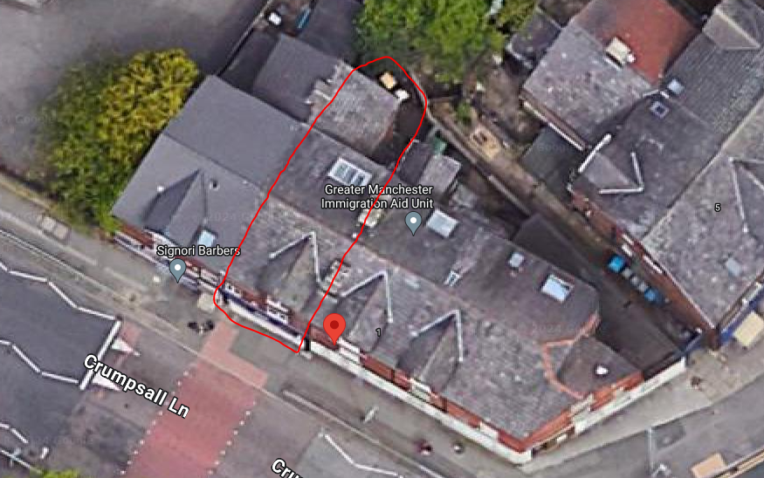

A view of the site from Google Maps
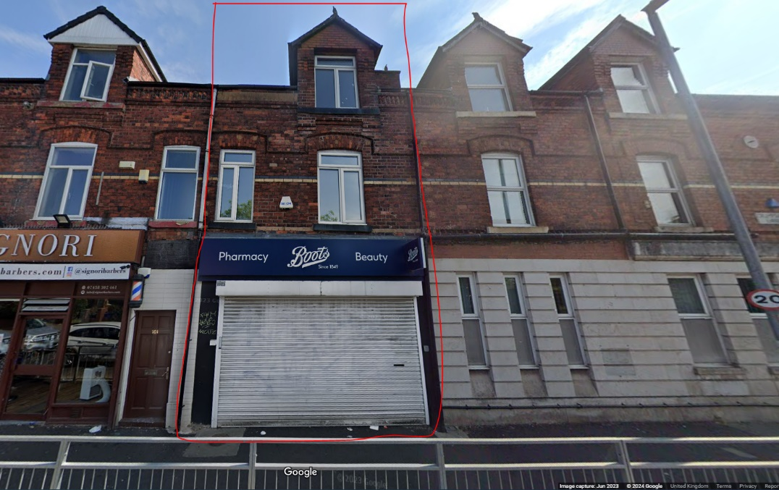

A street view of the front of the site

- Impact on significance
How will the proposals impact on the significance of the heritage asset(s) and/or their settings? Please discuss the impact of the proposals including for example impact on architectural detail, historic fabric, plan form, change of relationship with neighbouring buildings etc. What is the impact on views, the character or townscape of the wider area? Explain how have any harmful impacts been avoided or mitigated, including alternative options considered? Where harm is identified, what is the level of harm (substantial or less than substantial)?

Given that the proposal has no intervention or resulting any external changes to the building. Importantly, The proposal has no adverse effects on the Crumpsall Green Conservation Area.

- Enhancement and Public Benefits (where applicable)
Please describe how the proposals have been designed to enhance or better reveal the significance of the asset e.g. removal of later unsympathetic alteration. Where harm is identified, will there be any public benefit as a result of the works?

N/A

- Other
Use this space to provide any other useful information, for example details of relevant planning history and consultation undertaken or links to other relevant information and statements submitted, including your sustainable design statement.

Please see drawings attached.

- Conclusion

Summary of the heritage statement.

The proposed change of use from Class E - Retail to Class C3 - 3No. Self contained flats. It is anticipated that this intervention will not lead to any adverse effects on the Crumpsall Green Conservation Area.

In conclusion, the proposal seamlessly integrates into its environment. The proposed scheme suggests entirely internal change and maintaining the site's appearance.

In summary, the proposed development is expected to have no impact on the heritage value of the area, and therefore, prior approval should be granted.

