Planning Statement
Moon Under Water, 68-74 Deansgate, Manchester

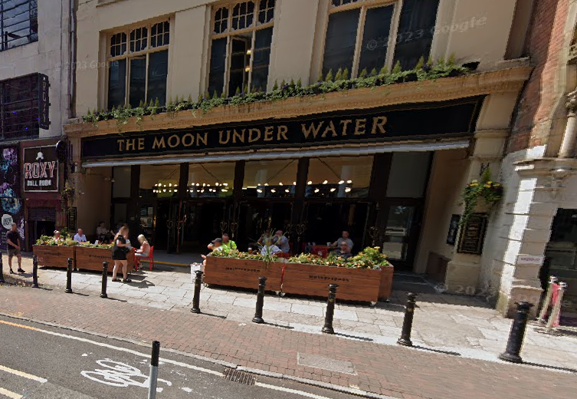

Background
The Moon Under Water opened in 1998 operating a seating area to the front on its private forecourt. In 2000 a Tables and Chairs Licence was issued by Manchester City Council for an additional row of tables and chairs on the public highway. Planning permission was granted for this use retrospectively on 28th October 2016 reference; 112315/FO/2016.
For some ten years the boundary design of the pavement seating area was freestanding post and canvas screen barriers. These were replaced 12 months ago with moveable planter troughs on lockable castors due to issues with the previous barrier design being caught by the wind and blown over, or out of the approved locations. There were concerns that they may cause a hazard to passing pedestrians at these times.

The Application
The application seeks consent to allow the planter troughs to remain on the public highway outside of permitted hours of use of the seating area, being 11pm to 8am Monday to Sunday. After the tables and chairs area removed the planters would be moved up against the forecourt step.
The planters would be removed entirely and stored securely at particular times this was requested by the police or a council representative, for instance during times of special events within the city.

The Reason
Damage is being caused to the planters by moving them onto the private forecourt area each night due to the lip of the step and has resulted in damage to the forecourt tiling.

