Condition 18 – Construction Management Plan

The proposed 1a Farrington Avenue, Withington, Manchester M20 1ER is off the intersection of Whitchurch Road and Farrington Avenue within the Withington Area of southern Manchester. The site is approximately centred on National Grid Reference 384404, 393040 and the site location and layout are shown in Figure 1.

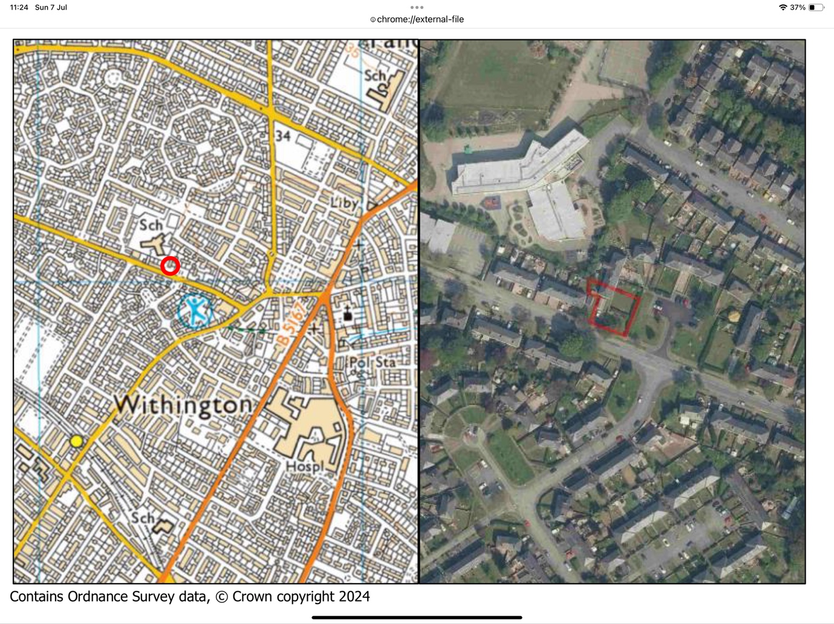

Fig 1

The site is located to the west of Farrington Avenue and the north of Whitchurch Road. Parking of construction vehicles and staff will be on 1 Farrington Avenue driveway, Figure 2 & 3 as an aerial photo.

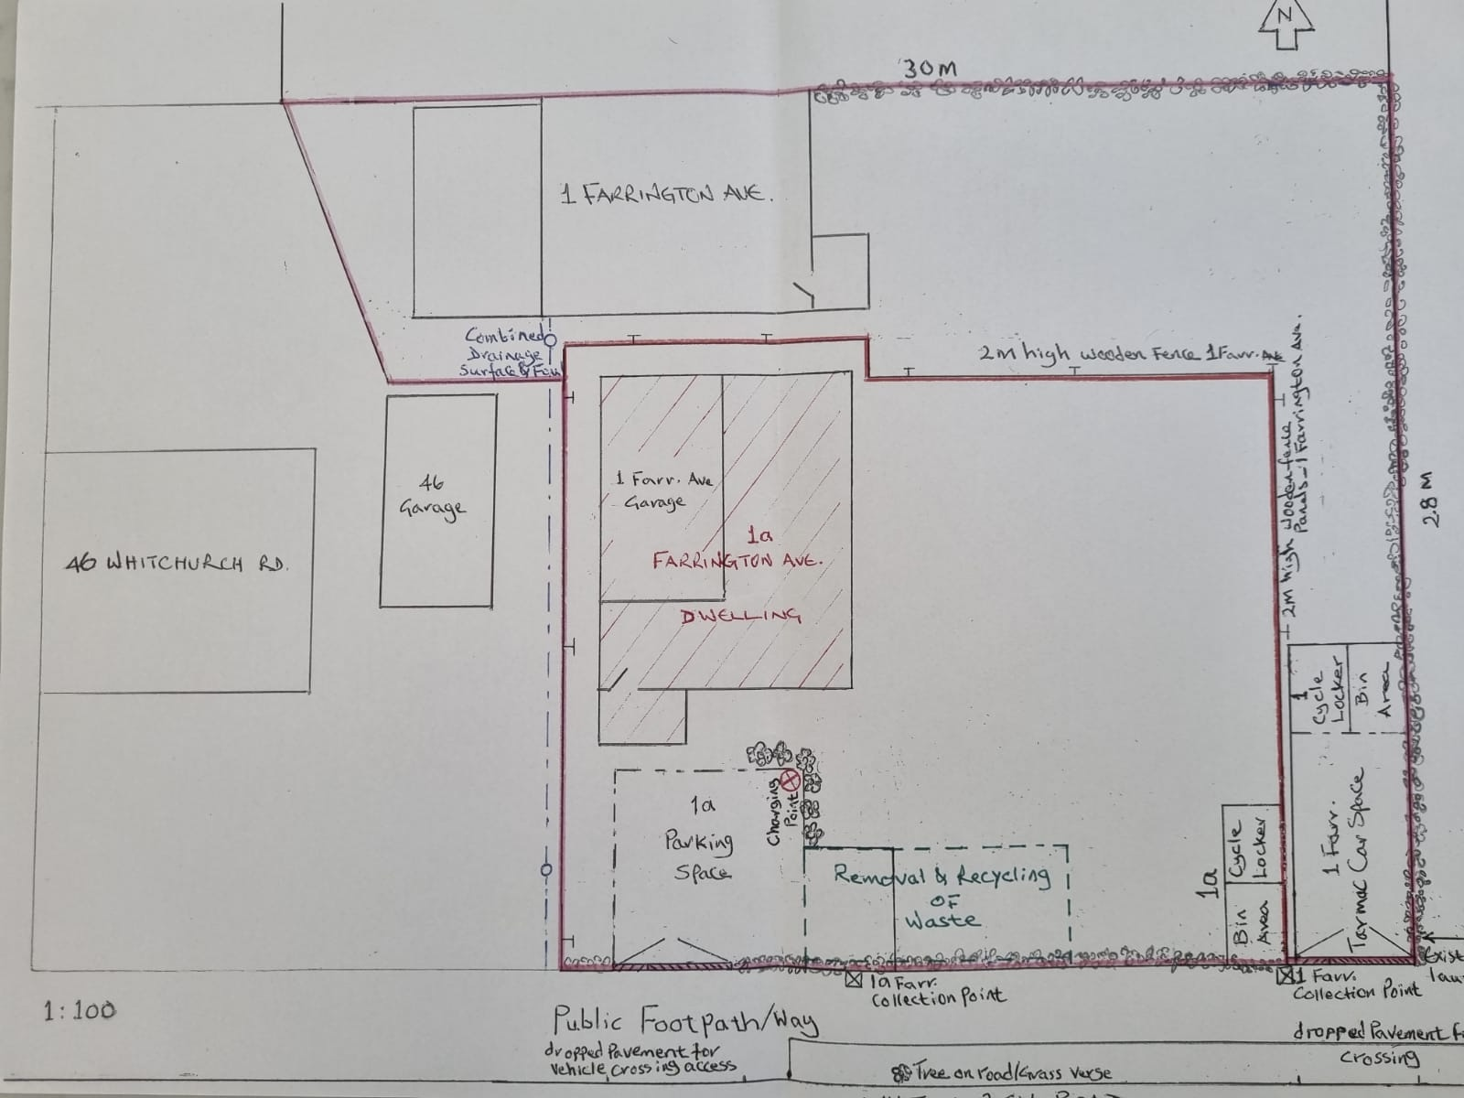

Fig 2

Wheel washing is unnecessary as the site is a very very small development of erecting a house in the garden of 1 Farrington Avenue where all adjacent areas are solid ground(s). Should there be any mud on hard surfaces outside the boundaries of this very small site, it will be collected and hard surfaces washed away immediately.

Dust suppression is unnecessary.

Location, removal and recycling of waste has been designated to the south of the plot marked in dotted green lines adjacent to the hedge as shown on Figure 2 above.

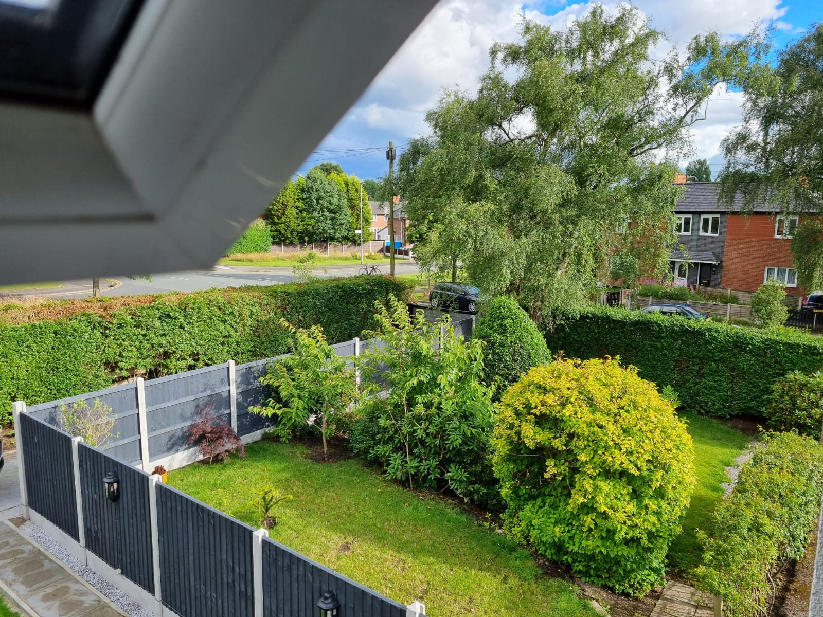

Fig 3

Hours of working are: Monday to Friday 7:30am to 6pm. Saturdays 8:30am to 2pm.

Zak Rees Barrington BSc(Hons) MIET MIEEE
Consultant Engineer
Design And Home Construction Ltd.

