
Bat box

1115.0

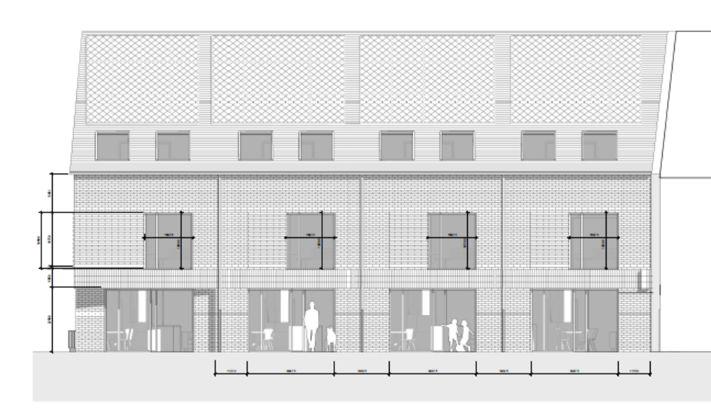
Bird box

