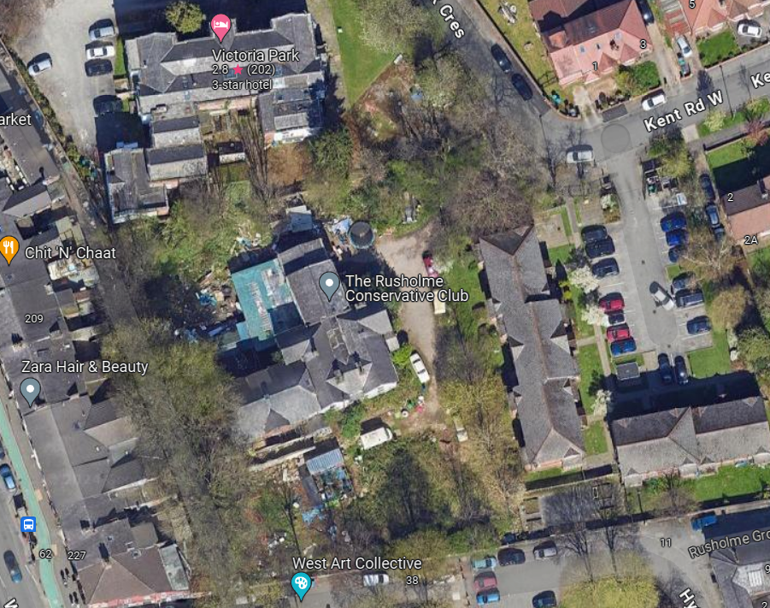
Flat Blocks
Public Footpath
Street Light
Beech Tree, T1

