PP-12714454
Consent application to fell holly (Ilex Aquifolium – male) at 34 Mayfield Road
Fig 1. Extract of the Whalley Range Conservation Map showing location of tree to be felled
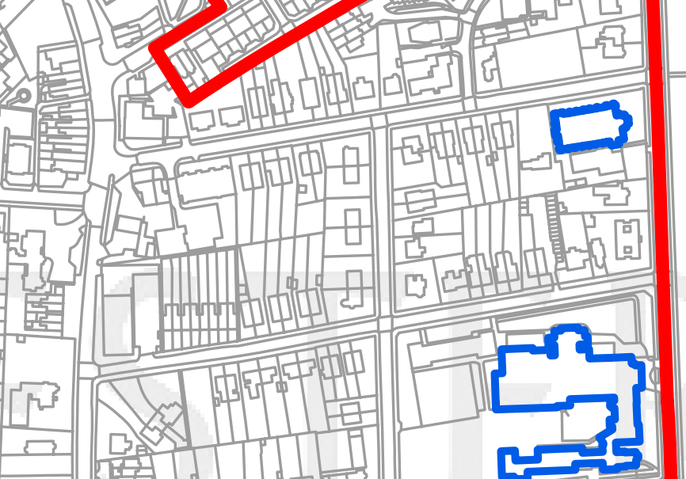
34 Mayfield Road
Ilex Aquifolium to be felled
Whalley Range Conservation Area
Range Road
R Road
Mayfield Road

