Draft Scaffolding Method Statement Addendum
1 May 2024

This is a draft note setting out the site constraints and best-practice methodology, which the scaffold contractor will use to update their drawings and Construction Phase Plan (CPP) in order to discharge the relevant condition at the Rutherford building.

Fixings and mortar mixes
On-site preliminary pull tests have indicated the suitability of using 8mm fixings into mortar joints for the scaffold at Rutherford building. We can confirm that this is how the scaffold will be fixed to the building for the duration of the works.

The scaffold would be raised and fixings made as it goes up. On striking the scaffold, the mortar holes, and any identified damage to the brickwork stonework or detailing, would be made good on a like-for-like basis as each level is taken down. We expect the mortar mix can be agreed by condition with MCC prior to use.

Safeguards to stonework and detailing
Any decorative stonework or detailing should be protected as part of the works, using the following methods:
- Cap ends to scaffold poles
- External floor protection
- Plywood boxes and foam packing (non-fixed) for any decorative stonework
- Dust sheets or wrapping to protect the exterior elevations

Prelim tests
Preliminary pull tests were carried out on 7th December 2023 at the Rutherford building and 8mm fixings into mortar joints were found to be acceptable, rather than the earlier proposal for 12mm fixings:

Test No. | Anchor Location | Drill Diameter (mm) | Depth (mm) | Required Load (kn) | Applied Load (kn) | Pass/Fail | Type Of Fixing Used
1 | Front Elevation | 8mm | 75mm | N/A | 10kN | N/A | Hex Bolt
2 | Front Elevation | 8mm | 75mm | N/A | 10kN | N/A | Hex Bolt
Preliminary test only. 2 no. tests requested only at this time to determine suitability of 8mm tie diameter.
Base Material: (Concrete, Brickwork etc.) |  |  | Mortar joints
Report Prepared By: |  | Lee Watson  IBN Scaffold Access Limited |  |  |  | Date: | 07/12/2023
Position: |  | Contracts Manager  Office 1.16  Hollinwood Business Centre  Albert Street  Hollinwood  Oldham  OL8 3QL

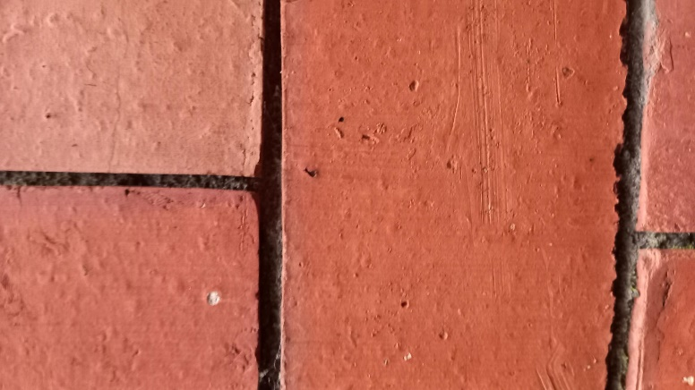
Prior to testing

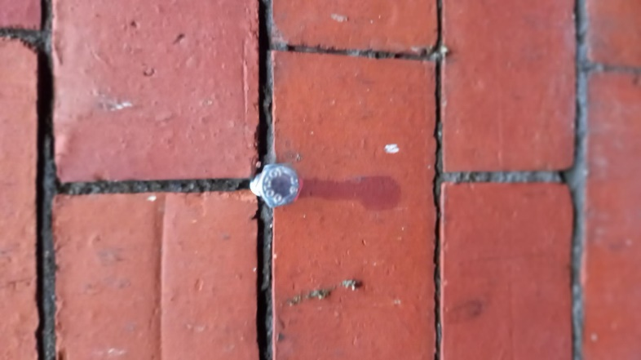
8mm Hex bolt in position
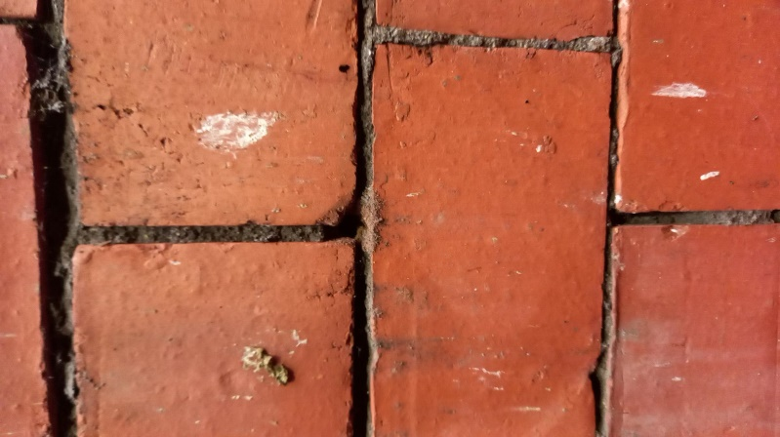
Result

