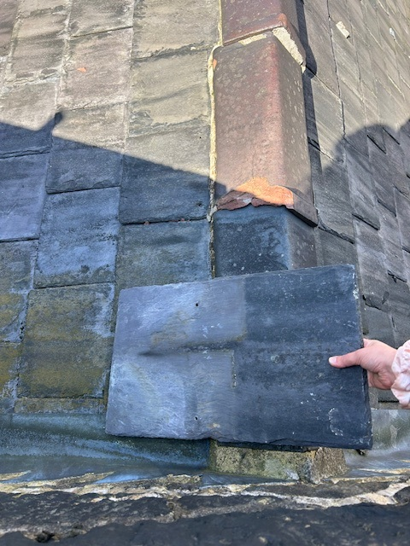 WELSH SLATE VIEWED 14/08/2024
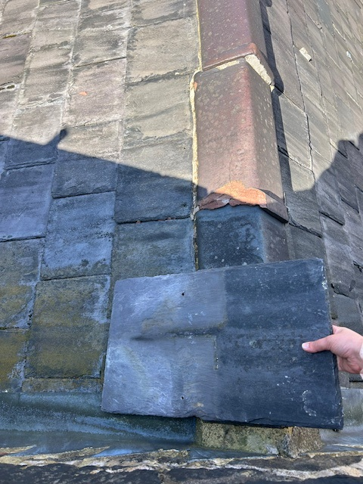
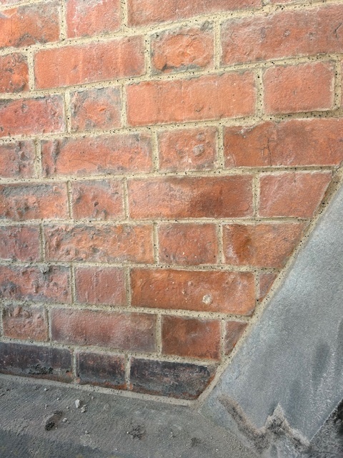
Mineral dry bagged building, pointing and rendering mortar based on Natural Hydraulic Lime binders and aggregates (Product designation MMHLM F or C) VIEWED 20/08/2024

