Details of a sustainable surface water drainage scheme and a foul water drainage scheme

Project:

Farrington Avenue, Manchester – details of a sustainable surface & foul water drainage scheme(s).

Site Address:

1 Farrington Avenue, Withington, Manchester M20 1ER.

Sources of Information:

The following section describe the environmental setting of the site, site history and the anticipated ground conditions based on information taken from a variety of sources including:
- Current maps and plans.
- Geological maps and records.
- Site photographs.
- Website of relevant authorities and organisations such as the British Geological survey, the Environmental Agency, Defra, Groundsure, Natural England and Historic England.
- United Utility – Property Searches (Wastewater & Surface Water) systems.

Site Location:

The site is located off the intersection of Whitchurch Road and Farrington Avenue within the Withington area of southern Manchester. The site is approximately centred on National Grid Reference 384404,393040 and the site location and layout are shown in Figure 1.

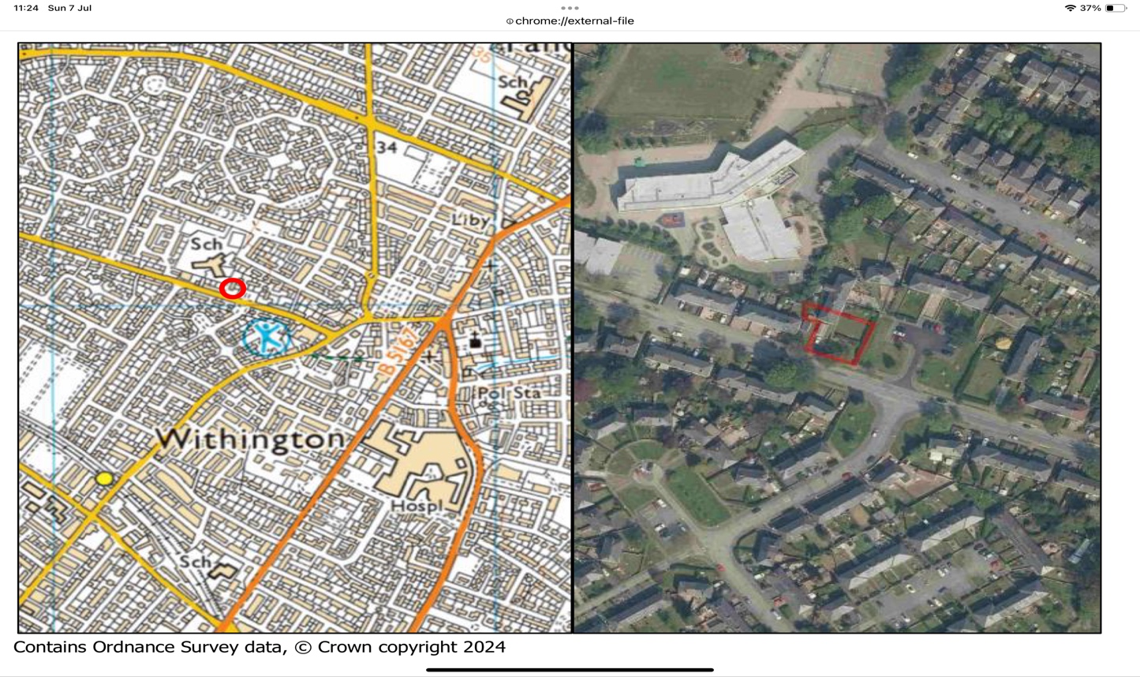 Fig 1 Site Location

Site Description:

The site comprises a two-storey end of terrace residential dwelling with associated garden and a small domestic garage with an assumed asbestos cement roof and covers an area of approximately 0.05 ha. The garage is detached and located to the south of the residential house. To the front (south) of the garage is a gravel driveway.

The site is located to the west of Farrington Avenue and the north of Whitchurch Road. The site is accessed via two driveways from Whitchurch Road.

The site is bound by residential properties to the north and west, a small ‘green’ and Farrington Avenue to the east, and Whitchurch Road to the south with residential properties beyond.

Proposed Development:

It is proposed to demolish the existing garage and replace it with a two-storey, detached, residential dwelling. The existing property will be accessed by the new dwelling which runs along the eastern boundary of the site. New fences are already installed which mark the boundaries of the new plot. The proposed development layout is shown in Figure 2.

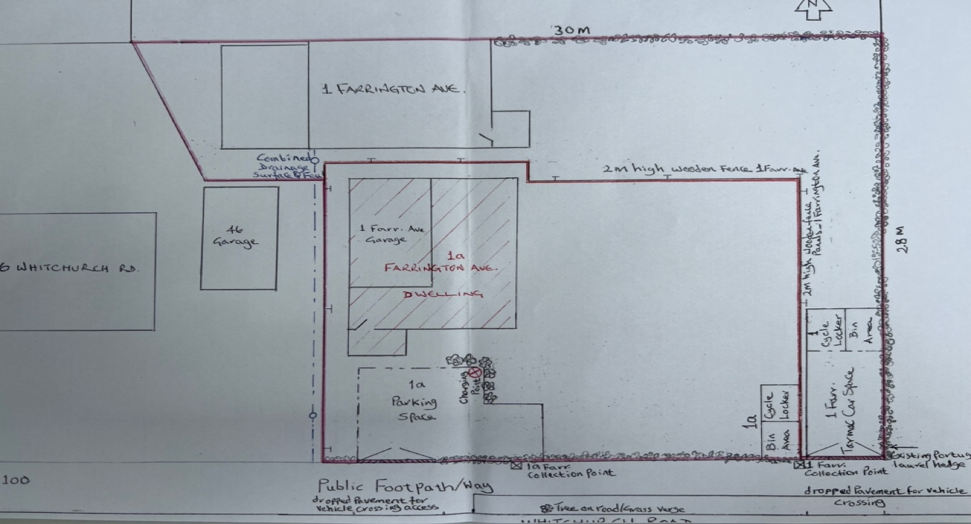

Fig 2 Proposed Development Layout

Ground Conditions:

The British Geological Survey (BGS) geological map of the area shows the site to be underlain by the bedrock geology comprising the gravelly sandstone of the Chester Formation as shown in Figure 3.

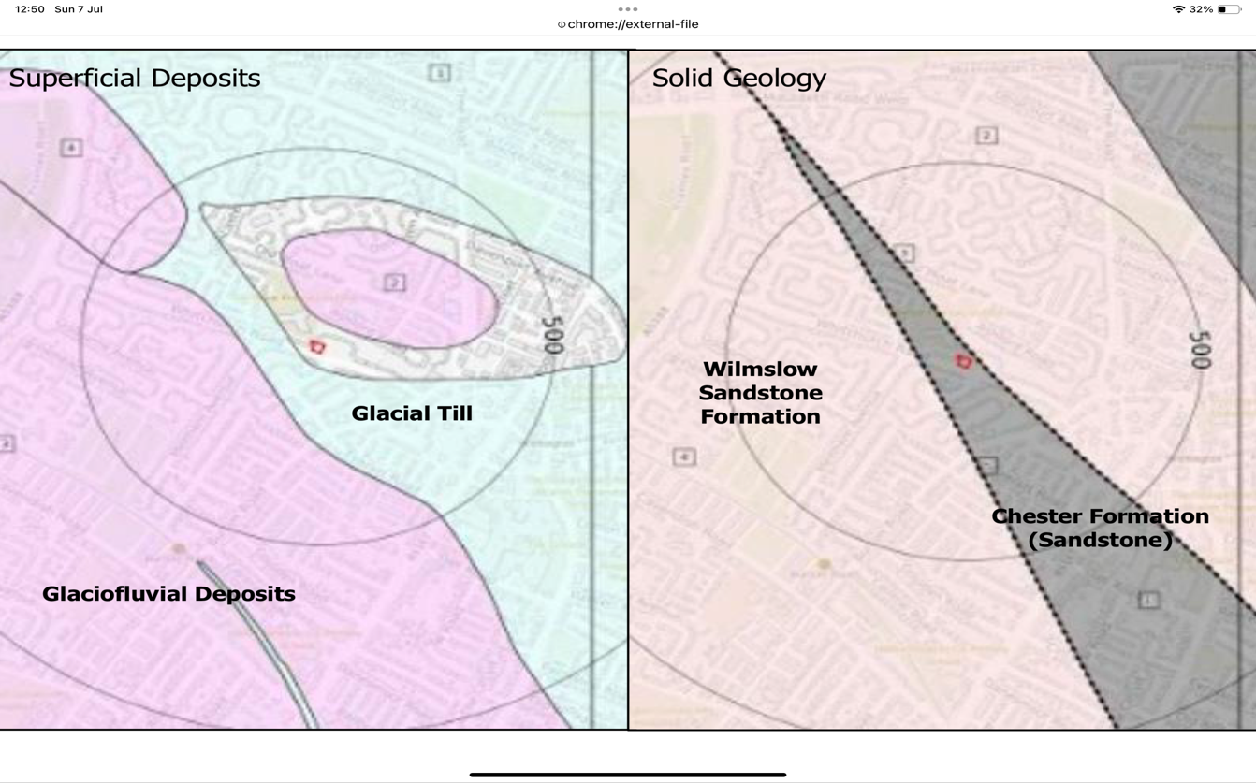
Fig 3 Geology

The underlaying Chester Formation is classed as Principle Aquifer, meaning it has a highly permeable layers capable of providing high level of water storage and supply at a strategic scale.

Site Drainage:

The development site is covered predominantly by soft ground and some limited hardstanding, therefore, drainage will be dominated by infiltration, with some run-off from the hard surfaces run-off.
The roof drainage from the existing residential property (1 Farrington Avenue) is directed to the man-made drainage system, which is a combined surface and wastewater system, Figure 4a. The existing combined surface and wastewater drain chamber is locate in the garden of next door property (46 Whitchurch Road), which is shown on Figure 4b. The proposed 1a Farrington Avenue will be connected to the same combined drain, which is also shown in Figure 2 (blue dotted line) leading to the combined surface and wastewater chamber.

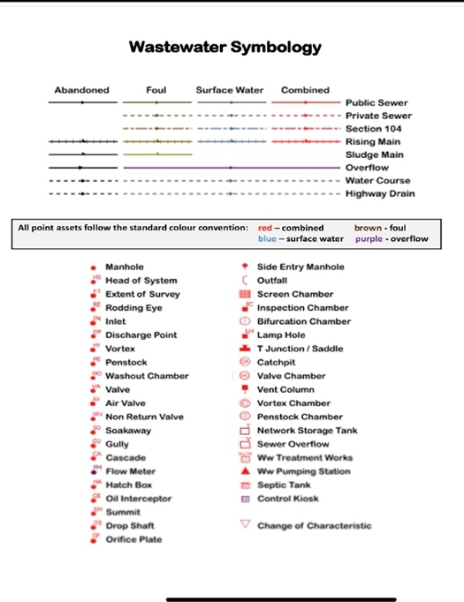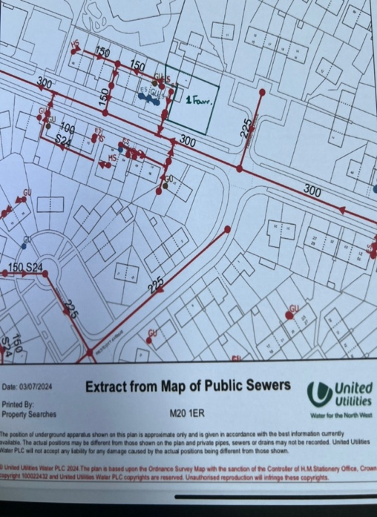

Fig 4a Combined Surface and Wastewater System

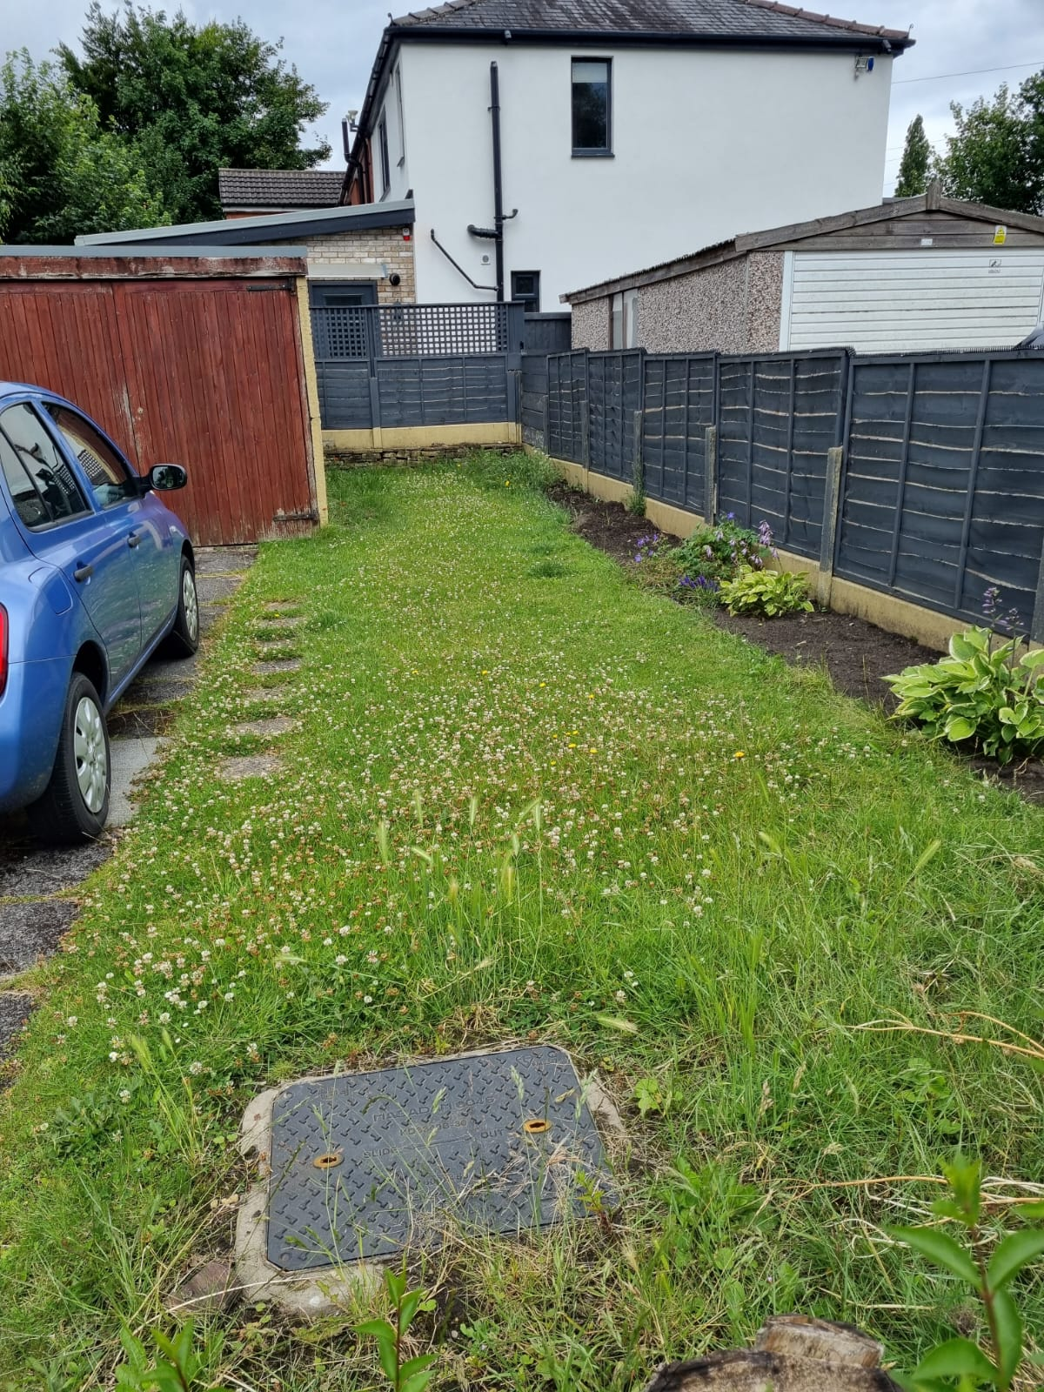

Fig 4b Combined Surface and wastewater Chamber

The proposed 1a Farrington Avenue dwelling-house will have a sustainable drainage system based on the excellent geology/ground condition of the site, keeping the existing permeable paving/driveway reducing runoff and enhancing the recharge of groundwater.

Also, harvesting rainwater from roofs using Rain Trap Diverter & storage, Figure 5.

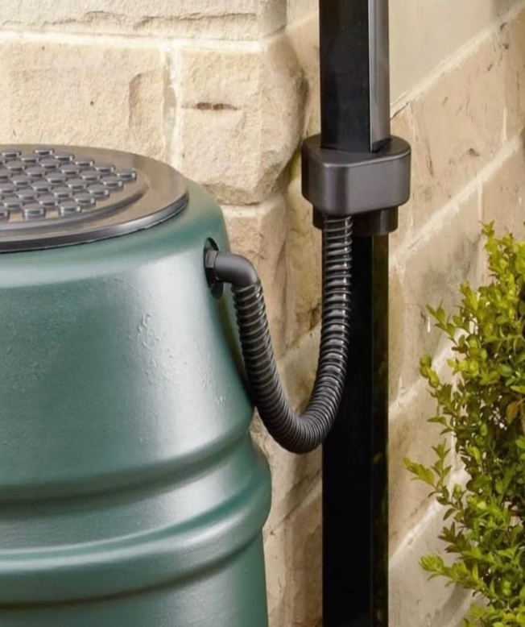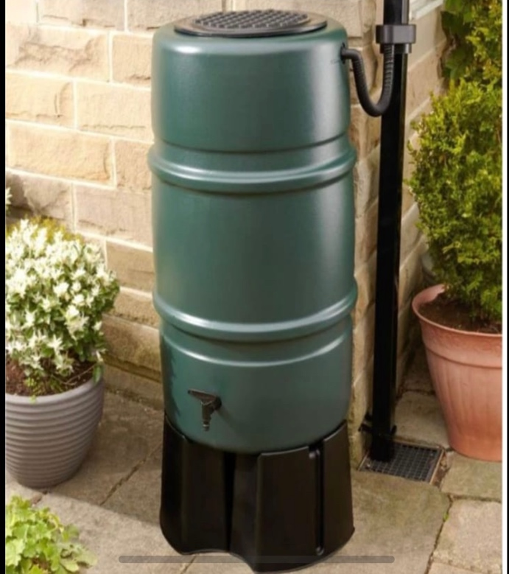

Fig 5 Rain Trap Diverter & Storage

Zak Rees Barrington BSc(Hons) MIET MIEEE
Consultant Engineer
Design And Home Construction Ltd

