EMERGENCY & PROJECT DUTY HOLDERS CONTACT SHEET

Project | 17 Quay Street | Project No | PO 1024
Site Address | 17 Quay Street, Manchester, M3 3HN

Description | Address | Contact/Role | Contact Details
Location of nearest hospital: | Manchester Royal Infirmary  Upper Brook St  Manchester  M13 9NZ |  | T: 0161 276 1234
Route Map from site to hospital:

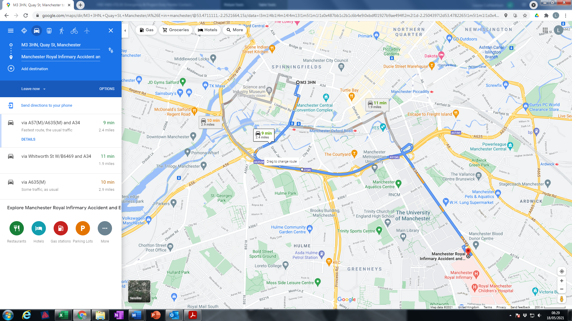

Location of nearest police station: | Northampton Road  Manchester  M40 5NB |  | T: 0161 872 5050
Client:  Urbana Partners |  |  | M:  E:
Architect:  3D Reid | 26 Cross Street  Manchester  M2 7AQ | Gosia Lebiest | T: 0345 271 6264  M: 0777 997 4498  E: Gosia.Lebiest@3dreid.com
Contract Administrator:  OBI Property | 80 Mosley Street  Manchester  M2 3FX | Dominic Horridge  Joe Wielding | T: 0161 237 1717  M: 07825 703834  E: dhorridge@obiproperty.co.uk  T: 0161 237 1717  M: 07990 747 375  E: jweilding@obiproperty.co.uk
Principal Contractor:  Spacescape Ltd | 49a Borough Road  Altrincham  Cheshire  WA15 9RA | Managing Director:  Lee Kight  Project Manager:  Mark Munday | T: 0161 928 2888  M:0787 650 5918  E: lee@spacescapeltd.co.uk  M: 07969 203 154  E: mark@spacescapeltd.co.uk
First Aider on Site: |  | Darren Lodge  Alan Morris | M: 07795 478 655  E: darren@spacescapeltd.co.uk  M: 07702 491 229  E: alan@spacescapeltd.co.uk
Electrical & Mechanical Contractor:  Pulse Project Solutions | Unit 4a  Zebra Court  White Moss View  Manchester  M24 1UN | Alex Webb | T:0161 655 0292  M: 07917 327 432  E: alex.webb@pulseprojectsolutions.com
Health & Safety Consultant:  Safety2Business | 10th Floor  Suite 33/34A  Regent House  Heaton Lane  Stockport  SK4 1BS | Health & Safety Consultant: Simon Morton | T: 0161 414 0504  M: 07540 126 490  E: simonmorton@safety2business.com

