24 Lever Street, Basement
Proposed Louvre

Louvre to be made to suit existing opening.
The Aluminium louvres are to be powder coated RAL 6028 Pine Green to match existing window frames and rain water goods.
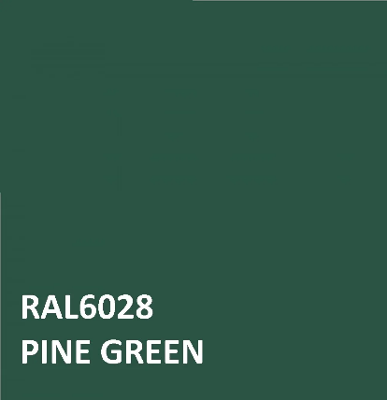
Indicative Image:
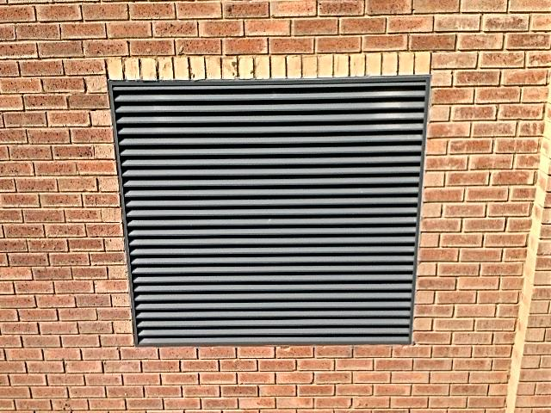

New Aluminium louvre to be installed within existing opening as shown.

