Project and Client Details

Date: | 21.07.22 | ATSM: John Wilkinson
Bauder reference: | B193311 | Project Address:
Client Name: | Mr Glenn Robinson | First Street South
Company: | Simpson Haugh | Manchester
Tel: |  | M15 6JG
Email: | g.robinson@simpsonhaugh.com

Rainfall Details

1) Type of Roof Warm (Specify Pitch) / Cold (Specify Pitch)
/ Warm Inverted (<1:80) / Warm Green or Brown (<1:80)

1) Roof Pitch <1:80 / 1:80 or more (assumed 1:80 if left blank)

2) Building Design Life Years (assumed 25 years if left blank)

3) Has the safety factor been set? Yes / No
If the answer is yes then please state Safety Factor (N/A to Roofs with <1:80 slope)

Safety Factor 1.5 - Cat 2 = Normal Buildings
Safety Factor 4.5 - Cat 3 = Higher risk Buildings (Hospital operating theatre – communications centre – buildings where any disruption will be very costly or any other high risk buildings)

Bauder will calculate the drainage required based on the rainfall intensity for the project location.

Roof Name | Roof Area (m²) | Area of Adjacent surfaces (m²) | Total Area (m²) | Type of Bauder Outlet Required | Diameter of Bauder Outlet Required (mm) | Number of Preferred Outlets
A1 | 328 |  | 328 | Hotmelt Compact | 100
A2 | 222 | 95 | 317 | “ | “
A3 | 214 | 97 | 311 | “ | “
A4 | 190 | 97 | 287 | “ | “
B1 | 255 | 94 | 349 | “ | “
B2 | 226 | 94 | 320 | “ | “
B3 | 336 |  | 33 | “ | “
B4 | 307 | 97 | 404 | “ | “
B5 | 249 | 97 | 346 | “ | “
D1 | 742 |  | 742 | “ | “

*See diagram on the following pages on how to calculate effective roof areas.

Note:
If a CLEAR Roof plan showing the direction of falls and the outlet location in either DWG and/or PDF is available then please forward this onto your local Area Technical Sales Manager along with this form.

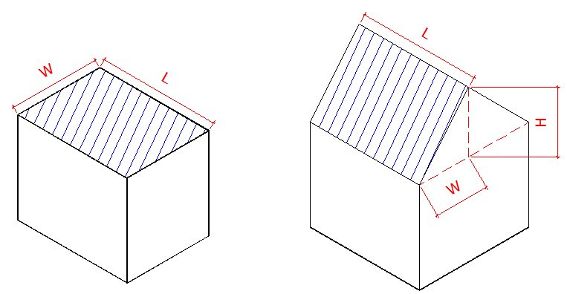
Flat Roof Catchment Area – L x W Pitched Roof Catchment Area – L x (W + 0.5H)

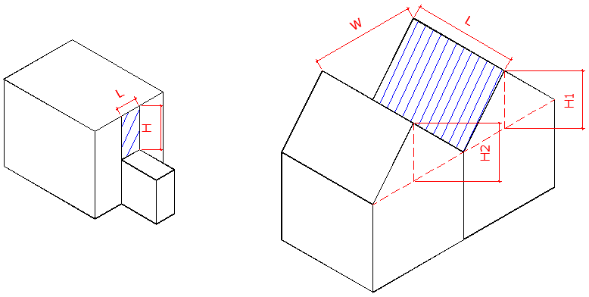

Vertical Wall Catchment Area – 0.5 x L x H Pitched Roof Valley Catchment Area
– L x (W + 0.5 (H1 – H2))

