Report:
Residential Management Strategy – Trinity Island Plot D
Revision B – 12th June 2024

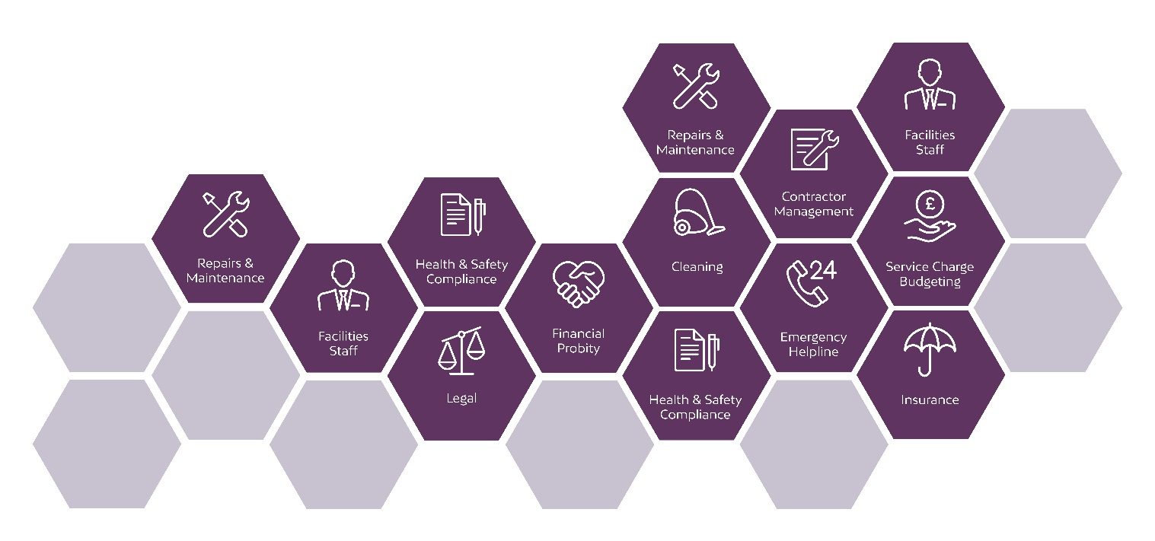

Overview
The purpose of this report is to detail the arrangements for the ongoing management and maintenance of the residential buildings. The report will detail how various tenant services will be operated and how tenant amenity and accommodation quality will be maintained throughout the life of the buildings.
The effective management and operation of mixed-use developments is crucial to the long-term success of any scheme. The importance of well thought out design cannot be overstated, as all too often consideration for the management process is inadequate, this in turn leads to an unsatisfactory result for all parties.
The importance of placemaking and stewardship must not be underestimated when assessing the suitability of a development and its strategy. Residents who feel engaged and part of a community will have a far more positive experience in their homes.
Zenith Management are ARMA accredited Managing Agent specialising in large city centre residential schemes. This design has been reviewed, and the report prepared, based on the experience and knowledge of schemes of a similar nature in the Manchester and Salford area as well accepted industry best practice.

Report Contents

- Introduction

- Staffing Levels and Concierge

- Refuse Strategy

- Vehicle Parking & Cycle Parking

- Access Arrangements & Security

- Cleaning & Maintenance

- Resident Management & On-going Management

- Service Charge Strategy

- Conclusions and Overview

- Introduction
The proposed scheme is a mixed-use development containing 532 high quality apartments in Tower D1 and 484 in D2. There are no commercial units in either tower.
The below document references the strategy that is applicable across both towers as they are internally similar with exception of apartment numbers.
The scheme will contain various amenities including:
Gym – A large gymnasium will contain both cardio and strength-based equipment and an outdoor area so that outdoor activities can be encouraged
Resident Lounges – A number of resident lounges will be provided.
Multi-Use Spaces – designed to allow various applications including private dining and co-working.
The scheme has been designed to ensure that an effective management structure is in place from day-one and is able to provide a high-quality resident experience, meeting the ever-increasing expectations associated with city centre mixed-use developments.

- Staffing Levels and Concierge

  - Management and Concierge Team

A dedicated Management Suite has been integrated into the scheme and is located in both towers on Level 1l immediately adjacent to the residential amenity space.

The Management Suite offers ample space for a fulltime Concierge team with full access to CCTV monitoring and all administrative ‘Back of House’ facilities via the concierge office.

The size and positioning of the Management Suite is such that constant resident and visitor engagement is achieved. In addition, a 24/7 presence offers a high security level and visual deterrent to any unauthorised persons seeking access.

The team will form an active part of the scheme and duties will include regular resident liaison, safety and building inspections, security monitoring and package handling.

  - Cleaning and Maintenance Operatives

The scheme will necessitate the appointment of fulltime cleaning and maintenance operatives who will be responsible for ensuring that the residential common parts and all outdoor areas remain in a clean and safe condition for residents, visitors and members of the public.

  - Staffing Level

The scheme has been designed with ample space and facilities to accommodate a site team capable of delivering a first-class service with residents benefiting from the provision of 24/7 staff. The permanent presence of a site team will provide a strong connection between the residents and the management team and help engender a sense of community.

- Refuse Strategy

  - Refuse Strategy Overview

The scheme has been designed such that every apartment will have access to a tri-separator refuse chute on their apartment level. This will be in close proximity to their apartment to promote effective waste disposal and avoid lengthy movement of waste across the development, which can often hinder recycling initiatives.

The strategy proposed will enable residents to segregate and dispose of waste in a reasonable and sustainable way in order to minimize environmental impact. We will also supply in apartment recycling bins and food waste containers (23 litre food waste caddy’s)

  - Refuse Management – Residential Areas

The scheme has been designed to incorporate a refuse chute to all residential levels with Tri-Separator functions. This Tri-Separator is designed specifically to provide a solution to the problem of re-cycling or separating waste generated in multi-storey buildings.

The user selects the type of waste to be deposited down the chute by pushing the respective button on the push button panel above the door, general waste being the default centre position.

The Chutes will discharge directly into Local Authority (1100 Litre) and/or private collection containers within the Refuse room located on the Ground Floor. This room will be managed by the site-based team. Containers will be monitored by CCTV and physical checks and transferred on the allocated days to their designated collection point on in the waste collection areas in the external non-adopted public realm

The site team will be adequately staffed on designated refuse collection days to pull bins out of the refuse store and presented at the collection point.

All Refuse Rooms will be sited on an impermeable surface to aid cleaning and general good housekeeping and the site team will have responsibility for ensuring cleaning is carried out routinely.

Notices will be installed prominently in all Refuse Chutes and Refuse Rooms around the development communicating to residents the refuse/recycling policy and clearly promoting the proposed system and encouraging recycling where possible.

Advice on how to dispose of larger items such as mattresses/washing machines etc. in line with the requirements of Manchester City Council will also be communicated.

  - Refuse Collection

The site team will ensure that the residential waste containers are placed in the designated collection point on the appointed days for collection by the Local Authority. Once emptied by the Local Authority the units will be returned to the Refuse Rooms for re-use.

    - Additional Private Refuse Collection
Given the efficiency of the Tri-Separator chute system it is expected that the collection and capacity of refuse containers will be improved and more effective in comparison to other developments that rely on the residents to separate waste streams manually within refuse rooms. A fully managed chute and refuse room will ensure that containers are utilised to their maximum capacity before being presented for collection.

However, should the management team feel additional collections would be beneficial then this will be undertaken via an approved private collector that can be used to supplement Local Authority collections.

If the bin store area provides an issue with full bins, an overflow area, screened from public view will be used to accommodate bins in a temporary state until the next collection.

In the unlikely event that additional private collections cannot be facilitated, a scheme is in place to satisfy the MCC requirements of the GD04 document for space provision for additional bin numbers. These areas are shown in Appendix 1 of this document

  - Recycling

Recycling is an integral element of effective Waste Management and is increasingly important to residents of high-rise developments who have historically found inadequate provisions to be in place. It is important that at design stage this concern is addressed in any new development to allow residents to engage in a meaningful and responsible recycling regime.

At the development residents will be provided with the correct infrastructure to recycle all streams of waste in accordance with Manchester City Council guidance. The Refuse Chute will allow waste to be segregated into general, mixed recycling and food waste streams.

Signage will be installed in all refuse rooms to educate and encourage residents to dispose of their waste correctly when discarding.

Pulpable waste will be taken directly to the Refuse Rooms by the residents.

Within each bin store area, recycling points will be safe, accessible area, for residents for larger cardboard and plastic items and food waste disposal from their 23 Litre in apartment caddy’s.

- Vehicle Parking & Cycle Parking

  - Vehicle Parking

The scheme comprises three levels of on-site car parking for the residents. 281 car park spaces and 15 motorcycle spaces will be provided, and these will be accessed by the secure car park off Trinity Way.

The car park will be well lit, maintained and monitored (including CCTV coverage relayed back to the Management Suite) to deter any anti-social behaviour.

  - Car Charging

The scheme will include 61 EV Charging Spaces enabled for use depending on demand and usage.

  - Cycle Parking

Cycling is becoming increasingly recognised for the contribution it can make as a sustainable and healthy form of transport for trips within large cities. It is particularly important that adequate provisions are made in large residential developments to make the choice to cycle a more convenient one for residents.

Cycle parking needs to be considered early in the project process, as space needed to accommodate cycles can be significant. The scheme has provided cycle stores containing 1 cycle space per apartment.

The cycle stores are within secure rooms and will be well lit, maintained and monitored (including CCTV coverage relayed back to the Management Suite) to deter any anti-social behaviour.

Adequate cycle storage is crucial within residential developments to discourage bikes from being kept within apartments/communal areas due to the issues associated with fire safety and cleanliness.

The process of gaining access will be communicated to all residents by the management team on a periodic basis.

  - Cycle Parking Evaluation
The design and location of the Cycle parking is such that it provides a secure yet accessible provision to residents.
The installation of CCTV and proximity to the Management Suite means that Cycle areas can be actively monitored to deter theft and trespass.
- Access arrangements & Security

  - Communal Security Management
The main residential entrances will operate via a programmable fob. The fobs will be monitored and programmable by the site management team.
In the event of lost/stolen fobs replacements can be provided and the original removed from the system ensuring that security is not compromised.
The fob system will undertake a periodic cleanse to ensure access is only available to current residents.
  - Apartment Security Management
Residents will access their apartments with individual fobs keys provided at the point of purchase. The management team will not hold any apartment keys unless requested directly by the resident.
Apartment doors will have a dead lock, door viewer and automatic door closer. Doors will be opened/locked via a fob key and will not self-lock. A thumb turn will be on the inside of the door. All doors will be PAS 24:2016 compliant.
  - CCTV
CCTV will be in operation on the development and signage will be displayed in prominent locations. A Privacy Impact Assessment will be carried out by the Managing Agent to ensure that the scheme is proportionate, and this will be supported by an annual review of the system.
CCTV recording equipment will be located in the Management and Concierge office to allow for private viewing by law enforcement and other agencies.
The Concierge area will have CCTV monitors situated behind their desks to allow for constant monitoring of the scheme.
Appropriate signage will be displayed for benefit of residents and visitors and to deter anti-social behaviour.
  - Visitor Pedestrian Access and Egress

Visitors/deliveries will gain access by contacting the apartment resident directly via the intercom system allowing residents the opportunity to screen visitors before permitting access.

Due to the design of the development and presence of a fulltime site team visitors will also be passively ‘screened’ by the Concierges as they pass through the Residents Lobby. Concierges will thus operate as a natural line of security and deterrent to any opportunistic individuals who would seek to enter the development.

  - Post and parcel delivery

    - Residential Post: Post will be delivered directly to the monitored post boxes located in the main lobby adjacent to the Concierge Desk. Royal Mail will be provided with fob access to allow them to gain entry to the front entrance doors to the development.

    - Residential Parcels: for parcels that are unable to be delivered directly to the post boxes these can be stored in the secured Parcel Room located in close proximity to the concierge desk for later collection by the residents. Parcels will be delivered to the concierge and signed for prior to dropping into the parcel room. Residents are notified of parcels via a dedicated resident app/system.

  - Move-in/outs
The facility for move-in/outs is often inadequately catered for in large developments and can cause logistical problems on site for residents.
The scheme however has a dedicated Move-in Store and Loading Bay situated to the rear of each building that can be utilised by residents for the move in/out process. This will be managed by the site team and will give residents easy and uninterrupted access to their apartment.
Residents will book move-in/out slots in advance with the management team, slots will be given only during non-peak times to prevent unnecessary delays to lift access for other residents.
All lifts will have ‘curtain hooks’ to allow the installation of protective curtains when in use and prevent damage to the lifts.
  - Access and Security Evaluation
Large residential developments in city centres are particularly prone to unauthorised access from individuals, this is particularly prevalent in schemes with no on-site staff and/or many entrance points. As such a robust and cohesive approach to access and security is crucial in large residential and mixed-use developments to ensure that security is maintained, and residents feel secure in their homes.
The provision of a fully manned site team combined with the physical design (i.e. programmable fob access, CCTV, two secure lines and limited access/egress points) will give the development a naturally high level of security whilst still ensuring an inviting and friendly experience for residents and visitors.

- Cleaning, Repair & Maintenance

  - Internal Cleaning of Common Areas

    - Residential corridors will be cleaned by a fulltime cleaner to ensure the highest standard of cleanliness. Sufficient cleaning facilities (power and water outlets) will be provided throughout the communal areas.
    - Residential amenity spaces will have a dedicated schedule to ensure these areas are cleaned daily and are always of the highest standard of cleanliness.
    - Refuse rooms will have water connection to allow them to be hosed down and cleaned regularly.
    - Landscape/amenity areas will be subject to a regular cleaning regime carried out by the contract cleaner.

  - External Cleaning and Maintenance

    - Window Cleaning
The external envelope of the building will be cleaned via a BMU system installed to the roof. This will be inspected and tested regularly to ensure a safe working system.
External cleaning will be carried out quarterly as minimum however more frequent visits may be required; this will be monitored by the site team for adequacy. Residents will also be able to open some windows inwards to allow for individual cleaning on an ad-hoc basis.
Low level and internal glass will be cleaned monthly (or even weekly in high traffic areas such as resident lobby and amenity areas) from ground level directly.
An external contractor will be appointed to carry out these works and will provide safe operating procedure.
    - External glazing/facade repairs and replacements
External facade and glazing elements will be repaired using the BMU access system located on the roof of the development. Low level units may be replaced by other forms of mechanical access from the ground level.
The main contractor will provide details on the safe replacement methodology for the external glazing and facade.
As part of the window cleaning strategy all windows and external façade will be checked by the contractors and any issues identified will be reported and addressed without delay.
    - External Landscaping
The public realm areas surrounding the development will be required to be kept in a constant state of good repair and maintenance for both the benefit of the residents and general public.
Any works and/or repairs to the public realm shall be undertaken in a timely manner and without risk or inconvenience to the public, residents or neighbours. Access to the area and the work shall be undertaken with due regard to the needs of those using the area and surroundings. Work shall be timed to avoid causing unnecessary nuisance or disturbance to occupants, the public or neighbouring residents.
Contractor’s vehicles will be temporarily parked in the basement car park during the works.
    - Planting & Landscaping
Initially it is expected that the original sub-contractor responsible for installing the soft landscaped areas will provide a maintenance regime for the ongoing maintenance of the planting and soft landscape during its early years. Regular visits will be instructed from a competent contractor to ensure the successful establishment and continued healthy growth through to maturity of the soft landscaping.
Planters and trees will be installed throughout the scheme with a variety of specieis. Although these areas are accessible by the public a maintenance plan will be in place to ensure they remain healthy and of the desired appearance.
In addition, the site-based management team will be required to carry out a weekly visual inspection of the public realm.
    - Hard Landscaping
The site-based management team will be required to carry out a weekly visual inspection of the hard surface areas recording any maintenance and/or safety concerns. Weekly inspections will be recorded and kept on site for audit purposes.
Where issues are identified during an inspection these will be dealt with by the management company to ensure that the hard surfaces remain useable and safe. Where repair works are required the appointed contractor will be responsible for ensuring the work is carried out in a safe manner avoiding risks to the health and safety of his employees, users of the site and the general public. A site-specific risk assessment for work will be submitted to the Management Company prior to commencement of the work.
    - External Litter Picking
The site will have a full time cleaner whose duties will include a regular external litter pick routine. The cleaning contractor will be responsible for ensuring that external areas are free from litter and debris. Where large items of rubbish are found these will be removed by an external contractor.
    - Contractors and Repair specialists
To ensure both quality of workmanship and safety of residents and visitors only suitably qualified and competent contractors will be engaged having due regard for the size and nature of the work.
- Resident Management & On-going engagement

The residents have access to several large areas of amenity space including the gym, terraces, main concierge and multi-purpose resident spaces which are often not available in city centre developments. These areas will provide focal social points for the building and provide an opportunity for residents to meet and engage as part of a community.

  - Resident Amenity Areas

    - Gym – the gym will be a managed amenity and as such site staff will monitor the area during hours of use. All users will be required to undergo an induction to ensure the safety of users.

The Management regime will include:
    - Risk Assessment and Emergency Protocols
    - Regular checks of equipment and emergency systems
    - Controlled access
    - CCTV monitoring
    - Clearly displayed ‘Gym rules’

    - Outdoor Terrace Amenity Space – Residents will have access to a Courtyard located on the 1st and 2nd floor. Each resident will only have secure access to the building amenity space of the tower they reside within.

A robust management regime will be implemented covering, amongst other elements, operating hours and permitted activities. This area will also be monitored by the site team directly through regular inspections and indirectly via CCTV to ensure that it is being effectively operated and any rules/regulations for its use will be enforced by the site management team. The rules/regulations will be created to deter any anti-social behaviour and should be incorporated with the residential leases.

  - Resident Welcome Pack

Each new apartment owner will receive a Welcome Pack document to help residents understand in ‘plain English’ the key elements of apartment living and what they can expect from the management team. It will also help to explain the often-confusing lines of responsibilities for repair/maintenance that exist in leasehold developments.

  - Regular Newsletter

It is proposed that the management team will prepare a quarterly newsletter that is distributed to all residents to keep them informed of news/events and any health, safety and maintenance bulletins.

- Service Charge Strategy

  - Initial Service Charge
The effective management and operation of service charge finances is crucial to the long-term success of any development. The importance of a well thought-out and robust service charge proposal cannot be overstated, as all too often consideration is inadequate, this in turn leads to unsatisfactory experience for leaseholders.
Zenith Management will provide a Service Charge Strategy to support the successful management of the Development and to ensure that the expectations of leaseholders and residents are met through a realistic and robust financial model.
  - Lease Structure Review
In order to ensure a seamless delivery of services it is vital that the Lease is adequately drafted to meet the needs and expectations of the end-user. Zenith Management will assist in the development of a functional and comprehensive lease to complement the desired service levels.
  - Service Charge Methodology and Matrix
The methodology adopted for the apportionment of service charge across mixed-use developments should be robust and demonstrably fair and reasonable to ensure that individual occupiers bear an appropriate proportion that clearly reflects the availability, benefit and use of services.
In order to provide for the payment of a service charge contribution that is fair and reasonable the below methodology will be adopted:
Step 1 - Establish Schedule of Costs and Benefit – A number of schedules will be proposed based on availability and benefit to Leaseholders. Leaseholders are only required to contribute to those services that they benefit from. Costs will be allocated to the appropriate schedules before being apportioned in line with Step 2.
Step 2 - Establish Fair & Reasonable Apportionment – Apportionment will be based on a method that best suits the development. This may be based on floor area as a common method of apportionment although alternative calculations can be utilised if more appropriate.
  - Reserve Funds and Long-term management
Unfortunately, it has been an all too familiar occurrence in large mixed-use and residential developments that little or no provisions are made for the long-term repair and replacement of major assets within the building. This often leads a steady decline in the quality of a building and can be the catalyst for other negative patterns to develop within a scheme.
To ensure that the scheme remains within the expectations of residents a long-term plan will be incorporated through Lease provisions and Service Charge planning in the form of a Reserve Fund. The fund will be formed on Day One to meet the anticipated future costs of maintenance and upkeep in order to avoid fluctuations, or an anticipated large, one-off increase in the amount of service charge payable each year (for example, regularly recurring items such as external roof replacement or internal redecorations).

- Conclusion & Overview
We feel that the scheme proposal will be well placed to deliver a comprehensive service to future residents and visitors.
The strategy and design anticipate and account for the operational needs of the management team and will ensure that a robust service is delivered to the resident as the ultimate end user.

Appendix 1
Additional designated areas for 1100l containers to meet MCC GD04 requirements
Basement Level 1
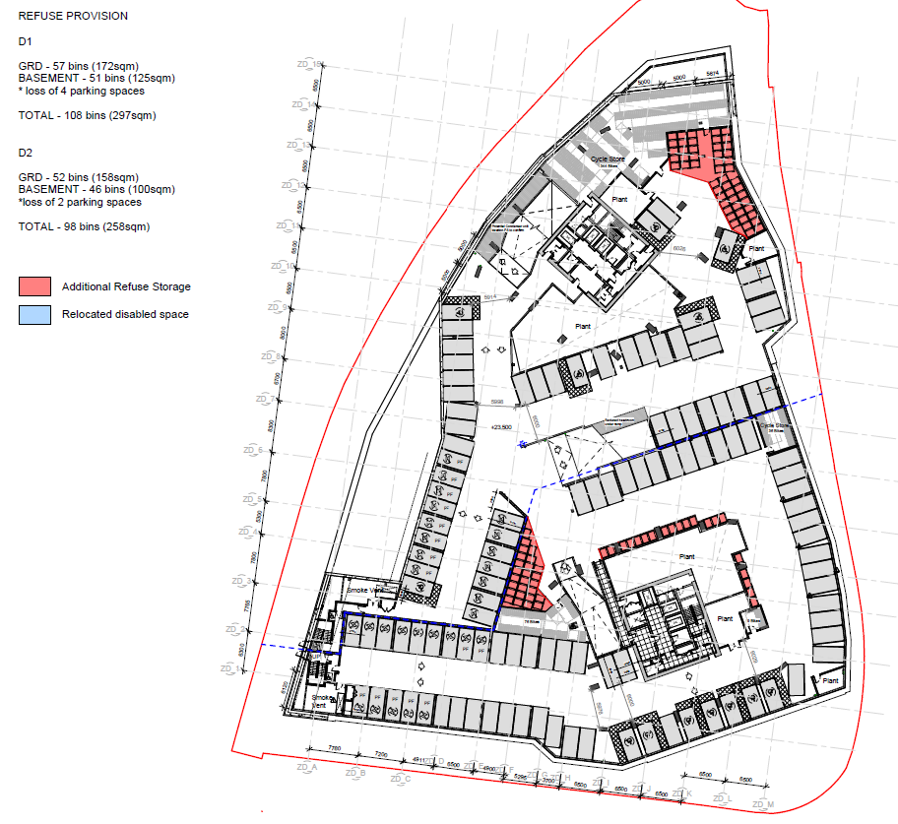
Basement Level 2
