Client:
Southway Housing Trust
Project:
VAREY STREET, GORTON, MANCHESTER, M18 8PJ
CROSS LANE, GORTON, MANCHESTER, M18 8TY-9
Completed by: Thom McKenna - Group Health and Safety Director
Jon Scurr – Managing Director
Date:
Revised:
18/03/2024

Construction Phase Plan

In Accordance with the Construction (Design & Management) Regulations 2015

R&M Property Group Ltd,
2 Highfield Rd, Bollington
SK10 5LR
Info@RandMproperty.co.uk

DOCUMENT CONTROL

Project Name: Cross Lane / Varey St

VERSION | DATE | DESCRIPTION | CREATED BY | REVIEWED BY
1.0 | 18/03/2024 | Initial Issue | Thom McKenna | Jon Scurr

CONSTRUCTION (DESIGN AND MANAGEMENT) REGULATIONS 2015

CONSTRUCTION PHASE PLAN INDEX

1.0 | INTRODUCTORY STATEMENT
2.0 | KEY PROJECT INFORMATION
2.1 | Client Representative
2.2 | CDM Principal Designer
2.3 | Project Manager / Administrator / Quantity Surveyor
2.4 | Lead Design Consultant
2.5 | Principal Contractor
2.6 | Principal Contractor Health and Safety Director
2.7 | Principal Contractors Health and Safety Advisor
2.8 | M&E Designer
2.9 | Fire Consultant
2.10 | Site Location
2.11 | Nature of Work
2.12 | Programme
2.13 | Local HSE Office
2.14 | Temporary Works Co – Ordinator
3.0 | HEALTH AND SAFETY INFORMATION
3.1 | Company Health and Safety Policy Statement
3.2 | Company Health and Safety Management Structure
3.3 | Procedures for Communicating Health and Safety Information to Site
3.4 | Emergency Procedures
3.5 | Notification to H.S.E. (F10 REV)

  - Monitoring Health and Safety Standards

  - Unplanned Events

  - Health and Safety File

  - EXISTING SITE INFORMATION

  - The Surrounding Environment

  - Services
  - Ground Conditions
  - Buildings/Structures
  - Existing Drawings
  - DESIGN
  - Anticipated Hazards

  - Method Statements

  - Risk Assessments

  - CONSTRUCTION MATERIALS

  - Materials

  - C.O.S.H.H.

  - Lifting/Manual Handling

  - Storage of Materials

  - SITE WIDE ELEMENTS
  - Traffic Systems and Restrictions
  - Compound Area
  - Welfare Facilities
  - Fire and Explosion
  - Waste Disposal

  - Control of Noise and Vibration

  - Control of Dust

  - Children

  - Personal Protective Equipment (PPE)

  - SUB – CONTRACTORS INFORMATION

  - List of Subcontractors
  - Information for Subcontractors
  - Selection
  - Co-ordination
  - Checklist
  - Agenda for Induction Meetings
  - Non-Compliance

- OVERLAP WITH CLIENTS UNDERTAKING

- SITE PROCEDURES

  - Site Rules

  - Training and Information

  - Site Liaison

  - Continuing Liaison

APPENDICES

App. 1 Risk Assessments & Method Statements App. 2 C.O.S.H.H. Assessments
App. 3 CDM Checklist (CGC/CDM/01) App. 4 Pre – Construction Information
App. 5 Plant /Machine Operators Certification & Evidence of Competency App. 6 Sub – Contractors Appraisal
App. 7 Accident / Incident Procedure
App. 8 Procedure on Discovery of Suspected Asbestos Containing Material App. 9 Smoke-free Policy

App.10 Poster Layout Office / Canteen App.11 Permit to Work
App.12 Welfare Details / Compound Layout App.13 COVID-19 Procedures
App.14 CEEQUAL
App.15 Induction Procedure

  - Introductory Statement

  - The document is in accordance with the recommendations laid down within Schedule 5 - Appendix 3 of Document L153 forming part of the Construction (Design and Management) Regulations 2015 (CDM 2015).

  - This Construction Phase Plan has been prepared from all available and relevant information relating to the project including the Pre – Construction Information dated 15th December 2021. It sets out the general framework for the management of health and safety during the duration of the project.
  - This document will need to be developed, reviewed, and updated as the project progresses, further design work is completed, information from sub-contractors becomes available and unforeseen circumstances or variations arise.
  - To maintain high standards of health and safety, all construction work will be monitored and controlled throughout the duration of the project.
  - The main objectives of this Construction Phase Plan are to achieve a safe working environment for all persons who may be affected by the work operations. Such objectives include inter alia:

    - The elimination of all reportable accidents (under the provisions of Reporting of Injuries, Diseases and Dangerous Occurrence Regulations)

    - To actively manage safety and in so doing, improve the safety awareness of all personnel involved with the site and ensure that safe working practices, for all employees, are established and adhered to

    - To encourage all employees to take part in improving the health and safety standards as detailed within this Construction Phase Plan.

This document details the various health and safety arrangements, which will be required during the progress of all construction work on the Client’s property/land.
This document will be completed in full, where relevant to this project, and developed as the project progresses and will provide the basis for the Health and Safety File.

  - Key Project Information

  - Client Representative

Southway Housing Trust
Address: Southern Gate
729 Princess Road
Didsbury
Manchester
M20 2LT
Telephone: 0161 448 4200
Email: R.Shenton@southwayhousing.co.uk
Contact: Ryan Shenton – Technical Design Officer

CDM Principal Designer
WhiteleyEaves Ltd
Address: Hollinwood Business Centre
Albert Street
Oldham
OL8 3QL
Telephone: 0161 393 8417/ 07496 554 589
Email: james@whiteleyeaves.co.uk
Contact: James Eaves
Project Manager / Administrator / Quantity Surveyor

WhiteleyEaves Ltd
Address: Hollinwood Business Centre
Albert Street
Oldham
OL8 3QL
Telephone: 0161 393 8417/ 07496 554 589
Email: james@whiteleyeaves.co.uk
Contact: James Eaves

  - Lead Design Consultant

Bernard Taylor Partnership Ltd
Elizabeth House, 486 Didsbury Road,
Heaton Mersey,
Stockport,
SK4 3BS

  - Principal Contractor
R&M Property Group ltd,
2 Highfield Rd,
Bollington,
Macclesfield
SK10 5LR

  - Principal Contractors Health and Safety Director

Thom McKenna
R&M Property Group ltd,
2 Highfield Rd,
Bollington,
Macclesfield
SK10 5LR
Thom@RandMproperty.co.uk

  - Principal Contractor’s Group Health and Safety Advisors

Daniel
Danny McCord
CMIOSH MIIRSM
DJM S.H.ECons Ltd.
MOB: 07714 703 534
OFFICE: 0161 270 8240

  - M&E Designer

TBC
  - Fire Consultant

TBC
  - Structural Consultant

Nick McGorry BEng (Hons) IEng MICE
Regional Director
SCP Transport Ltd
Colwyn Chambers
19 York Street
Manchester
M2 3BA
Telephone: 0161 832 4400 · Direct dial: 0161 819 7410
email: nick.mcgorry@scpdesign.co.uk

  - Site Locations

VAREY STREET, GORTON, MANCHESTER, M18 8PJ

CROSS LANE, GORTON, MANCHESTER, M18 8TY
  - Nature of Work

Southway Housing Trust – P500 Sites at Varey Street and Cross Lane, Gorton, Manchester.
• Construction of 5 new build plots (1 x 3-bed house and 4 x 1-bed cottage flats) to the land on
the land at Varey Street, Gorton, Manchester, M18 8PJ
• Construction of 8 new build plots (4 x 2 bed houses and 4 x 1-bed cottage flats) to the land on
the land at Cross Lane, Gorton, Manchester, M18 8TY

  - Programme

Start Date : 18th March 2024

Enabling Works : 18th March 2024

Completion Date : 05th April 2025

  - Health and Safety Executive

Redgrave Court Merton Road Bootle Merseyside
L20 7HS

  - Temporary Works Co – Ordinator

TBC

  - Health and Safety

  - Company Health & Safety Policy Statement

As enclosed.

  - Company Health & Safety Management Structure

As enclosed diagram.

    - Jon Scurr (Managing Director) has overall responsibility for the Company’s health and safety performances on sites.
    - Thom McKenna, Company Group Health and Safety Advisor will make regular site inspections, reporting directly to the Managing Director.
    - The Site Managers have the day to day responsibility for the management of health and safety.
  - Procedures for Communicating Health & Safety Information to Site

This Construction Phase Plan will be issued to the Jon Scuur & site manager prior to commencement.

An induction meeting will be held by the Site Manager and Health and Safety Advisor before site work commences, to ensure that the operatives are aware of all basic health and safety practices, site rules etc.

This will be further augmented by ongoing inductions of new operatives and “tool box” talks by the Site Manager / Jon Scurr as necessary.

  - Emergency Procedures

The attached list of emergency telephone numbers will be completed by the Site Manager on commencement and displayed in the site office, (prior to this the local Hospital A&E information must be appropriately entered) adjacent to the telephone. All operatives shall be advised of its existence during induction processes.
The Company accident/emergency procedure will also be displayed alongside the above – indicating the precise location of the site and the name and location of the nearest Hospital with accident and emergency facilities.
Air horns will be used to raise the alarm should a fire occur on site, these will be placed at strategic points and discussed on induction with all operatives prior to commencement.

  - Notification to H.S.E.

Copies of this form will be always displayed on site.

  - Monitoring Health and Safety Standards

The Company Health and Safety Advisor / Group manager will make inspections of the site unannounced. Inspections will be carried, and reports left, drawing any non - compliance to the Site Manager’s immediate attention. Any serious situations or continuing non - compliance will be reported to senior management. In addition, Directors will make unannounced quarterly audits.
At the conclusion of the project the reports will be reviewed, and any incident report studied, in order to eliminate any similar circumstances or occurrences in the future.
  - Unplanned Events
The Site Manager shall inform, by telephone immediately, and subsequently confirm in writing, any of the following to the Principal Designer and the Company Health and Safety Advisor.
- Any incident/accident required to be reported to the H.S.E. under the R.I.D.D.O.R. Regulations.

- Any enforcement action by the H.S.E. or any other enforcement body, whether in relation to Health & Safety matters or otherwise.

- Any major change of the design and/or to the resources required to complete the work which may involve amendment to the Construction Phase Plan.

  - The Health & Safety File

No specific Health and Safety File information exists. The Health and Safety File for the Project will be in accordance with CDM Regulations.
All relevant documentation will be handed over to the Principal Designer at the end of the project for incorporation into the Project Health & Safety File.
All alterations to the “original design proposals” will be recorded by the contractor/subcontractor concerned and incorporated within this Construction Phase Plan in order that they can be included within the final Health & Safety File.

COMPANY HEALTH & SAFETY POLICY STATEMENT

THE HEALTH AND SAFETY AT WORK ETC ACT 1974

The health, safety and welfare of employees are of prime importance to R&M Property Group Ltd Ltd as is the health and safety of anyone else affected directly by our operations. We are committed to achieving continuous improvement in all aspects of our activities and recognise that the effective and efficient management of health and safety is a key aspect of our overall management performance.

We undertake to comply with all of our legal duties in pursuance of providing safe and healthy working conditions for all employees and take positive action to ensure that clients, other contractors and the general public are not adversely affected by our activities. Over and above that, we are committed to ensuring that we meet best practice guidelines, meet our client’s safety rules and support their health and safety improvement initiatives. We ensure that we co-operate effectively with all those with an interest in health and safety; other employers, clients, sub-contractors, and the enforcing authorities.

The responsibility for safety at work rests upon all sectors and levels of management, and the Company will ensure that this policy is pursued throughout the organisation. The overall responsibility for the health, safety and welfare of the Company and its personnel is vested in the Company’s CEO Mr T McKenna. The Company will give full backing to this policy and to the Company’s Health and Safety Director and Representative, whose function it is to monitor and operate the policy, and support all those who endeavour to carry it out.

The Company will provide sufficient financial support and other necessary resources for the full implementation of the policy.

The policy is reviewed and updated on an ad hoc basis, when considered necessary by the CEO or Health and Safety Director. All employees shall be issued with a copy of the health and safety policy on induction and made aware of subsequent changes to the policy. Access to controlled copies will be made widely available.

The Company expects employees to conform to this policy and to comply with the relevant sections of the Health and Safety at Work Act and to exercise all reasonable care for their own health and safety and that of others who may be affected by their acts or omissions.

Signed:

25/8/20

CEO /Chair Date

HEALTH & SAFETY MANAGEMENT STRUCTURE

Organisation Chart
Mr T McKenna
CEO / Chair

Jon Scurr Director Contracts
Inc. H & S
Health & Safety Advisor
Quantity Surveyors & Estimators
Foreman Fitter
Office Manager
Director Contracts Inc. Demolition
Director Contracts Inc. IT
Engineers/Site Management
Office Staff
Fitters
Sub-contractors
General Operatives
Drivers
Machine Operators
Foreman

First Aider

TO BE DISPLAYED ADJACENT OR AS CLOSE AS POSSIBLE TO THE SITE TELEPHONE:-
POLICE , FIRE, AMBULANCE | 999
POLICE STATION | 101
NEAREST ACCIDENT & EMERGENCY HOSPITAL DEPT | Manchester Royal Infirmary  Oxford Road  Manchester  M13 9WL  Tel: +44 (0)161 276 1234
ELECTRICITY BOARD | 0845 055 4321
GAS BOARD | 0800 111 999
HEALTH AND SAFETY EXECUTIVE | 0151 951 4000
CONTRACTORS 24 HOUR EMERGENCY NUMBER | 07725546048
ENVIRONMENT AGENCY | 01925 840000

  - Existing Site Information

  - The Surrounding Environment

The 2no parcels of land are located on opposite sides of Cross Lane, Gorton, Manchester, M18 8TY and are both located in predominately residential area of Gorton, Manchester.

The addresses and sites are known as:
• Varey Street, Gorton, Manchester, M18 8PJ - The site is centred on NGR SJ 88940 96320and covers an area of approximately 0.07 Ha. (site boundary shown in pink and 250m buffer in purple).

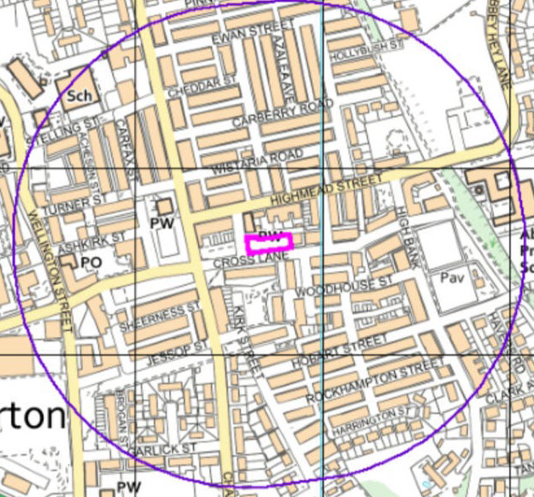

Cross Lane, Gorton, Manchester, M18 8TY – The site is centred on NGR SJ 88820 96270 and covers an area of approximately 0.16 Ha. (site boundary shown in pink and 250m buffer in purple).

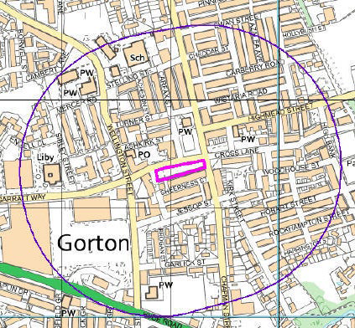

  - Services

Refer to service location plans and underground services search report.

Works must be in accordance with CDM Regulation’s and safe working practices that are planned and carried out by trained operatives.

The Principal Contractor must ensure all services are located and where necessary isolated prior to works commencing.

On site investigations will be carried out using a cable avoidance tool prior to any excavation work commencing. Any services located will be clearly marked and hand digging employed to discover the exact position. Once exposed they should be fully supported and protected for the duration of the works.
Where required details of known buried services are contained in the Network Rail Hazard Directory. Notwithstanding the Principal Contractor must consult the current version of the Hazard Directory for the location of known hidden services prior to commencement of work. Services must always be assumed to be present unless it is proven otherwise.

  - Ground Conditions

The Principal Contractor / The Client / The Project Manager and chosen suppliers shall consider the following when agreeing the finalised positions of the associated infrastructure.
- Ground and surface conditions (solid floors, tiling, suspended platforms)
- Underground services (comms, power, earthing and bonding)
- Water courses (drains, top water, sewer connections)
- Structural supports and members
- Fire stopping materials/barriers
- Presence of Asbestos
  - Buildings / Structures
As part of any design development and station survey, the Principal Contractor and suppliers shall carefully consider the impact to existing station structures. Typically, this will include stations, walls, platforms, glazed panels, roofs, canopies and so on. Site specific issues shall be identified and dealt with under the design phase. These will need careful assessment and approval under the Landlords Consent process.
  - Drawings

Refer to contract drawings.

  - Design

  - Anticipated Hazards

The following significant hazards or work sequences, which cannot be avoided or designed out, have been identified:
    - The Site Set – Up, Member of the Public, Material Deliveries and Traffic Management
    - Groundworks / Excavations
    - Concealed Services
    - Hazardous Substances
    - Control of Noise, Vibration and Dust
    - Work at Height
    - Manual Handling
    - Mechanical Handling
    - In situ Concrete
    - Use of Powered Hand Tools
    - Removal of Rubbish
    - Vandalism
    - Procedures for Dealing with Needlesticks
    - Tarmac Works
    - Line Marking
    - Street Furniture
    - Electrical Works
    - More as the works proceeds

  - Risk Assessments & Method Statements

Risk Assessments & Method statements addressing the hazards will be prepared before commencing any of the operations. These will be included in Appendix 1 of this Construction Phase Plan.

Method statements incorporating risk assessments will be required from sub- contractors as the project progresses but before their commencement on site. The Principal Contractor shall co-ordinate the preparation of method statements where the activities and risk relate to more than one sub-contractor.

  - Construction Materials

  - Materials

In general, the materials to be used in this project are commonly used in construction and their handling and use will be strictly in accordance with the manufacturer’s information and recommendations and good practice.
Asbestos registers to be referred to prior to commencement of works.
Should any asbestos or suspect asbestos be uncovered then work must cease in the area and the Client be notified. The procedure for discovery of suspected asbestos containing material must be followed which is located in appendix 9.
  - COSHH

Any materials or substances which fall under the Control of Substances Hazardous to Health Regulations; the manufacturer’s health and safety data sheets will be obtained and a COSHH assessment prepared before any such material is brought to site.

This information will be made available on site and all staff and site operatives are instructed to refer to the COSHH assessments before handling, storing or using the material.

All sub-contractors will be required to carry out their own COSHH assessments on any materials which they intend to use and these, together with the manufacturer’s health and safety data sheets, will be submitted to this Company for approval before the materials are brought to site.

  - Lifting/Manual Handling

Risk assessments in relation to the handling, lifting or carrying of heavy or awkward loads will be carried out in accordance with the Manual Handling Operations Regulations and all operatives will be instructed and trained accordingly. Wherever practicable, mechanical handling aids will be employed or additional labour will be used to assist.

  - Storage of Materials
Specific areas will be set aside for the delivery, loading and unloading of materials and contractors’ storage.
All unloading will be at the site accommodation or direct into the works area and will not be left blocking public access routes. Storage of material will be within suitable containers. This includes all materials supplied by the client through the supply contract.

  - Site Wide Elements

  - Traffic Systems and Restrictions

A logistics management plan and compound layout will be drawn up by the Site Manager prior to commencement of the works.
Site access and egress arrangements will use existing station access and egress points.
The Project Manager will make available formal procedure to secure Site Access permits and ensure formal control of contractor’s process is fully understood and briefed to the Principal Contractors managers for briefing to all project personnel.
All incomplete works will be barriered off when left unattended and identified as ‘work in progress/restricted area’.
Any highways work will be under a separate TM plan and advised to the local authority for their permissions.

All mobile plant will be removed from site each day or to be fully isolated when left unattended.

Access for Emergency vehicles will be always maintained.

  - Compound Area

The compound area will be set up in the agreed location a compound layout plan will be drawn up for enabling works and construction phase.
The whole site will be fenced off by Heras fencing for e enabling works and hard metal fencing for construction phase which will be double clipped and have lockable gates. The gates will be always locked when not in use. Suitable fencing will be placed around the compound area to prevent any unauthorized access, and suitable signage will be posted.

All materials will be stored within the compound area except materials being used for the day, this will however be returned to the compound at the end of the working day.

  - Welfare Facilities

Welfare facilities will consist of initially self-contained garic unit foir enabking works, and then full establishment will consist of the below: -

    - A heated and ventilated mess room for site personnel.

    - Facilities to heat food.
    - A hot water supply for hand washing and facility for warm water

    - An adequate supply of wholesome drinking water.

    - Toilet and hand washing facilities.

    - Provision will be made for changing out of wet clothing and for drying wet clothing.
    - An appointed first aider and adequate and suitable first aid during normal working hours.
    - An Accident Book will be always kept in a prominent position in the site office. All accidents must be reported to the Site Manager and entered in the Site Accident Book.
    - Access to and egress from all site accommodation and welfare facilities will be kept in a safe, clean and tidy condition.

    - All site accommodation and welfare facilities will be cleaned regularly and kept in a clean, tidy and hygienic condition.

    - Suitable fire extinguishers for all staff and welfare accommodation and for all storage heaters will be provided.

    - All cabins and offices using mains electricity will be a protected electricity supply by means of a residual current device (RCD).
    - LPG, if used, will be stored in secure external ventilated gas cages and not be stored in site accommodation or storage units.
  - Fire and Explosion

There will be a fire risk assessment drawn up by the Site Team prior to commencement of the works.

All site operatives and sub-contractors will be made aware of company procedure in the event of fire and explosion.

The Site Manager will advise the operatives of the sound of the intended fire alarm and the location of the designated assembly point where everyone must register their presence in the event of a fire.

Operatives will be trained to consider the changing nature of the site and that to understand, unlike an office or warehouse, where very little changes, the site is constantly changing: ‘Last week’s evacuation route could be this week’s dead end.’

All site offices, stores, mess cabins etc. will be fitted with suitable fire extinguishers and all site personnel will be made aware of correct usage in case of emergency.
All materials and substances must be stored in accordance with the manufacturer’s instructions and the information contained in the COSHH assessment records and the manufacturer’s health and safety data sheets.
All flammable materials will be kept in a separate flameproof lockable container fitted with suitable extinguishing media. This type of material will be stored in strict accordance with the following:
HSE: HSE(G)3, HS(G)34, HS(G)51, CS4 and CS6.
All spare and empty LPG cylinders will be stored in a lockable gas cage situated at least 3 meters from any other building, cabin, structure, perimeter fence or excavation and in the open air. All gas cages must be fitted with the regulation inflammable gas warning signs and notices. Gas cylinders will not be stored in cabins, containers, or other similar buildings unless they are an integral part of the equipment.
  - Waste Disposal

Rubbish, debris, etc. will be collected regularly from the work area and not allowed to accumulate. An enclosed skip will be located in the compound area for general waste. Waste material from site will be stockpiled in the compound area fenced off and then loaded onto wagons and taken away. The correct duty of waste form will be completed.

The Company is registered with the Environment Agency as required by The Controlled Waste (Registration of Waste Carriers and Seizure of Vehicles) Regulations 1991, Registered Carrier No. CBDU110120.

  - Control of Noise and Vibration

All necessary steps will be taken to reduce noise levels from plant and machinery in accordance with The Noise at Work Regulations. Where reasonably practicable, noise levels will be reduced at source to their lowest reasonable level and Personal Protective Equipment must only be employed as a last resort.

Noise assessments, where considered necessary, will be carried out by the Company Health and Safety Advisor and appropriate measures taken to protect site operatives, residents and the general public from the effects of noise.
Vibration assessments will be carried out on site for all tools which are being used, this is undertaken by either collecting data from the tool and then transferred onto the HSE vibration calculator or using our in house Havimeters.

  - Control of Dust

All necessary precautions will be taken to protect residents, site operatives and the public from the effects of the inhalation of respirable dust caused by the works. All operations which create dust, will include a type of dust suppression technique, such as damping down or mechanical dust extraction. This applies especially to cutting or grinding operations. All operatives will be issued with and required to wear suitable goggles and masks or respirators, wherever this type of work is being carried out. All operatives who wear a dust mask will have received a face fit test Members of the public will be excluded from work areas where dust arises.
  - Children

It will be assumed that there will be children living on or near the work areas. Therefore, all work operations will be carried out in accordance with HSE Guidance Note GS7 “Accidents to Children on Construction Sites” and HSE publication “Protecting the Public – Your Next Move”, both of which are issued to all sites in the Company Site Starter Packs.

All high-risk areas will be made safe at the end of each working day by the erection of a secure fence (Heras or similar) around the area. Suitable warning signs and notices will be securely affixed to the fencing.

All site plant will be either locked securely away or be effectively immobilised to prevent unauthorised use.

  - Personal Protective Equipment (PPE)

All contractors and visitors are required to wear PPE in accordance with the Client’s standards:
- Hard hat
- high visibility clothing
- Safety boots
- Safety gloves
- Safe glasses /goggles For site specific activities
  - Sub – Contractors Information

  - Sub-Contractors

Various subcontractors will be employed who are either known to R&M or have passed their competency requirements and proved their experience’s in quality and safety.

  - Information for Sub-Contractors – Notification of Risks
All Sub – Contractors will be given a copy of the Construction Phase Plan or relative sections, Group Health & Safety Policy and the Casey Group Safe Systems of Work and will be required to confirm their agreement to comply with these documents before a contract is placed.
  - Selection Procedures

The Principal Contractor will ensure the competence and resources of all Sub - Contractors to be engaged in the works (see CGC/CDM/03).

Sub – Contractors will be required to submit their Company Health & Safety Policy, general systems of work, COSHH/risk assessments, and specific method statements before commencing work on site. These documents will be checked by the Principal Contractor and copies of relevant information forwarded to site for inclusion into this Construction Phase Plan.

The Health and Safety performance of Sub – Contractors will be monitored and recorded during health and safety inspections and audits.

  - Co-ordination

The Site Manager / Director will be responsible for the co-ordination of the works carried out by separate contractors and ensuring the Sub - Contractors compliance with the Construction Phase Plan.
The Site Manager / Director will ensure that all operators of plant possess the requisite training and certificates and copies will be retained for inclusion into the Construction Phase Plan.
  - Checklist

The enclosed checklist will be completed before a sub-contractor commences on site.

  - Agenda for Induction Meetings

The enclosed agenda will be used as a guide for all CDM induction meetings held on site.

  - ? IJllompliance

In the event of any subcontractor failing to comply with the Health and Safety Regulations and continuing to do so following verbal warning, will be formally notified in writing as per our standard letter.

List of Sub – Contractors

Contractors  Name | Address | Contact | Telephone  Number

CHECKLIST CGC/CDM/02 SUB – CONTRACTORS

To be completed before a sub-contractor commences on site.

Name of Sub-Contractor: -

Description of Work: -

 |  | Tick | Date | Action
a) | Sub-Contractors Health & Safety Policy:
 | - copy sent to Principal Designer
 | - added to Construction Phase Plan
b) | Sub-Contractors Risk Assessments:
 | - copy sent to Principal Designer
 | - added to Construction Phase Plan
c) | Sub-Contractors Method Statement:
 | - copy sent to Principal Designer
 | - added to Construction Phase Plan
d) | Form CGC/CDM/03 completed and added
 | to Construction Phase Plan
e) | Sub-Contractors Safety Induction
 | Meeting held. Form CGC/CDM/04
f) | Sub-Contractors Plant & Machinery Operators
 | Certificates added to Construction Phase Plan

CGC/CDM/02

AGENDA FOR C.D.M. INDUCTION MEETINGS FOR SUB - CONTRACTORS

- Introduction
- Principles of Construction Phase Plan

- Site Access and Egress Points

- Site Rules

- Welfare Facilities

- Lines of Communications

- Plant and Machinery Operators Certificates

- Materials Storage and Distribution

- Underground Services

- First Aid Arrangements
- Variations and Updating of the Construction Phase Plan
- Requirements for the Health & Safety File.

CGC/CDM/04

- Overlap with Clients Undertaking
Please refer to section 7.0 Site Rules, 8.0 Construction Phase Plan, Work Package Plan and Task Briefing Sheets, 9.0 – Co-Ordination with Client and 10.0 CEEQUAL Requirements of the PCI located in Appendix 4 of this Construction Phase Plan.
Signage will be erected to give information to members of the public.

Health & Safety Objectives

The overall objective is to complete this project with due regards to the health, safety and welfare of all parties directly and indirectly involved with the project together with others such as adjacent contractors, user personnel, visitors and members of the general public.

To achieve Zero complaints in relation to health, safety and welfare. To achieve Zero accidents, incidents and near misses.

- Site Procedures
  - Site Rules
The following site rules shall be copied and displayed in the site office and mess rooms in order that all operatives will have the opportunity to make themselves aware of them.
SITE RULES TO BE ADHERED TO AT ALL TIMES

    - All operatives, including those of sub-contractors, have a duty to be aware of and observe the requirements of the Construction Phase Plan.

    - All operatives and visitors to site must report to the Site Manager before proceeding onto the site.

    - The site will be a “Hard Hat” site at all times where there is a risk of head injury. All operatives, staff and visitors to the site are provided with safety helmets complying with BSEN397. The wearing of safety helmets will be enforced at all times and appropriate signs will be posted. All other items of PPE will be worn in strict compliance with the specific risk assessment.

    - All personnel, including Sub – Contractors personnel, must wear identification badges with photographs, clearly displayed at all times. They shall be issued in this time each morning and the same number collected each evening.

    - An appointed first aider will be available on site at all times during normal working hours.

    - No person will be allowed on site if under the influence of alcohol or drugs (unless prescribed) or if they are in the possession of alcohol or drugs.
    - The notification of the project to the Health and Safety Executive will be prominently displayed on the site office notice board.
    - All temporary warning signs and notices are to be maintained and replaced where necessary.
    - All machinery, tools and plant on site, including power hand tools, must be tested every three months and maintained in good condition. All temporary electrical equipment and power tools must not exceed 110 volts.
    - All ladders and access equipment must be securely locked away during non-working hours and when not in use or required for imminent use to prevent unauthorised access to scaffolding etc.

    - All necessary and reasonably practicable measures must be taken to exclude unauthorised persons from the work area at all times.
    - The site is to be kept clean and the creation of dust is to be eliminated as far as is practicably possible.
    - The playing of radios, or the like will not be permitted on site at any time.

    - All site security fencing, including gates and hoardings must be properly maintained and made secure at the end of each working period.

    - Protective footwear must be worn by all persons whilst on site.

    - No fires will be allowed on site.

    - Smoking shall not be permitted within the curtilage of any dwelling on which contractors personnel are working. For further assistance contact your visiting Health and Safety Advisor or refer to the Smokefree Law guidance supplied by H M government.

    - Sun cream will be available in the site office for use by operatives on site during sunny periods.
  - Training and Information
All personnel on will receive appropriate induction before they start working and personnel will also receive periodic “tool box” talks from the Site Manager. These will include the implementation of safe working practices, the proper use of personal protective equipment and general conduct.

Operators of plant, machinery and portable electrical equipment will be trained in accordance with relevant regulations before being authorised to use these items on site.
All personnel on site will have already received, or will be given, suitable training to ensure their health and safety so far as reasonably practicable, as required by the Health and Safety at Work Act 1974.
Training falls into three basic categories: - General Training
Trade Specific Site Specific

General Training
Employees will be given information on the risks to their health and safety. Training is linked to capabilities to ensure that anyone given a specific task is capable of carrying this out in the prescribed manner.
In addition, employees and subcontractors will be provided with adequate health and safety training through induction talks prior to commencement and “Tool Box” talks aimed to make employees aware of risks and the necessary controls prior to commencing an operation.

Trade Specific

Most of this training is covered by organisations such as the C.I.T.B., and the Site Manager will ensure that only properly trained persons, holding a current training certificate, undertake the required during the duration of the project.

Site Specific

All personnel employed on the site will receive a Site-Specific Induction before commencing work on site.
  - Site Liaison
- Daily chats, weekly briefings and toolbox talks will be undertaken by the Site Manager with all operatives on site.

- Regular site meetings will be held with all Sub – Contractors and major suppliers, at which the Company will present the following information in relation to health and safety.

  - A report on any accident along with the H.S.E.’s comments and a copy of the Accident Book.
  - Notes of any meetings with Police/Emergency services.
Arrangements for co-operation and co-ordination between Sub – Contractors and major suppliers will be discussed and methods agreed for ensuring that all health and safety decisions will be passed between all parties and to the site operatives
Meetings to discuss health and safety will be held as and when required either by the Principal Designer or Principal Contractor.

- Any unforeseen eventualities during the execution of the works, which could have implications on health and safety matters, will be brought to the attention of the Company Safety Advisor immediately.

  - Continuing Liaison
This document will be reviewed and developed throughout the project, to incorporate any procedures occurring later in the programme which may not have been detailed in this Construction Phase Plan.
Procedures for considering the health and safety implications of design elements of the Principal Contractors and other Contractors packages.

Where a change in design is required, then the Principal Contractor will consult with the Principal Designer to consider safety implications of possible design changes; for example:

- What new hazards arise from the design changes;

- How these hazards can be designed out or minimised and additional safety measures that may be required.

Procedures for dealing with unforeseen eventualities during project execution (resulting in substantial design change and which might affect resources).

The Principal contractor will consult with the Principal Designer to consider:
- Safety implications of proposed design changes;
- What new hazards arise from the proposed design changes;

- How these hazards will be designed out or minimised and additional safety measures that may be required

Liaison with any subcontractor who may be involved, or possibly manufacturer/supplier may be necessary during consultations, but in all cases the Contract Administrator / Principal Designer will be advised on the outcome and the effect upon the Construction Phase Plan.

Appendix 1

Method Statements & Risk Assessments

Appendix 1

Method Statements & Risk Assessments

Method Statement

The following information has been prepared in order that work can proceed without risk of personal injury or damage to plant or equipment on this project. This method statement will be brought to the attention of all those operatives and others concerned with this part of the project. This will be done during the induction talk prior to commencement on site.

Job Description: Cross St and Varey St

Summary of risk analysis:

- The Site Set – Up, Member of the Public, Material Deliveries and Traffic Management
- Groundworks / Excavations
- Concealed Services
- Hazardous Substances
- Control of Noise, Vibration and Dust
- Work at Height
- Manual Handling
- Mechanical Handling
- In situ Concrete
- Use of Powered Hand Tools
- Removal of Rubbish
- Vandalism
- Procedures for Dealing with Needlesticks
- Tarmac Works
- Line Marking
- Street Furniture
- Electrical Works
- More as the works proceeds

Method Statement
- The Site Set – Up, Members of the Public, Material Deliveries and Traffic Management
The site office and compound are to be located in an agreed area, a site compound layout plan will be drawn up prior to commencement.

Heras fencing will be placed around the compound area to prevent any unauthorised access, and suitable signage will be posted.

The welfare facilities for the site will be as listed within Section 7.3 of the Construction Phase Health and Safety Plan and in accordance with The Construction (Design and Management) Regulations 2015.

The routes of least inconvenience will be used for transporting materials to and from their place of use from the compound and a scheme Traffic Management Plan and Assessment will be developed as the site progress.

Delivery drivers to the site will first report to the Site Manager. Reversing without a Banksman will not be permitted.
Delivery times will be phased to avoid high vehicular and pedestrian times.
- Groundwork / Excavations

Before excavating all available service drawings of the immediate area will be assessed.

Prior to excavation, on-site investigations must be carried out by a trained operative using a cable avoidance tool (CAT). Any services located must be identified and clearly marked.
Having assessed that no services will be affected, excavate for foundations accordingly. If any services are likely to be affected, all excavation work must be carried out in strict accordance with the Company’s Safety System of Work.
All excavations must be kept to a minimum and where possible, excavations will not be left open overnight.
Take all necessary precautions to prevent unauthorised access to excavated areas. All necessary safety signs and notices to be erected and maintained.

All arisings and debris from excavation operations must be maintained within the Heras fencing.
All surplus materials, which cannot be made safe, must be returned to the compound area at the end of each working day.
- Concealed Services

A visual inspection will be carried out prior to the erection of any access equipment and prior to excavation work. Service drawings will be viewed and the area will be scanned using a cable avoidance tool. Any services located will be clearly marked and hand digging employed to discover the exact location.

All work will be undertaken in accordance with HS(G) 47 Avoiding Danger From Underground Services.

- Hazardous Substances

A COSHH assessment will be undertaken for all substances on site. Substances without a COSHH assessment will not be permitted to be used.

Copies of COSHH assessments will be maintained in the Company’s Risk Assessment Manual on site for quick and easy reference.
The Company Buying Department will inform the Company Health and Safety Advisors of new products to be used so that the necessary assessments may be undertaken. The product hazard data sheets must also be obtained by the Buying Department.

All substances to be used on this project will be notified to the Health and Safety Advisors by the Company Buying Department.
All substances to be used by a nominated sub-contractor will be brought to the attention of the Health and Safety Department at the time of the pre-contract appraisal therefore allowing the Health and safety Advisors to assess the use of such substances.
Hazardous substances and the required control measures will be discussed during the Site Specific Safety Induction before work commences on site.
- Control of Noise, Vibration and Dust

All necessary steps will be taken to reduce noise levels from plant and machinery in accordance with The Noise at Work Regulations. Where reasonably practicable, noise levels will be reduced at source to their lowest reasonable level and Personal Protective Equipment must only be employed as a last resort.

Noise assessments, where considered necessary, will be carried out by the Company Health and Safety Advisor and appropriate measures taken to protect site operatives, and the general public from the effects of noise.
All necessary steps will be taken to reduce vibration levels to be below the current threshold limit of 2.5 m/s² from tools, equipment, plant and machinery.

Those using tools which vibrate and which potentially cause ill health will be specifically trained to eliminate or reduce the harmful effects of vibration through good operating techniques and job rotation.

All necessary precautions will be taken to protect site operatives and the general public from the effects of the inhalation of respirable dust caused by the works. All operations, which create dust, will include a type of dust suppression technique, such as damping down or mechanical dust extraction. This applies especially to cutting or grinding operations. All operatives will be issued with and required to wear suitable goggles and masks or respirators, wherever this type of work is being carried out. Residents will be excluded from work areas where dust arises. Area to be thoroughly cleaned on completion.

- Working at Height
All work at height will be carried out in accordance with The Working at Height Regulations.
All working at height will have a risk assessment for the task in hand.

- Manual Handling
Risk assessments in relation to the handling, lifting or carrying of heavy or awkward loads will be carried out as necessary in accordance with the Manual Handling Operation Regulations 1992. Any operative involved in the operations will receive clear instructions from a Competent Supervisor before commencing and will be provided with the necessary PPE i.e. hard hat, gloves, suitable footwear and hi visibility clothing.
Copies of Manual Handling Assessments will be maintained on site in the Company’s Risk Assessment Manual on site for quick and easy reference.
Materials will be delivered as close as possible to the site of use.

Wherever possible mechanical lifting aids will be employed or additional labour used to assist.

Those required to manually lift will be trained in kinetic handling techniques. No person will be expected or permitted to work beyond their physical capabilities. No work rate will be imposed on this activity.

All weights of heavy or awkward items will be made available to those concerned.
Where any lifting operations involving glass are to take place, the area will be cordoned off to prevent unauthorised access.
- Mechanical Handling

Site supervisors must ensure that:

Each lifting operation is pre-planned and organised, taking full account of visibility, environment, proximity hazards, ground stability etc.

Only trained and certified plant operators operate machinery.

All lifting operations are under the control of an experienced slinger / signaller.

The Safe Working Load (SWL) is clearly labelled on the machine boom and in the machine cab.

Only the correct and tested chains, slings, wire ropes or webbing are used. Any safe working load is not exceeded.
Only necessary, authorized operatives are present in the immediate lift area during any lifting operations.

All operatives involved in the lifting operation are wearing the necessary personal protective equipment (PPE) i.e. safety helmet, protective footwear, gloves and high visibility clothing.
All lifting gear is inspected regularly and maintained in accordance with statutory and manufacturer’s instructions.
GSO307 register is completed every 7 days and all records of tests and certificates are available on site.
All operations of this nature are carried out in strict accordance with The Lifting Operations and Lifting Equipment Regulations (LOLER) 1998 and The Provision and Use of Work Equipment Regulations (PUWER) 1998.

- In-Situ Concrete
The handling of in-situ concrete must be kept to a minimum so as to prevent a risk from manual handling or occupational diseases.
COSHH Assessments and data sheets are available for information on the exposure of operatives to concrete based materials and these will be maintained on site.

Suitable and effect PPE will be issued to and must be worn by all operatives at risk.

So far as is reasonably practicable, mechanised processes will be employed to minimise the risk from manual handling injuries or exposure to concrete.

All concrete based materials must remain within the protective fenced areas.

Surplus or waste materials, which cannot be made safe, must be returned to the compound area at the end of each working day.

- Use of Powered Hand Tools

The majority of portable tools will be battery operated, however if electric is used the following must apply.
All portable electric tools shall be 110V rated and supplied from either a mains supply via a transformer or alternatively a generator (petrol or diesel).

Where a mains supply is used, the 240 volt lead from the socket to the transformer should be kept as short as possible AND A Residual Current Device (RCD) fitted between the power supply source and the tool.

Where a generator is used, consideration needs to be given to the siting of this in an attempt to reduce the effect of noise and fumes. The generator should be switched off as soon as it is not required to keep noise to a minimum.
In all cases, the trailing leads should be kept to a minimum to avoid damage to them, and possible tripping, and care needs to be taken when using cable drums or reels as they can overheat and cause fires.
Maintenance

The risks from damaged or faulty equipment or leads are HIGH and the consequences SERIOUS - therefore a PRO-ACTIVE maintenance system has been developed in an attempt to prevent accidents from happening.

All portable electric tools are inspected and tested prior to issue by our own Plant Department, and thereafter at 3 monthly intervals. The date of issue is recorded by the Plant Department and also by site to which it is issued. Should the equipment be required for an extended period, the site must return it for inspection and testing at the end of the 3 month period. The same procedure is followed for any equipment hired externally from a Plant Hire company.
In addition to the above, a responsible person on site will be allocated and suitably trained to carry out a weekly visual site inspection of all portable electric tools and leads and maintain a record for each item. This should not involve taking the equipment apart but will include checks that:

- the plug has a proper and correct fuse
- cable terminations are correct
- no signs of damage to tools or extension cables
- no ingress of liquid into equipment

Any item found to be faulty will be taken out of use immediately, reported to the Site Manager and returned to the Plant Department for repair.

Further, the actual user is asked to carry out visual checks of any item, before commencing work to ensure that:
- bare wires are not visible
- the cable covering is not damaged, free from cuts and deep abrasions
- plug is in good condition, i.e. casing not cracked, pins are not bent or the socket is not blocked
- there are no taped or other non - standard joints in the cable
- the cable sheathing is securely gripped where it enters the plug or equipment (the coloured insulation of the internal wires must not be visible)
- the outer casing of the equipment is not damaged or loose and all screws are in place
- there are no overheating or burn marks on the plug, cable or the equipment
Users Checklist

Disconnect before adjusting or working on machine Disconnect when not in use
Check that colour codings are correct Do not use “unofficial” extension cable Do not carry out “makeshift” repairs
Report defects immediately to Site Manager and do not use Keep machine clean and free from damp
Do not carry equipment by the cable

Do not start or stop the machine under load
Emergency Treatment for an Electric Shock Casualty
In the event of someone suffering an electric shock, the first priority for the rescuer is to avoid becoming a casualty themselves.
DO NOT TOUCH the casualty with bare hands until you have made sure that they are not still connected to the electric current in any way.

Break the electrical contact by either SWITCHING OFF the supply or wrenching the cable free.

If you are unable to isolate as above, stand on dry insulating material such as a plastic or rubber mat, wooden box or a pile of dry newspapers and then use a wooden stick, plastic implement or a length of rope to free the casualty from contact with the electricity.
Once this has been achieved, ensure there is no more danger to anyone, and send for assistance of the first aider who is always on site during working hours.

Where these portable tools are used in occupied premises, extra care must be taken to ensure that they are never left with power switched on when not attended and must be protected against interference by residents, particularly children.
Trailing leads must be kept as short as possible to avoid tripping.

- Removal of Rubbish

Rubbish, debris, etc. will be collected regularly from the work area and not allowed to accumulate.

The Company is registered with the Environment Agency as required by The Controlled Waste (Registration of Waste Carriers and Seizure of Vehicles) Regulations 1991, Registered Carrier No. CBDU110120.
- Vandalism
All necessary steps must be taken to prevent unauthorised access to working areas by the use of 2m high Heras security fencing.
No items of plant must be left unattended. When not in use, all vehicles must be switched off and the ignition key removed.

To reduce the risk of vandalism, all surplus and valuable materials and equipment must be returned to the site compound at the end of each working day.
All materials and equipment must be stored in secure lockable containers, which must be kept locked at all times when not in use.
- Procedures for Dealing with Needlesticks

There is an obvious risk of injury and possible risk to health of persons who come into contact with hypodermic needles. The risk is low, nevertheless it cannot be discounted.

In order to minimize any risk involved, the following precautions should be taken.

All employees must be aware of the possibility of finding hypodermic syringes and needles in valve, hydrant and stop-tap boxes, any sewage or drainage system, sand piles etc and in all areas frequented by drug users.

Before reaching into any valve box etc a careful examination should be made to ensure that no syringes or needles are present. If the presence of water prevents this, then it should be pumped or baled clear.

Any employees working in areas where syringes or needles may be found must wear protective gloves at all times.
If a syringe or needle is found and cannot be handled or disposed of safely, then the nearest Environmental Health Department is to be contacted immediately, for them to deal with the situation safely.

On no account must syringes or needles be disposed of on tips or in rubbish bins or skips, they must be incinerated in a safe manner.
In the event of a puncture wound occurring, the injured person should squeeze the affected area to promote bleeding and the affected area should be thoroughly cleansed with clean warm water. The injured person must then attend the Accident & Emergency Department of the nearest hospital immediately, as immunization against Hepatitis B needs to be administered within 72 hours of the incident.
The Company Health & Safety Department and the local Environmental Health Department must be notified immediately.
- Tarmac
- Line Marking
- Street Furniture
- Electrical Works

These will be carried out by a nominated sub-contractor. The sub-contractor will be subject to a formal health and safety appraisal before being appointed. This will include the completion of a Pre-Contract Questionnaire, Details of Insurance Cover, Job Specific Method Statements and Risk Assessments. All information will be assessed and confirmed as being satisfactory by the Company Health and Safety Department before work on site commences.
In addition, the sub-contractor will be issued with a copy of the Company’s Health and Safety Code for Sub-Contractors and be required to acknowledge receipt and confirm that they will comply with the Code.

- More to follow as the works proceed General Safety
All persons employed on this project will be required to wear a hard hat, safety boots and high visibility clothing along with any other personal protective equipment (PPE) identified by risk assessment and required by their activity.

Materials will be positioned so as not to cause tripping hazards or obstructions, especially to access and egress points to properties and pedestrian walkways and footways.
The working area will not be left unattended during working hours unless it is made safe.
Operatives will clean up and remove loose debris from around the general work area ensure debris is periodically removed from the working area in order to reduce any potential risk from the accumulation of material.

Materials will be deposited and debris removed under the supervision of a banksman at the working areas. This includes skips.
All works will take account of statutory provisions.
Plant Operators will hold CITB / NPORS Plant Operator Certificates or equivalent.

Hazard | Persons in Danger | Harmful Consequences | Risk Rating before control measures | Control Measures / Method Statement | Residual Risk after control measures
Electrical faults, damage to powered equipment, cables and plugs etc. | Operatives.  Others in vicinity of use.  Members of the general public. | Electric shock, burns and possible death. | H | Inspect equipment prior to use.  Use low voltage equipment (110v) where possible.  Regular testing of equipment to be carried out, as recommended by manufacturer, by a competent person.  Ensure power cables are suitably slung, secured and protected as necessary.  Report any defect immediately to the Site Supervisor and do not use equipment until the defect is remedied.  Regular inspections carried out by Site Supervisor.  Specific Legal Requirements  Electricity at Work Regulations 1989.  Provision and Use of Work Equipment Regulations 1998. | L

*
Hazard | Persons in Danger | Harmful Consequences | Risk Rating before control measures | Control Measures / Method Statement | Residual Risk after control measures
Collapse of excavation sides.  Striking buried services such as gas, electric, water etc.  Plant running into excavations.  Persons falling into excavations.  Contact with adjacent structures. | Operatives.  Others in immediate vicinity.  Members of the general public. | Injuries of various severities:  Crushing, entrapment and possible death.  Contact with services may give rise to electrocution, explosion, fire, flooding.  Damage to adjacent buildings, structures etc. | H | Ensure method statements are in place.  Adequate supports to be used in excavations or the sides battered back as appropriate. No person must enter an unsupported excavation  Supervisors and key operatives to be trained in Trenching Operations if appropriate.  Ensure that a safe access and egress is provided.  Ensure plant, equipment and arisings are not placed near edges of excavation i.e. within the shear zone of the embankment.  Ensure that adjacent structures etc. are not undermined.  Where there is a risk of plant running into excavations physical barriers should be provided in the way of stop blocks, bunds, barrier tape and suitable signage as required.  Precautions must be taken to prevent persons from falling into excavations i.e. effective barriers and suitable signage. | L

Hazard | Persons in Danger | Harmful Consequences | Risk Rating before control measures | Control Measures / Method Statement | Residual Risk after control measures
Cont …. |  |  |  | Whilst excavating if unusual or unidentified materials are exposed ‘digging’ operations must cease until the material has been positively identified.  Depending on depth and the material through which the excavation is dug the excavation may be considered as a confined space and therefore suitable additional precautions may be required.  Work to be supervised by a competent person.  Regular inspections to be carried out by the Site Supervisor. If excavations are open for 7 days or more the results of the inspection should be recorded. Notwithstanding the recorded inspection the excavation must be inspected each time before entry and after adverse weather conditions.  Ensure the correct PPE is worn e.g. safety helmet, safety footwear, gloves etc.  Specific Legal Requirements  Construction (Design and management) Regulations 2015.

Hazard | Persons in Danger | Harmful Consequences | Risk Rating before control measures | Control Measures / Method Statement | Residual Risk after control measures
Striking buried services such as gas, electric, water etc. | Operatives.  Others in immediate vicinity.  Members of the general public. | Injuries and damage of various severity, such as:-  Burns. Electrocution. Explosion.  Fire. Flooding. | H | Contact must be made to the pipeline owner prior to working within 50 metres of pipeline.  No work to take place within 3 metres of Cadent owned pipelines unless Cadent have been to site and clearly located and marked out the pipeline. Also Specification for safe working in the vicinity of National Grid high pressure gas pipelines and associated installations – requirements for third parties booklet (T/SP/SSW/22 April 2014 must be adhered to.  Obtain plans / drawings of immediate area.  Use suitable detector to locate services prior to digging.  Operatives using detectors must be suitably trained.  Mark position of services once located. Re – mark every 500mm of excavating down.  Ask utility owners to make safe before excavation begins.  Dig trial holes. | L

Hazard | Persons in Danger | Harmful Consequences | Risk Rating before control measures | Control Measures / Method Statement | Residual Risk after control measures
Cont …. |  |  |  | Use blunt digging tools.  Excavate alongside the service rather than directly above it. Final exposure of the service by horizontal digging is recommended, as the force applied to hand tools can be controlled more effectively.  Insulated tools should be used when hand digging near electric cables.  Do not mechanically excavate within 0.5m of the services identified.  All operatives who hand dig must be warned of the hazards and instructed in the safe system of work.  Work to be supervised by the Site Supervisor.  Specific Legal Requirements  HS(G)47 - Avoiding Danger from Underground Services.

Hazard | Persons in Danger | Harmful Consequences | Risk Rating before control measures | Control Measures / Method Statement | Residual Risk after control measures
Leptospirosis (Weils disease) - contracted through exposure to rat’s urine. | Site Operatives. | Leptospirosis - Weils disease (flu like symptoms with the possibility of death if not treated at an early stage). | H | Keep mess areas clean and free from debris and waste.  Rodent control by competent pest control company.  Issue Leptospirosis cards to those employees at risk.  Ensure that cuts, grazes / dressings etc. are effectively covered.  Ensure correct PPE is worn when working in risk areas such as ditches, watercourses, and excavations e.g. impervious gloves etc.  Ensure a high standard of personal hygiene.  Ensure that suitable and adequate welfare facilities are provided.  Regular inspections to be carried out by Site Supervisor.  Specific Legal Requirements  Control of Substances Hazardous to Health 2002.  HSE Leptospirosis Card. | L

Hazard | Persons in Danger | Harmful Consequences | Risk Rating before control measures | Control Measures / Method Statement | Residual Risk after control measures
Excessive noise. | Operatives.  Others in immediate vicinity. | Noise induced hearing loss. Stress. | H | Carry out a noise assessment, where necessary. Noise exposure to be reduced so far as reasonably practicable i.e. isolate the noise or the operative. NB. PPE should only be considered as a last resort.  Ensure that consideration is given to purchasing low noise emission equipment.  The equipment should display the maximum noise levels emitted by the equipment.  Establish an exclusion zone if appropriate and erect suitable signage.  Ensure that suitable ear defenders are worn as necessary.  Any defect in any hearing defenders must be reported immediately to the Site Supervisor and replacements obtained.  Young persons are not to use or be in the vicinity of equipment which produces noise above 80db this will be covered on induction and monitored by their work buddy.  Regular inspections to be carried out by the Site Supervisor.  Specific Legal Requirements  Noise at Work Regulations 2005. Personal Protective Equipment at Work Regulations 1992. | L

Hazard | Persons in Danger | Harmful Consequences | Risk Rating before control measures | Control Measures / Method Statement | Residual Risk after control measures
Vibration.  N.B. Noise is usually associated with vibrating equipment. Please refer to the Noise Risk Assessment Record. | Operatives. | Vibration White Finger / Hand Arm Vibration.  Muscle damage. Musculoskeletal disorders.  Potential for long term back injury. | H | Use low anti vibration models of equipment.  Work to be effectively shared or a job rotation scheme implemented to reduce exposure.  Ensure that vibration levels are clearly marked on tools and equipment.  Ensure equipment is maintained in effective working condition and tips, blades etc. are kept sharp so as to reduce vibration levels.  Keep hands warm especially in cold weather. VWF is more prevalent in cold weather.  N.B. VWF is known to be more prevalent in those who smoke.  Ensure correct PPE is worn i.e. ear defenders, suitable and effective gloves, footwear etc.  Items of plant and equipment must be periodically inspected.  Report any defective equipment to the Site Supervisor and do not use equipment until defects are remedied. | L

Hazard | Persons in Danger | Harmful Consequences | Risk Rating before control measures | Control Measures / Method Statement | Residual Risk after control measures
Cont …. |  |  |  | Items of plant and equipment must be periodically inspected.  Report any defective equipment to the Site Supervisor and do not use equipment until defects are remedied.  Young persons are not to use any vibrating tools this will be covered on induction and monitored by their work buddy.  Regular inspections to be carried out by Site Supervisor.  Specific Legal Requirements  Provision and Use of Work Equipment Regulations 1998.  Control of Vibration at Work Regulations 2005.

Hazard | Persons in Danger | Harmful Consequences | Risk Rating before control measures | Control Measures / Method Statement | Residual Risk after control measures
Excessive exposure to environmental / nuisance dust. | Operatives.  Others in the immediate vicinity.  Neighbours. | Respiratory disorders of various severities from temporary mild discomfort and coughing to debilitating conditions.  Environmental Impact. | H | Ensure that operations are carried out so as to prevent the production and spread of environmental / nuisance dust.  Provide suitable dust suppression techniques i.e. ‘damping down’ with water.  Provide suitable personal protective equipment i.e. dust masks or respirators of the correct type.  Provide environmental and personal monitoring as necessary.  Regular inspections to be carried out by the Site Supervisor.  Specific Legal Requirements  Control of Substances Hazardous to Health 2002. Environmental Protection Act 1990. | L

Hazard | Persons in Danger | Harmful Consequences | Risk Rating before control measures | Control Measures / Method Statement | Residual Risk after control measures
Excessive exposure dust. | Operatives.  Others in the immediate vicinity.  Occupants Neighbours. | Respiratory disorders of various severities from temporary mild discomfort and coughing to debilitating conditions.  Environmental Impact. | H | Ensure that operations are carried out so as to prevent the production and spread of dust.  Ensure that equipment is operated in accordance with the manufacturers instructions at optimum speeds etc. and blades and bits are maintained in effective working condition.  Provide suitable and adequate ventilation if working in enclosed areas.  Ensure, if necessary, that dust extraction equipment is fitted to tools and equipment.  Provide suitable dust suppression techniques, i.e. ‘damping down’ with water, if appropriate.  Provide suitable personal protective equipment i.e. dust masks or respirators of the correct type.  Provide environmental and personal monitoring as necessary.  Regular inspections to be carried out by the Site Supervisor.  Specific Legal Requirements  Control of Substances Hazardous to Health 2002. | L

Hazard | Persons in Danger | Harmful Consequences | Risk Rating before control measures | Control Measures / Method Statement | Residual Risk after control measures
Contact with hazardous substances through Ingestion, inhalation and contact with skin.  Environmental contamination. | Operatives.  Others in immediate vicinity of use. | Injuries and conditions of various severities such as sickness and nausea, burns, sensitisation, respiratory conditions, etc.  Environmental impact. | H | Ensure that the working area is safe and free from risk.  Ensure that a COSHH assessment and hazard data sheet are available for reference.  Ensure that non-essential personnel are removed from the immediate area of use and unauthorised access is prevented if necessary. Establish an exclusion zone if required.  Ensure that all substances are stored, used and disposed of in accordance with the manufacturer’s instructions.  Ensure that any spillages are immediately cleaned up and disposed of in accordance with the manufacturer’s instructions.  Ensure that suitable first aid facilities are provided and maintained.  Ensure that emergency procedures are maintained. Ensure a high standard of personal hygiene.  Ensure that suitable Personal Protective Equipment (PPE) is worn as necessary i.e. safety glasses / goggles, impervious gloves, respirators etc. | L

Hazard | Persons in Danger | Harmful Consequences | Risk Rating before control measures | Control Measures / Method Statement | Residual Risk after control measures
Cont ………… |  |  | H | Defects in any piece of PPE must be reported immediately to the Site Supervisor and a replacement obtained.  Regular inspections to be carried out by the Site Supervisor.  Specific Legal Requirements  Control of Substances Hazardous to Health 2002. The Environmental Protection Act 1990. | L

Hazard | Persons in Danger | Harmful Consequences | Risk Rating before control measures | Control Measures / Method Statement | Residual Risk after control measures
Heavy, awkward loads.  Lifting in confined areas.  Tripping, stumbling etc. whilst carrying load. | Operatives. | Injuries of various severities, such as sprains and strains and more serious musculoskeletal injuries. | H | Ensure that items to be manual handled are located in accessible places and deposited as close to their site of use by mechanical means.  Use mechanical aids whenever possible.  Consideration must be given to 2 man lifts when lifting items in excess of 25kg.  Walk through the intended route before the lift takes place. Remove any obvious obstructions or tripping hazards.  Ensure that safety footwear and suitable gloves are worn.  Ensure all operatives are adequately trained in good manual handling techniques.  Ensure that you do not work beyond your physical capabilities.  All loads should be assessed prior to lifting checking for weight, centre of gravity, stability, any sharp edges.  Regular inspections to be carried out by the Site Supervisor or nominated competent person.  Specific Legal Requirements  The Manual Handling Operations Regulations 1992. | L

Hazard | Persons in Danger | Harmful Consequences | Risk Rating before control measures | Control Measures / Method Statement | Residual Risk after control measures
Defective tools, Tools in poor repair. | Site Operatives.  Other in immediate vicinity of use. | Injuries of various severities such as cuts / bruises / penetrating eye injuries etc. | H | Use the correct hand tool for the job.  Keep hand tools maintained in good condition,  Ensure that tools are stored in accordance with manufacturers instructions.  Report any defect immediately to the Site Supervisor and do not use any defective or worn tools.  Ensure that defective tools are taken out of use and cannot be used by others.  Ensure PPE is worn e.g. eye protection, if required, gloves etc.  Regular inspections to be carried out by the Site Supervisor.  Specific Legal Requirements  Provision and Use of Work Equipment Regulations 1998. | L

Hazard | Persons in Danger | Harmful Consequences | Risk Rating before control measures | Control Measures / Method Statement | Residual Risk after control measures
Defectives. Electrical faults.  Tools in poor state of repair.  Defective or incorrect attachments etc.  Incorrect usage. | Site Operatives.  Others in vicinity of use. | Injuries of various severities such as:  - Cuts  - Amputation of fingers  - Penetrating eye injuries  - Electric Shock | H | Use the correct tool for the job.  Provide and maintain an exclusion zone if necessary.  Ensure any guards provided are maintained in working order and are effectively used.  Keep blades, drill bits etc. sharp.  Ensure 110 volts supply tools. If impracticable RCD’s and transformers must be used as necessary.  Ensure that power is from an authorised source with the owner’s permission.  Ensure electric leads and plugs are effectively maintained and positioned so as to prevent trips and injuries etc.  Ensure tools are inspected on a regular basis.  Ensure tools are stored in accordance with manufacturers instructions.  Ensure PPE is worn e.g. eye protection, if required, gloves of practicable etc. | L

Hazard | Persons in Danger | Harmful Consequences | Risk Rating before control measures | Control Measures / Method Statement | Residual Risk after control measures
Cont …. |  |  |  | Regular inspections to be carried out by Site Supervisor.  Specific Legal Requirements  Provision and Use of Work Equipment Regulations 1998.  Electricity at Work Regulations 1989.

Hazard | Persons in Danger | Harmful Consequences | Risk Rating before control measures | Control Measures / Method Statement | Residual Risk after control measures
Contact with abrasive wheel.  Bursting of discs. Machine fuel. | Operatives.  Others in vicinity of use.  Members of the general public. | Injuries of various severities i.e. Loss of sight.  Head and face injuries.  Burns from fuel. | H | Only operatives who have been trained to use and change abrasive wheels must use or change abrasive wheels.  Only machines fitted with the correct guards and effectively in place must be used.  Ensure that the disc is mounted correctly.  Only use the correct disc for the material to be cut.  Ensure that spin speed of the machine does not exceed the wheel spin speed.  Ensure discs are stored correctly.  Ensure that the work area is clear and free from tripping hazards.  Establish an exclusion zone if necessary. Allow the machine to cool before refuelling. Refuel away from the work area.  Avoid wearing loose clothing. | L

Hazard | Persons in Danger | Harmful Consequences | Risk Rating before control measures | Control Measures / Method Statement | Residual Risk after control measures
Cont …. |  |  |  | Ensure that the correct PPE is worn i.e. boots, gloves, safety helmet, eye and ear defenders.  Ensure that defects are recorded and immediately reported to the Site Supervisor and the saw not used until the defect is remedied.  Regular inspections carried out by Site Supervisor.  Specific Legal Requirements  Provision and Use of Work Equipment Regulations 1998.  Personal Protective Equipment Regulations 1992.

Hazard | Persons in Danger | Harmful Consequences | Risk Rating before control measures | Control Measures / Method Statement | Residual Risk after control measures
Contact between plant / vehicles and pedestrians  Reversing.  Mis-use of plant. Unauthorised use. Use of defective plant.  Contact with buried services and overhead power lines.  Work on gradients. Overturning. | Site Operatives. Visitors.  Others in the immediate vicinity. | Injuries of various severities, including death. | H | Only trained and authorised operatives must operate site plant / vehicles (CPCS or equivalent).  Ensure that plant is operated at a safe speed and as conditions permit i.e. gradients, ground conditions, weather conditions etc.  Ensure that the item of plant / vehicle is used for its intended purpose and it is not used beyond its capabilities  If fitted, wear the seat belt provided and do not carry passengers unless suitable seats and belts are provided.  Ensure that designated traffic routes provided for customers / site users vehicles etc. are not encroached upon without effective control measures being provided.  Ensure that consideration is given to the presence of buried and overhead services and other proximity hazards, adjacent structures etc.  Do not operate plant / vehicles in close proximity to pedestrians.  Ensure that Towing operations are carried out in accordance with the Company Towing Procedure. | L

Hazard | Persons in Danger | Harmful Consequences | Risk Rating before control measures | Control Measures / Method Statement | Residual Risk after control measures
Cont …. |  |  |  | Ensure that visual driving aids such as rear view mirrors and CCTV are effectively used and maintained in working order.  Ensure that suitable warning devices, such as flashing beacons, reversing alarms etc. are effectively used and maintained in working order.  Care should be taken during all reversing activities.  Mobile phones must not be used whilst operating plant / vehicles.  Ensure that plant and vehicles are inspected before use and any defects immediately reported to the Site Supervisor and in turn the Plant Department.  Ensure that the Company’s Daily Plant Inspection Sheet is completed.  Ensure that plant and vehicles are maintained in accordance with manufacturers recommendations.  Young persons are not to use any item of mobile plant.  Specific Legal Requirements  The Provision and Use of Work Equipment Regulations 1998.  The Lifting Operations and Lifting Equipment Regulations 1998.

Hazard | Persons in Danger | Harmful Consequences | Risk Rating before control measures | Control Measures / Method Statement | Residual Risk after control measures
Contact between plant / vehicles and pedestrians.  Reversing activities. Overturning.  Working on gradients.  Climbing on and off machine.  Loading and tipping operations.  Greasing / maintenance operations.  Refuelling.  Mis-use of plant. Unauthorised use. Use of defective plant. | Site Operatives. Visitors.  Others in the immediate vicinity. | Serious and possible fatal injuries caused by contact with moving Dumper and parts thereof.  Damage to other plant and vehicles.  Damage to nearby structures. | H | Only trained and authorised operatives must operate site plant / vehicles (CPCS or equivalent).  Ensure that plant is operated at a safe speed and as conditions permit i.e. gradients, ground conditions, weather conditions etc.  Ensure that the dumper is used for its intended purpose and it is not used beyond its capabilities  Get on and off the machine by the authorised way. Never jump from a machine.  Do not stay on the machine during loading operations.  Ensure that stop blocks or bunds are effectively used whilst tipping into excavations or over leading edges.  Ensure that the machine is fitted with a ROP’s and that the seat belt is worn whilst operating the dumper.  Be aware of soft ground whilst operating the dumper especially when tipping loads.  Do not encroach close to unprotected / un-bunded edges. | L

Hazard | Persons in Danger | Harmful Consequences | Risk Rating before control measures | Control Measures / Method Statement | Residual Risk after control measures
Cont …. |  |  |  | Ensure that operatives do not stand in the oscillating point.  Ensure that machines are refuelled at designated areas and do not decant fuel into non-approved containers. Impervious gloves should be used to prevent accidental skin contact and safety goggles in windy weather.  Suitable personal protective equipment (PPE) should be worn whilst greasing and undertaking daily checks etc. i.e. goggles, impervious gloves etc.  Ensure that, if fitted, driving aides such as mirrors are effectively used.  Exercise great care during reversing activities.  Ensure that suitable warning devices, such as flashing beacons and reversing alarms, if fitted, are effectively used and maintained in working order.  Mobile phones must not be used whilst operating plant / vehicles.  Ensure that plant and vehicles are inspected before use and any defects immediately reported to the Site Supervisor and in turn the Plant Department.

Hazard | Persons in Danger | Harmful Consequences | Risk Rating before control measures | Control Measures / Method Statement | Residual Risk after control measures
Cont …. |  |  |  | Ensure that the Company’s Daily Plant Inspection Sheet is completed.  Ensure that plant and vehicles are maintained in accordance with manufacturers recommendations.  Do not undertake any unauthorised repairs or maintenance.  Regular inspections to be carried out by the Site Supervisor.  Specific Legal Requirements  The Provision and Use of Work Equipment Regulations 1998.

Hazard | Persons in Danger | Harmful Consequences | Risk Rating before control measures | Control Measures / Method Statement | Residual Risk after control measures
Contact between plant / vehicles and pedestrians  Reversing activities. Overturning.  Working on gradients.  Climbing on and off machine.  Loading and unloading operations.  Greasing / maintenance operations.  Refuelling.  Mis-use of plant. Unauthorised use. Use of defective plant. | Site Operatives. Visitors.  Others in the immediate vicinity. | Serious and possible fatal injuries caused by contact with moving machine.  Damage to other plant and vehicles.  Damage to nearby structures. | H | Only trained and authorised operatives must operate site plant / vehicles. CPCS or equivalent.  Ensure that plant is operating at a safe speed and as conditions permit i.e. gradients, ground conditions, weather conditions etc. Please refer Traffic Plan.  Ensure that the machine is used for its intended purpose and it is not used beyond its capabilities. Please refer to lifting chart in the manual / cab.  Lifting plan to be completed with weights of material being lifted within allowed height and extension.  Get on and off the machine cab by the authorised way. Never jump from a machine.  Ensure that the machine is operated with its forks in lowered position.  Ensure that loads are effectively seated on the forks and that the forks are spread according to the load.  Ensure that loads are deposited in designated areas.  If at any time the operator’s vision is impaired ensure that a Banksman is available. | L

Hazard | Persons in Danger | Harmful Consequences | Risk Rating before control measures | Control Measures / Method Statement | Residual Risk after control measures
Cont …. |  |  |  | Ensure that visual driving aids such as mirrors are effectively used and maintained in working order.  Exercise extreme caution during reversing activities.  Ensure that machines are refuelled at designated areas and do no not decant fuel in to non-approved containers. Impervious gloves should be used to prevent accidental skin contact and safety goggles in windy weather.  Suitable personal protective equipment (PPE) should be worn whilst greasing and undertaking daily checks etc. i.e. goggles, impervious gloves etc.  Ensure that suitable warning devices, such as flashing beacons, reversing / warning alarms are effectively used and maintained in working order.  Mobile phones must not be used whilst operating plant / vehicles.  Ensure that plant and vehicles are inspected before use and any defects immediately reported to the Site Supervisor and in turn the Plant Department.  Ensure that the Company’s Daily Plant Inspection Sheet is completed.

Hazard | Persons in Danger | Harmful Consequences | Risk Rating before control measures | Control Measures / Method Statement | Residual Risk after control measures
Cont …. |  |  |  | Ensure that plant and vehicles are maintained in accordance with manufacturers recommendations.  Do not undertake any unauthorised repairs or maintenance.  Regular inspections to be carried out by the Site Supervisor.  Specific Legal Requirements  The Provision and Use of Work Equipment Regulations 1998.  The Lifting Operations and Lifting Equipment Regulations 1998.

Hazard | Persons in Danger | Harmful Consequences | Risk Rating before control measures | Control Measures / Method Statement | Residual Risk after control measures
Contact between plant / vehicles and pedestrians  Reversing activities. Overturning.  Working on gradients.  Climbing on and off machine.  Greasing / maintenance operations.  Refuelling.  Mis-use of plant. Unauthorised use. Use of defective plant. | Site Operatives. Visitors.  Others in the immediate vicinity. | Serious and possible fatal injuries caused by contact with moving machine.  Damage to other plant and vehicles.  Damage to nearby structures. | H | Only trained and authorised operatives must operate site plant / vehicles (CPCS or equivalent card).  Ensure that plant is operated at a safe speed and as conditions permit i.e. gradients, ground conditions, weather conditions etc.  Ensure that the machine is used for its intended purpose and it is not used beyond its capabilities  Get on and off the machine by the authorised way. Never jump from a machine.  Continual consideration must be given to the presence of pedestrians whilst rolling material.  Ensure that visual driving aids such as mirrors are, if fitted, effectively used and maintained in working order.  Ensure that machines are refuelled at designated areas and do no not decant fuel in to non-approved containers. Impervious gloves should be used to prevent accidental skin contact and safety goggles in windy weather.  Ensure that the machine, if necessary, is fitted with a Roll Over Protection (ROP’s) and an effective seat belt, which must be worn whilst the machine is in use. | L

Hazard | Persons in Danger | Harmful Consequences | Risk Rating before control measures | Control Measures / Method Statement | Residual Risk after control measures
Cont …. |  |  |  | Ensure that suitable warning devices, such as flashing beacons and reversing alarms, if fitted, are effectively used and maintained in working order.  Exercise extreme caution during reversing activities.  Mobile phones must not be used whilst operating plant.  Ensure that plant and vehicles are inspected before use and any defects immediately reported to the Site Supervisor and in turn the Plant Department.  Ensure that the Company’s Daily Plant Inspection Sheet is completed.  Ensure that plant and vehicles are maintained in accordance with manufacturers recommendations.  Do not undertake any unauthorised repairs or maintenance.  Specific Legal Requirements  The Provision and Use of Work Equipment Regulations 1998.

Hazard | Persons in Danger | Harmful Consequences | Risk Rating before control measures | Control Measures / Method Statement | Residual Risk after control measures
Contact between plant / vehicles and pedestrians  Reversing activities. Out of control.  Working on gradients.  Greasing / maintenance operations.  Refuelling.  Mis-use of plant. Unauthorised use. Use of defective plant. Vibration. | Site Operatives. Visitors.  Others in the immediate vicinity. | Serious and possible fatal injuries caused by contact with moving machine.  Damage to other plant and vehicles.  Damage to nearby structures. | H | Only trained and authorised operatives must operate vibrating rollers  Ensure that rollers are unloaded and loaded in a controlled manner. Delivery vehicle / trailer must be securely parked.  Ensure that plant is operating at a safe speed and as conditions permit i.e. gradients, ground conditions, weather conditions etc.  Ensure that the machine is operated under power when working both up and down slopes.  Ensure that the machine is used for its intended purpose and it is not used beyond its capabilities  Continual consideration must be given to the presence of pedestrians whilst rolling material.  Exercise extreme caution during reversing activities and be aware of tripping or trapping situations.  Ensure that machines are refuelled at designated areas and do no not decant fuel in to non-approved containers. Impervious gloves should be used to prevent accidental skin contact and safety goggles in windy weather.  Mobile phones must not be used whilst operating plant / vehicles. | L

Hazard | Persons in Danger | Harmful Consequences | Risk Rating before control measures | Control Measures / Method Statement | Residual Risk after control measures
Cont …. |  |  |  | Ensure that the roller is inspected before use and any defects immediately reported to the Site Supervisor and in turn the Plant Department.  Ensure that the Company’s Weekly Plant Inspection Sheet is completed.  Ensure that plant is maintained in accordance with manufacturer’s recommendations.  Do not undertake any unauthorised repairs or maintenance.  To eliminate or reduce vibration the machine handles must be fitted with anti vibration hand grips. Implement job rotation if necessary.  Suitable PPE must be worn. In particular safety footwear, ear defenders.  Regular inspection to be carried out by the Site Supervisor.  Specific Legal Requirements  The Provision and Use of Work Equipment Regulations 1998.

Hazard | Persons in Danger | Harmful Consequences | Risk Rating before control measures | Control Measures / Method Statement | Residual Risk after control measures
Contact between plant / vehicles and pedestrians  Reversing activities. Overturning.  Working on gradients.  Climbing in and out of cab.  Greasing / maintenance operations.  Refuelling.  Mis-use of plant. Unauthorised use. Use of defective plant.  Contact with buried and overhead. Services.  Shuttering / un-shuttering operations. | Site Operatives. Visitors.  Others in the immediate vicinity. | Serious and possible fatal injuries caused by contact with moving excavator and parts thereof.  Other injuries caused by falling materials and falling from heights.  Damage to other plant and vehicles.  Damage to nearby structures. | H | Only trained and authorised operatives must operate site plant / vehicles (CPCS or equivalent).  Ensure that plant is operated at a safe speed and as conditions permit i.e. gradients, ground conditions, weather conditions etc.  Ensure that the item the excavator is used for its intended purpose and it is not used beyond its capabilities  Access and egress the machine cab by the designated way. Never jump from a machine.  Ensure that site operatives are not in the machines working radius whilst the machine is in operation.  If operating the machine in a confined area a minimum of 1 metre clearance must be maintained to allow for tail swing. Exercise extreme caution during reversing activities.  A Banksman must always be deployed when working in a confined area or when the operator’s vision is impeded. | L

Hazard | Persons in Danger | Harmful Consequences | Risk Rating before control measures | Control Measures / Method Statement | Residual Risk after control measures
Cont …. |  |  |  | The manufacturers recommended bucket size or load / capacity must never be exceeded and the bucket must be effectively secured to the boom.  Excavator buckets, whether loaded or not, must not be slewed directly over site operatives or vehicle cabs.  Consideration must be given to the tip stability if loading material from a spoil heap/tip - heap/tip stability alters as material is removed from it.  Ensure that machines are refuelled at designated areas and do not decant fuel in to non-approved containers.  Suitable personal protective equipment (PPE) should be worn whilst greasing and undertaking daily checks etc. i.e. goggles, impervious gloves etc.  Ensure that visual driving aids such as mirrors and CCTV, if fitted, are effectively used and maintained in working order.  Ensure that suitable warning devices, such as flashing beacons and reversing alarms, if fitted, are effectively used and maintained in working order. Only pass under overhead power lines at designated points.

Hazard | Persons in Danger | Harmful Consequences | Risk Rating before control measures | Control Measures / Method Statement | Residual Risk after control measures
Cont …. |  |  |  | Mobile phones must not be used whilst operating plant / vehicles.  Ensure that extreme care is taken whilst shuttering and un-shuttering machine cabs especially in wet or frosty conditions. Do not undertake this unless there are two people present.  Ensure that the machine is inspected before use and any defects immediately reported to the Site Supervisor and in turn the Plant Department.  A competent person must inspect these machines at intervals not exceeding 7 days and record the results on Company Form LE2 and ensure that the Company’s Daily Plant Inspection Sheet is completed.  Ensure that plant and vehicles are maintained in accordance with manufacturers recommendations.  Do not undertake any unauthorised repairs or maintenance.  Specific Legal Requirements  The Provision and Use of Work Equipment Regulations 1998.  The Lifting Operations and Lifting Equipment Regulations 1998.

Hazard | Persons in Danger | Harmful Consequences | Risk Rating before control measures | Control Measures / Method Statement | Residual Risk after control measures
Danger from debris and its removal.  Interaction between the operatives and the general public. | Operatives.  Others in immediate vicinity. | Injuries of various severities such as slips, trips and falls leading to puncture wounds from sharp objects etc. | H | Ensure that debris is located within the confines of a secure area using Heras fencing, barrier fencing or skips until removed.  Debris must be transported away from the work area at suitable intervals in order to minimise the risk from excessive debris.  A banksman should be deployed during the removal of the debris from the work area.  Ensure suitable signage is used as necessary.  Ensure that operatives wear correct PPE i.e. high visibility coats / vests.  Young persons are to be supervised at all times whilst undertaking tasks, they will be assigned a work buddy on induction.  Regular inspections to be carried out by Site Supervisor.  Specific Legal Requirements  The Construction (Design and Management) Regulations 2015. | L

Hazard | Persons in Danger | Harmful Consequences | Risk Rating before control measures | Control Measures / Method Statement | Residual Risk after control measures
Hazardous substances and materials.  Unstable materials  Danger from the removal of the debris.  Interaction between the operatives and the general public. | Operatives.  Others in immediate vicinity.  Trespassers. | Injuries of various severities from slips and trips, falls from height or falling materials.  Possible death. | H | Ensure that all materials are stored in a designated compound.  Ensure that suitable signage is used to denote unauthorised access and potential dangers which cannot be eliminated.  Hazardous materials must be stored in lockable containers.  Ensure that packs of materials are set on a firm and level base. Packs are not stacked over 2.0m high.  Split or broken packs must not be stacked but lowered to ground level.  All materials which cannot be made safe on site must be returned to the site compound for safe keeping outside of working hours.  Regular inspections to be carried out by Site Supervisor.  Specific Legal Requirements  The Construction (Design and Management) Regulations 2015. | L

Hazard | Persons in Danger | Harmful Consequences | Risk Rating before control measures | Control Measures / Method Statement | Residual Risk after control measures
Tripping / falling in poorly lit areas. | Site Operatives. Visitors.  General Public. | Injuries of various severities. | H | Ensure that adequate lighting is provided for the work to be undertaken.  Ensure that lighting is provided by approved means and established by competent persons.  Fit light guards where required.  Festoon lighting cables must be slung above head height and clearly demarcated where required.  General housekeeping standards to be kept under control.  Report any defect in equipment to the Site Supervisor and ensure that defective equipment is not used.  Regular inspections to be carried out by Site Supervisor.  Specific Legal Requirements  Construction (Design and Management) Regulations 2015.  Electricity at Work Regulations 1989. | L

Hazard | Persons in Danger | Harmful Consequences | Risk Rating before control measures | Control Measures / Method Statement | Residual Risk after control measures
Contact with plant and machinery.  Contact with the construction process.  Access to Lagoons, watercourses etc.  Access to hazardous and/or contaminated materials.  Soft, uneven ground etc. | Site Operatives. Visitors.  Clients. | Injuries of various severities and possible death. | H | Ensure all visitors sign the Visitors Book and receive a Site Induction as required.  Access routes / areas to be kept free from obstruction and loose material.  Keep visitors and clients clear of risk areas. Ensure hazardous areas are clearly demarcated.  Where practicable visitors must be accompanied by a member of staff and issued with a copy of the Company Site Rules on Induction.  All visitors, clients, customers must wear appropriate PPE i.e. hardhat, safety footwear and high visibility vests.  Maintain a good standard of house keeping. Ensure suitable signage on site.  Regular inspections to be carried out by Site Supervisor.  Specific Legal Requirements  Construction (Design and Management) Regulations 2015.  Occupiers Liability Act 1957. | L

Hazard | Persons in Danger | Harmful Consequences | Risk Rating before control measures | Control Measures / Method Statement | Residual Risk after control measures
Fire. | Site Operatives.  Others likely to be affected. | Injuries of various severities such as burns, asphyxiation, possible death.  Damage to plant and or property. | H | Ensure suitable and effective means of raising the alarm, means of escape, number of fire extinguishers, fire notices etc.  Emergency procedure for calling the fire brigade.  All employees should briefly inspect their place of work to ensure that any emergency exits are free from obstruction and can be easily opened.  Keep offices/mess rooms tidy and do not accommodate refuse or waste paper.  Ensure flammable materials are stored in accordance with manufacturers instructions.  Hot works must cease not less than 1 hour before the working shift ends.  Keep a clear space around heaters of all types.  New employees, as part of their induction, must be instructed on what to do and where to go in the event of a fire.  Records must be kept of fire alarm tests, extinguishers, other appliances and emergency evacuations. | L

Hazard | Persons in Danger | Harmful Consequences | Risk Rating before control measures | Control Measures / Method Statement | Residual Risk after control measures
Cont ………… |  |  | H | Regular inspections to be carried out by Site Supervisor.  Specific Legal Requirements  The Precautions Act 1971.  Fire Precautions (Workplace) Regulations 1997. | L

Hazard | Persons in Danger | Harmful Consequences | Risk Rating before control measures | Control Measures / Method Statement | Residual Risk after control measures
Fire. Explosion. | Site Operatives.  Others likely to be affected. | Injuries of various severities such as burns, asphyxiation, possible death.  Damage to plant and or property. | H | Ensure that there are:  Suitable means of raising the alarm.  A suitable and sufficient number of fire extinguishers, fire blankets etc.  Suitable means of escape. Fire notices.  Emergency Procedure for calling the fire brigade.  All employees should briefly inspect their place of work to ensure that any emergency exits are free from obstruction and are easily opened.  Keep offices / mess-rooms tidy and do not accommodate refuse or waste paper.  Ensure that flammable materials are stored in accordance with the manufacturers instructions.  ‘Hot Works’, if applicable, must cease not less than 1 hour before the working shift ends.  Keep a clear space around heaters of all types. | L

Hazard | Persons in Danger | Harmful Consequences | Risk Rating before control measures | Control Measures / Method Statement | Residual Risk after control measures
Cont ………… |  |  | H | New employees, as part of their induction, must be instructed on what to do and where to go in case of fire.  Records must be kept of fire alarm tests, extinguishers, other appliances and emergency evacuations.  Regular inspections to be carried out by Site Supervisor.  Specific Legal Requirements  The Regulatory Reform (Fire Safety) Order 2005. | L

Hazard | Persons in Danger | Harmful Consequences | Risk Rating before control measures | Control Measures / Method Statement | Residual Risk after control measures
Contact with diesel.  Accidental spillage.  Access and egress to tank.  Fire.  Falls form height. | Operatives.  Others in immediate vicinity of use. | Injuries and conditions of various severities.  Environmental Impact. | H | Ensure safe access and egress to diesel storage / tanks at all times. Ensure that working platforms are provided for refuelling and filling operations.  Ensure that all tanks, pipework, gauges and structures are constructed to recognised engineering standards and Statutory Requirements and associated codes of Practice.  Ensure the installation is sited so as to eliminate or minimise the risks to personnel, plant, watercourses etc likely to be affected.  Ensure the installation is set on firm, level and stable ground capable of withstanding the weight of the installation.  Ensure the installation is positioned so as not to restrict the safe cleaning, repair and maintenance of the installation.  Ensure that bunds are kept free from debris and rainwater.  Spillages must be cleaned up immediately.  A suitable adequate number of fire extinguishers must be maintained readily available for use. | L

Hazard | Persons in Danger | Harmful Consequences | Risk Rating before control measures | Control Measures / Method Statement | Residual Risk after control measures
Cont ………… |  |  | H | Ensure a high standard to personal hygiene.  Ensure that operatives wear the necessary PPE i.e. impervious gloves.  Regular inspections to be carried out by Site Supervisor.  Specific Legal Requirements  The Control of Pollution (Oil Storage) (England) Regulations 2001.  The Environmental Protection Act 1990. The Work at Height Regulations 2005. | L

Hazard | Persons in Danger | Harmful Consequences | Risk Rating before control measures | Control Measures / Method Statement | Residual Risk after control measures
Contact with sharps and needles. | Site Operatives. | Injuries of various severities. | H | Operatives to be informed of the dangers of contact with needles etc.  Visual checks to be undertaken on a regular basis for any needles etc.  Particular care must be taken when working in void properties showing signs unauthorised access.  Operatives to wear gloves when removing debris, residents rubbish etc.  On discovering sharps / needles the items must be collected and disposed of in an approved manner  i.e. sharps box and removal service.  Any lacerations or abrasions must be reported, and medical attention sought.  Regular inspections to be carried out by Site Supervisor or nominated competent person.  Specific Legal Requirements  The Management of Health and Safety at Work Regulations 1999. | L

Hazard | Persons in Danger | Harmful Consequences | Risk Rating before control measures | Control Measures / Method Statement | Residual Risk after control measures
Incorrect selection. Incorrect use.  Poor maintenance. | Operatives. | Injuries of various severities. | H | Ensure that the correct item of PPE is selected and used in accordance with the manufacturer’s instructions.  Ensure that damaged items of PPE are not used and that replacements are sought.  PPE must be maintained in good repair and in a clean and hygienic condition.  PPE must be stored in accordance with the manufacturer’s instructions.  PPE must be worn as per risk assessments and site rules.  Regular inspections to be carried out by the Site Supervisor.  Specific Legal Requirements  The Personal Protective Equipment Regulations 1992. | L

Hazard | Persons in Danger | Harmful Consequences | Risk Rating before control measures | Control Measures / Method Statement | Residual Risk after control measures
Poor hygiene.  Exposure to uncleanliness – unclean floors, work surfaces and other areas. | Operatives. Visitors. | Conditions relating to poor hygiene.  Bacteria and general discomfort. Poor company perception. | M | Welfare facilities must be provided in accordance with The Construction (Design and Management) Regulations 2015.  Ensure all offices, mess rooms and workplaces are cleaned on a regular basis.  Ensure that waste is removed on a regular basis.  Facilities must be provided and maintained in good repair.  Regular inspections to be carried out by the Site Supervisor.  Specific Legal Requirements  The Construction (Design and Management) Regulations 2015. | L

Hazard | Persons in Danger | Harmful Consequences | Risk Rating before control measures | Control Measures / Method Statement | Residual Risk after control measures
Lifting of panels / concrete feet.  Tripping over panels / concrete feet.  Possible damage from using tie wire.  NB. A tie wire may be used when connecting a panel to something other than another panel where conventional clips are not effective i.e. existing fence line, hedge rows etc. | Operatives.  Others working in or passing the vicinity of the works.  Members of the public. | Injuries of various severities such as back injuries, tripping and eye injuries. | M | Ensure other operatives who are not involved with erecting the fence are clear of work area.  Ensure two-man lift for placing of panels and panel bases.  Ensure so far as is reasonable practicable that panel bases do not restrict the safe passage of pedestrian (if practicable ensure that the majority of the panel base is within the site or the base is highlighted with paint etc.)  Ensure that panels are double clipped.  Ensure the correct P.P.E. to be worn i.e. safety footwear, safety helmet, protective gloves and goggles if using tie wires to secure panels.  Regular inspections to be carried out by Site Supervisor.  Specific Legal Requirements  The Manual Handling Operations Regulations 1992. | L

Appendix 2

C.O.S.H.H. Assessments


COSHH ASSESSMENT SUMMARY SHEET

PRODUCT INFORMATION
Product: Diesel |  |  |  |  | Activity: Use of Diesel
Description / Product Details:
Fuel for generators and plant equipment
Persons at risk:
-Persons using the product
-Persons within the immediate vicinity.
Components: |  |  | WORKPLACE EXPOSURE LEVELS
 |  |  | Long Term |  |  |  |  | Short Term
Naphthalene |  |  | 52 mg/mᶟ |  |  |  |  | 79 mg/mᶟ
Oil, mist, mineral |  |  | 5 mg/mᶟ
HAZARD CLASIFICATION
  Flammable | 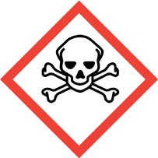  Toxic |   Harmful |   Oxidising | 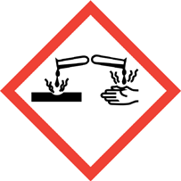  Corrosive |  |  | 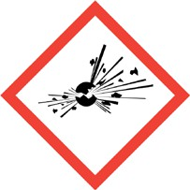  Explosive |  | 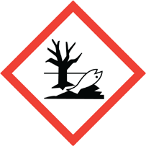  Harmful to Environment |   Health Hazards
☑ | □ | ☑ | □ | □ |  |  | □ |  | ☑ | □
CONTROL MEASURES |  |  | Measures to be adopted to prevent exposure and control  risk(s):
- Keep away from sources of ignition / heat
- No smoking
- Keep out of reach of children
- Wear Personal Protective Equipment (PPE)
- Use in a well ventilated area
- Avoid release into the environment
- Avoid breathing in vapours
FIRST AID PROCEDURE AND SPILLAGE SUMMERY
Eye: In case of contact with eyes, rinse immediately with plenty of water and seek medical advice.

Skin: After contact with skin, wash immediately with plenty of soap and water.

Inhalation: In case of accident by inhalation, remove casualty to fresh air and keep at rest.

Ingestion: If swallowed, do not induce vomiting: seek medical advice immediately and show this document. If swallowed, rinse mouth with water (only if the person is conscious).

General: Get medical attention if any symptoms persist.
Spillage: small spillage; allow residues to evaporate or soak up with an appropriate absorbent material and dispose of safely. Large spillage; transfer by mechanical means (vacuum/ salvage truck) for recovery or safe disposal. Eliminate sources of ignition

DISPOSAL PROCEDURES
The Group will fully comply with the duties placed upon it within the requirements of Statutory Legislation, whilst at all times complying with, as a matter of best practice, the requirements and duties set out within Approved Guidance as issued by the Environment Agency and other organisations.
RISK ASSESSMENT RATING | WITHOUT CONTROLS |  | WITH CONTROLS
RISK ASSESSMENT RATING | HIGH |  | LOW

COSHH ASSESSMENT SUMMARY SHEET

PRODUCT INFORMATION
Product: Mortar |  |  |  |  | Activity: Use of Mortar
Description / Product Details:
Mortar is a workable paste used to bind building blocks such as stones, bricks, and concrete masonry units together, fill and seal the irregular gaps between them, and sometimes add decorative colours or patterns in masonry walls.
Persons at risk:
- Persons using the mortar
- Persons within the immediate vicinity
Components: |  |  | WORKPLACE EXPOSURE LEVELS
 |  |  | Long Term |  |  |  |  | Short Term
Total Dust of Mortar |  |  | 10 mg/mᶟ
Respirable Dust of Mortar |  |  | 4 mg/mᶟ
Respirable Quartz: Crystalline  Silica |  |  | 0.3 mg/mᶟ
HAZARD CLASIFICATION
Flammable | Toxic | Harmful | Oxidising | Corrosive |  |  | Explosive |  | Harmful to  Environment | Health Hazards
□ | □ | □ | □ | □ |  |  | □ |  | □ | □
CONTROL MEASURES |  |  | Measures to be adopted to prevent exposure and control  risk(s):
- Keep out of reach of children
- Wear Personal Protective Equipment (PPE)
- Use in a well ventilated area
- Avoid release into watercourses / environment
FIRST AID PROCEDURE AND SPILLAGE SUMMERY
Eye: In case of contact with eyes, rinse immediately with plenty of water and seek medical advice.

Skin: After contact with skin, wash immediately with plenty of soap and water. Where material enters boots / gloves / saturates clothing, the article should be removed immediately and washed before further use.

Inhalation: In case of accident by inhalation, remove casualty to fresh air and keep at rest.

Ingestion: If swallowed, do not induce vomiting: seek medical advice immediately and show this document. If swallowed, rinse mouth with water (only if the person is conscious).
General: Get medical attention if any symptoms persist.
Spillage: Needs to be cleaned up before it hardens. Should be collected and disposed of in accordance with local and national requirements.

DISPOSAL PROCEDURES
The Group will fully comply with the duties placed upon it within the requirements of Statutory Legislation, whilst at all times complying with, as a matter of best practice, the requirements and duties set out within Approved Guidance as issued by the Environment Agency and other organisations.
RISK ASSESSMENT RATING | WITHOUT CONTROLS |  | WITH CONTROLS
RISK ASSESSMENT RATING | MEDIUM |  | LOW

COSHH ASSESSMENT SUMMARY SHEET

PRODUCT INFORMATION
Product: Portland Cement |  |  |  |  | Activity: Use of Portland Cement
Description / Product Details:
Used as a hydraulic binder for the production of concrete, mortars, grouts etc.
Persons at risk:
- Persons using the Portland Cement
- Persons within the immediate vicinity
Components: |  |  | WORKPLACE EXPOSURE LEVELS
 |  |  | Long Term |  |  |  |  | Short Term
Exposure Limit Values for product |  |  | 10 mg/mᶟ |  |  |  |  | mg/mᶟ
HAZARD CLASIFICATION
Flammable | Toxic | Harmful | Oxidising | Corrosive |  |  | Explosive |  | Harmful to Enviroment | Health Hazards
□ | □ | ☑ | □ | □ |  |  | □ |  | □ | □
CONTROL MEASURES |  |  | Measures to be adopted to prevent exposure and control  risk(s):
- Do not handle or store near food or beverages or smoking materials
- Keep out of reach of children
- Avoid contact with skin
- Wear Personal Protective Equipment (PPE)
- Use in a well ventilated area
- Avoid release into the environment
FIRST AID PROCEDURE AND SPILLAGE SUMMERY
Eye: In case of contact with eyes, rinse immediately with plenty of water and seek medical advice.

Skin: After contact with skin, wash immediately with plenty of soap and water.

Inhalation: In case of accident by inhalation, remove casualty to fresh air and keep at rest.

Ingestion: If swallowed, do not induce vomiting: seek medical advice immediately and show this document. If swallowed, rinse mouth with water (only if the person is conscious).

General: Get medical attention if any symptoms persist.

Spillage: If spillage occurs, use dry clean-up methods that do not cause airborne dispersion e.g. vacuum cleaner with a HEPA filter or wipe up the dust by mopping/ wet brushing/ water sprays/ hoses and remove slurry

DISPOSAL PROCEDURES

The Group will fully comply with the duties placed upon it within the requirements of Statutory Legislation, whilst at all times complying with, as a matter of best practice, the requirements and duties set out within Approved Guidance as issued by the Environment Agency and other organisations.
RISK ASSESSMENT RATING | WITHOUT CONTROLS | WITH CONTROLS
RISK ASSESSMENT RATING | MEDIUM | LOW

Appendix 3

CDM Checklist

THE R&M GROUP
CONSTRUCTION DESIGN & MANAGEMENT REGULATIONS 2015
CHECK LIST CGC/CDM/01

To be completed before work commences.
 |  | TICK | DATE | ACTION
a) | Construction Phase Plan on site
b) | F10 Rev A Form displayed on site
c) | Site Starter Pack on site
i) | Mandatory posters on display
ii) | First aid box fully stocked & in prominent  position
iii) | Trained First Aider on site
iv) | Accident book in prominent position
v) | Accident reporting procedure in place
vi) | Company insurance certificate on display
vii) | Accident & Emergency procedure completed
viii) | Copy of Company Health & Safety Policy on  display
ix) | Safety equipment register on site
x) | Head Protection declaration forms on site
xi) | Safety helmet regulations in force on site
xii) | C.O.S.H.H. assessment records on site
xiii) | L.P.G. storage regulations complied with
d) | Site Restrictions :-
i) | Service drawings obtained for :-
ii) | Electricity
iii) | Water
iv) | Gas
v) | B.T.
vi) | Cable
vii) | Other

CGC/CDM/01

Appendix 5

Pre – Construction Information

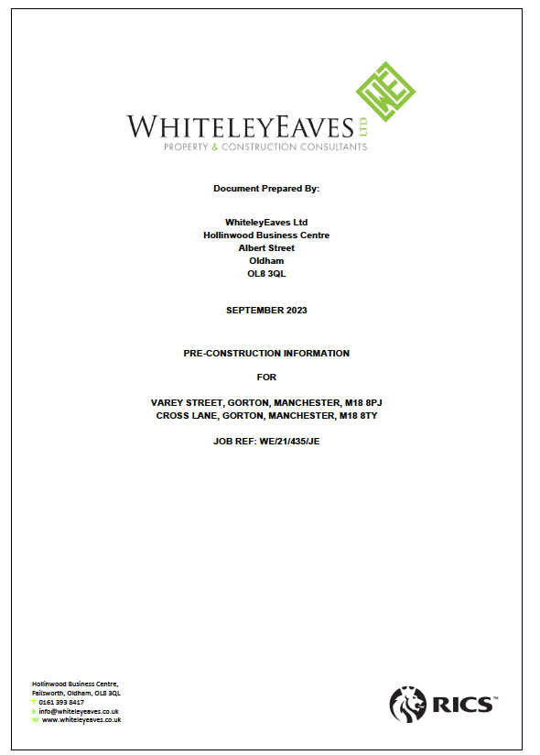
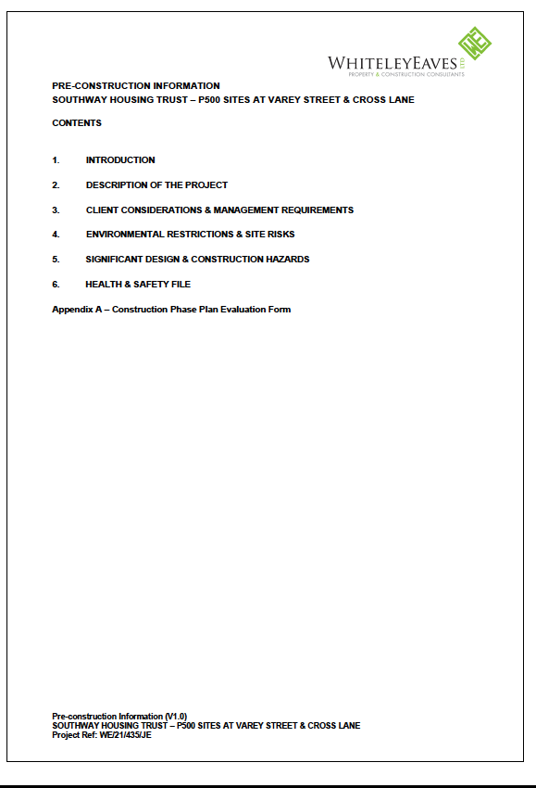
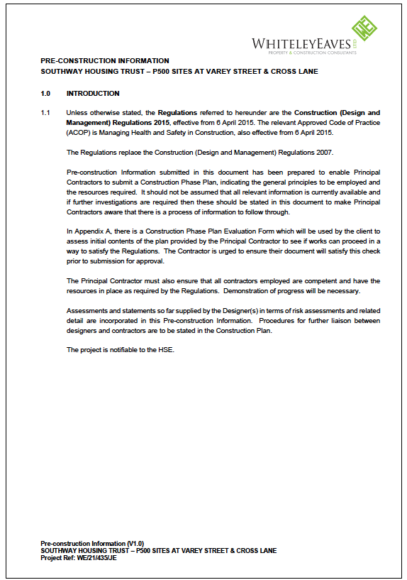

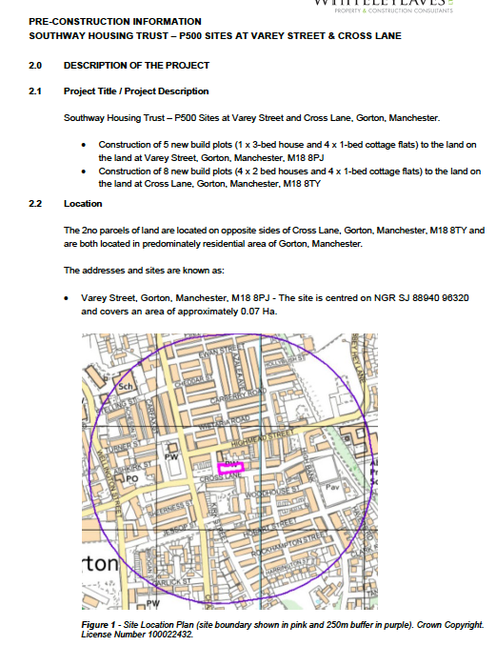
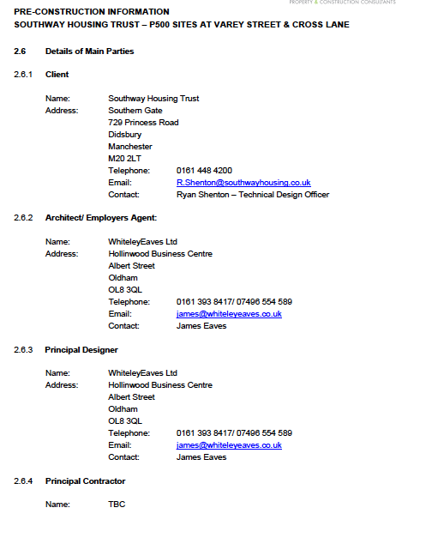
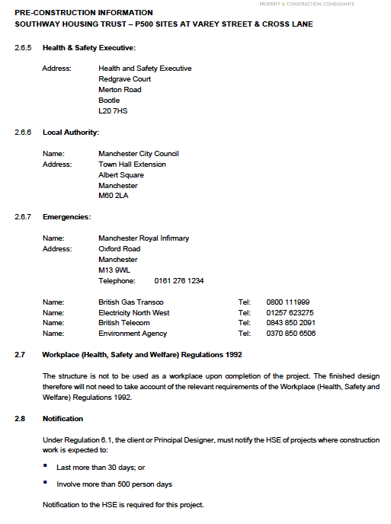

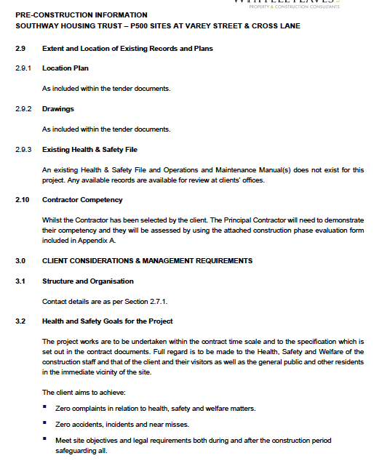

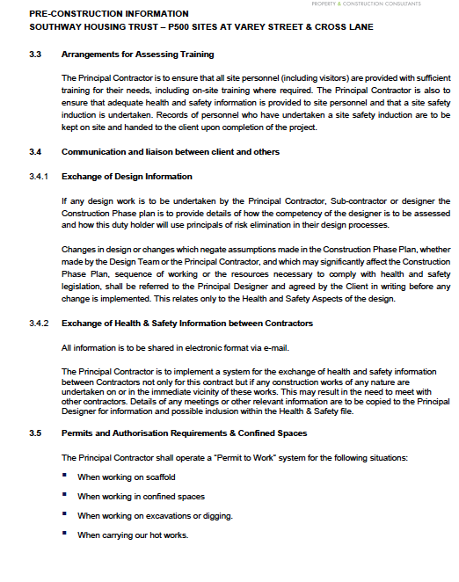

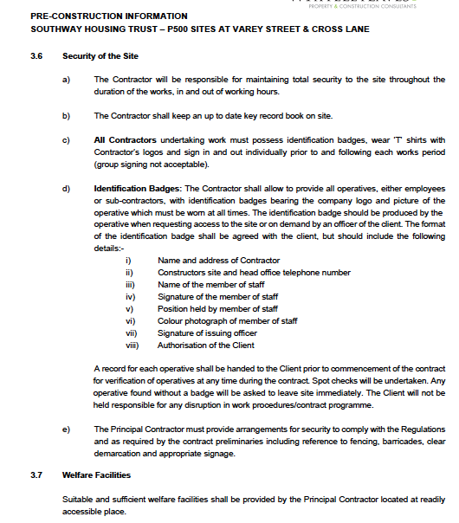

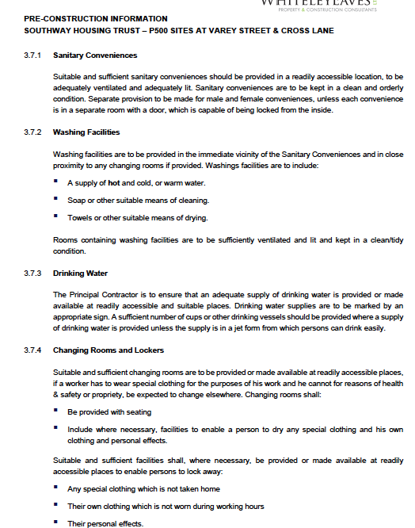

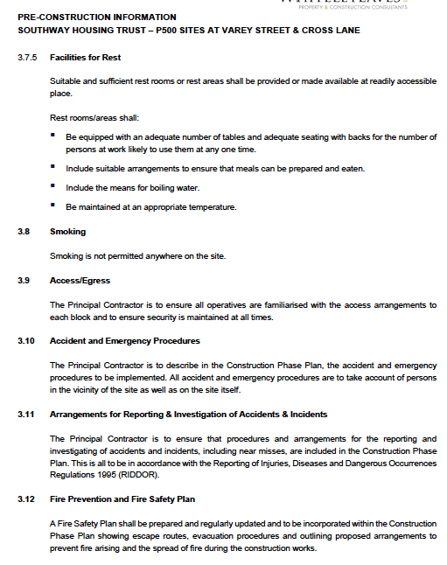
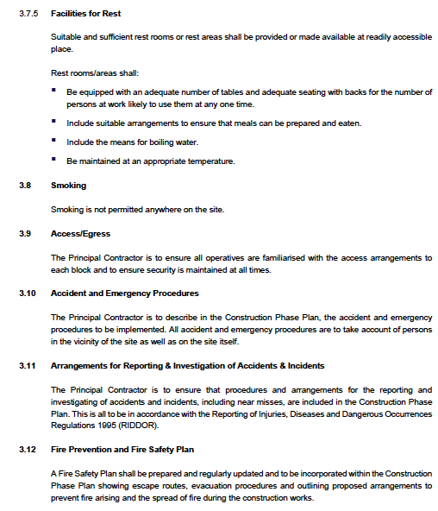

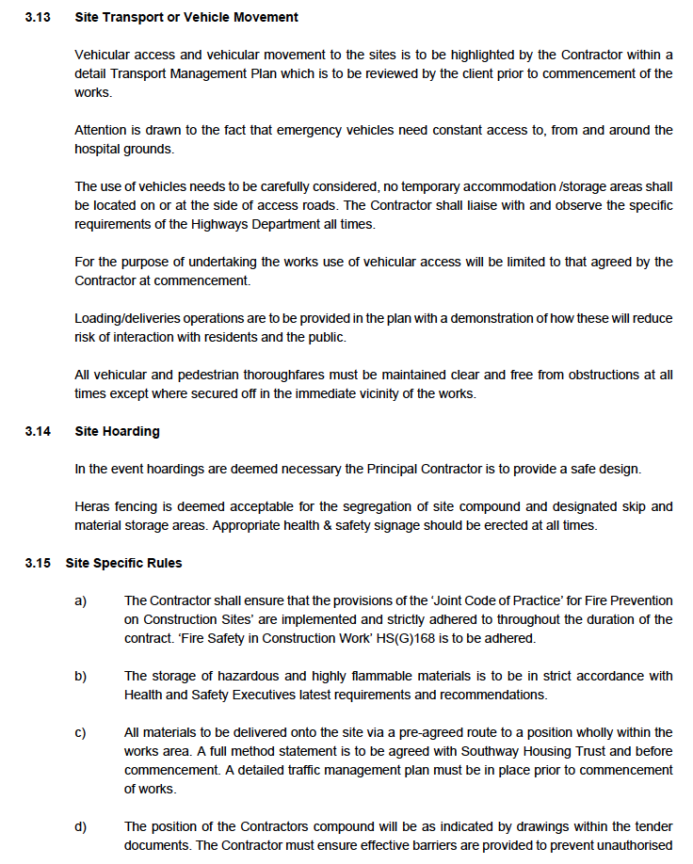

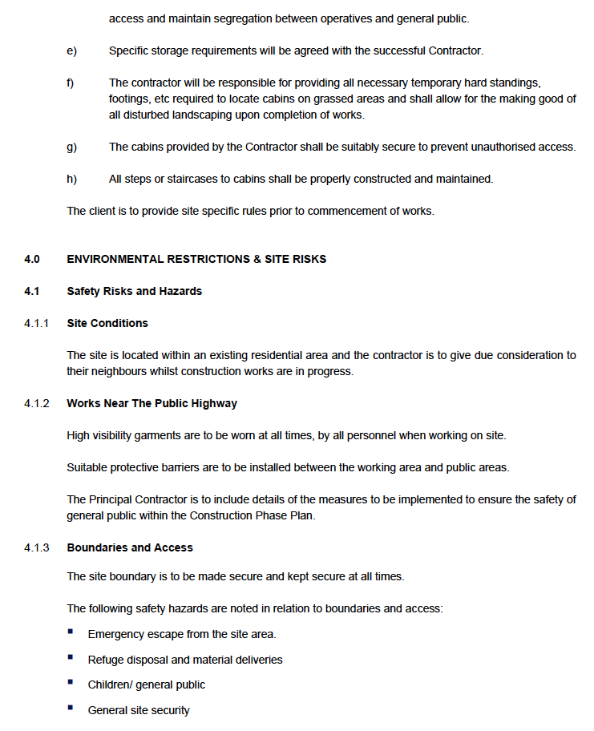

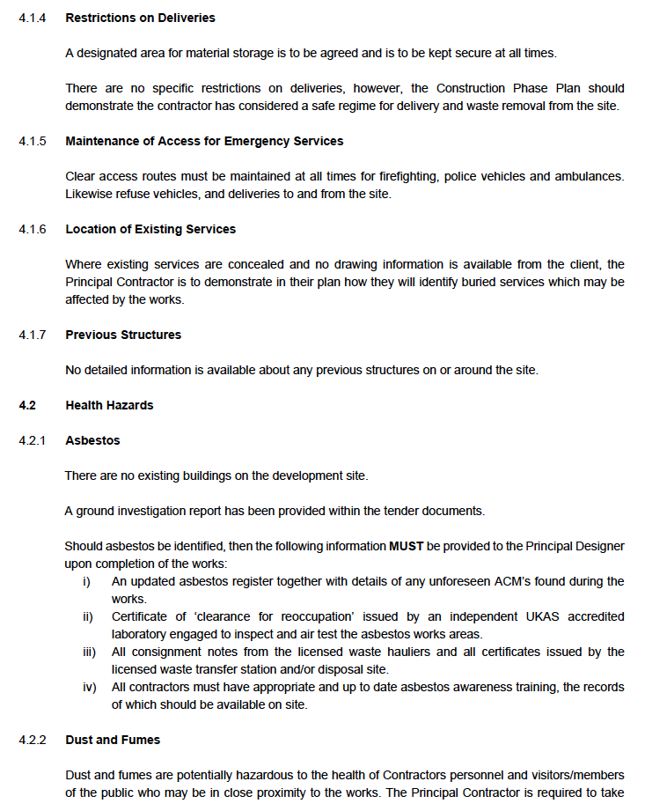

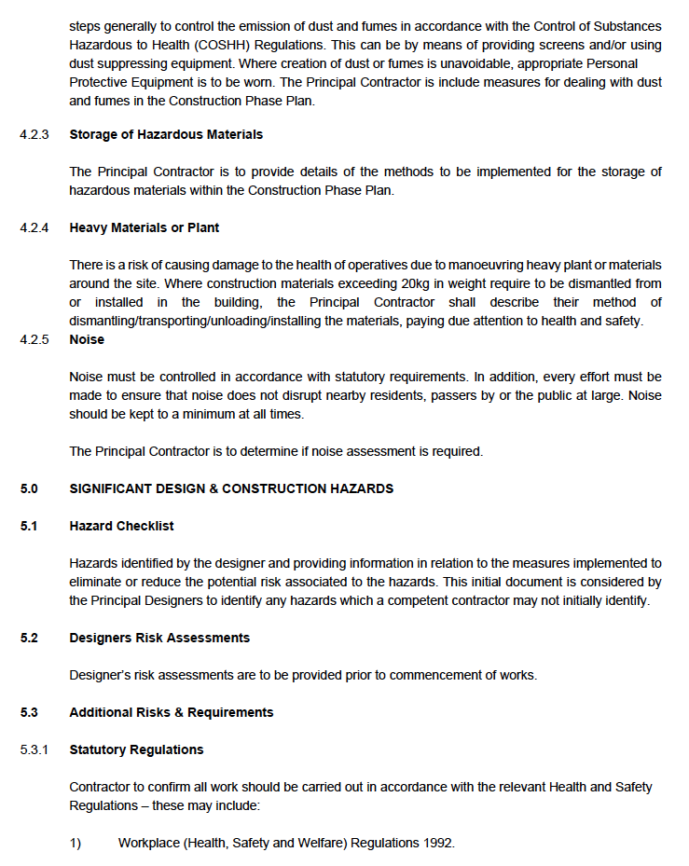

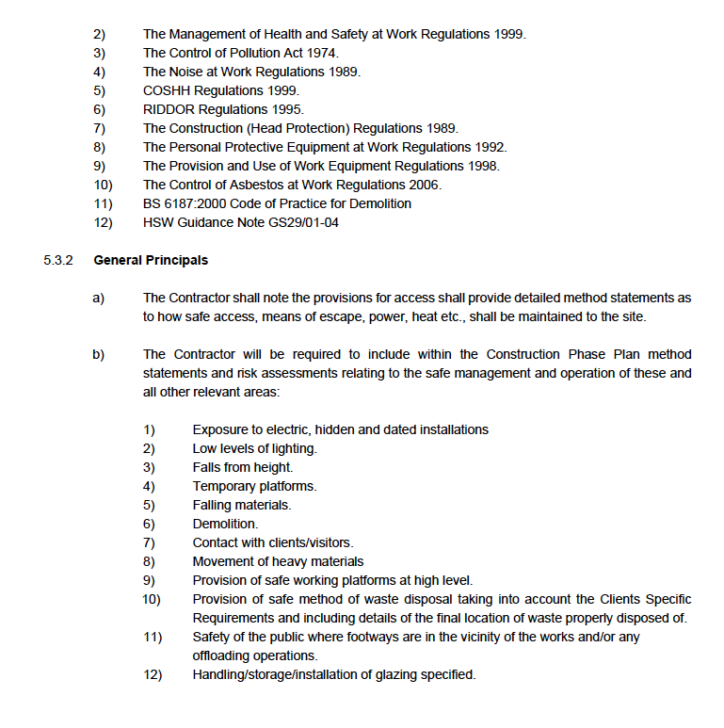

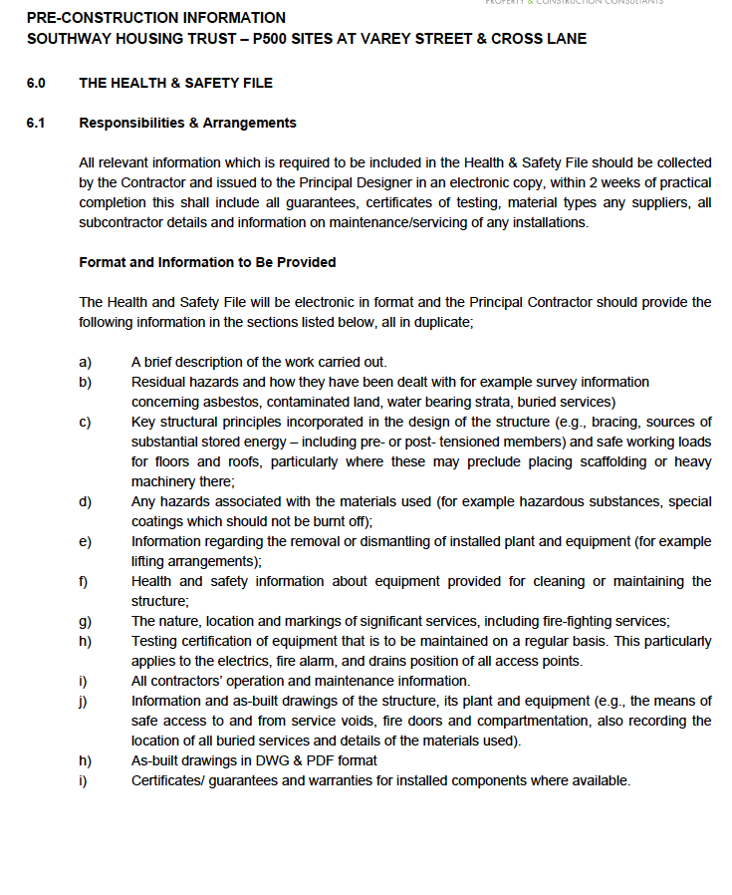

Appendix 6

Plant / Machine Operators Certification
Evidence of Competency

See copies on site Health & Safety file

Appendix 7

Sub – Contractors Appraisal

Health Safety and Environmental Compliance Manual

SECTION TEN

MANAGEMENT OF SUB-CONTRACTORS

THE R&M GROUP OF COMPANIES
HEALTH AND SAFETY CODE FOR SUBCONTRACTORS’ INTRODUCTION
This Code ie.g., assist and promote the achievement of safe working methods and good practice on site. Whilst the content is believed to be comprehensive, the subcontractor should recognise that Health and Safety Regulations and HSE Publications are regularly updated and is responsible for checking references relevant to their own undertaking and for keeping pace with industry standards.
SECTION 1- MANAGEMENT OF SAFETY
Acknowledgement of Safety Code
The subcontractor is required to sign and return the Acknowledgement at the front of this Code to the named sender at the Company Head Office.
Subcontractors are required and will be deemed to have included copies of the Health and Safety Code for Subcontractors in any subcontract let by them and shall ensure that this Code is a condition of any such subcontract. Any subcontracting of works must be notified in writing to the named sender at the Company Head Office for approval. Further copies of this Code are available, on request from the named sender.
- Definitions

The term ‘The R&M Group of Companies’ covers all operating companies and divisions within The R&M Group and affiliates.

The term ‘site’ means any site or premises where the subcontractor carries out work on behalf of the Group.

The term ‘subcontractor’ means any contractor who enters into a contract with the Group and on certain sites may be called a trade, works contractor or other contractor.

This Code does not alter the terms and conditions of the subcontract or exempt the subcontractor from compliance with any Statutory Regulations but is intended to assist the subcontractor in complying with any such Regulations.

- Responsibilities under the Health and Safety at Work etc. Act 1974 and Associated Regulations and or Codes

Health and Safety at Work etc. Act 1974

Under the terms of this Act all employers, including subcontractors, have a statutory duty to ensure, so far as is reasonably practicable, the health, safety and welfare of all at work and others who may be affected by their undertakings.
Safety Policy
A written safety policy is a statutory requirement under the Health and Safety at Work etc. Act 1974 for any employer with five or more persons. Prior to commencement of work on site all subcontractors will be required to provide a copy of their safety policy document. A copy of the Group Health and Safety Policy will be made available to the subcontractor on request and it will also be available at each site.
Duties of Employees and the Self Employed

Employees and the self employed have a duty under the Health and Safety at Work etc. Act 1974 similar to that placed on employers to avoid danger and injury to themselves or to others by their work activities.

Although the Health and Safety at Work, etc. Act 1974 remains the ‘principal’ act, subcontractors should be aware that other Regulations have been made under the European Framework Directive.

A summary of the requirements of the main Regulations is set out below and must be adhered to by all subcontractors.
Management of Health and Safety at Work Regulations 1999
These Regulations require employers to: -
- Assess the risks to employees and others and record any significant findings

- Appoint competent people to help assist an employer to apply health and safety policies and procedures, e.g. Safety Adviser / Consultant
- Ensure that adequate competent supervision is provided at all times

- Provide information and training to employees

- Co-operate with others
Other Regulations made under the Framework Directive deal with matters such as Plant and Equipment, Manual Handling and Personal Protective

Equipment and the subcontractor's attention is drawn to these matters under the respective headings in this Code.

Construction (Design & Management) Regulations 2015

These Regulations affect clients, developers, principal designers, designers, principal contractors and contractors.
For the majority of projects, the Group will undertake the role of Principal Contractor and the subcontractor will undertake the role of Contractor as laid down in these Regulations. All subcontractors and self-employed persons who are contracted to the Group have a duty to: -
- Comply with Regulation 11 of the above Regulations if ‘design’ is included

- Provide Risk Assessments and Method Statements relating to the work being undertaken

- Ensure operatives and supervisors are suitably trained, have adequate information and effectively perform their role
- Comply with any health and safety directions given by the Group

- Co-operate with the Group and other contractors in the interests of health and safety to provide information about injuries, ill health and dangerous occurrences
- Provide information that is relevant for the Construction Phase Plan and the Health and Safety File

- Comply with all site rules

Part 4 of the Regulations make reference to work in excavations, provision of welfare facilities and other related items and require those responsible for construction work to take appropriate measures relevant to the risks to ensure the health and safety of workers. Guidelines for compliance with Part 4 are outlined in Section 2 of this Code, ‘Site Operations’.
- Subcontractors
All subcontractors will be expected to complete a pre-contract questionnaire setting out details of their health and safety policy, training, accident history, enforcement action and other relevant matters.
Subcontractor's personnel must be over 16 years of age (unless other restrictions apply e.g. operation of plant and machinery) and should be competent, fit and able for the work they are expected to undertake and have previously been given adequate information, instruction and training for the works proposed.

The Group has a strict policy of not allowing the consumption of alcohol or the taking of drugs by persons at work, before or during working periods, and the Group requires subcontractors to implement this policy with their employees. For cause sampling may be requested to ensure compliance with this policy.

Subcontractors shall not sub-let work without written permission from the Group.
- Supervision
The subcontractor shall ensure that sufficient supervision is available at all times when work is being undertaken on site. Supervisors shall be competent, experienced and trained as necessary and set a personal example all times.
- Pre-Start Meetings
Subcontractors may be required to attend a pre-start meeting to discuss the necessary measures, which need to be implemented to reduce and control risks to workers and others. Regular site meetings during the construction works may also be held to review the subcontractor’s performance to the required standards.

Subcontractors must submit the name of the individual responsible on their behalf for health and safety on site to the Group's Site Manager.

- Monitoring of Subcontractors

The health and safety performance of subcontractors will be monitored by various members of the Group's management team and by their Health and Safety Advisors.

Subcontractors have a legal duty to ensure they have the services of a competent person to provide specialist health and safety assistance appropriate to their operations.
Subcontractors should be aware of the disciplinary provisions, which apply in the event of a breach of Group Policies, Safety Regulations or Site Rules even if the breach does not result in an accident. Such breaches may result in verbal and / or written warnings, work being stopped or subcontractors being removed from site.

At the end of the contract the Group will complete a review form relating to the subcontractor's operations and the details will be kept on record and considered before awarding further work.
- The Construction Phase Plan and Health and Safety File
Subcontractors have a duty to provide information to the Group about the following health and safety matters: -

  - The risks to health and safety arising from their activities and how they are controlled, including details of any proposed changes to work practices, which might affect approved Method Statements and the Construction Phase Plan
  - Construction / installation activities, which may affect others carrying out future maintenance or alteration / demolition of the building / structure

- Consultation

The Group recognises the importance of ensuring that personnel are able to express their views on health and safety matters and subcontractors are required to co-operate with the Group to ensure effective lines of communication remain open. Where appropriate the Group will recognise Representatives of Employee Safety and any arrangements for monitoring and discussing health and safety matters at site level.

The Group recognises its duty to ensure that only authorised and suitably qualified persons are allowed on site. The co-operation of subcontractors is essential to ensure that appropriate checks are made to identify and authorise workers for specific tasks having regard to their skills and experience. In addition, all subcontractors operatives must attend the Group's Induction prior to commencement of work on site.
The prevention of accidents to employees, members of the public, especially children, on sites is of paramount importance. Subcontractors must comply at all times with the requirements laid down in the Construction Phase Plan and Site Rules, especially those control measures which are intended for the protection of the employees, occupants, members of the public or others likely to be affected by work in progress.

- Welfare Provision
Subcontractors are responsible for providing their employees with suitable and sufficient welfare facilities. This will be subject to the normal arrangements made for sharing any welfare facilities that are provided by the Group.
If subcontractors are required to provide their own accommodation it shall be of a good standard with proper consideration for the Construction (Design and Management) Regulations 2015 and the Fire Code*.

Subcontractors will be required, unless otherwise agreed, to provide their own First Aiders dependent on the nature and duration of the contract.

* The "Fire Code" in this document means the Joint Code of Practice on the Protection from Fire on Construction Sites and Buildings Undergoing Renovation unless some other code is applicable to the specific project.

Refer also to Section 2(g) - Fire.

- Personal Protective Equipment (PPE)

The subcontractor shall comply with the Group policy for the wearing of safety helmets, high visibility vests and protective footwear when on site.

Other PPE appropriate to the work upon which workers are engaged, e.g. eye and ear protection, respirators, gloves and full body harness’s for example shall be provided by the subcontractor to the appropriate Industry Standard and training given for use and maintenance of such.
The subcontractor will be required to remove from the workplace any operative, working under their jurisdiction, who fails to wear the appropriate PPE when so required.
- Accident Reporting

Subcontractors must report any accident or near miss involving their employees or others to the Group's site management immediately to enable an entry to be made in the Accident Book.

In the event of any accident / occurrence covered by the Reporting of Injuries, Diseases and Dangerous Occurrences Regulations, the subcontractor shall report the occurrence to the Incident Contract Centre (Tel.No. 0845 300 9923) or on line and the Group.

SECTION 2 - SITE OPERATIONS

- Asbestos
If a subcontractor thinks they have encountered anything involving asbestos they must stop work and report the matter to the Group's site management immediately.
Subcontractors whose operations involve the removal of licensed asbestos are required to hold a current licence issued by the Health and Safety Executive which must be available for inspection immediately upon request. Failure to comply with these requirements in full will result in the immediate suspension of operations until the situation can be clarified.

Subcontractors must ensure that work involving asbestos is effectively isolated from those not connected with the operation, warning notices are in place and arrangements are made to certify that the air is tested and is safe following completion of the work.

- Control of Substances Hazardous to Health

Prior to commencement of work involving hazardous substances or processes, subcontractors are required to provide the Group with copies of all assessments made and the measures they will undertake for the control of any substance hazardous to health which is intended for use on or in any of the Group's sites, premises or undertakings.
All subcontractors must ensure that their workforce is trained and informed on all aspects of the use and control of hazardous substances and all appropriate records must be maintained.
Where work conditions result in exposure to biological hazards, e.g. Weil's disease, suitable precautions must be taken.
When required the subcontractor must supply all necessary personal protective equipment to comply with the control measures for hazardous substances.

- Demolition

All demolition work must be planned ahead of work commencing and in consultation with the Group. A detailed safe system of work must be prepared and submitted to the Group for approval. All work must be carried out by competent subcontractors and be supervised by a competent person. Where the demolition subcontractor is appointed as Principal Contractor they must comply with the duties placed on them by the Construction (Design and Management) Regulations 2015.

No demolition work may proceed until services have been adequately protected or rendered harmless. Demolition areas must be clearly marked and safety barriers as substantial as the circumstances require must be erected and maintained in good order together with prominent warning notices wherever appropriate.
When work is taking place inside or near to existing buildings every reasonable precaution must be taken to prevent damage by dust by the use of suitable covers or other means.

The training standards of the demolition operatives must be made known to the Group prior to the commencement of operations.
A high level of protection for members of the public is required at all times.
Demolition contractors should be members of the recognised trade association or be able to demonstrate their competency through the Group's pre- qualification requirements.
Refer also to Section 2 (a) - Asbestos.

- Electricity

Any work associated with an electrical system must be undertaken in strict accordance with The Electricity at Work Regulations 1989.

It is the Group's policy to operate wherever possible portable tools and lighting at 110 volts.
Where special equipment requires a voltage greater than 110 volts then written agreement must be obtained from the Group's site management and additional protective measures put in place.
All temporary distribution cables, plugs, sockets and equipment installed to serve small tools, handlamps etc., must conform to the requirements of the current I.E.E. Regulations. Fuses of the correct type and capacity must be used at all times. All electricity cables and equipment being used must be regularly inspected and the results recorded as appropriate to ensure that any defective equipment is identified and taken out of service until repaired or replaced.
Electricity cables shall be routed in a safe manner avoiding transport routes and areas where water might accumulate with further protection provided as appropriate.

Particular attention must be given at the planning stage to ensure that temporary cables and leads do not restrict working areas, access and emergency evacuation routes.

Refer also to Section 2 (l) - Permits to Work.

- Gas

Any work associated with a gas installation or appliance must be undertaken in strict accordance with The Gas Safety (Installation and Use) Regulations 1998.
Persons employed on a gas installation or appliance must be Gas Safe Registered.
Refer also to Section 2 (l) - Permits to Work.

- Excavations

Excavations and trenches must be reviewed for stability and be adequately supported or battered back to a safe angle to prevent falls of earth and the uncontrolled movement of materials.
Suitable barriers must be erected where necessary around trenches or excavations with a risk of persons falling into them.

Any excavations and trenches, whatever their depth, in places to which the public have access to and are left open after work ceases, must be adequately guarded and if necessary, lighting provided.

Excavations and trenches must have a proper means of access and egress.

Where plant or vehicles are used to deposit materials, proper steps must be taken to ensure such equipment cannot overrun the edges of the excavations.
Plant or vehicle exhausts must be directed away from excavations / trenches or other areas where fumes may accumulate.
Spoil heaps and materials must be deposited a safe distance from the edges of excavations / trenches.
Consideration must be given to providing adequate protection and to capping steel reinforcement to prevent impaling type injuries.

Where excavations could be considered as a confined space, consideration must be given to testing the atmosphere and also the preparation of a Safe System of Work in line with the requirements of The Confined Spaces Regulations 1997.

Statutory inspections / examinations must be made by competent people and a record maintained by the subcontractor, which must be maintained available on site.

- Fire

The Group considers that a policy of implementing fire prevention and protection measures is of paramount importance. On construction sites strict compliance with the Fire Code must be achieved (document referred to in Section 1 (i) - Welfare Provision).
The storage and use of high risk / potentially hazardous substances must be in strict compliance with current Regulations, e.g. Petroleum Spirit, Highly Flammable Liquids and Liquefied Petroleum Gases. Such substances must be stored in suitable places as designated by the Group. On no account must cylinders / containers be left in a hazardous area on site. Where burning / welding equipment is used, flash back arrestors must be fitted.

The Group requires assessments to be carried out by subcontractors that will eliminate / reduce the use of substances which give rise to fire risks.
Naked lights, burning / welding equipment, etc. must not be used in hazardous areas. Any "NO SMOKING" notices must be strictly observed.
Existing emergency exits and access to fire fighting equipment must be kept clear at all times and rubbish must not be allowed to accumulate.

Refer to Section 2 (h) - Housekeeping. Refer to Section 2 (n) - Permits to Work.

- Housekeeping

Subcontractors must deposit rubbish created by their activities in designated areas or receptacles and must take an active role in maintaining a tidy site. Failure to maintain the required standard of tidiness may result in the Group carrying out the work and charging the cost of the cleaning etc. to the subcontractor. Persistent untidiness resulting in unsafe conditions will result in the removal of the subcontractor from site.
Storage areas must be kept tidy and stacked materials properly arranged to maintain stability within a designated and secure area. Materials must not be stacked against any boundary fence.
If work is being carried out in occupied premises particular attention is required to observe the client's / occupier's rules for tidiness, restricting access to authorised working areas only and to assist fire prevention by avoiding the build up of combustible materials.

Where materials are stacked within or upon a completed or partially completed structure, then appropriate calculations and necessary temporary works must be undertaken by the subcontractor to avoid overloading the structure.

- Lifting Operations

All lifting operations must be undertaken under the specific control of a competent person who has received appropriate training. Crane operations must be properly planned in accordance with the relevant statutory regulations and codes of practice.
For ‘Contract Lifts’ where crane operations are under the direct control of the subcontractor, the lifting operation ‘Safe System of Work’ must be approved by the Group. Individual Method Statements must be prepared and followed.
Particular attention must be given to the positioning of cranes in relation to proximity hazards, such as overhead electric power lines, public footpaths, occupied dwellings etc. and ground conditions. Consideration must also be given to the use of cranes in adverse weather conditions.

Lorry loaders (HIAB type equipment) must only be used for self-loading / unloading.
Certificates of thorough examination and any tests undertaken, together with any inspection register entries must be available for checking in connection with lifting operations and their accessories before work commences.

Crane drivers, plant operators and banksmen / slingers must be competent and evidence of training must be checked and verified by the subcontractor and be made available to the site management upon request.

Banksmen / slingers must be competent, trained and be formally appointed, wear high visibility clothing and use industry approved signals.

- Manual Handling
The subcontractor must consider proposing alternative products or specifications to the Group to minimise the need for manual handling wherever reasonably practicable.
Any Designer / Specifier responsible to the subcontractor must consider any alternatives by following a risk assessment approach as required under the Construction (Design and Management) Regulations 2015.
Wherever possible, the need for the repetitive manual handling of loads above 25kgs should be avoided by operatives. Where this is not reasonably practicable the subcontractor must provide the appropriate mechanical handling devices to eliminate / reduce the need for manual handling.

Where manual handling is required the subcontractor must make an assessment of the operation considering the following points: -

  - the work task
  - the load to be lifted
  - the local environment
  - the capabilities of the individuals
  - any other factors applicable to the operation

The subcontractor must ensure that his employees are given the appropriate training, instruction and supervision to enable them to perform all manual handling operations in a safe manner.
- Noise
Subcontractors are required to make noise assessments where appropriate and submit the results to the Group on request. Where possible noise levels should be reduced at source by the careful selection of plant, machinery etc. and where this is not practicable, suitable hearing protection must be provided, worn correctly and training given.
Care must be taken to ensure that noise does not cause a nuisance to persons in the vicinity of the work being carried out.

- Vibration

Subcontractors are required to make noise assessments where appropriate and submit the results to the Group on request. Where possible noise levels should be reduced at source by the careful selection of plant, machinery etc. and

where this is not practicable, suitable hearing protection must be provided, worn correctly and training given.

Care must be taken to ensure that noise does not cause a nuisance to persons in the vicinity of the work being carried out.

- Overhead and Underground Services

- Overhead Services
Where work has to be carried out in the vicinity of overhead electrical power lines approval is required from the Group following the review of the subcontractor's proposed Safe Systems of Work
- Underground Services
The subcontractor's attention is drawn to the requirement for a trained and competent person to check the routes of underground services using appropriate detection equipment to mark the line of any service identified and to excavate by careful hand digging

Any damage to a service must be reported to the Group and to the statutory undertaker immediately. No pneumatic tools should be used in the vicinity of electric or communication cables. No road pins or metal stakes should be driven into the ground in the vicinity of any cable routes.

Attention is drawn to the Health and Safety Executive Notes GS6 ‘Avoidance of Danger from Overhead Electric Lines and HS(G)47 ‘Avoiding Danger from Underground Services.

- Permits to Work

Subcontractors must agree in advance with the Group any working areas / practices, which are to be the subject of strictly enforced ‘Permits to Work’ procedures.
Such circumstances may include restrictions and control in connection with: -
  - Digging in areas with new or existing underground services
  - Hot work, e.g. welding, burning, cutting
  - Confined spaces, work in sewers, tanks, vessels
  - Mains electricity, work adjacent to switchgear, substations
  - Gas installations
  - Machinery, lift motor rooms, overhead gear.
The Permit will determine the nature and extent of the isolation or physical controls, the equipment, the timing and the extent of the work, the number of people involved and the duties of those in attendance and any associated emergency procedures.

The authorisation, receipt, clearance and cancellation procedures must be strictly adhered to.

- Plant and Equipment

All mechanical plant and equipment used by subcontractors on site must be in good working order and be regularly inspected with appropriate records maintained to comply with the relevant statutory requirements. Only competent persons must operate plant and equipment.
Drivers of plant covered by the Construction Plant Certification Scheme (CPCS) or National Plant Operators Registration Scheme (NPORS) must hold appropriate certification.
Drivers of plant must be suitably trained for the items of plant, which they are to operate and be at least 18 years of age, unless other requirements prevail.

Dangerous parts of machinery must be securely fenced. Guards must remain in place and immediate working areas kept tidy.

Woodworking machinery must be securely fenced and ‘push sticks’ used where applicable.

The use of chain saws is not permitted on Group sites except where, in the opinion of the Site Manager, the operation to be undertaken is particularly suited to the use of a chain saw. Chain saws are not to be brought to or used on site except with the prior written approval of the Site Manager. Where permission is granted, the equipment must be operated by a trained and competent person wearing the full personal protective equipment recommended by the manufacturer.
Where the subcontractors work could expose their operatives to the risks of Hand Arm Vibration Syndrome (HAVS) they must eliminate / reduce the use of hand held tools by using mechanical means and management techniques.
Subcontractors are reminded of the requirement for only trained and competent persons to operate power tools.

Subcontractors who use Mobile Elevating Work Platforms (MEWPs) must ensure the equipment is suitable for the purpose and is operated only by persons who hold a certificate of training. The short instruction given by suppliers when a MEWP is delivered to site is not considered satisfactory on its own. A full body harness must be worn in all MEWPs and secured to a suitable anchorage point on the carrier to prevent falls.
No person other than the driver must ride on power driven vehicles except where seating is specially provided for the carriage of passengers.

Drivers of vehicles that are not provided with protective cabs, i.e. dumpers etc. must not remain on the vehicle during machine loading.

Where there is a risk of ‘roll-over’, suitable protection shall be provided to the item of plant. This may include a Roll-Over Protection System (ROPS) with a seat belt that must be worn by the driver of the item of plant, e.g. dumpers and ride-on rollers.
Drivers must report any defects to their supervisor immediately. This also applies to any accident or damage, however minor.
- Roadworks
The subcontractor shall execute all works in accordance with The New Roads and Streetworks Act and shall provide all necessary signage, traffic and pedestrian management to Chapter 8 requirements. High visibility clothing shall be worn at all times. Reference must be made to the Code of Practice ‘Safety at Streetworks and Roadworks’ published by The Stationery Office.
- Transport

Drivers must always report to the site office before travelling around the site and observe any speed limits, designated access routes and storage areas, if appropriate, etc.

Vehicles with high loads must not travel under overhead power lines etc. unless adequate arrangements have been made to prevent accidental contact. Vehicles must not travel around site with the body raised.

Particular note must be taken of overhead services, Section 2 (k) - Overhead and Underground Services and the proximity of excavations, Section 2 (e) - Excavations.
Drivers must have a safety helmet available for use when outside the cab and must wear safety footwear, high visibility vests and any other appropriate protective clothing.
Care must be taken to verify that roadways, bridges, platforms, etc. on routes inside the site area are capable of carrying the vehicles and their load.
Drivers must drive in a safe manner at all times paying due regard to the site speed limits, the condition of site roads and the presence of pedestrians and other site transport.

No person other than the driver must ride on power driven vehicles except where seating is specially provided for the carriage of passengers.

Children are not permitted as passengers in delivery vehicles.

Persons working on or near vehicles must be safeguarded during loading and unloading operations.

If loads are classified as hazardous, the appropriate regulations regarding carriage and labelling must be followed.

Vehicles must be loaded within any appropriate loading restriction and loads must be properly secured.
In all cases where a lorry or similar vehicle needs to reverse on or around site, a banksman must be provided and used by the subcontractor.
Vehicles must never be left unattended with the engine running, or with the ignition keys in place.
Vehicles must be parked in a safe place, on level ground, away from excavations, evacuation routes, assembly points, hoists and storage areas etc.

At all times, drivers and operators of site transport must remain vigilant regarding occupants, visitors and the general public and follow the requirements of the Site Traffic Rules for the site.

- Work at Height Regulations 2005

These Regulations make reference to all work at height including scaffolding, roofing, steel erecting etc. and require those responsible for construction work to take appropriate measures relevant to the risks to ensure the health and safety of workers.

Working at Height General Requirements

All subcontractors who work at height are required to carry out their operations in a safe manner with particular consideration given to the measures required to prevent falls from height.
No work is to be undertaken at height without a full assessment of the potential risks and the appropriate control measures in place.

Subcontractors must co-operate with the Group to ensure that the Group policies relating to the control of working at height are strictly adhered to.

All work carried out at height must be undertaken from a suitable working platform.
Material handling and storage shall be undertaken in a safe manner taking particular account of other subcontractors and the loading capacities of scaffolding or the structure.
Consideration must be given to ensuring the security of materials stacked onto the structure to ensure they are not displaced.

Scaffolding

Where a subcontractor provides his own scaffolding for the sole use of his employees, the responsibility for ensuring its safety rests with the subcontractor.

Any subcontractor who utilises a scaffold erected for common use must, prior to use by his employees, inspect the scaffold to ensure that it is safe and suitable for use and immediately report any defects.
Co-ordination arrangements for the use of scaffolding will usually be under the direction of the Group. Subcontractors shall comply with the site rules as they affect scaffolding and access.
Responsibility for the provision of scaffolding will be as stated in the subcontract and all scaffolding must comply with current Regulations and Codes of Practice, including the use of appropriate signage when the scaffold is not in use.

All operatives must be trained and competent and hold a CISRS card or an affiliated scheme to the CISRS scheme. Proof of their training must be provided prior to commencement on site.

Scaffold components i.e. scaffold boards, brackets, clips, tubes etc. not in use should be removed from site. Where this is not practicable access to component parts must be effectively eliminated or restricted so as to prevent personal injury, especially to children.

Where scaffolders are working above four metres they must comply with the requirements of NASC Guide SG 4:10 - The Use of Fall Arrest Equipment whilst Erecting, Altering and Dismantling Scaffolding.
Scaffolding must not be overloaded.
Where scaffolding is required for use in close proximity to occupied dwellings or the general public extra control measures must be initiated by the subcontractor during erection, use and dismantling.

All trades who utilise scaffolding must ensure they bring any defects to the attention of the Site Manager.
Aluminium Scaffold Towers
The safety of tower scaffolds requires special consideration, particularly those made up of proprietary lightweight materials. They must be erected and dismantled by competent operatives and used in accordance with the Prefabricated Aluminium Scaffolding Manufacturers Association (PASMA) or similar guidelines with outriggers / stabilisers used when there is more than one

vertical section erected. Towers must not be moved whilst persons remain on the platform.

Roofing

Roof work is a high risk activity requiring close attention to health and safety planning and a detailed safe system of work.

In particular, the roofing subcontractors attention is drawn to the need for: -
- protection from falls from height,
- wearing the correct PPE when cutting roof tiles,
- not cutting tiles on the scaffold boards,
- closing the loading bay gates, if fitted, after use.

Consideration must be given to ensuring the security of roofing materials when stacked at height to ensure they are not accidentally displaced.

Steel Erection

A comprehensive Safe System of Work must be prepared and submitted to the Group for approval before the work commences.

The Safe System of Work shall specify a working sequence and method of access, which reduces the possibility of falls of persons to an absolute minimum.

The use of MEWP’s is preferred with walking / climbing / shinning steelwork prohibited.

Full body safety harnesses must be worn and connected to a secure anchorage when appropriate, with appropriate emergency arrangements in place.

Tools must be secured in suitable belts, and fixings, bolts etc. must be kept in bags to avoid being dislodged and falling to the ground.

Health Safety and Environmental Compliance Manual

MANAGEMENT OF SUBCONTRACTORS

All proposed subcontractors and key partners are required to complete the Company’s Pre – Contract Questionnaire, copy enclosed, and provide other supporting evidence of their competence to undertake the work required. A draft letter supporting this request is also enclosed for use.

Information typically requested includes job specific risk assessments and safe work method statements, confirmation of insurance details, health and safety performance, details of training etc. No subcontractor or partner should be appointed unless the information provided is job specific and conclusive of their competence. Every subcontractor is also required to acknowledge receipt and of the Company’s Health and Safety ‘Code for Subcontractors’. Copy enclosed.

The information submitted must be assessed and authorised as satisfactory by our internal Health and Safety Department or Site Management. A copy of the assessment form used is also included in this section.

Before work commences on site all subcontractor’s employees are required to attend the Site Specific Health Safety Induction during which the site rules and other essential information such as safe work method statements will be discussed. Refer to Section 1 of this Manual. This will ensure that subcontractor’s and their employees have sufficient knowledge and an understanding of the relevant health and safety issues to ensure that the proposed work is undertaken safety, efficiently and in accordance with current legislation and the Company’s policies and procedures.

As work progresses the performance of the subcontractor will be monitored at periodic site visits and inspections. During these visits and inspections the Site Management should also raise any matters of concern.

On completion of the project the enclosed End of Contract Review Form should be completed.

References: 1. Company Health and Safety Policy

DRAFT

For the attention of:

Dear Sirs

Health and Safety at Work etc. Act 1974
Construction (Design and Management) Regulations 2015

With regard to the above, it is necessary for the Company to request certain information from you in order that we may maintain our records and fully comply with the relevant legislation.

In view of this would you please forward to us the following information:-

- Health and Safety Policy Statement.

- Job Specific Risk Assessment and Method Statement.
- Completed Health and Safety Questionnaire - copy attached.
- Liability Insurance Certificate and completed Insurance Questionnaire - copy attached.
The above information should be returned to the writer at the earliest opportunity. As you will appreciate, your cooperation in this matter is essential as no work can commence on site this exercise is complete.
Thank you in anticipation of your co-operation. Yours faithfully
For R&M Property Group Ltd

Pre – Contract Health and Safety Questionnaire
This form must be completed and returned to:

R&M Property Group of Companies
2 Highfield Rd,
Bollington
Macclesfield
SK10 5LR

Name of Contractor: ……………………………………………………………………… Address: ………………………………………………………………………
………………………………………………………………………

……………………………………………………………………… Contact Name: ……………………………………………………………………… Position in Company: ……………………………………………………………………… Telephone No: ……………………………………………………………………… Date: ……………………………………………………………………… Type of Work Activity: …………………………………………………………………… Does your Company have a Health and Safety Policy? .………………………………….
N.B. If you employ 5 or more persons, you require a written Health and Safety Policy by law.
Who is responsible for health and safety within your Company?
……………………………………………………………………………………………… What health and safety training has this individual received?
………………………………………………………………………………………………

………………………………………………………………………………………………

………………………………………………………………………………………………

Who is the Professional Health and Safety Advisor / Consultant for your Company? Name: ……………………………………………………………………………… Address: ………………………………………………………………………………
………………………………………………………………………………
……………………………………………………………………………… What health and safety training do you provide?
- for Supervisors: ………………………………………………………………………
………………………………………………………………………

………………………………………………………………………

- for Operatives: ………………………………………………………………………

………………………………………………………………………

………………………………………………………………………

Have any formal notices been issued or legal proceedings been taken against your organisation or a Director / Officer of your organisation by the Health and Safety Executive in the last 3 years?

If yes, please give details: …………………………………………………………………...

………………………………………………………………………………………………

………………………………………………………………………………………………

Give details of any accidents / incidents reported by, or on behalf of, your organisation to the Health and Safety Executive during the last 3 years:
………………………………………………………………………………………………
………………………………………………………………………………………………
………………………………………………………………………………………………
………………………………………………………………………………………………

Give details of your procedure for reporting accidents / incidents:
………………………………………………………………………………………………
………………………………………………………………………………………………
……………………………………………………………………………………………… Give details of the personal protective clothing / equipment issued to your employees:
………………………………………………………………………………………………

………………………………………………………………………………………………

If you sub-contract work to third parties how do ensure their compliance with your health and safety rules and procedures?

………………………………………………………………………………………………

………………………………………………………………………………………………

Please provide details and copy certificates of any health and safety or trade accreditation, memberships or awards.

………………………………………………………………………………………………

………………………………………………………………………………………………

………………………………………………………………………………………………

………………………………………………………………………………………………

Signed: …………………………………………………… Date: ……………………… Name (please print): …..…………………………………………………………………..

THANK YOU FOR YOUR CO-OPERATION IN THIS EXERCISE

Health and Safety Code for Subcontractors

HEALTH AND SAFETY CODE FOR SUBCONTRACTORS

Acknowledgement

R&M Property Group of Companies
2 Highfield Rd,
Bollington
Macclesfield
SK10 5LR

For the attention of: …………………………………………………………… From (Name of Company): ……………………………………………………………
Re: Health and Safety Code for Subcontractors
We accept receipt of your Company’s Health and Safety Code for Subcontractors and having read and understood its content confirm that we will comply with the Code: the Health and Safety at Work etc. Act 1974 and all relevant statutory provisions: appropriate Codes of Practice and your Site Rules received during Induction and at other times thereafter.

Signed: ……………………………………………………………. Name: ……………………………………………………………. Position: ……………………………………………………………. Date: …………………………………………………………….

SUB-CONTRACTOR HEALTH AND SAFETY APPRAISAL FORM

Part 1 Contract Details

Contract Name: …………………………………. Contract No. …………………… Job Description: .………………………………………………………………………. Part 2 Contractor Details
Company: ………………………………… ………….. Trade: ………………………. Contact Name: ……………………………………. Tel No. ………………………… Part 3 Health and Safety Information
Have we received the following information, and it has been approved for use on site?

 | Yes | No | N/A
1. Health and Safety Policy Statement | □ | □ | □
2. Liability Insurance Certificate | □ | □ | □
3. Pre Contract Questionnaire | □ | □ | □
4. Code of Conduct acknowledgement Slip | □ | □ | □
5. Job Specific Risk Assessments | □ | □ | □
6. Safe Work Method Statements | □ | □ | □

Part 4 Authorisation

This sub-contractor has / has not* fulfilled the requirements of the Health and safety Appraisal and can / cannot proceed to work on this contract.

Assessed By: ……………………………………... Date: …………………………… Agreed By: ……………………………………….. Date: …………………………….

Part 5 Feedback

………………………………………………………………………………………………
………………………………………………………………………………………………
………………………………………………………………………………………………
………………………………………………………………………………………………
………………………………………………………………………………………………
………………………………………………………………………………………………
………………………………………………………………………………………………
………………………………………………………………………………………………
………………………………………………………………………………………………
………………………………………………………………………………………………
………………………………………………………………………………………………
………………………………………………………………………………………………
………………………………………………………………………………………………
………………………………………………………………………………………………
………………………………………………………………………………………………
………………………………………………………………………………………………
………………………………………………………………………………………………
………………………………………………………………………………………………
………………………………………………………………………………………………
………………………………………………………………………………………………
………………………………………………………………………………………………
………………………………………………………………………………………………
………………………………………………………………………………………………
………………………………………………………………………………………………
………………………………………………………………………………………………
………………………………………………………………………………………………

Signed ……………………………………. Date …………………………………….

SUB-CONTRACTORS
END OF CONTRACT REVIEW FORM

Name of Contractor: ………………………………………………………………….. Address: …………………………………………………………………..
…………………………………………………………………..
Contractors Current Grade:
G - Good, S - Satisfactory, U - Unsatisfactory, N/A - Not Applicable Operating Division: ………………………………………………………………….. Site Name & Contract No. ……………………………………………………….............. Nature of works carried out by Contractor ………………………………………......... Person completing Report …………………………. Job Title ……………………........ Brief description of Contractor Performance:
G - Good, S – Satisfactory, U - Unsatisfactory, N/A - Not Applicable

PPE |  | Compliance with Site Rules |  | Training
Safe Work Practice |  | Defective Plant & Equipment |  | Supervision
General Behaviour |  | Dangerous Occurrences |  | Waste
Co-operation |  | Noise/Dust |  | Others (specify)

This form should be completed at the end of Contract in order to re-grade Contractor and forwarded to the Divisional Director and a copy to Health and Safety Department.

Comments ……………………………………………………………………………………

…………………………………………………………………………………………………..

………………………………………………………………………………………………….. Recommendations ………………………………………………………………………......
…………………………………………………………………………………………………..

Appendix 8

Accident / Incident Procedure

ACCIDENT/EMERGENCY PROCEDURE

This site office is situated at:

Cross Lane

Site Telephone Number:
When telephoning the emergency services, please give the exact address and location of the site and state the precise nature of the accident or emergency.

The name and address of the NEAREST HOSPITAL with accident and emergency facilities is:

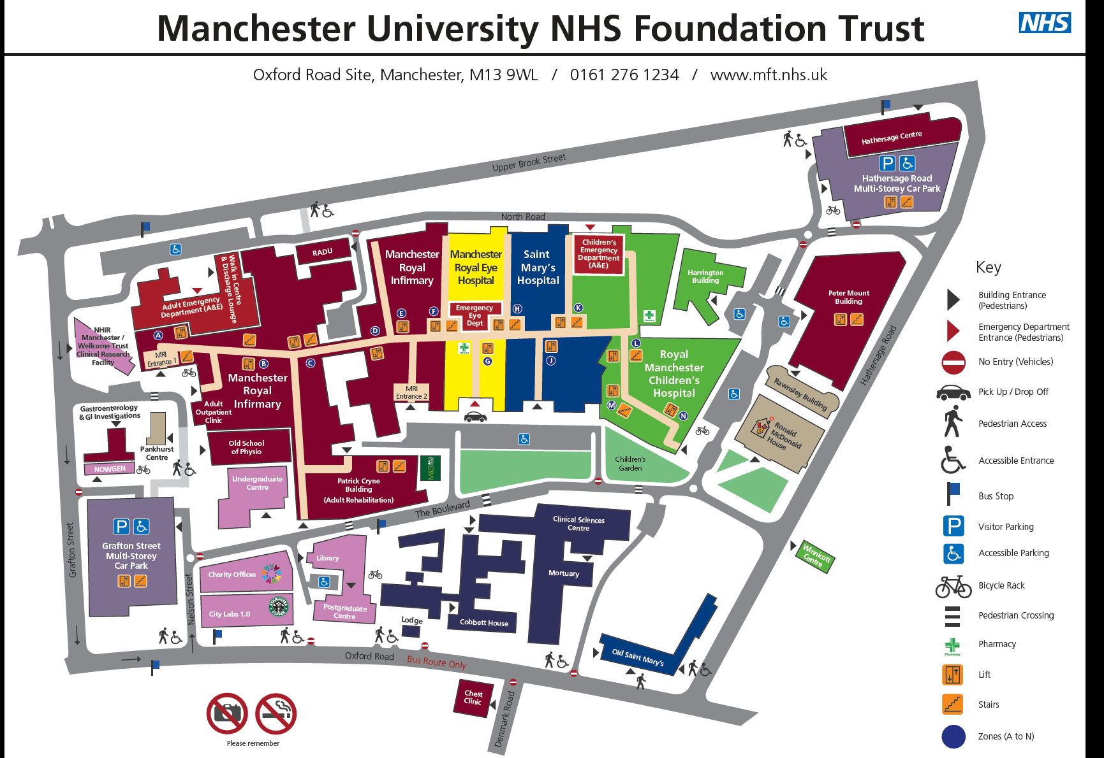

In case of an accident or emergency contact immediately:

(Ensure that all the details are recorded in the Site Accident Book)

Appendix 9

Procedure on Discovery of Suspected Asbestos Containing Material

All Personnel
Start

Evacuate area if necessary and prohibit further access, leave all
suspect and contaminated material in the area

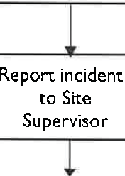
Line Manager
r'
3
0
3
P
:
&
0
=
- No
Line Manager to contact approved Asbestos Contractor
Site Supervisor to make area safe and contact Line
Manager/Health & Safetv Deot
ls ACM
presend
Arrange for sample to be taken and delivered to analyst
g
r: g
If' s
'1
n. B
rD
3
rZD ' u0.
B
8
Z
0
-

Yes
11
0<

Invoke remediation procedure as per Contractors Risk Assessment and Method Statement
End

Appendix 10

Smokefree Policy

SMOKEFREE POLICY

THE R&M GROUP LTD AND ITS SUBSIDIARIES

Smokefree Policy
Policy Statement

To enable employees to work in a smoke-free environment, the Company’s business premises are designated “no smoking”. Smoking is prohibited in all areas of the Company’s premises, unless designated shelters are provided, including the areas immediately outside the entrance to our premises.
The Company’s prohibition on smoking applies not only to employees but also visitors, including clients and customers.
If you wish to smoke, you must do so in your own time either outside your normal hours of work or during your lunch break. You are not permitted to take additional smoking breaks during the day.
Failure to comply with the above rules is a disciplinary offence and will be dealt with in accordance with the Company’s Disciplinary Procedure. Where smoking creates a clear health and safety hazard, then such behaviour constitutes potential gross misconduct and could render the employee liable to summary dismissal.

Importantly, those who do not comply with the ‘smokefree law’ may also be liable to a fixed penalty fine and possible criminal prosecution under current legislation.

All staff, employees, subcontractors, consultants, service users, customers and visitors are obliged to adhere to and facilitate the implementation of the Policy.
The NHS offers a range of free services to help smokers give up smoking. Visit nhs.uk/smokefree/help-and-advice/support or call the NHS Smoking Helpline on 0300 123 1044.

Managing Director:

Mr. J.Scurr
Date: 28.02.2024

Ref: POL-004-SAF Rev No: Date of Issue: May 18 Page 1 of

Appendix 12

Permit to Work

Health Safety and Environmental Compliance Manual

SECTION NINE

PERMIT TO WORK

GENERAL GUIDANCE
Permit to Work
Confined Spaces:

All confined space work must be covered by a suitable Risk Assessment and Method Statement.

Things to consider: Can the work be carried without confined space entry? All work in confined spaces must be undertaken by fully trained and competent persons, access equipment, PPE, emergency procedures, lone working etc.
Excavations:

All excavation work must be covered by a suitable Risk Assessment and Method Statement. Especially when working outside the site or undertaking work not usual to our undertaking.

Things to consider: Location, existing plans etc. services, depth, supports, access and egress, material, flooding, unauthorised access, confined spaces, inspections etc.

Buried Services:

All work must be covered by a suitable Risk Assessment and Method Statement. Especially when working outside the site or undertaking work not usual to our undertaking.

Things to consider: Plans and drawings, survey of site looking for existing clues - lighting columns, road crossing etc. CAT, demarcating line of service, trial holes, safe digging practices etc.

Contacting service owners if working around them.

Hot Works:
All Hot Work must be covered by a suitable Risk Assessment and Method Statement.

Things to consider: The immediate environment and those likely to be affected by the work, unauthorised access, existing waste and debris, possible explosive atmospheres, suitable fire extinguising equipment must be readily available.

Important: Hot Work must be inspected at least 1 hour after completion to inspect for remaining heat and smouldering.
Overhead Electric Cables:

All work must be covered by a suitable Risk Assessment and Method Statement.

Things to consider: Approach the Local Electricity Board.

Determine safe passing distances.

Erect goal posts and safety corridors in line with GS6 Avoidance of Danger from Overhead Electric Lines.
Work on Crushers, Screeners and Shreaders:

All work must be covered by a suitable Risk Assessment and Method Statement.

Things to consider: Are those required to undertake such work trained and authorised, unauthorised access, key holding, procedure - inadvertent starting, testing and commissioning, safe operation and use, loneworking etc.

Work with Asbestos:
All asbestos removal work must be carried out by a specialist sub – contractor.

All work must be covered by a suitable Risk Assessment and Method Statement.

Work involving Licenced Asbestos must be carried out by Licenced Asbestos Contractors.

Things to consider: The Asbestos must be positively identified by laboratory analysis, always assume a material to be Asbestos until proved otherwise, training and unauthorised access, exclusion zones, safe storage and disposal, welfare facilities, PPE, emergency procedures etc.

References: 1. Company Health and Safety Policy

- Company Risk Assessment Manual

- HSE Guidance Note HS(G)47 Avoiding Danger from Underground Services

- HSE Guidance Note GS6 Avoidance of Danger form Overhead Electric Lines

PERMIT TO WORK
CONTRACT |  | Contract No.
 |  | Permit No.
1. Name of Company |  |  | Part 1
2. No. of men involved
3. Precise nature of work to be carried out
4. Precise location of operation
5. Special Hazards
6. Safeguards to be observed
Provided all the above are complied with, you may proceed to Part 2
 |  |  | Part 2
This permit is valid from: Time…………………hrs Date…………………………….
Until: Time….......................hrs Date by which time work must cease and the area made safe

Signed: ……………………………………………………… Time: …………………..….hrs Date: …………………
ACCEPTANCE |  |  | Part 3
I accept the responsibility for ensuring that I and all operatives under my control will comply fully with this Permit to Work
Signed………………………………………………….. for……………………………………………………………….. Time…………………..…...hrs Date…………………..
CLEARANCE |  |  | Part 4
I hereby declare that work detailed on this Permit has been completed or stopped and the area left safe. All persons under my control have been withdrawn from the area.
Signed………………………………………………… for………………………………………………………….. Time………………………hrs Date…………………
I hereby declare this Permit cancelled. |  |  | Part 5
Signed………………………………………………………..
Time………………………...hrs Date…………………...

Appendix 13

Welfare Details / Compound Layout

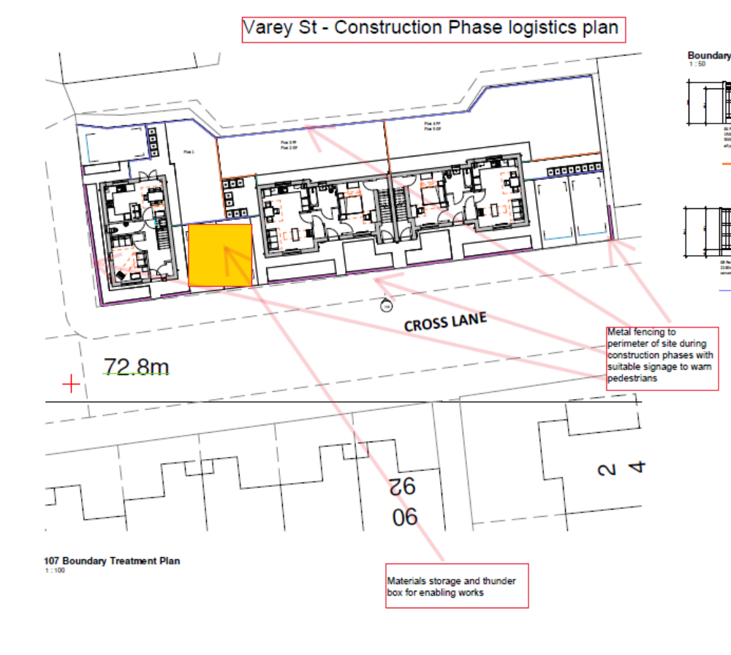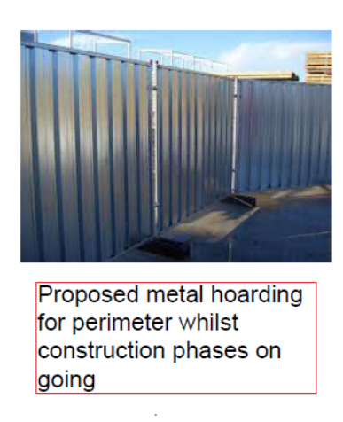

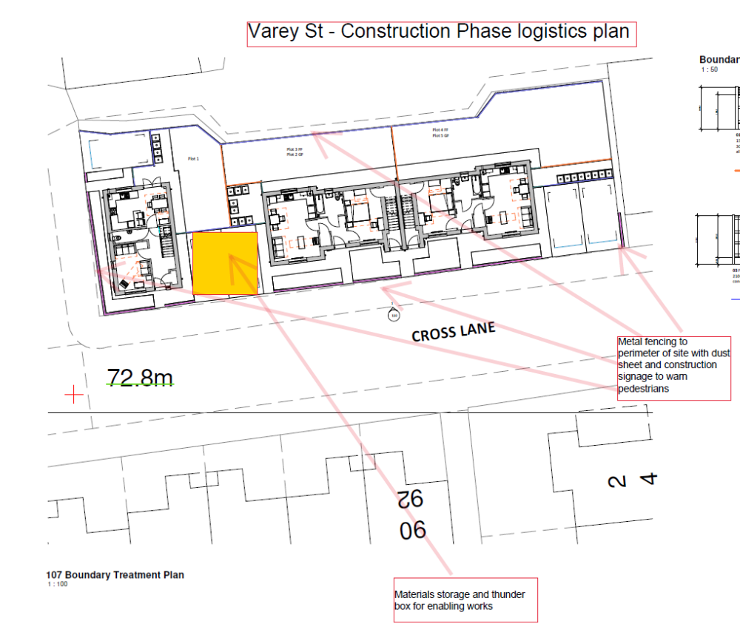

App.15

Induction Procedure

SECTION ONE

HEALTH AND SAFETY INDUCTION

INDUCTION OF NEW EMPLOYEES TO SITE
When a new employee is appointed, he or she should receive a Site Health and Safety Induction before commencing on site.

Some 50% of site accidents are caused within the first 2 weeks of employees starting on a new site.

Therefore, it is important that new employees are to receive a tour of the site and their attention drawn to any potential hazards along with the necessary control measures, site rules, the position of fire extinguishers, emergency procedures and evacuation routes etc., by their Site Manager or General Foreman.

They should be made aware of relevant sources of health and safety information i.e. Health and Safety Policy, COSHH and Risk Assessments, Method Statements, Notice Boards etc.

It is essential that the new employee understands all the information given to them and is given the opportunity to ask questions.

On completion of the induction a record of the new employees details asbestos made.

Induction forms will include:

- Record of Induction
- Site Specific Risk Assessment
- Code of Conduct
- Next of Kin Form
- Medical Questionnaire

ITEMS TO BE DISCUSSED AT INDUCTION

- Location of Site Telephone

- Accident / Accident Reporting Procedure / Emergency Procedure

- Site First Aider/ Location of First Aid Box

- Location of Fire Extinguishers / Fire Assembly Point

- Welfare Facilities - Toilet / Canteen

- Company Health and Safety Information Booklet
- Site Rules - including the importance of PPE.

- Known Potential Site Hazards - Site Specific Risk
- 1Environmental Matters - Duty of Care / Waste Disposal etc. 11. Visitors Book / Site Register
- Respect of Residents Privacy / Code of Conduct (if appropriate)

- Next of Kin Form for New Starters

- Medical Questionnaire

Any other matters specific to your site

………………………………………………………………………………

………………………………………………………………………………

………………………………………………………………………………

GENERAL GUIDANCE
When a new employee is appointed, they should receive a always required and Safety Induction.

Inductions: Why, When and Who
Why: To ensure that new employees or employees new to a job or site are made aware of the hazards and risks associated with the job and they are aware dos and don’ts, emergency procedures, first aid etc.

When: Before commencing work on site.

Who: If an employee is new to the Company, the employee must be:

  - Have read a copy of the Company’s Health and Safety Information Booklet.

  - Issued with a copy of the Site-Specific Risk Assessment and relevant Method Statements.

  - Given a tour of the site, especially known hazardous areas or activities, and introduced to the emergency procedures, fire assembly point, welfare facilities etc.

  - The employee must sign the induction record sheet confirming that they have received the induction and associated information.

If an employee is not new to the Company but new to the site, the employee must be:

- Issued with a copy of the Site-Specific Risk Assessment and relevant Method Statements.

- Given a tour of the site, especially known hazardous areas or activities, and introduced to the emergency procedures, fire assembly point, welfare facilities etc.

- The employee must sign the induction record sheet confirming that they have received the induction and associated information.

If an employee is returning to the site after being on another Company site.

- If the Site-Specific Risk Assessment and / or the site hazards have not changed then the employee need not be inducted. However, inducting the employee may be a measure of good practice taking in to account the time the employee has been away from the site.

- If the Site-Specific Risk Assessment or known site hazards have changed then the employee must be again inducted.

If the Employee is a Young Person (A young person is defined as any person who is above school leaving age but who has not attained the age of eighteen).

- Contact the Health and Safety Department for specific information.

Preparation:

- Think about what preparation is required before the Induction.

- Keep distractions to a minimum.

- Consider effective aids you can use to enhance the Induction.

Delivery:

- An Induction shouldn’t be just ONE WAY. It is important to engage with people.

- Clearly indicate the major points of the Induction you will concentrate on.

- Don’t think that you have to mention every piece of information - choose the information which is relevant to your workplace.

Questions

- Remember, ask the question, pause to give people time to think and finally, choose who you want to answer. Make sure as many people as possible get to answer questions.

- If incorrect, don’t ridicule, put down or laugh. Restate the question to make sure it is clear and give people time to think of a reply but avoid simply giving the answer yourself.

- If there is an awkward silence, rephrase the question and allow people a reasonable amount of thinking time.

- Repeat the reply so that whole group can hear. You can then check your understanding of the answer given.

The Site Health and Safety Induction must be delivered to all Employees, Sub-Contractors, Clients Representatives and Visitors

References: 1. Company Health and Safety Policy

  - Company Health and Safety Information Booklet

  - Company Health and Safety Risk Assessment Manual

R&M Group of Companies
RECORD OF SITE INDUCTION

Name | Date | Company Name | Induction Training inc COVID 19 | Site Risk Assessment | Method Statement | Next of Kin Medical Q | Code of Conduct | Adequate PPE | Signature  (I have received and understood the items) | Signature of person providing Induction
Contract Code:
SHEET N°

The Management of Health and Safety at Work Regulations 1999

Site Specific Risk Assessment

Contract:
Contract No:


Nature of site Work:

Persons affected:

Issue date:

Revised date:

Revised date:
Revised date:

This assessment will be reviewed and revised as necessary considering changes in legislation, working operations and site conditions.

Further information on Risk Assessment is maintained in the Site Office.

CODE OF CONDUCT

The following are the minimum standards required when working on this contract.
Follow the COVID 19 RAMS.

Before commencing work on a property, you should:
Ensure you are wearing the appropriate dresswear and safety equipment when applicable.

Introduce yourself to the Resident Display clearly your company I.D. badge.
Report back to the site management team if access is not available. Explain the nature and likely duration of the task in hand to the Resident. When working on a property you should:
Use clean dust sheets to protect the resident's belongings before
commencing work.

Ensure disruption to the resident is kept to a minimum. Keep materials and equipment safe within the working area.
Keep the resident informed of progress and arrange and agree further access if you cannot complete the task in hand during that visit. Inform the RLO of any arrangements made.

Listen to any grievance the resident may have and inform the Resident Liaison Officer immediately.
Ensure the property, it's surrounds, and garden are clean and tidy at all times and in 'working order' at the end of the working day.
Do not leave unfixed materials in the property. Make sure the property is always secure.

Do not work outside the permitted working hours without the express permission of the site manager and the resident.
When working on a property you should NOT:
Smoke.

Use bad language.

Use resident's tools or equipment. Use a radio etc.
Use resident's facilities.

Be under the influence of alcohol or any other substance.
ALWAYS:
Be courteous.

Respect resident's confidentiality e.g. does not gossip or indulge private information.

Observe Health and Safety Regulations and current Codes of Practice. Appreciate that you are working in a home and not a building site.
Respect resident's belongings and gardens. Use the messing facilities provided on site.
Return all keys to the site management team upon completion of your task or at the end of the working day.

REMEMBER

GET IT RIGHT - BE POLITE

MEDICAL QUESTIONNAIRE
Please complete this form and hand it to your Site Supervisor. The information you give will be kept entirely confidential and is needed to ensure your safety and the safety of others. Any points of uncertainty can be discussed further with your Site Supervisor.

First name Surname

Date of Birth Date of
Commencement

Medical History

Please indicate if any of the following apply or have applied to you in the past. Please give details below where appropriate.
Yes No

Circulatory problems such as varicose veins, thrombosis?

Heart problems such as angina, high blood pressure, heart attack? Chest problems such as asthma?
Diabetes?

Epilepsy or fainting attacks? Skin disorders?
Recent operation or fracture? Any current medication?
Back trouble, arthritis, rheumatism?

Injury to bones, joints, tendons, including wrist tendons? A claim for industrial injury etc.?
Have you worked in an industry with high noise levels? Have you worked in an industry with high vibration levels?
Any other significant health problems (eyes, hearing, skin etc.)?

Details
I hereby declare that the above information is correct to the best of my knowledge Signature Date
The Casey Group of Companies - Medical Questionnaire April 2017

R&M Property Group Ltd and Group of companies

NEXT OF KIN / CHANGE OF DETAILS FORM

DATE:

EMPLOYEE’S DETAILS
SURNAME: FORNAMES:
Department: NI NUMBER:
Job Title: Date of Birth:
Home Address:

Postcode:

Home Telephone Number

EMERGENCY CONTACT INFORMATION
NEXT OF KIN NAME:
RELATIONSHIP:
DAYTIME CONTACT DETAILS
DAYTIME PHONE:
DAYTIME ADDRESS:

If any of these details change, please inform us immediately.

R&M Property Group Ltd and Group of companies

Department: access,

Helmet Declaration Form

From 6 April 2013, the PPE Regulations 1992 apply to the provision and use of hard hats on construction sites.

Under Regulations 6 and 7 of the regulations, and NWR 23 of the NJCBI National Working Rule Agreement, employees are required to wear suitable head protection when directed to do so by his employer, or to comply with rules made by the person in control of the site.

Failure to wear a safety helmet when required to do so is a disciplinary offence and will be followed by disciplinary action.

I, the undersigned, have read, understood, and agree to abide by the above regulations. Name (block capitals) …………………………………………………………………….. Signed……………………………………. Date……………………………..

SITE INDUCTION CONFIRMATION FORM

CONTRACT CODE |  | CONTRACT NAME
FULL NAME |  | DATE OF BIRTH
COMPANY NAME |  | EMERGENCY CONTACT  (NAME & RELATIONSHIP)
SUPERVISOR’S NAME |  | TELEPHONE NUMBER

SITE SAFETY
PLEASE INITIAL
Health & Safety at Work - Outline of project and site constraints.
Employers responsibilities – HASAWA 1974 - CDM 2015 – Management Regs 1999 etc
Informed of the R&M Property Group Personnel involved on this project.
Employees responsibilities
- Co-operate with instructions;
- You must wear PPE that is provided by your employer;
- Do not interfere with safety equipment unless authorised to do so;
- Carry out work in accordance with your companies RAMS and any training you have undertaken;
- Report any situation that is or could become dangerous;
- Take reasonable care of yourself and others who may be affected by your actions.
Location of statutory notices – H&S Law poster – F10 – Insurance documents.
I have been made aware of who are the First Aiders and Fire Marshalls on this site.
Fire procedures and assembly point
- Ensure that you sign in and out of site.
- Make yourselves aware of the Fire Plan which clearly displays the Fire Exits and Assembly Point.
- Be aware of the Fire Point in your working area which displays what to do in case of a Fire.
- Follow all instruction given to you by the Fire Marshalls
The company’s Core Values have been explained along with the Open-Door Policy.
I know what Welfare facilities are available on this site and will assist in keeping them clean and tidy for use by others.
I understand and will follow the Site Rules.
I am aware of the site’s Environmental Rules and specific site requirements– Tree Protection fencing, newt fences, water courses, re-fuelling etc.
I have produced for photocopying all Training Cards and Certificates specific to my trade/site activities.
This site is a no Smoking Site and I have been made aware of the location of the permitted Smoking Area.
I have been made aware of the Casey’s policy on Mobile Phone use on this site.
I will only operate Plant and Equipment that I am competent to use and will undertake and record all statutory pre- user checks and weekly inspections.
I agree to Report all accidents and near misses to the site management team.
I know that I may be asked to leave site if I am found to be under the influence of Drugs or Alcohol.
I am aware of the Traffic Management Plan and will assist in its implementation.
I have read, understood and signed my company’ Risk Assessments and Method Statements.
I understand that I may require to obtain a Permit to work e.g. permit to dig, hot works, confined space.
I am aware of the standard PPE requirements are on this site and understand I may need to consider using other
Personal Protective Equipment where there is an additional hazard identified in the Risk Assessment.
Considerate Contractors Scheme – I understand the Outline of the scheme
I understand the guidance provided on COVID-19 and I am aware I must adhere to them including social distancing

Medical information:

Do you have any medical condition that you are taking medication for, or that may affect where you work or anyone working with you? If so, please detail:

Condition | ……………………………………………. | Medication | ……………………………………………….
Condition | …………………………………………….. | Medication | ……………………………………………….
Condition | …………………………………………….. | Medication | ………………………………………………..

Please complete the following questions to demonstrate your induction knowledge:

Q: Who has duties under Health and Safety on this site?
A:
Q: Who is the First Aider on this site?
A:
Q: Fire Points are shown on what drawing?
A:
Q: Where is the smoking shelter located?
A:
Q: Which three items of PPE should be worn at all times whilst on site?
A:
Q: Where is the Muster point located?
A:
Training
Have you handed in, for photocopying, the following Training Cards and Certificates that are applicable for the work you are undertaking? Please tick the ones that are applicable to you.

☐ | CSCS | ☐ | CPCS | ☐ | FIRST AID | ☐ | IPAF | ☐ | CISRS | ☐ | SSPTS | ☐ | FACE FIT
☐ | SSSTS | ☐ | SMSTS | ☐ | NPORS | ☐ | PASMA | ☐ | ASBESTOS | ☐ | GAS SAFE | ☐ | ABRASIVE WHEEL

I have been instructed on the above safety requirements and agree to abide by them at all times.

PRINT NAME: …………………………………………….. SIGNED: …………………………………………………… DATE: …………………………………
Internal Use
Are the training cards/certificates appropriate for the task? Are they a true likeness of the person and in date?
Is the person under 18? And requires a Young Person’s Risk Assessment?
Y / N
Y / N Y / N
INSTRUCTOR: ………………………………………..
DESIGNATION: ……………………………………
SIGNED: …………………………………

