PLANNING STATEMENT

- Site Details

Site Name: | Grimshaw Lane | Site Address: | Grimshaw Lane  Manchester  Greater Manchester  M40 2AX
NGR: | E: 386961, N: 399787 | Site Address: | Grimshaw Lane  Manchester  Greater Manchester  M40 2AX
Site Ref Number: | NTQ 21278 | Site Type: Macro | NTQ Replacement

- Pre-Application Check List

Site Selection

Was an LPA mast register used to check for suitable sites by the operator or the LPA? |  | No
If no explain why:

After a phone call to the LPA it was felt that the industry database was a more up to date source of information.

Was the industry site database checked for suitable sites by the operator: | Yes
If no explain why:

N/A

Pre-application consultation with LPA

Date of written offer of pre-application consultation: | 15th August 2024
Was there pre-application contact: |  | No
Date of pre-application contact: | N/A
Name of contact: | The Director of Planning
Summary of outcome/Main issues raised:

At the time of preparing this submission, and despite our attempt to engage in pre-application dialogue with the LPA, no comments had been received in respect to the proposals.

Ten Commitments Consultation

Rating of Site under Traffic Light Model: | Green
Prior to the submission of this application the applicant initiates pre-consultation discussions with the local planning authority. This provides an opportunity for the LPA to discuss development proposals and identify site specific issues.

Summary of outcome/Main issues raised:

No responses had been received at the time of submission.

School/College

Location of site in relation to school/college:

There are no schools in close proximity to the site.

Outline of consultation carried out with school/college:

N/A

Summary of outcome/Main issues raised:

N/A

Civil Aviation Authority/Secretary of State for Defence/Aerodrome Operator consultation

Will the structure be within 3km of an aerodrome or airfield? |  | No
Has the Civil Aviation Authority/Secretary of State for Defence/Aerodrome Operator been notified? |  | No
Details of response:

N/A

Developer’s Notice

Copy of Developer’s Notice enclosed? | Yes
Date served: | 21st August 2024

- Proposed Development

The proposed site:
THIS APPLICATION FOLLOWS THE APPROVAL OF APPLICATION NO: 134253/TEL/2022 BY MANCHESTER CITY COUNCIL ON 16/8/2022. THIS PREVIOUS APPROVED SITE CANNOT BE CONSTRUCTED FOR TECHNICAL REASONS AND THUS HAS BEEN DISCOUNTED.

It is imperative to consider that this proposal is to replace an existing installation and is not a new additional installation. The need for this mast stems from MBNL having been issued with an NTQ (Notice to Quit) on their existing site and thus this new mast is urgently required to maintain coverage.
The previous proposed site was at George Jones & Son, 232 Briscoe Lane, Manchester, Greater Manchester, M40 2XG has now been discounted as it cannot be progressed. This new proposal is to replace that previously approved scheme.

The search area centres around the NTQ site 93536 Riverside Trading Estate (which must be replaced). The whole estate has been sold and is to be redeveloped, so a replacement site is urgently required.

The new proposal is for the installation of a new 20.0m High Slimline Monopole that will provide new coverage for EE and has the potential for H3G LTE. The proposed new facility will require the installation of a limited number of equipment cabinet housing radio equipment at ground level and in close proximity to the base of the pole. The cabinet equipment are however, permitted development (without Prior Approval) and thus do not form part of this application. The sharing of base stations between multiple operators is one of the key strategic policy principles contained within the NPPF. H3G and EE have a network sharing agreement and thus these installations are fully compliant with the NPPF.

Central Government attaches great importance to the design of the built environment and outlines this within Section 12 (para. 124) of the National Planning Policy Framework. It states:

“Good design is a key aspect of sustainable development, creates better places in which to live and work and helps make development acceptable to communities.”

In keeping with the National Planning Policy Framework (NPPF). guidelines of using: “high quality communications” (Section 10), the proposed design has been selected to minimise visual impact upon the street scene by integrating with the existing built environment.

The design of the proposed equipment is considered to be the least visually intrusive option available. In keeping with the National Planning Policy Framework (NPPF). guidelines of using: “high quality communications infrastructure”, the proposed 20.0m High Valmont Slimline Climbable Monopole has been selected to minimise visual impact upon the street scene by integrating with the existing street furniture, having similar vertical lines and overall appearance to the street lighting columns that are common feature in the built environment. As stated above the National Planning Policy Framework advocates site sharing, and as such we believe that there are no sequentially preferable locations within the defined site search area.

Figure 1:
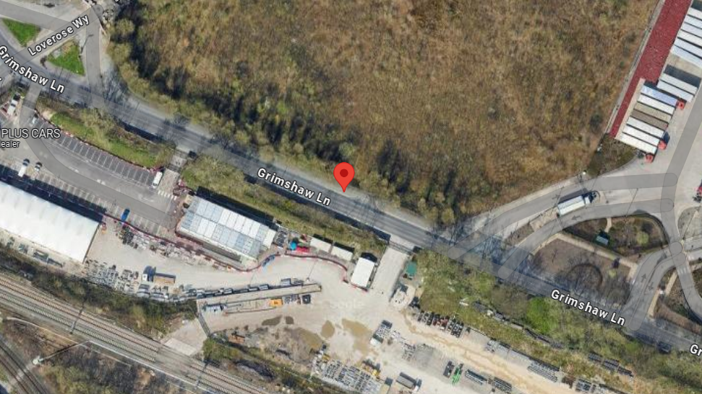

Figure 2:
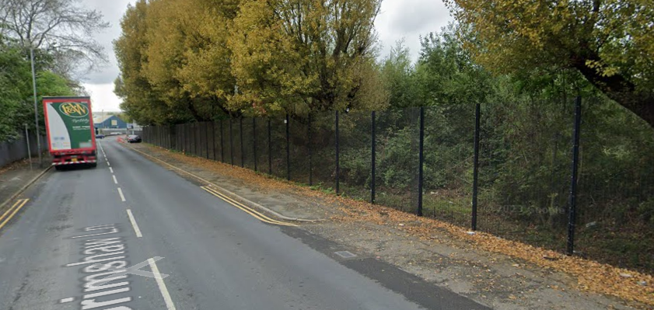
Figure 3:
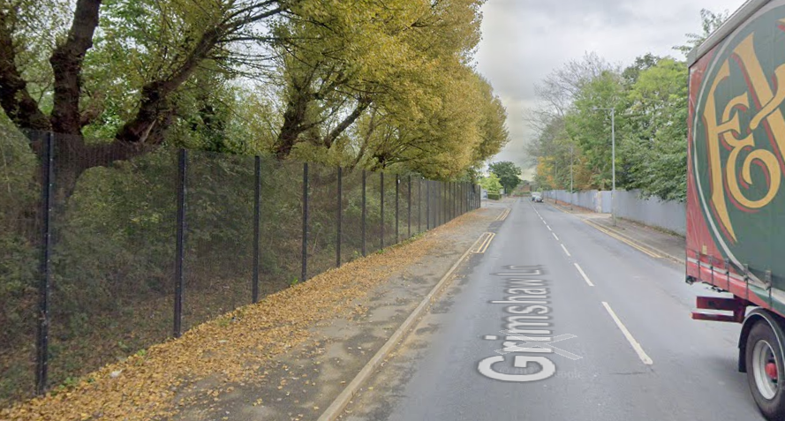

Site Ref: | 21278 | Site Address: | Grimshaw Lane, Manchester, M40 2AX

Local Planning Authority: Manchester City Council

Development Plan: Manchester Core Strategy (2012) / Manchester UDP (saved policies) / Places for Everyone Joint DPD (2024)

Fig.1: LP Plan Extract (Reference Only):


Site and its surrounds

Policy Relevant to the Development Site:

The site is designated as being within the settlement boundary, with urban uses to the north, east, south, and west. The site designation is not a material consideration.

Manchester Council does have a specific telecoms policy. This, together with the NPPF is of relevance. The National Planning Policy section of this supporting statement goes into detailed analysis of why this site is in compliance with the NPPF.

Policy Analysis:

Policy DC17.1 states:

“Applications for telecommunications developments will normally be approved if the Council can be satisfied that the development has been sited and designed to minimise its impact on residential amenity and in environmentally sensitive areas. Wherever possible, the Council will expect the potential of existing buildings and masts, including the sharing of such facilities, to be fully explored before agreeing to additional separate development.”

In addition, the following objective is important:

“Objective 9: Ensure access to physical and social infrastructure. We will:

• Improve the capacity and network coverage of digital, energy, telecoms, transport and water in key growth locations.”

The proposed development at this site is required to deliver the requisite level of electronic communication service on a single installation that is to be adapted to accommodate multiple users (so enable future site sharing opportunities), yet seeks to minimise its impact or change to the character of this location (being utilitarian in appearance, in a location characterised by industrial uses). The form and design of the proposed configuration would not appear out of context in this location, so according with wider Development Plan policy and would ensure the appearance and character of the area is fully maintained.

In addition to the above, Paragraph 118 of the NPPF (December 2023) states:

18. Advanced, high quality and reliable communications infrastructure is essential for economic growth and social well-being. Planning policies and decisions should support the expansion of electronic communications networks, including next generation mobile technology (such as 5G) and full fibre broadband connections. Policies should set out how high-quality digital infrastructure, providing access to services from a range of providers, is expected to be delivered and upgraded over time; and should prioritise full fibre connections to existing and new developments (as these connections will, in almost all cases, provide the optimum solution).

The LPA should look to support this proposal as the equipment will bring “reliable communications” to the area.

Paragraph 121 states that

“for a new mast or base station, evidence that the applicant has explored the possibility of erecting antennas on an existing building, mast or other structure and a statement that self-certifies that, when operational, International Commission guidelines will be met.”

The discounted options section of this planning statement fully illustrates that all other potential masts, roof tops and other locations have been investigated. The proposed site is the optimum location from a planning and coverage perspective.

The public benefits of a greatly enhanced communications network for businesses, residents and visitors alike in this location would qualify as a substantial benefit with near benign change or impact on amenity.

The enhanced digital service would very much accord with the objectives of the Development Plan policy.

The proposal fully accords with the requirements of the NPPF.

RADIO PLANNING AND PROPAGATION
When planning cellular telecommunications networks it is important for engineers to predict, with a high degree of confidence, the behaviour of cellular transmissions. This then enables the operator to calculate how many cell sites are needed to provide the level of coverage required by the services they offer under the terms of their licence.
The strength of radio signals detected at a receiving device naturally reduces the further away it is from the transmitter. In general the reduction (or decay) in signal power is affected by a number of variables. The main factors are

- frequency,
- distance (from transmitter),
- terrain (such as hills),
- clutter (such as buildings, foliage, vehicles, and water)
- and atmospheric conditions (such as rain).

A reduction in the strength of the radio signal increases the likelihood of dropped calls and reduced data rates for internet browsing, for example.
Clutter
Any physical object obstructing the propagation of radio signals causes a reduction in signal strength reaching a customer’s device. A common term for these objects is ‘clutter’. The more obvious examples are buildings and geographical terrain such as hills and trees.
Buildings cause a varying amount of signal reduction depending on their height, construction, thickness of walls, amount of windows etc. Glass causes a lower reduction in signal than brick/concrete walls.
Customers will inadvertently be aware of this by finding that sometimes they need to go near windows, a higher floor of a building or even outside in order to achieve a stronger signal for their mobile devices.
Tree Clutter
The effects of trees on signal degradation should never be underestimated. Signal absorption and shadowing effects vary according to vegetation and density, and are caused by the main tree trunk, branches and leaves.
Cell sites located in or near trees will have signals significantly reduced. As a result a number of extra sites may need to be built locally in order to counter-effect this.
Signal variation throughout the seasons is also a practical concern. Leaves on trees in the spring and summer can cause shadowing and reduce radio voice quality and increase the number of dropped calls.
As a result the bottom of an antenna should be a) above the top level of the trees, b) allow greater height due to the antenna downtilt at build or for future requirements and c) allow some room for future growth of the trees.
In the case where the cell site utilises point-to-point microwave backhaul transmission the microwave dish should not be obscured at all.
Propagation Models
In essence these are mathematical formulae used to characterise radio wave propagation, in order to determine the received signal strength at a receiving device.
The most well-known propagation model used for mobile telecommunications is ‘Okamura-Hata’. More specific studies have been performed to investigate specific clutter and terrain such as dense-urban and urban environments. Resulting from these are propagation models for specific clutter types.
Coverage Planning Tools
Radio planning engineers plan cellular networks using highly sophisticated computer programs that incorporate the above propagation models. Armed with data on cell site location, cell site configuration, maps, terrain etc they are used to predict areas of coverage deficiency (so called ‘coverage holes’), new site requirements and configurations.
Network Changes
Over time the topography and clutter in an area is subject to change. For example, building developments, housing and tree growth can all change. As a consequence the signals received from local phone masts can degrade, as they are dependent on these factors. These reasons along with customer complaints, network consolidation (mast sharing) and new technologies (4G) require a re-evaluation of a network operator’s telecommunications infrastructure.
Mast sharing can result in some masts no longer being needed. As a result they are decommissioned and physically removed.
Technical surveys undertaken for reasons above may highlight that antenna height increases are required – this is more likely for sites with low antenna heights around 15m AGL, particularly street furniture sites. More details on these reasons below.
While thus far this document is generic to mobile telephony masts it should be noted that each mast has to be dealt with on a case-by-case basis.
Site Height increases
There are a number of reasons why an operator may request a height increase on existing structures. The main ones are described below.
Maintaining existing coverage
The antennas inside, for example, street furniture sites are generally of 2 physical build designs – ‘Single Stack’ and ‘Dual Stack’. The former describes when the set of antennas are all at the same height. The latter describes a site with 2 sets of antennas one above the other.
The ‘Dual Stack’ is by far the preferred option. This is due to a number of factors including greater flexibility & control for different technologies and providing optimum service performance to customers.
Network Consolidation between H3G LTE and EE and new 4G technologies facilitate a Single Stack structure being upgraded to a Dual Stack structure. In a straight swap scenario at equal height the new lower aperture antennas would be lower than they were originally - resulting in significantly reduced coverage. To ensure existing coverage is maintained the whole structure needs to be increased in height.
Clutter changes
A more extreme example is when the local clutter or tree lines have changed, or are such that the mobile signals are blocked, resulting in lower quality calls and downloads for mobile device users. To provide sufficient services to customers height increases on existing masts or additional new masts are required. The former is the preferred option in many cases.
ICNIRP Compliance
The addition of new technologies and mast sharing affects ICNIRP compliance – a higher minimum mast height is required in some cases.

Enclose map showing the cell centre and adjoining cells:
This can be emailed to the LPA upon request.

Type of Structure
Description:

TOP OF TOWER +20.0m AGL
C/L OF H3G AAU +19.37m AGL
C/L OF EE AAU +18.07m AGL
C/L OF SHARED APERTURES +16.17m AGL
C/L OF DISHES +13.60m AGL

PROPOSED H3G 1No. GPS NODE
PROPOSED EE 1No. GPS NODE
PROPOSED H3G 3No. APERTURES
PROPOSED EE 3No. APERTURES
PROPOSED EE/H3G 3No. SHARED APERTURES
PROPOSED EE/H3G 2No. 600mmØ DISHES
PROPOSED EE/H3G VALMONT 20m HIGH PHASE 7 MK2 STREETWORKS POLE ON ROOT FOUNDATION
PROPOSED EE/H3G WRAP-AROUND CABINET
PROPOSED EE UNILATERAL CABINET ON ROOT FOUNDATION
PROPOSED EE WILTSHIRE CABINET ON ROOT FOUNDATION
PROPOSED H3G UNILATERAL CABINET ON ROOT FOUNDATION
PROPOSED H3G BOWLER CABINET ON ROOT FOUNDATION
PROPOSED EE/H3G MK5B LINK ACCABINET ON ROOT FOUNDATION

Overall Height: +20.0m AGL
Height of existing building |  | N/A
Equipment Housing: Can be provided upon request
Length:
Width:
Height:
Materials
Tower/mast etc – type of material and external colour:
Equipment housing – type of material and external colour:

Reasons for choice of design:
The proposed installation is an EE Ltd and H3G LTE 20m High Streetworks Pole which will house both EE and H3G LTE. The sharing of base stations between multiple operators is one of the key strategic policy principles contained within the NPPF.

Central Government attaches great importance to the design of the built environment and outlines this within Section 12 (para. 131) of the 2023 National Planning Policy Framework. It states:

“Good design is a key aspect of sustainable development, creates better places in which to live and work and helps make development acceptable to communities.”.

In keeping with the National Planning Policy Framework guidelines of using high quality communications infrastructure the proposed monopole design has been selected to minimise visual impact by integrating with the existing street furniture, having similar vertical lines to the street lighting columns/ telegraph poles in the locale. The proposed design has a slimmer appearance to the previously refused monopole design, with a narrower headframe further ensuring that any visual intrusion is minimised as much as possible.
Whilst it is accepted that this proposed installation is taller than the previously refused monopole, physical objects such as the tall surrounding buildings and trees can obstruct radio signals causing a reduction in signal strength and coverage. The height of the proposed monopole is therefore necessary for this installation to enable the continued and improved coverage and capacity to be achieved and delivered to the residents and businesses in the area.

- Technical Information

ICNIRP Declaration attached  ICNIRP public compliance is determined by mathematical calculation and implemented by careful location of antennas, access restrictions and/or barriers and signage as necessary. Members of the public cannot unknowingly enter areas close to the antennas where exposure may exceed the relevant guidelines.  When determining compliance the emissions from all mobile phone network operators on the site are taken into account. | Yes

- Technical Justification

Reason(s) why site required
The National Planning Policy Framework clearly states that authorities should not question the need for the service, nor seek to prevent competition between operators. Notwithstanding this fact, the Applicant considers it to be important to explain the technical justification for the site and how the facility fits into the overall network.

Notwithstanding this fact, the Applicant considers it to be important to explain the technical justification for the site and how the facility fits into the overall network.

The site is required to provide new 5G coverage for EE Ltd in order to improve coverage in the M40 area of Manchester. The cell search areas for 5G are extremely constrained with a typical cell radius of approximately 250m meaning that it would not be feasible to site the column outside of this locale.

Further detail regarding the general operation of the network can be found in the accompanying document entitled ‘General Background Information on Radio Network Development for Planning Applications’. This information is provided to assist the local planning authority in understanding any technical constraints on the location of the proposed development.

The installation of this replacement telecommunications Streetworks Pole within this area of Manchester, is essential to ensure continued provision and to meet the growing demand for reliable and high-speed communication services. The proposed mast will also enhance mobile network coverage, ensuring that residents have continued and improved access to seamless and efficient communication services. This connectivity is not only crucial for personal communication but also plays a vital role in supporting businesses, education, and emergency services within the community.
- Site Selection Process – alternative sites considered and not chosen

Discounted Options
In accordance with the sequential approach outlined in the National Planning Policy Framework (NPPF) following search criteria have been utilised. Firstly, consideration is always given to sharing any existing telecommunication structures in the area, secondly consideration is then given to utilising any suitable existing structures or buildings and thirdly sites for freestanding ground-based installations are investigated.

This sequential approach is outlined below:

- Mast and Site Sharing
- Existing Buildings Structures
- Ground Bases Installations

In compliance with its licence and the sequential approach outlined in the NPPF all attempts to utilise any existing telecommunication structures where they represent the optimum environmental solution have been employed. The Ofcom Site Finder mast register is always examined prior to the submission of an application.

DISCOUNTED OPTIONS:

Site Type | Site Name and Address | NGR | Reason for not choosing
D1 - GF | Riverpark Trading Estate | 387190, 399542 | No scope to relocate equipment on NTQ land as the whole estate will be sold under a redevelopment scheme.
D2 - GF | Meat World | 387096, 399568 | Small car park associated with Meat World. Limited space for telecom equipment.
D3 - GF | Park Works | 387036, 399974 | Site too far away from existing site so would not provide required replacement coverage.
D4 - GF | Princes | 386820, 399830 | Site too far away from existing site so would not provide required replacement coverage.
D5 - SW | Grimshaw Lane | 387235, 399675 | Pavement littered with underground services. SW tower would also not be tall enough to provide required coverage.
D6 - GF | Fine Ladies Bakeries | 387064, 399803 | The land is Leased, which does not allow underletting.
D7 - GF | Old Park Works Site | 387057, 399925 | Planning recently approved for 12No industrial units under 129444/FO/2021. Therefore, no scope for equipment.
D8 - GF | Mont Blanc | 386962, 399579 | Site within 1.5x falling distance from trainline, therefore discounted for H&S reasons.
D9 - RT | Dobson Court | 388000, 399648 | Multi-storey residential block towards the East. Discounted due to proximity to an existing site.
D10 - GF | Whispering Smith | 387348, 399595 | Site within 1.5x falling distance from trainline, therefore discounted for H&S reasons.
D11 - GF | Gorge Jones & Son | 386980, 399529 | This is the location of the existing telecoms equipment where a NTQ has been served.

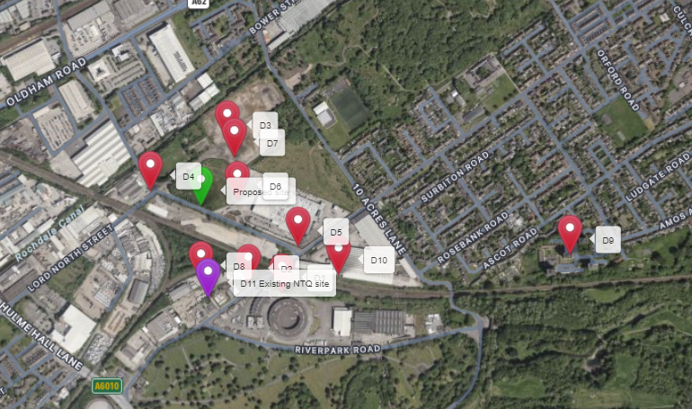

https://gridreferencefinder.com?gr=SJ8696199787|Proposed_s_site|2,SJ8719099542|D1|1,SJ8709699568|D2|1,SJ8703699974|D3|1,SJ8682099830|D4|1,SJ8723599675|D5|1,SJ8706499803|D6|1,SJ8705799925|D7|1,SJ8696299579|D8|1,SJ8800099648|D9|1,SJ8734899595|D10|1,SJ8698099529|D11_s_Existing_s_NTQ_s_site|5&v=r&labels=1

If no alternative site options have been investigated, please explain why:

N/A

- Additional Relevant Information

Background to the Proposal
This specific proposal forms part of an integral requirement for EE Ltd, ESN and H3G LTE to expand their respective 5G telecommunications network across Manchester specifically in this instance to enhance 5G coverage levels and network capacity within the M40 area.

This partnership has resulted in the development and production of an array of “dual user” structures and cabinets, which have the ability to accommodate both operator’s antenna systems and radio equipment.

Mobile phone base stations operate on a low power and accordingly base stations therefore need to be located in the areas they are required to serve. Increasingly, people are also using their mobiles in their homes, and this means we need to position base stations in, or close to, residential areas.

A further limiting factor is that the position has to be one that fits in with the existing network. Sites have to form a patchwork of coverage cells with each cell overlapping to a limited degree with the surrounding base stations to provide continuous network cover as users move from one cell to the other. However, if this overlap is too great unacceptable interference is created between the two cells.

DEVELOPMENT PLAN POLICY.

Development plan considerations have a special significance in law. Section 54A of the Town and Country Planning Act 1990 (The Act), and re-iterated in Section 38 of the Planning and Compensation Act 2004, it is stated that:

“Where in making any determination under the Planning Acts regard is to be had to the Development Plan, determination shall be made in accordance with the Development Plan unless material considerations indicate otherwise.”

NATIONAL PLANNING POLICY

The Government remain committed to promoting telecommunications and place emphasis on the importance of telecommunications to the wider economy. The National Planning Policy Framework (NPPF July 2021) sets out the Government’s planning policies for England and how these are expected to be applied at the Local level. It provides a framework within which local people and their accountable Councils can produce their own distinctive local and neighbourhood plans, which reflect the needs and priorities of their communities.

The purpose of the planning system is to contribute to the achievement of sustainable development. There are three dimensions of sustainable development, each of which give rise to the need for the planning systems to perform a number of roles including: -

- Economic Role – contributing to building strong, responsive and competitive economy;
- Social Role – Supporting strong vibrant and healthy communities; and
- Environmental Role – Contributing to protecting and enhancing our natural, built and historic environment.
The NPPF contains at its core a presumption in favour of sustainable development which runs through both plan-making and decision-making processes. The NPPF recognises the vital importance of high-quality telecommunications and dedicates a whole chapter to this. Chapter 10 of the NPPF outlines the Governments support for high quality communications. The paragraphs below clearly outline the overarching support from Central Government for telecommunications and how Local Planning Authorities should embrace this vital infrastructure:

NPPF Paragraph 114 states:

“Advanced, high quality and reliable communications infrastructure is essential for economic growth and social well-being. Planning policies and decisions should support the expansion of electronic communications networks, including next generation mobile technology (such as 5G) and full fibre broadband connections. Policies should set out how high-quality digital infrastructure, providing access to services from a range of providers, is expected to be delivered and upgraded over time; and should prioritise full fibre connections to existing and new developments (as these connections will, in almost all cases, provide the optimum solution).”

It continues in Paragraph 115:

“The number of radio and electronic communications masts, and the sites for such installations, should be kept to a minimum consistent with the needs of consumers, the efficient operation of the network and providing reasonable capacity for future expansion. Use of existing masts, buildings and other structures for new electronic communications capability (including wireless) should be encouraged. Where new sites are required (such as for new 5G networks, or for connected transport and smart city applications), equipment should be sympathetically designed and camouflaged where appropriate.”

Operators always follow the sequential site selection process. Where an existing site can be shared or upgraded this will always adhered to before a new proposal is put forward for consideration.

The support for telecoms and the need not to constrain Operators is laid out in Paragraph 118:

“Local planning authorities must determine applications on planning grounds only. They should not seek to prevent competition between different operators, question the need for an electronic communications system, or set health safeguards different from the International Commission guidelines for public exposure.”

Conclusion

We consider that the development is complaint with the council’s policy and that in accordance with Section 38 (6) of the Planning and Compensation Act 2004 permission should be granted for the installation.

We consider the development complies with both central government and local planning policy guidance where the underlying aim is to provide an efficient and competitive telecommunication system for the benefit of the community while minimising visual impact.

Taking into account the factors of technical constraints, available sites and planning constraints we consider that this site and design clearly represents the optimum environmental solution.

On the basis of a recognised need to expand and promote telecommunications networks across the region, it is considered that the proposal fully accords with the requirements of the National Planning Policy Framework and Council’s Local Plan Policies.

Julia Marshall
Planning Manager
Email: j.marshall@whptelecoms.com

Contact Details

Name: (Agent) | Julia Marshall | Telephone:
Operator: | EE and H3G LTE | Fax no: | N/A
Address: | WHP Telecoms Ltd  1a Station Court Station Road  Guiseley  Leeds  LS20 8EY | Email Address: | j.marshall@whptelecoms.com
Signed: |  | Date: | 22nd August 2024
Position: | Planning Manager | Company:  (on behalf of above operator) | WHP

