Photographs of proposed site Address: 58 Greville Street, Manchester, M13 0YG

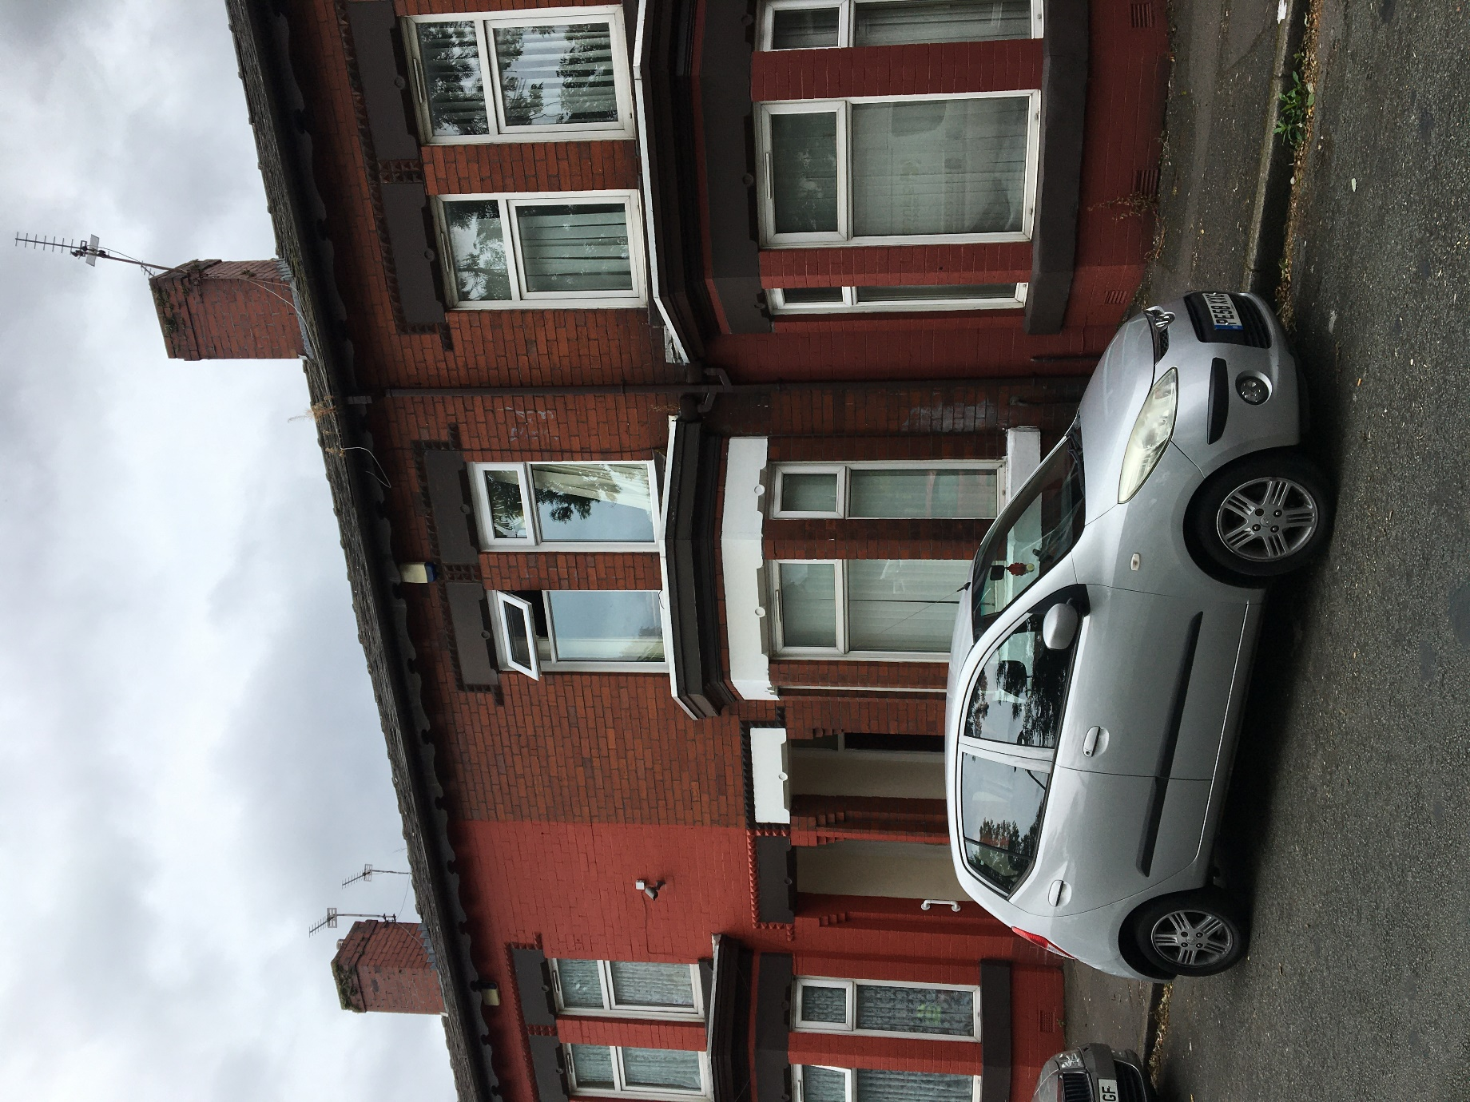
Front of property

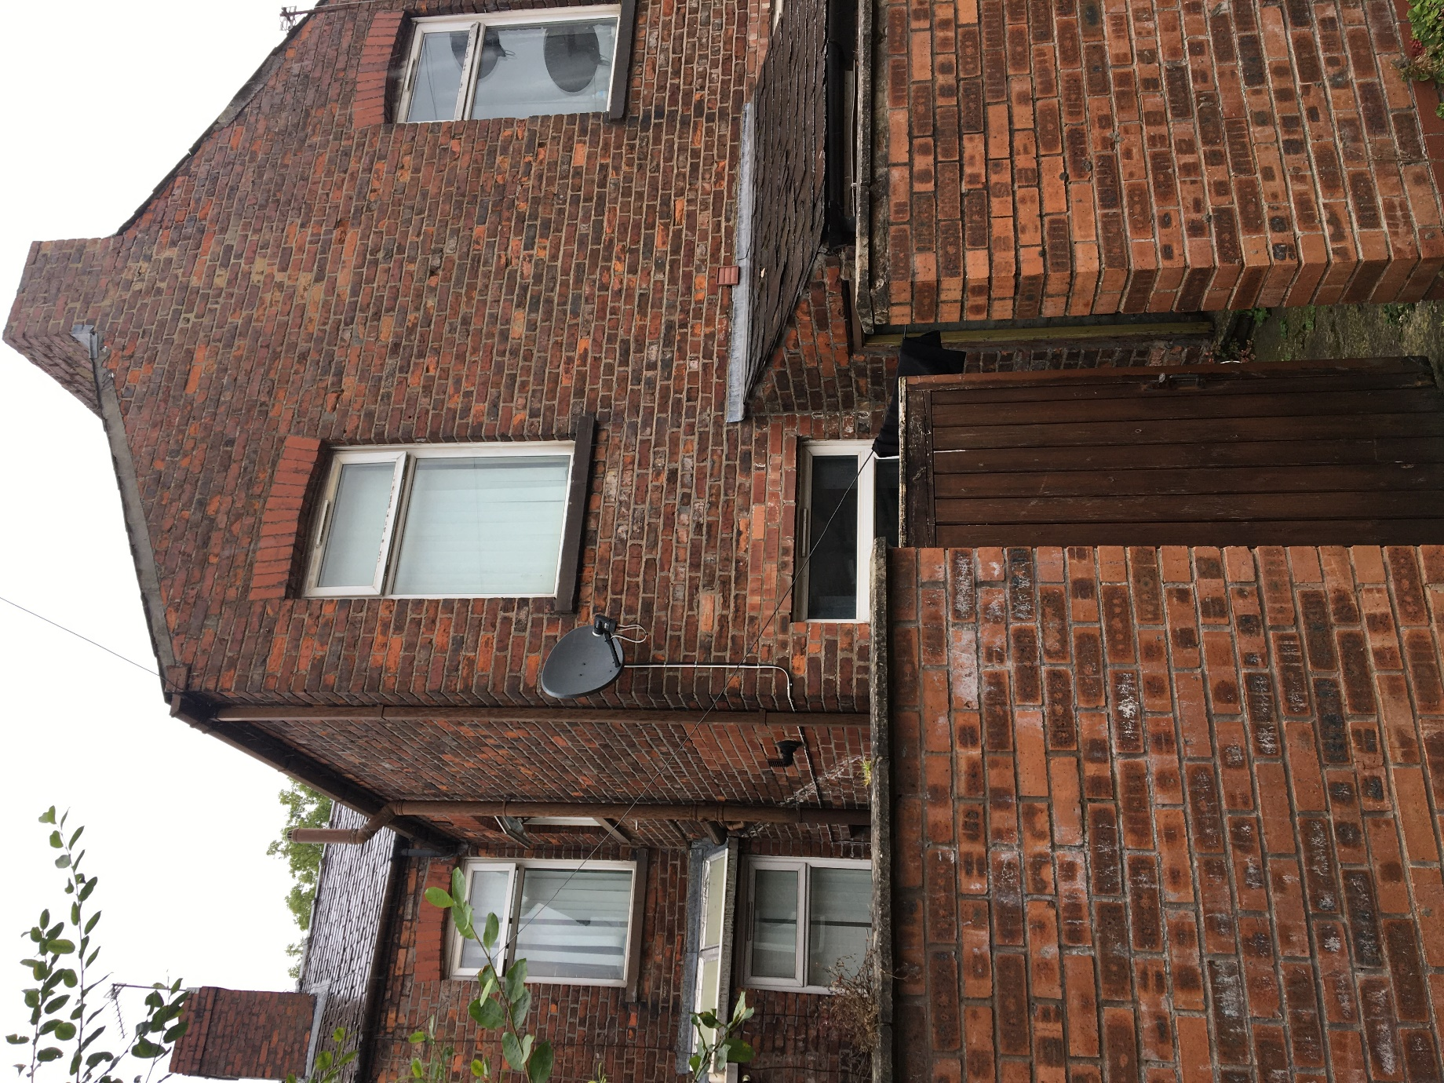
Back of property including rear boundary

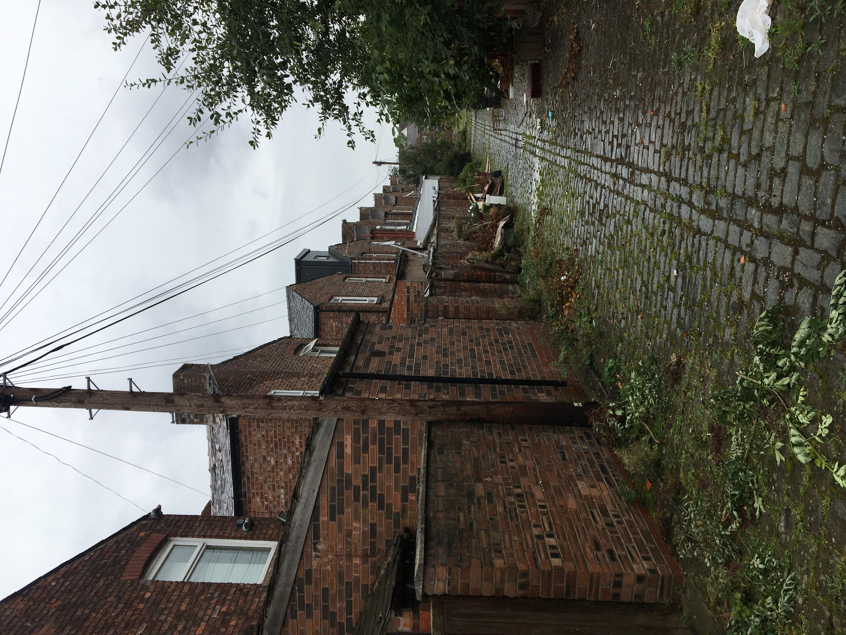
Back Street view including similar extension opposite the rear of proposed site,

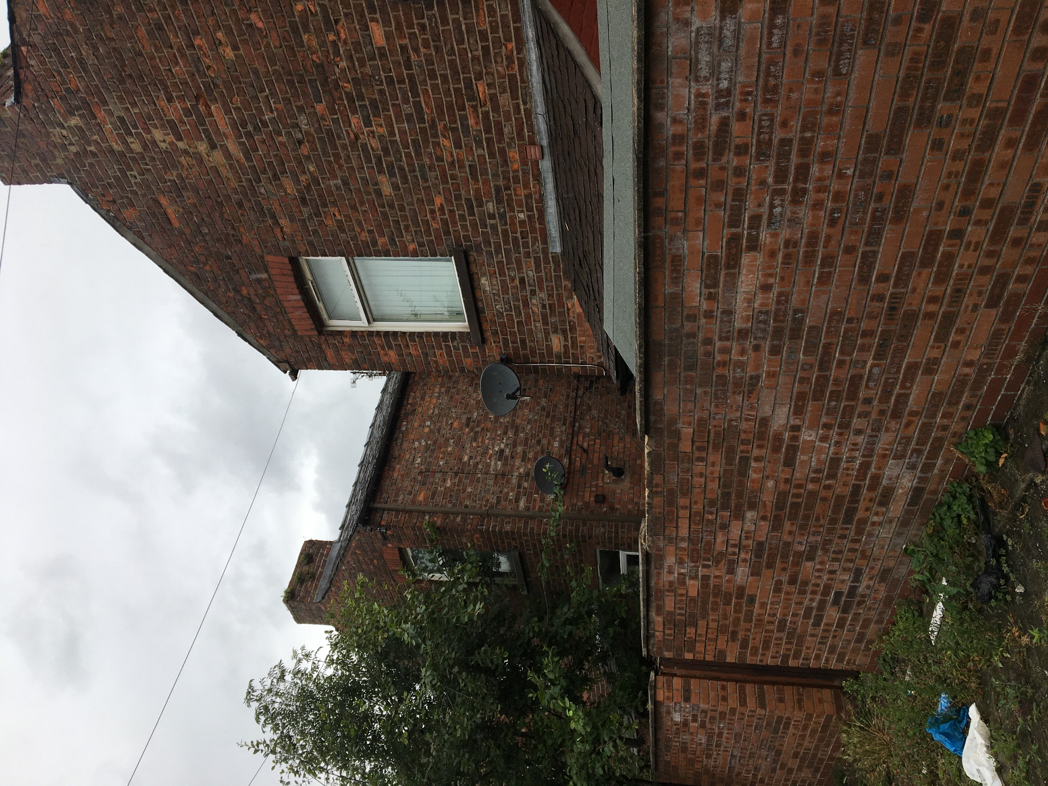

Rear street including proposed site

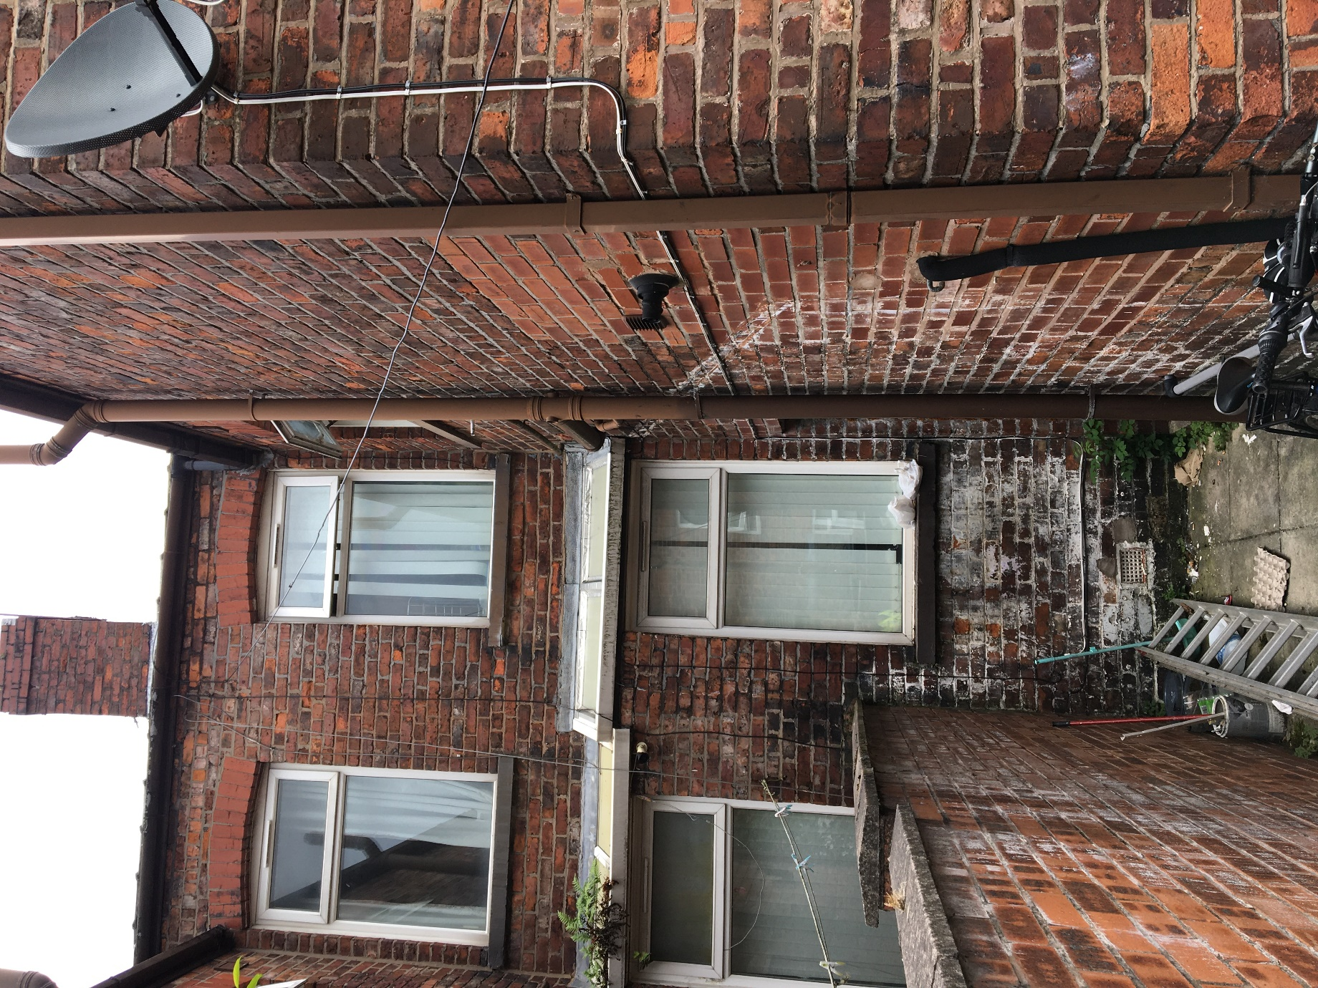

Rear Yard of proposed site

