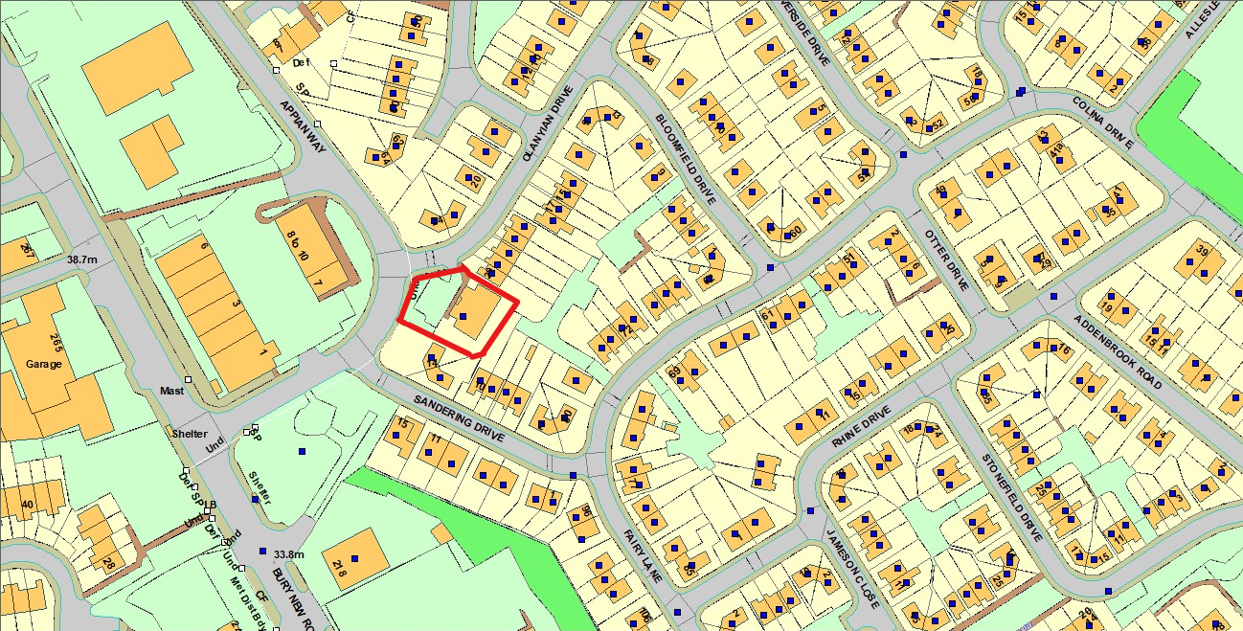
Current OS Base layer map of 31 Olanyian Drive

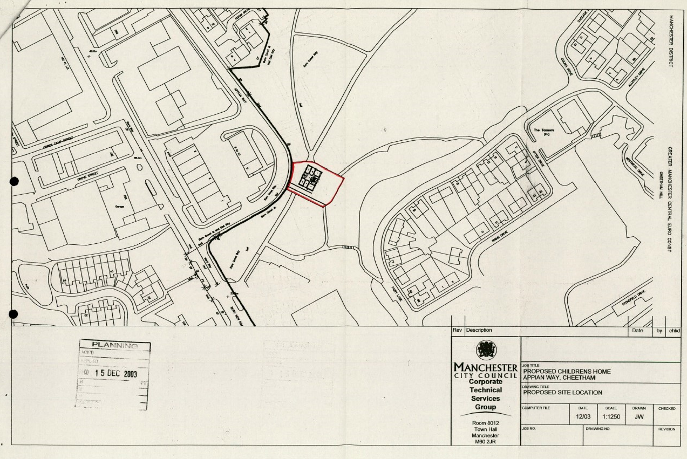
Site Edge Red application site for Outline Planning Approval reference 070334/VO/2003/N1 – Approved 19.02.2004 (note date stamp of 15.12.2003)
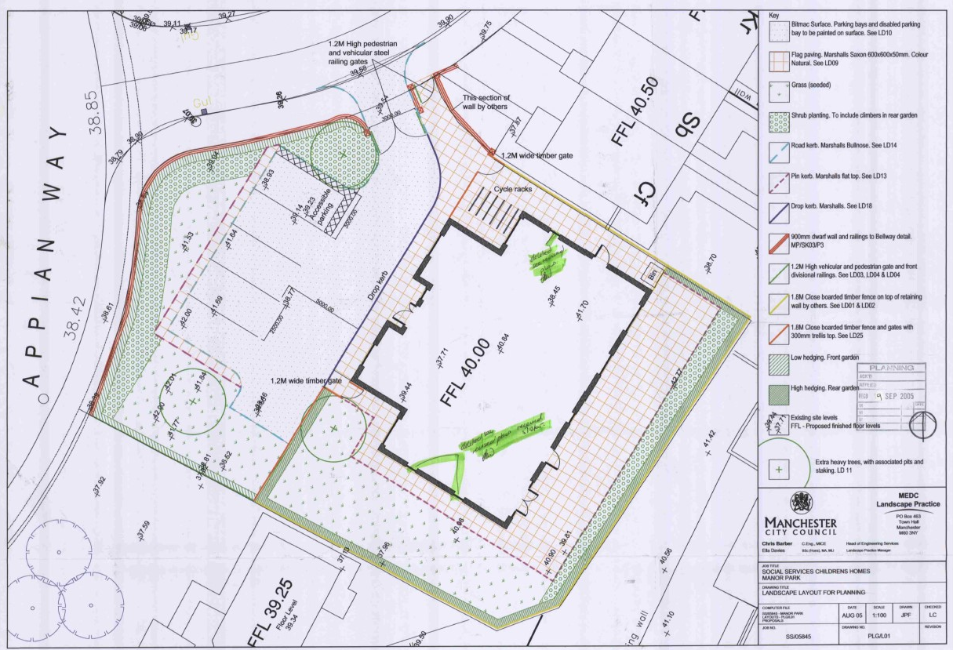
Approved site layout plan from Reserved Matters planning approval 076833/VO/2005/N1 – Approved 21.12.2005
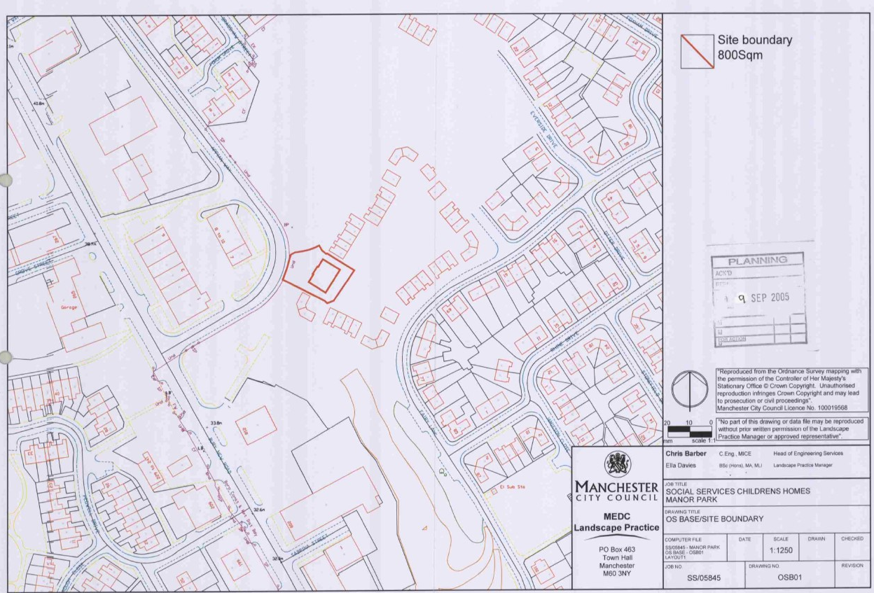
Site edge red and layout plan submitted alongside Reserved Matters planning approval 076833/VO/2005/N1 (note outline of surround residential plots)
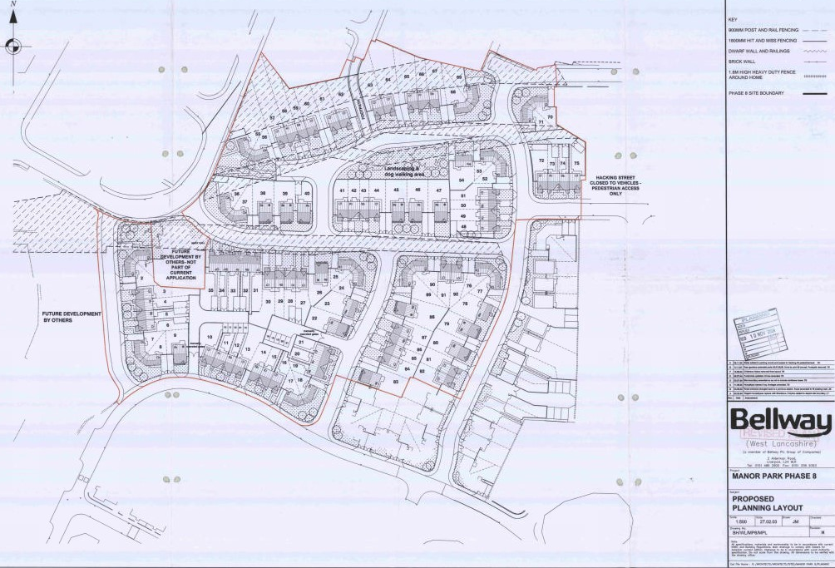
Approved site layout for residential development around the Children’s home (note annotation in relation to the Childrens Home site)
Planning approval reference 071826/FO/2004/N1 Approved 9.12.2004

