


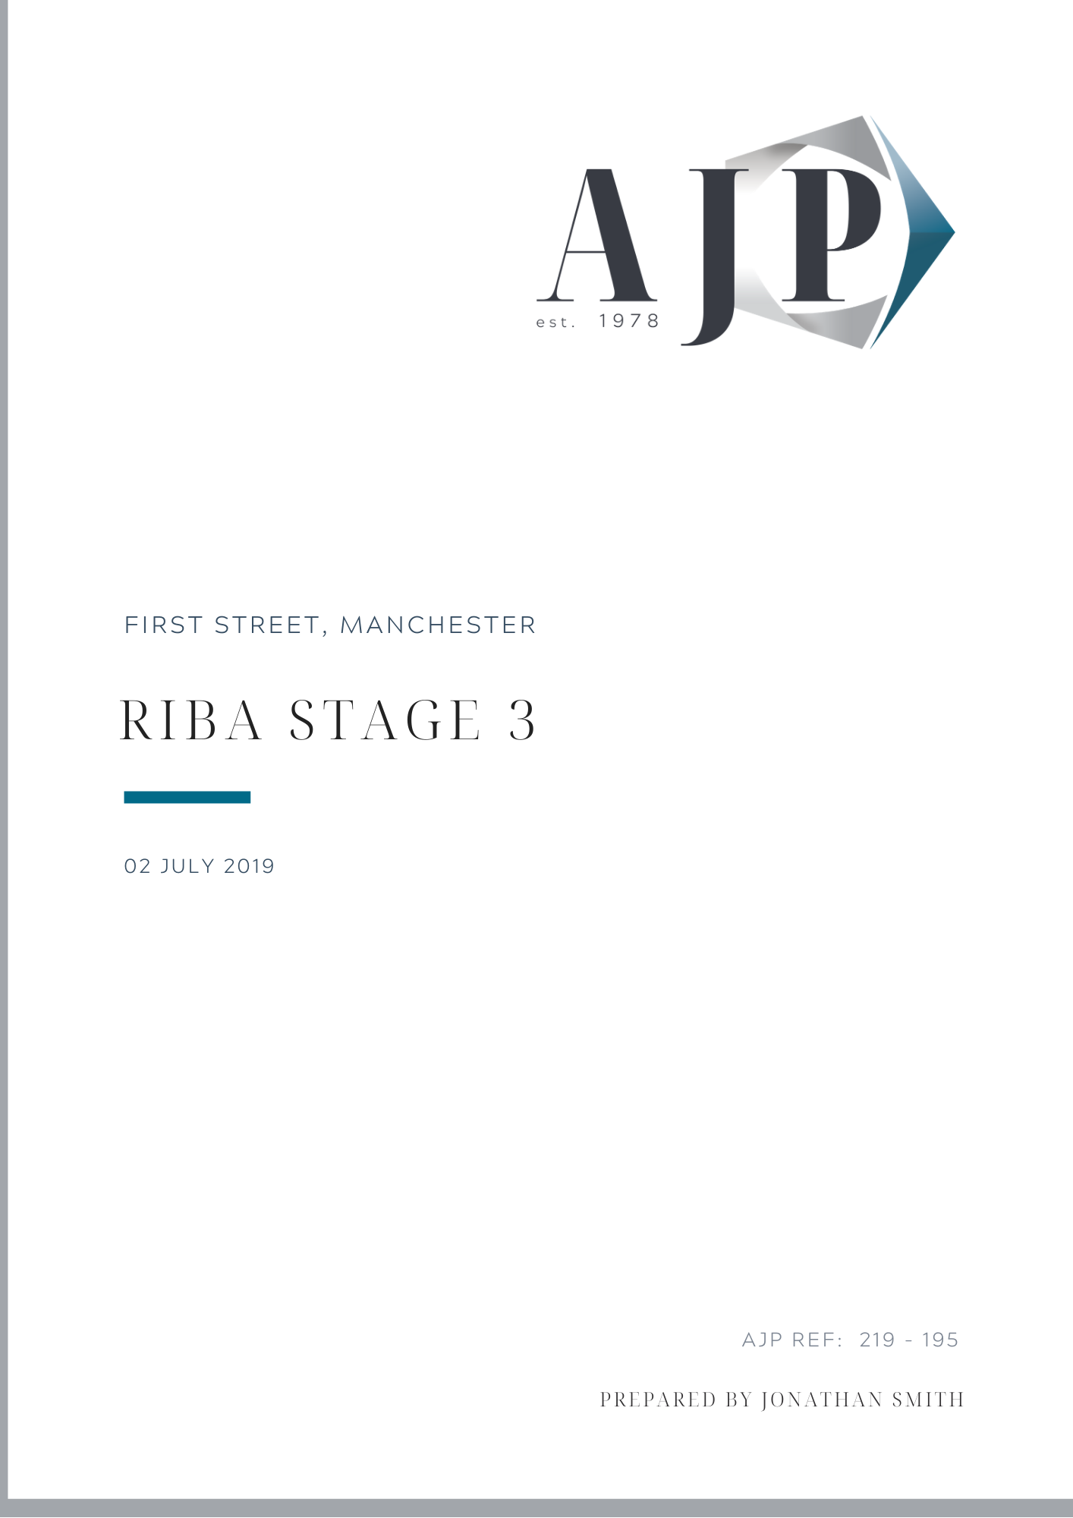

30th June 2023

Benmore Road, Manchester

PROJECT NAME, LOCATION

PROJECT NAME, LOCATION

FLOOD RISK ASSESSMENT



AJP Ref: 223-008
PREPARED BY John Marshall


Flood Risk Assessment
Prepared for One Housing
Benmore Road, Manchester

Record of  Approval | Originator: | Approved: | Date:
Record of  Approval | J. Marshall - Engineer | J. Smith - Director | 30.06.2023
Version | Author: | Change Description:
01

Contents

1.0 Introduction 5
2.0 site description 6
2.1 Geology 7
2.2 Hydrogeology 7
3.0 Proposed development 8
4.0 Planning Policy 9
4.1 Sequential Test 9
4.2 Exception Test 9
5.0 Assessment of Flood Risk 9
5.1 Flooding from Rivers 9
5.2 Flooding from the Sea 10
5.3 Flooding from Land 10
5.4 Flooding from Groundwater 10
5.5 Flooding from Sewers 10
5.6 Flooding from Reservoirs, Canals and Other Artificial Sources 11
5.7 Flood Mitigation Measures 11
6.0 Development and Drainage Strategy 12
6.1 Effect of Proposed Development on Flood Risk 12
6.2 Existing Drainage Systems 12
6.3 Proposed Drainage Strategy 13
6.3.1 Surface Water Drainage 13
6.3.2 SuDS Summary 17
6.3.3 Water Quality Assessment 18
6.3.4 Foul Water Drainage 19
6.4 Compliance with LASOO Non-Statutory Technical Standards for SUDS 19
6.4.1 Peak Flow Control 20
6.4.2 Volume Control 20
6.4.3 Flood Risk Within Development 21
6.5 Future Maintenance 21
6.6 Managing Residual Flood Risk 23
7.0 Conclusions 23
8.0 RECOMMENDATIONS 24
Appendix A Site Location Plan 25
Appendix B Aerial Photograph 26
Appendix C Topographic Survey 27
Appendix D Proposed Site Plan & Catchment Areas 28
Appendix E Flood Risk Maps 29
Appendix F UU Maps & Correspondence 30
Appendix G Existing & Proposed S.W Network Calculations 31
Appendix H Outline Drainage Strategy 32
Appendix I Phase II Geotechnical Report 33



Alan Johnston Partnership Ltd.
Company No. 13204766

Benmore Road, Manchester
Flood Risk Assessment

- Introduction
This Flood Risk Assessment (FRA) has been prepared on behalf of One Housing for the development of the land off Benmore Road in Manchester. The site is less than 1 hectare in size and situated in Flood Zone 1, and shall provide twenty new dwellings For the local area. The site is currently a disused grassed area, following the demolition of the previously existing care home in excess of twelve months ago; the site is classed as Greenfield.
As the development is less than 1 hectare and lies within Flood Zone 1, in accordance with PPS25 a Flood Risk Assessment should not be required. However, the Manchester City Council (MCC) Strategic Flood Risk Assessment (SRFA) has identified the site as being situated in the Conurbation Core Critical Drainage Area (CDA). Therefore, in accordance with the SRFA, a FRA is required for all developments over 0.5 hectares situated in a CDA; regardless of the Flood Zone it is situated within.
This FRA has been prepared in accordance with the general requirements of the National Planning Policy Framework and the Technical Guidance to the National Planning Policy Framework, both published by the Department for Communities and Local Government. This involves the identification of flood risk to new development(s) on the site, the possible effect of this development on flood risk elsewhere and the investigation of the impact on the development as a result of increased sea levels, fluvial flows and larger pluvial events due to increased impermeable areas and climate change. It has also been prepared in accordance with the requirements of the Local Authority’s SFRA.
The purpose of this report is to present a site-specific assessment of flood risk based on available information, to identify relevant flood levels affecting the site with respect to a particular probability of flooding. The flood levels identified are dependent on the correctness of the current conditions, as stated in this report and the prediction of future climatic conditions implicit in the National Planning Policy Framework.
For any size of storm event, the procedure will always yield a probability that the event will occur in any year, albeit the probability is smaller for larger events. The predicted storm event has a probability of occurrence in any year and the derived flood level has an associated probability of exceedance. This means that there is always a risk that property flooding could occur one or more times in any year.
Therefore, this report should not be interpreted or relied upon as providing a guarantee against flooding. There is always a residual risk that flooding will occur, and it is not possible to predict a zero risk of flooding.
In accordance with National Planning Policy Framework (NPPF) and the associated Technical Guidance document, flood risk must be assessed for all sources including tidal (from the sea), fluvial (from rivers), pluvial (from land), groundwater, sewer and artificial water bodies (e.g. reservoirs, canals, major water supply infrastructure etc.).
More specifically, the development of any site must be carried out in such a way as to mitigate any potential flood risk, both on and off site from all sources of flooding.
2.0 site description
The proposed development site is located in the Manchester, to the north and east of Benmore Road, at National Grid Reference SJ 866658 03511 and postcode M8 6DN. To the north and west of the development area is existing terraced housing. The site is currently overgrown with grasses and a number of existing established trees sitting on the boundaries, around the extent of the previous Care Home position.
The location of the existing site is illustrated in Appendix A, showing the surrounding areas and the current site situation, the extent of the area to which the application relates is shown as a red line boundary.
The total site area available is 053ha with the topography of the site having the northern and eastern boundaries around the 101.50m AOD, the western boundary sitting at 100.50m AOD and the point of access set at 101m AOD; with levels uniformly falling east to west.
An aerial photo is included in Appendix B to illustrate the site at the present day and the topographic survey is included in Appendix C.

2.1 Geology
The British Geological Survey 1:50,000 geology maps show that the development site is underlain superficial deposits comprising of Till Devensian Diamicton of Sandy gravelly cobbly deposits, underlying bedrock is reported to be of Lower Coal Measures Formation, comprising of Mudstone, Siltstone and Sandstone.
This is supported by the Phase II Geotechnical investigation (Appendix I) which has boreholes and trial holes identifying the superficial deposits as firm clays, soft clays with sandy components and silts, beneath depths of made ground; with the bedrock encountered comprising of mudstone. The bedrock lies at circa 4.1m-4.7m below the ground level and the made ground has a range of depths across the site from 0.30-0.90m below the existing ground level.

2.2 Hydrogeology
The DEFRA groundwater magic maps show that the Glacial Till superficial deposits are classified as a secondary undifferentiated aquifer, the groundwater maps also show that the underlying Lower Coal Measures is classified as a Secondary A aquifer.
There are no recorded groundwater / potable water abstraction licenses within 500m of the site and the site is not recorded to be within a Groundwater Source Protection Zone.
The development site is shown to be within an area of low-medium Groundwater vulnerability,
The Phase II exploratory logs in Appendix I show that the depths of made ground is not anticipated to contain contaminants ,therefore the risk to controlled waters is considered low to very low, as there is limited permeability within the sub strata; with perched water likely to sit lying within the made ground and at the interaction line with the cohesive materials.
The nearest watercourse feature is Boggart Hole Brook that lies 600m to the south of the proposed development. The site is located in Flood Zone 1, as an area identified by the Environment Agency (EA) not at risk of flooding from rivers and streams.
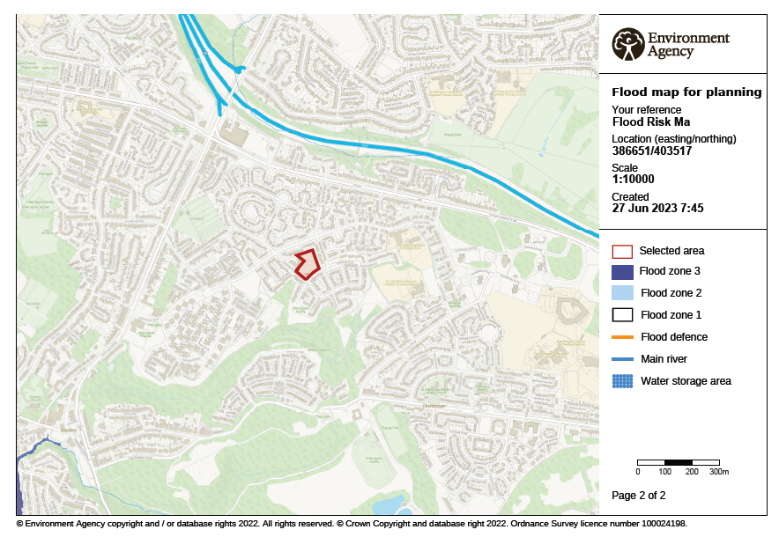
3.0 Proposed development
The proposed development consists of circa 20 new dwellings consisting of 2 and 3 bedroom houses. These dwellings shall be accessed by a new proposed highway network, that shall be accessed off Benmore Road, with some dwellings fronting directly onto Benmore Road; with associated driveways. The proposed highways shall be accompanied by private parking provision off the highway and a shared drive to the north west of the site.
The proposed development site covers a total area of approximately 0.53ha (App D), the development layout is shown within Appendix D indicating the dwellings, proposed highway and associated parking provision.
The total impermeable area from the proposed development is 0.302ha, encompassing, the proposed houses and apartment buildings, alongside the associated driveways and proposed highway to facilitate the development, an impermeable percentage of 56% for the development area.
To enable a viable scheme, the proposed site levels are constrained by the surrounding highway and existing buildings to the north and east. A proposed site plan is attached in Appendix D.
4.0 Planning Policy
The National Planning Policy Framework (NPPF) sets out the Government’s policy on meeting the challenges of climate change, flooding and coastal change. The NPPF states that:
“Planning plays a key role in helping shape places to secure radical reductions in greenhouse gas emissions, minimising vulnerability and providing resilience to the impact of climate change, and supporting the delivery of renewable and low carbon energy and associated infrastructure. This is central to the economic, social and environmental dimensions of sustainable development. Local planning authorities should adopt proactive strategies to mitigate and adapt to climate change taking full account of flood risk, coastal change and water supply and demand consideration.”
This Flood Risk Assessment proposes recommendations to facilitate the proposed development so that it takes into account flood risk at all stages of the development.

4.1 Sequential Test
Based on the site’s location in outside a flood zone, the development is deemed appropriate according to NPPF therefore the development is appropriately situated and the Sequential Test is not required.
4.2 Exception Test
NPPF classifies the residential element of the development as ‘More Vulnerable’ but as the site is located outside a flood zone the Exception Test is not required.

5.0 Assessment of Flood Risk
The Technical Guidance to the National Planning Policy Framework requires all forms of flooding to be considered.
5.1 Flooding from Rivers
The Flood Risk map is included in Appendix E.
It can be seen from the map that the site is located in Flood Zone 1 with a chance of flooding of less than 0.1% (or 1 in 1000).
The nearest designated main river is the Boggart Hole Brook which lies at least 600m to the south, therefore the risk of flooding to the new development from river is considered to be low.
5.2 Flooding from the Sea
The site is not at risk of flooding from the sea. The lowest level of the site is approximately 100.50m AOD, i.e., well above tidal flood levels, as demonstrated in Appendix E.
5.3 Flooding from Land
Intense rainfall, often of short duration, that is unable to soak into the ground or enter drainage systems can run quickly off land and result in local flooding.
The Surface Water Flooding map is included in Appendix E. It can be seen from the map that the site is classified as having a low risk of surface water flooding within the middle of the development area, within a depression of levels sat in the site.
The Low risk identified across the site area shall be mitigated by the development that shall actively drain these areas, preventing the ponding of surface water.
Therefore, the risk of flooding from overland flows due to surface water flooding is considered to be low and as such the overall site is considered to be at low risk of flooding from surface water/surrounding land.
5.4 Flooding from Groundwater
As per the magic maps, and a Groundwater Risk Map in Appendix E, the risk of groundwater flooding can be considered to be low to medium, the medium flood risk suggests that there is a sub-surface risk of flooding, that would affect property where there are proposed basements and finished floor levels are set below the existing ground level.
To mitigate the flood risk from groundwater the development shall ensure that it has no proposals for basements and finished floor levels are to be set at or above existing ground levels, during detailed design the development, with adequate S.W drainage systems ensuring the surface run off from the development does not discharge to ground and end up perched.
5.5 Flooding from Sewers
A record of Public Sewers surrounding and serving the development site has been obtained from United Utilities and this is included in Appendix F.
There is an existing 225mm diameter Combined sewer which runs within Benmore Road to the south of the development, running east to west. This sewer drops into a 450mm diameter Combined sewer, also within Benmore More; running south to north; from manhole 6401 to manhole 6403.
There are no surface water sewers located within proximity to the site or in the surrounding locales.
No sewers are present within the boundary of the development site area.
There are no known flooding incidents for these sewers.
With all identified sewers outside the boundary of the development area, this means that should any flooding from sewers occur this should be contained within the highways and not encroach upon the proposed site dwellings.
Therefore, as a result of the public sewers being located outside the site itself and no recorded instances of flooding, is considered to be at low risk of flooding from sewers.
5.6 Flooding from Reservoirs, Canals and Other Artificial Sources
The Reservoir Flood Risk map is included in Appendix E. It can be seen from the map that the site is not as risk of flooding from reservoirs.
The reservoir flood maps are used to identify the extent of flooding caused in the event of a catastrophic failure event and therefore the site is considered to be at low risk of flooding from reservoirs.
Within the MCC SFRA, there is a historical culvert identified to the north of the development outside the bounds of the development area, running in White Moss Road; as shown in Appendix E. This culvert is identified on the SFRA Critical Drainage Areas Plan as a “Lost Watercourse” it is therefore considered defunct. Accordingly due to the identified position and status of said watercourse, it is considered that risk of flooding from this source is low.

5.7 Flood Mitigation Measures
As outlined above the only flood mitigation measures required for the proposed site are
associated with the minimal risk of groundwater flooding. These are summarised below:

- No basement construction to be completed across the site.
- The external ground levels should fall away from the proposed building.
- Proposed building finished floor level should be set above the existing site levels.

6.0 Development and Drainage Strategy

6.1 Effect of Proposed Development on Flood Risk
As previously outlined in Section 2.0, the existing site covers a total area of 0.53ha and is a Greenfield site, As the existing site has active no drainage systems positively connecting to the UU sewer system, the introduction of the new roof area, access road and parking area, the development will need to assessed to determine if it leads to an increase in impermeable area.

Existing Impermeable Area (Ha) | Proposed Impermeable Area (Ha)
0.000 | 0.302

As demonstrated in the above table, for the proposed development, the changes to the existing site will increase the volume of impermeable areas and as such, the proposed development in these areas will lead to an increase in the;
- Volume of surface water ponding on the site
- Volume of surface water runoff leaving the site or discharging into surrounding areas
- Peak discharge rate from the site.
Accordingly, site-wide drainage systems are required to drain the foul and surface water flows arising from the proposed development. Where possible, any existing drainage networks should be utilised. Appropriate design and construction of these systems as set out in Section 6.3 should ensure that there is no increase in offsite flood risk that would otherwise impact downstream areas.

6.2 Existing Drainage Systems
As can be seen from the United Utilities maps, attached in Appendix F, there is an existing 450mm C.W public sewer located within Benmore Road. The MH 6401 on the south west tip of the site has an invert of 94.70m AOD. This sewer has been identified as a point of discharge for S.W & F.W flows from the proposed development.

6.3 Proposed Drainage Strategy
As outlined above in section 6.1, site-wide drainage systems are required to drain the foul and surface water flows arising from the proposed development. The proposed drainage systems must ensure that there is no increase in offsite for flood risk, for all storms up to the 1:100-year event with an allowance for climate change; that would otherwise impact downstream areas.

6.3.1 Surface Water Drainage
The Building Regulations - Approved Document H (2002) details a hierarchy of potential methods for disposing of surface water as shown below in order of preference:
- Discharge via infiltration
- Discharge to watercourse
- Discharge to sewer
Considering the hierarchy above, the surface water network for the proposed site should infiltrate to ground where viable.
As laid out within section 2.2 the site investigation information and the British Geological Survey (BGS) 1:50,000 superficial geology maps & Phase II logs show that that the site is underlain Till Devensian Diamicton of granular strata above a shallow bedrock and has areas of made ground above cohesive clays.
While no infiltration testing or falling head tests are noted within the Phase II Geotechnical report, the evidence of the subs strata material and numerous water strikes identified as perched water; identify the ground as having low permeability. Further investigation In accordance with the requirements of BRE 365 should be carried out to confirm this.
With the infiltration capacity within the ground initially dimissed, it is not considered a viable option for the discharge of surface water to utilise SuDS and infiltration systems.
As the possibility of infiltration is ruled out by at this point, the intention for the development would be to discharge to watercourse/ waterbody. The nearest waterbody is Boggart Hole Brooke.
Due to the location of the Watercourse, it is not considered viable to discharge S.W flows to this point, as it is separated from the development area, by third party land and is inaccessible to any proposed sewerage network in service purely of the proposed development.
With discharge via infiltration and to a watercourse ruled out. The only practical solution for discharge of the surface water and Foul drainage is to discharge to the public sewerage system.
To this effect, correspondence with United Utilities (Appendix F) has been sought for clarification of their preferred point of discharge and rate of S.W discharge from the development. UU have confirmed that they would accept flows limited to 5l/s from the development; discharging into the 450mm diameter Combined sewer within Benmore Road.
While every effort to utilise, any suitable existing systems should be made, the drainage systems should be designed to suit the proposed site layout and topography which aims to provide an efficient design.
In line with the Design & Construction Guidance (DCG) the requirements for the design of new surface water drainage systems are as follows:
Below ground piped drainage to be sized to accommodate the 1 in 2-year (50% AEP) design storm without surcharge.
System to be designed not to flood any part of the site in a 1 in 30-year (3% AEP) design storm.
For events in exceedance of the 1 in 30-year design storm and up to and including the 1 in 100-year event, site drainage and topography should be designed where practicable to route surface water run-off away from buildings to safe above-ground storage areas on site, thereby removing flood risk to properties and preventing this run-off from leaving the site and increasing flood risk elsewhere.
For each design case described above, the design storm is the critical storm duration for the site conditions. In the case of the 1 in 100-year design storm, a 45% increase in the peak rainfall intensity is applied to allow for the estimated worst-case impacts of climate change. This is in accordance with Table 5 of the Technical Guidance to the National Planning Policy Framework.
Suitable systems of below ground drainage will be required to contain as a minimum requirement, the 1 in 30-year event. Additionally, any surface water run-off from events that exceed the design capacity of the new drainage system, up to and including the 1 in 100-year (+45%) event, will be contained within the drainage network or retained on-site in safe storage areas.
Should they be required, measures to prevent oil and other contaminants being passed forward to the existing surface water sewer should also be incorporated into the design of the surface water system, through the use of appropriate oil separators or other appropriate pre-treatment methods.
In line with common practice and MCC LLFA guidelines, it is proposed the surface water discharge from the proposed development should discharge at rates not in excess of a value equivalent to the Greenfield Qbar rate or the minimum practicable rate of discharge, whichever is the greater; for all respective storm periods. A calculation of the Greenfield Run off can be found in Appendix E.

Return Period (yr.) | Existing Discharge Rate (l/s)
1 in 2 (Qbar) | 3.3
1 in 30 | 5.6
1 in 100 | 6.9

An assessment of the existing Greenfield surface water run-off from the existing site area has been carried out and demonstrates that the Qbar value for the site with is 3.3l/s,. Therefore, in accordance with reducing flood risk and compliance with MCC LLFA requirements, a restricted flow rate equivalent to Qbar is recommended for the proposed development area for all storms up to and including the 1 in 100-year return period, with an allowance for climate change.
This should be considered in conjunction with the maintenance requirements of the proposed hydrobrake in service of limiting surface water flows from the development, which will require a minimum orifice size of 100mm in diameter; producing a minimum practicable rate of discharge from the development of 5l/s . Therefore in accordance with the requirements of UU, the LLFA and practical restrictions, the development should be limited to a maximum pass forward flow rate of 5l/s for all return periods and storm events.
Based on the above discharge limit, there shall be a new S.W network to serve the proposed development that shall discharge the combined sewer to the west of the development. Discharge into this sewer shall be agreed under with United Utilities Section 104 of the of the Water Industry Act 1991 and with MCC LLFA.
As shown in Appendix H outline drainage layout the proposed S.W Network shall discharge no more than 5l/s. This network shall consist of oversized pipes and manholes providing effective storage to accommodate all storm events, subject to control by a vortex flow control system prior to discharging to a new manhole constructed on the existing 450mm diameter combined sewer in Benmore Road.
Porous paving shall be installed as a source control measure to accommodate the first 5mm of rainfall, prior to discharging to the attenuation system.
The surface water drainage systems are to be designed to restrict the discharge to the required rate, up to and including a 1 in 100-year return period plus 45% climate change design storm, while ensuring that no flooding occurs within the 100-year return period and that any flood water for extreme events shall be appropriately accommodated away from proposed and existing dwellings. . This S.W network shall be designed in accordance with the below hydraulic criteria:
- Volumetric Run off Co-efficient – 0.84 (winter)
- Urban Creep factor - 10%
- Climate Change factor for 1:100 return event – 45%
- Maximum Storm duration up to - 1440 minutes
- M5-60 (mm) 18.8 Ratio R 0.302(suitable for the locale)
The hydraulic calculations demonstrating the system dynamics for the proposed network is shown in Appendix G, as are the calculations for the proposed network’s operated in the scenario where the receiving sewer is surcharged.
The surface water drainage strategy and discharge rate should be confirmed via more detailed discussions with United Utilities and the Lead Local Flood Authority prior to the commencement of any works.

6.3.2 SuDS Summary
As outlined within the summary table below, all SuDS techniques have been considered for this development;

SuDS Technique | Suitable for This Development? | Reasoning
Green Roof✓ |  | Impractical due to roof pitch and domestic ownership
Rainwater Harvesting |  | Impractical due to lack of demand for greywater.
Basins, Ponds & Swales |  | Unsuitable due to lack of available space to south of site.
Filter Strips |  | Unsuitable due to topography of site and lack of available areas to south of site.
Bio-retention Areas |  | Suitable but only incorporated for small hardstanding areas due to impermeable strata and topography of site.
Infiltration Techniques |  | Unsuitable due to impermeable strata.
Permeable Surfaces |  | Suitable and incorporated where possible, but only as non-infiltration due to impermeable strata.
Tanked/Piped Systems |  | Suitable and incorporated.
Green roof areas have not been included due to roof pitch being untenable for the installation and maintaining of sufficient support system for plant life.
Rainwater harvesting was also considered but due to a lack of greywater demand and the
cost associated with tanks and pumping of the separate system, it has been deemed as
impractical to include a rainwater harvesting system.
Due to the lack of available space across the south of the site it is envisaged that a pond, detention basin or swale would not be suitable for the proposed site.
Filter drains/strips were also considered but due to a lack of available areas, filter drains/strips areas have not been included. Due to a lack of available areas and the topography of the site, bio-retention areas have only been incorporated to drain small impermeable areas.
As previously stated infiltration is not feasible across the site and therefore the use of infiltration SuDS techniques is not possible. Despite this, the use of non-infiltration permeable surfaces such as permeable paving/porous tarmac has been considered and incorporated within the private and shared drives.
Finally, the use of oversized pipe networks is suitable and is therefore also incorporated. As indicated within the Outline Drainage Strategy Drawing attached in Appendix H,
The use of SuDS solutions across the site is subject to change and is dependent upon the finalised site layout, detailed drainage design and the results of additional surveys. However, the drainage strategy and proposed SuDS solutions should adhere as close as possible to the above outline drainage strategy and SuDS solutions.

6.3.3 Water Quality Assessment
Managing the water quality of the surface water runoff from the proposed development is important to ensure that the receiving surface waters or groundwater are well protected. Generally, this can be achieved through the use of well-designed SuDS systems which provide treatment and pollution removal to the surface water runoff.

Standard S3 of the Statutory National Standards for Sustainable Drainage Systems (2018) details the water quality management and addresses the drainage design requirements to minimise the potential pollution risk.

As the proposed development consists of roof areas, car park areas and low traffic roads, in accordance within Table G3.2 of the Statutory National Standards for Sustainable Drainage Systems (2018) the pollution hazard level is low and as such the simple index approach can be used to assess the treatment requirements for the low risk of pollution.

The simple index approach is outlined within Chapter 26 of CIRIA Report C753 – The SuDS Manual. Therefore, using Table 26.2 and applying the proposed site description above, results in a low pollution hazard level, with the pollution hazard indices being; TSS – 0.5, Metals – 0.4 and Hydrocarbons – 0.4.

Assessing this against Table 26.3 of CIRIA Report C753 – The SuDS Manual using the SuDS treatment train of green roofs and permeable paving results in the mitigation indices outweighing the pollution hazard indices identified above. The use of a porous paving itself results in mitigation indices of; TSS – 0.7, Metals – 0.6 and Hydrocarbons – 0.7, which would be sufficient.

Therefore, as the mitigation indices are equal to or greater than each of the pollution hazard indices the use of permeable paving is deemed acceptable from a pollution mitigation perspective and as such complies with the water quality requirements of Standard S3 of the Statutory National Standards for Sustainable Drainage Systems (2018).

6.3.4 Foul Water Drainage
Foul water drainage disposal is set out in Part H of the Building Regulations in order of priority the preferred methods are;
- Public sewer
- Septic tank
- Cesspool.
The foul water system shall be designed in accordance with;
BS EN 752:2008 (Drain and sewer systems outside buildings)
The Design & Construction Guidance (DCG)
Technical Guidance to the National Planning Policy Framework document (Department for Communities and Local Government, March 2012).
BS EN 12056-2:2000 (Drainage systems inside buildings)
Building Regulations Approved Document H, Drainage and waste disposal. (Office of the Deputy Prime Minister, December 2010).
Foul water shall discharge to the existing C.W sewer to west of the site in Benmore Road, via a new manhole, at an unrestricted rate.
The F.W shall combined with the S.W flows, prior to discharging into the local combined sewer and the proposals shall be agreed with UU under a Section 104 Agreement. The proposed foul water drainage design can be found in Appendix H.
The foul water drainage strategy and discharge rate should be confirmed via more detailed discussions with United Utilities and the Lead Local Flood Authority prior to the commencement of any works.

6.4 Compliance with LASOO Non-Statutory Technical Standards for SUDS
In compliance with the runoff destinations guidance within the LASOO Non-Statutory Technical Standards for Sustainable Drainage: Best Practice Guidance, infiltration is not feasible; therefore, the surface water runoff is designed to discharge to the public sewer.
S1. Where the drainage system discharges to a surface water body that can accommodate uncontrolled surface water discharges without any impact on flood risk from that surface water body (e.g., the sea or a large estuary) the peak flow control Standards (S2 and S3) and volume control Standards (S4 to S5) need not apply.
The site does not discharge to a surface water body that can accommodate uncontrolled surface water discharges, as it has only previously received greenfield run off and the culvert has been sized appropriately; therefore, Standards S2 – S5 shall apply.

6.4.1 Peak Flow Control
S2. For greenfield developments, the peak runoff rate from the development to any highway drain, sewer or surface water body for the 1 in 1-year rainfall event and the 1 in 100-year rainfall event should never exceed the peak greenfield runoff rate for the same event.
The site is considered greenfield and the discharge rate for the 1 in 100-year return period has been restricted to a minimally practicable rate of 5l/s.
S3. For developments which were previously developed, the peak runoff rate from the development to any drain, sewer or surface water body for the 1 in 1 year rainfall event and the 1 in 100-year rainfall event should be as close as reasonably practicable to the greenfield runoff rate from the development for the same rainfall event, but should never exceed the rate of discharge from the development prior to redevelopment for that event.
The site is Greenfield and this standard does not apply.

6.4.2 Volume Control
S4. Where reasonably practicable, for greenfield development, the runoff volume from the development to any highway drain, sewer or surface water body in the 1 in 100-year, 6-hour rainfall event should never exceed the greenfield runoff volume for the same event.
S5. Where reasonably practicable, for developments which have been previously developed, the runoff volume from the development to any highway drain, sewer or surface water body in the 1 in 100-year, 6-hour rainfall event must be constrained to a value as close as is reasonably practicable to the greenfield runoff volume for the same event, but should never exceed the runoff volume from the development site prior to redevelopment for that event.
S6. Where it is not reasonably practicable to constrain the volume of runoff to any drain, sewer or surface water body in accordance with S4 or S5 above, the runoff volume must be discharged at a rate that does not adversely affect flood risk.
SuDS components such as infiltration have been confirmed as feasible due to the ground conditions still subject to investigation. Other SUDS measures including green roofs or rainwater harvesting may assist in constraining the volume of surface water runoff, these have not been feasible due to proposed construction methods for the development, therefore S5 cannot be complied with.

6.4.3 Flood Risk Within Development
S7. The drainage system must be designed so that, unless an area is designated to hold and/or convey water as part of the design, flooding does not occur on part of the site for a 1 in 30-year rainfall event.
S8. The drainage system must be designed so that, unless an is designated to hold and/or convey as part of the design, flooding does not occur during a 1 in 100-year rainfall event in any part of: a building (including a basement) or in any utility plant susceptible to water (e.g., pumping station or electricity substation within the development)
S9. The design of the site must ensure that so far as is reasonably practicable, flows resulting from rainfall in excess of a 1 in 100-year rainfall event are managed in exceedance routes that minimise the risks to people or property.
The drainage system proposed in service of this development shall attenuate the Surface water flows for up to the 100-year storm event without any flooding occurring in compliance with S7 & S8.
The levels of the proposed highways and properties are such that flooding in excess of the 100-year storm event provide exceedance flow routes away from properties to proposed and existing highways; satisfying the requirements of S9.

6.5 Future Maintenance
It is proposed that the surface and foul water drainage systems and Surface water systems will be a mixture of adopted and private, therefore some elements (manholes and oversized pipes) will be the responsibility of United Utilities, while others will be maintained by a responsible organisation as nominated by the developer; in accordance with the CIRIA SUDS Manual C753. Accordingly.
The S.W run off from the roofs and hard surfaces shall discharge by gravity to S.W sewers adopted and maintained by UU.
The SUDS porous pavements systems shall remain private and therefore be the responsibility of a resident’s maintenance manage company as appointed responsible organisation in accordance with the CIRIA SUDS Manual C753.

Accordingly, as stated in the SUDS Manual the operation and maintenance of the SuDS system shall be as the the maintenance requirements for permeable paving are outlined within Table 20.15 of the CIRIA SUDS Manual C753. An extract of that table is given below to set out the maintenance schedule for the permeable/porous tarmac component of the proposed drainage systems.

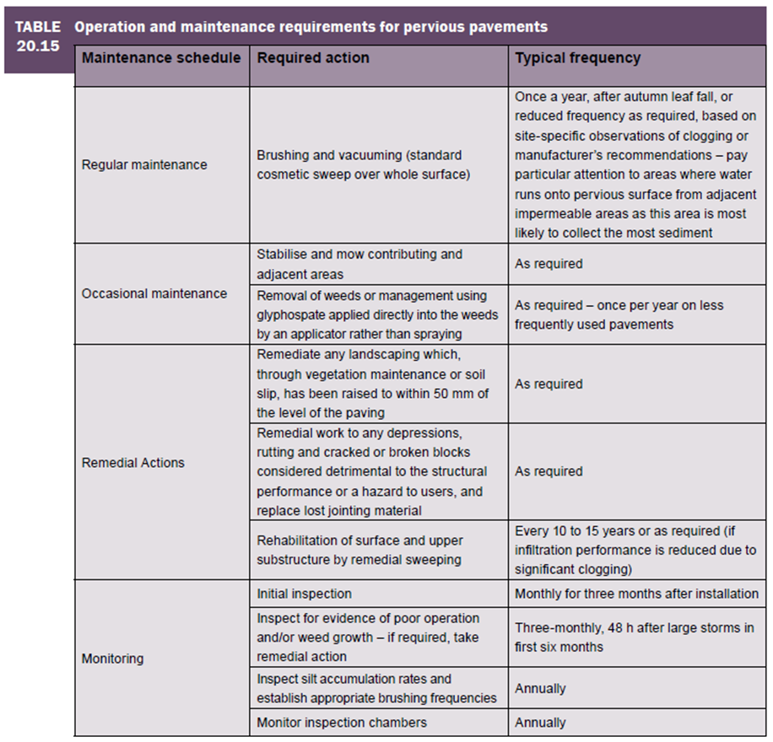

The remaining drainage systems (Hydrobrake unit) will be maintained in accordance with manufacturer’s requirements which will be provided within the O&M manual which will be issued as a compliance requirement to the maintenance contractor on completion of the works.

The hard surfaces proposed for the development that are not the responsibility of the householder shall require regular annual sweep and suction brush following leaf fall in autumn. An annual inspection of control chamber, ACO channels and the inspection chambers shall be necessary to remove any silt build up and check the free flow use of the hydrobrake.

6.6 Managing Residual Flood Risk
With the impermeable area surface water run off explicitly considered and accommodated by the proposed drainage system a consideration must be given to the remaining permeable area within the bounds of the site, comprised of private garden areas. For the private garden areas surface water run-off will be mitigated by ensuring the top soil is freely draining and that at the lowest point of the garden a gravel trench should be in place to capture surface water for extreme events; with the surface water slowly dissipating post the storm event. Householders shall be responsible for ensuring these systems remain in situ.
There is a finite risk that the design flood conditions required by current design standards are exceeded by an extreme and rare event. However, with the design measures reported such a risk is low and the exceedance flow path routes required to channel flows around the development buildings will be such that no specific flood risk management procedures are envisaged to be necessary. A Flood routing plan can be seen in Appendix H, that identifies the likely flow routes in extreme events, demonstrating that existing or proposed dwellings are not put at risk

7.0 Conclusions
- The site is located within flood zone 1 and has been deemed to have a low risk of flooding from rivers.
- The site is at a low-medium risk of flooding from Groundwater at the surface.
- The site is at low risk of flooding from Surface water that’s shall be mitigated through development.
- Infiltration is not viable due to the ground conditions and mobile contaminants.
- The surface water discharge from the proposed site should discharge at no more than the 5.0ls/ value for all storm events up to and including the 1 in 100-year event (+ 45% CC)
- The Surface water shall be contained within the attenuation system for the 1 in 100-year return period (+ 45% climate Change), ensuring that no properties are at risk of flooding and all flows are contained on site.
- The S.W network shall discharge into the 450mm diameter Combined sewer, with a 5.0l/s discharge from the network
- The S.W network represents the attenuation requirement based utilising online piped storage, to be adopted by United Utilities
- Foul water discharge from the proposed site should discharge, at unrestricted rate to the existing United Utilities Combined Water Sewer
- The F.W & S.W drainage systems shall combine within the development; prior to discharge to the Combined Sewer.
- Porous paving shall be installed on site, as a Source Control SuDS Measure.
- The proposed drainage systems comply with Standards contained within the LASOO Non-Statutory Technical Standards for Sustainable Drainage: Best Practice Guidance.
8.0 RECOMMENDATIONS
- The development shall have a S.W networks consisting of oversized pipes, manholes, a vortex flow control device should be utilised to restrict the surface water runoff and prevent any flooding for rainfall events up to and including the 1 in 100 year plus 45% climate change event.
- The external ground levels around the proposed buildings shall fall away from the proposed building with any new levels being designed to ensure overland flood routes, for events in excess of the 100 Year + 40% CC, exit towards the highway, allowing for surface water risk mitigation and groundwater risk mitigation.
- Infiltration testing in accordance with BRE 365 should be carried out on site, to confirm that the sub strata has low infiltration capacity.
- The proposed scheme should be submitted to UU for technical review and adoption under a Section 104 Agreement.

Appendix A Site Location Plan

Appendix B Aerial Photograph

Appendix C Topographic Survey

Appendix D Proposed Site Plan & Catchment Areas

Appendix E Flood Risk Maps

Appendix F UU Maps & Correspondence

Appendix G Existing & Proposed S.W Network Calculations

Appendix H Outline Drainage Strategy

Appendix I Phase II Geotechnical Report

