

Appendix E - Waste Management Strategy (v7.00 from September 2023)
Planning Application Number:
Date Submitted:
Estimated volumes / m2 required by the development

Will this property be used as a House in Multiple Occupation (HMO)? | / No  (delete as appropriate)
If this property will be used as an HMO,
how many people do you intend to accommodate (5+)?
Low Rise Domestic

Waste Types | Capacity required (litres) | Number of bins required  (per household) | Confirm what is to be provided  (and whether the developer or the  resident will be responsible for ordering these)
General refuse | 140 standard /  240 in certain circumstances | 1 x wheeled bin (possibly more for  HMO)
Pulpable Recycling | 240 | 1 x wheeled bin  (possibly more for HMO)
Mixed Recycling | 240 | 1 x wheeled bin  (possibly more for HMO)
Garden Waste | 240 | 1 x wheeled bin  (possibly more for HMO)
Food Waste | 23 | 1 x 23 litre caddy (Possibly more for  HMO)



High Rise Apartment Developments

0.43m2 has been provided per apartment for the containers, with extra space for residents to access each container and space for staff to manoeuvre each container for collection.  (different for purpose-built student accommodation – see guidance) | Yes / No (delete as appropriate)  How many of each container do you plan to provide?  x general refuse x 1100 litre (based on 110 litres per apartment)  x pulpable Recycling x 1100 litre (based on 55 litres per apartment)  x mixed recycling x 1100 litre (based on 55 litres per apartment)  x food waste x 240 litres (based on 10 litres per apartment)  x garden waste (if applicable) x 240 litres
Is it as easy, or easier, for residents to recycle, as it is for them to dispose of  general waste? | Yes / No (delete as appropriate)

Commercial Developments
Please state number of bins you propose, showing calculations where appropriate.
General Waste – 800kg per month (based on existing site in Manchester)
Dry recycling (include material type details – 250kg per month of cardboard
Food Waste – 50 kg
Industrial Waste -
Other -

Has / will a contract be obtained with a licenced waste carrier? | Yes (delete as  appropriate

2

Mixed Use Developments

Are the stores for residential and commercial waste completely separate from each other, with residents having no access to the commercial store  and the commercial units having no access to the residential store? | Yes (delete as  appropriate)

Internal Stores (Residential and Commercial)
Please provide details of internal stores / segregation of waste and recycling.
There has been an designated bin store created in the basement. Several bins are used until full to ensure recycling occurs

Storage Areas for Waste Containers (Residential and Commercial)
Please provide details of container stores, attaching plans if appropriate.
We have been told that we are not allowed waste containers so bags will go out and the end of service for overnight collections. This is the same as our existing Piccadilly branch

Ensure all bins in the store are accessible
Ensure recycling facilities are as easy to access as general refuse
Please confirm details of waste store ventilation and hygiene / cleaning proposals
Ventilation – There is vents from the extract system being installed in the basement and there is also vents in the basement to the outside

Hygiene – Bin store will be cleaned daily after collection goes out

Please provide details of who will be responsible for placing the bins at the collection point and returning them to the store / property promptly e.g., resident / management company
The closing manager will be responsible to put the rubbish out for collection and the opening manager will ensure the area is cleaned after collection the following day

Please ensure that you have attached:

Detailed plans of bin stores
Location plans showing stores
Location plans showing the proposed collection point and the route the collection vehicle will take
(please refer to the Road, Vehicle and Waste Operative Access Specification – paying
particular attention to turning space and reversing)

Please ensure that you have completed this form in accordance with the latest version of GD04 Waste Storage and Collection Guidance for New Developments – v.7 September 2023, read in conjunction with the Waste and Recycling Service Standard found on the Council website.

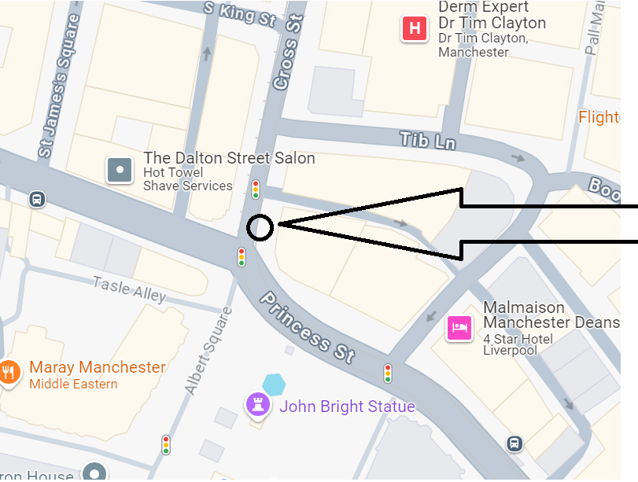location of bin collection

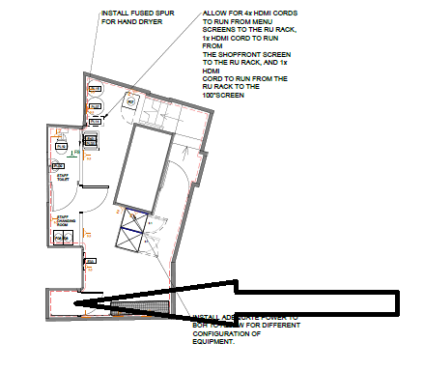Location of bin store in basement

