Application details: | Discharge of Conditions 6 (Drainage), 8 (Materials), 13 (ES) and 17 (Lighting) attached to Planning Permission 136492/FO/2023.

LLFA Comments 21/05/2024
The following Information has been considered:
Planning Portal uploads: | 11/04/2023
Further submission emails: | -
Previous CDN attempts to discharge the Condition: | -

AECOM CIVIL RESPONSES ARE IN PURPLE AND AECOM STRUCURES RESPONSES ARE IN GREEN

Condition number | 6
Decision Notice | 136492/FO/2023

Decision Notice Clause | Contained in submission | Approvable standard | Further information required:
A finalised drainage layout showing all components, outfalls, levels and connectivity including confirmed as-built information where reliant on phase 1 infrastructure; | Y | N | -We are unable to correlate the submitted drainage drawing (CCPH2-ACM-Z0-XX-DR-C-6000) with the submitted hydraulic modelling (dated:18/01/2024). The engineering layout must indicate all nodes included within the hydraulic model, it must also accurately reflect all cover levels, invert levels, pipe diameters, manhole dimensions, and flow rates.  See drawing CCPH2-ACM-Z0-XX-DR-C-6000 Drainage Strategy Layout C02  -Attenuation tank dimensions need to be reflected within the proposed engineering layout.  See drawing CCPH2-ACM-Z0-XX-DR-C-6000 Drainage Strategy Layout C02  -The proposed drawing indicates a maximum flow rate of 16l/s. However, as outlined within the following conditions, a maximum flow rate of 15l/s must be achieved.  See drawing CCPH2-ACM-Z0-XX-DR-C-6000 Drainage Strategy Layout C02 – note 27  -The drawing states; “PHASE 2 SYPHONIC DRAINAGE ARRANGEMENT TO BE CONFIRMED (BY OTHERS)”. Can the developer please confirm any further arrangements which will benefit from the constructed network. 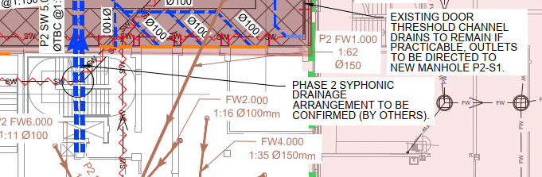  See drawing CCPH2-SAP-ZZ-XX-DR-X-0001 Siphonic Roof Drainage Plan  -The proposed drawing indicates a potential ‘clash risk’ between multiple pipes, the developer must provide a long-section through this area for review.  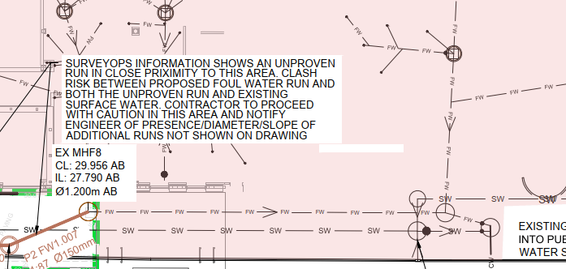  See drawing CCPH2-ACM-Z0-XX-DR-C-6005 Long Section  -The final drawing must clearly indicate the connection point onto the public sewer.  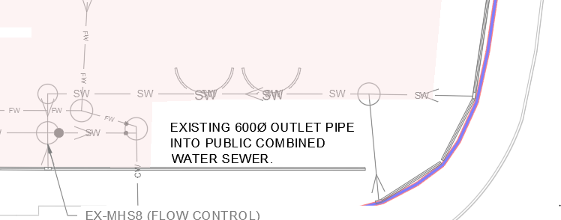  standard comment: The applicant must present a consistent package to discharge this condition (Including all layouts and calculations). The layout  and calculations must be jointly updated to account for any edits required. When preparing a resubmission, the applicant must ensure that the drainage layout and hydraulic calculations correspond, and that they can be cross-referenced for checks. This includes layout annotations and schedule printouts.  See drawing CCPH2-ACM-Z0-XX-DR-C-6000 Drainage Strategy Layout C02
Maximised integration of green SuDS components (utilising infiltration or attenuation) if practicable; | Y | Y
Details of surface water attenuation that offers a reduction in surface water runoff rate in line with the Manchester Trafford and Salford Strategic Flood Risk Assessment, to a maximum of 15 l/s. | Y | N | The proposed drainage layout and hydro-brake specification provided indicates a proposed flow rate of 16l/s. The condition requires the developer to limit flows to a maximum of 15 l/s. This needs to be amended and reflected within the overall submission.  See drawing CCPH2-ACM-Z0-XX-DR-C-6000 Drainage Strategy Layout C02 – note 27
Runoff volume in the 1 in 100 year, 6 hours rainfall shall be constrained to a value as close as is reasonable practicable to the greenfield runoff volume for the same event, but never to exceed the runoff volume from the development site prior to redevelopment; | Y | N | The proposed modelling indicates a maximum flow rate of 16l/s. However, as outlined within the above conditions, a maximum flow rate of 15l/s must be achieved.  The developer will need to ensure a maximum flow rate of 15 l/s is reflected within all engineering documents.  See drawing CCPH2-ACM-Z0-XX-DR-C-6000 Drainage Strategy Layout C02 – note 27
Evidence that the drainage system has been designed (unless an area is designated to hold and/or convey water as part of the design) so that flooding does not occur during a 1 in 100 year rainfall event with allowance for 45% climate change in any part of a building; | Y | N | All nodes included within the hydraulic modelling must be clearly reflected within the engineering layout.  See drawing CCPH2-ACM-Z0-XX-DR-C-6000 Drainage Strategy Layout C02  Manhole schedules must accompany the proposed modelling.  See MH schedule CCPH2-ACM-Z0-XX-SH-C-5204  The proposed modelling indicates a maximum flow rate of 16l/s. However, as outlined within the above conditions, a maximum flow rate of 15l/s must be achieved.  See drawing CCPH2-ACM-Z0-XX-DR-C-6000 Drainage Strategy Layout C02 – note 27
Assessment of overland flow routes for extreme events that is diverted away from buildings (including basements) and managed within the proposed development boundary. Overland flow routes need to be designed to convey the flood water in a safe manner in the event of a blockage or exceedance of the proposed drainage system capacity including inlet structures. A layout with overland flow routes needs to be presented with appreciation of these overland flow routes with regards to the properties on site and adjacent properties off site. | Y | Y
Where an application is part of a larger site which already has planning permission it is essential that the new proposal does not compromise the drainage scheme already approved. | Y | N | We are unable to correlate the submitted drainage drawing (CCPH2-ACM-Z0-XX-DR-C-6000) with the submitted hydraulic modelling (dated:18/01/2024). The engineering layout must indicate all nodes included within the hydraulic model, it must also accurately reflect all cover levels, invert levels, pipe diameters, and flow rates.  This must be for both phases, to ensure the hydraulic model has taken into account both drainage layouts during an extreme event (1:100 + 45%cc).  See drawing CCPH2-ACM-Z0-XX-DR-C-6000 Drainage Strategy Layout C02
Hydraulic calculation of the proposed drainage system including all parameters of the model; | Y | N | Manhole schedules must accompany the proposed modelling.  The proposed modelling indicates a maximum flow rate of 16l/s. However, as outlined within the above conditions, a maximum flow rate of 15l/s must be achieved.  See drawing CCPH2-ACM-Z0-XX-DR-C-6000 Drainage Strategy Layout C02 – note 27  standard comment: The applicant must present a consistent package to discharge this condition (Including all layouts and calculations). The layout  and calculations must be jointly updated to account for any edits required. When preparing a resubmission, the applicant must ensure that the drainage layout and hydraulic calculations correspond, and that they can be cross-referenced for checks. This includes layout annotations and schedule printouts.  See drawing CCPH2-ACM-Z0-XX-DR-C-6000 Drainage Strategy Layout C02
Construction details of flow control and SuDS elements. | Y | N | Attenuation tank construction details must be provided.  The attenuation tank is in close proximity to the proposed building, good practice is 2.5 from boundaries, and 5m away from buildings to allow future maintenance access. If this cannot be achieved, the developer will need to provide a plan indicating easement distance. If appropriate the proposed section should include foundation specification, to ensure the zone of influence has not been impacted.  The attenuation tank has been designed for a 40 tonnes vehicle 400Kn’s. Between wheel loads gives 40 to 50 kn’s. A typical foundation leg load of a scaffold 15kn’s, i.e within the load capacity of the attenuation system.  Piles are end bearing piles, bearing into Manchester Bedrock approx 5 meters below the surface. The pile capacity does not rely on skin friction and thus is not influenced by the proximity of the attenuation, permitting any maintenance works to the attenuation to be carried out without influencing the substructure.

% Complete submission:  (less than 20% complete will trigger a recommended Refusal) | 100%
% At approvable standard: | 23%

LLFA Recommendation: | Further information required (as detailed above).

