Contract Name | Plot 9a | Contract Number | 0335
RAMS Reference Number | Medlock 1 | Operation / Activity | Site environnement issues control document.
Author / Date | S. Oxby | Reviewed By / Date | S.Atkinson

Revision | Description | Issued By | Reviewed By | Date
A | Addendum to Project management plan | S.Oxby | S.Atkinson | 16.07.24

- Project Particulars & Key Contacts
Project | Plot 9a First Street
Client PM | Chris Smith (Chroma for Ask) | Telephone: |  | 0758155804
Project Manager | Simon Atkinson | Telephone: |  | 07917436267
Site Manager | Steve Oxby | Telephone: |  | 07901237242
- Site Address
Plot 9a
First Street
Manchester
M15 4AA

- Location of Works
Whole Site
Appendix 1 – Aerial satellite image of site in relation to the River Medlock
Appendix 2 – Site Logistics plan

- Scope of Work
The scope of works shall be as follows:
To protect the River Medlock from Accidental pollution spillage dust and debris during any demolition or construction by following Bams procedures and any specific items listed in this document.
To monitor and control vibration through methodology and on site measurement around gas main.
To ensure noise is contained to specified site hours
To prevent nuisance from contractor parking
To control site traffic, site waste

- Duration, Working Hours any Restrictions
The project is open from 7.30 to 18.00 hours Monday to Friday for any construction operations. Welfare opens at 7.00am
The project is open from 8.30 to 14.00 Hours on Saturday for any construction operations. Welfare opens at 8.00am
The project is closed Sundays and bank holidays.

THESE HOURS ARE TO BE STRICKLEY ADHEARED TO

- Required to Complete the Task
Parties involved in Task and Competencies |  |  | Materials
All Subcons on site in particular Groundworks, Piler, fame erection, envelope and logistics team. |  |  | All construction materials  Note temp haul roads to be constructed at start of project from ‘Tarmac’ to reduce dust in addition to existing hard standings.
Plant / Work Equipment |  |  | Trade
Road Brush |  |  | Groundworker
Jet wash wheel wash station |  |  | Ground worker and piler
Hosepipes |  |  | BAM Logistics and Groundworker
IBC – Water Vessels |  |  | Ground worker
Telehandler |  |  | Bam Logisitics
360 Excavator |  |  | Groundworker
Kelly tanks or similar |  |  | Groundworker and piler
Bunded fuel stores |  |  | Bam, Groundworker, Piler, Steel Frame Erector, Envelope sub con.
Covered Skips and bins |  |  | Bam Logisitics
Covered Muckaway Wagons |  |  | Groundworker
Vibration Monitoring |  |  | Piler
- Identified Hazards and Environmental Impacts
Identified Hazards and Risks to Health and Safety (Contractors, Client, Public) |  |  | Environmental Impacts  (Water, Air, Land, Waste, Noise, Wildlife)
See Appendix 1 – location of River Medlock via drainage systems, due to distance river is away from site minimal discharge likely other than storm system. |  |  | Damage to wildlife in river system, use of wash out cube (as image for concrete wash out) silt busters and over pumping of site water onto area of site Not into drains that could run into River.
See Appendix 2 – Site logistics for locations of wheel wash and haul roads. |  |  | Dust, water.
Fuel Store on Hard ground only away from main traffic route, double bunded and spill kits present |  |  | Damage to water course through fuel spill, minimised by hard ground store only, bunded tanks and spill kits / plant nappies at point of discharge / filling.
Noise from Plant |  |  | Disturbance to neighbours is reduced by strict working hours. Note site install of early HV substation in compound will reduce the need for fuel on site and no overnight noise by generators. Site hoarding has timed led lights and powerline to reduce the need on site for mobile fuel powered generators.
Vibration From Plant – CFA piling method selected to reduce noise and vibration to neighbours |  |  | Disturbance levels reduced through selection of plant and piling method.
Control of dust from site |  |  | Damping down with bowser and tarmac haul road to reduce areas. Vehicles delivering stone or removing muck are to be sheeted over  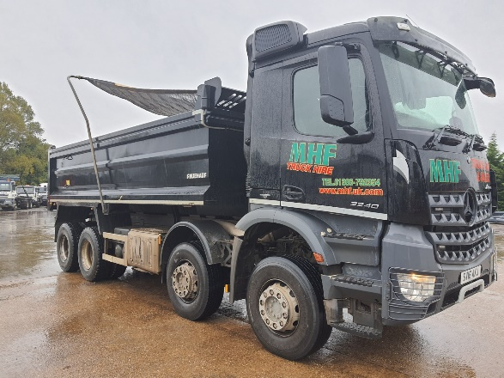  Example of 8 wheel tipper with cab controlled sheeting to prevent dust escape.

- Personal Protective and Other Safety Equipment Required Not Required
High-Visibility  Vest / Jacket |  | Gloves |  | Safety Glasses |  | Safety Boots
Overalls |  | Waterproofs |  | Hard Hat |  | Safety Goggles
Respiratory Protective Equipment |  | Barrier/Signs |  | Ear Protection |  | Oil Spill EnviroPad
Fire  Extinguishers |  | Spill Kit |  | First Aid Kit |  | Fall Arrest Harness / Lanyard / Inertia | x
Details if other:
- Site Methodology
Stage | Description
1 | Basic Site Safety Measures  All ops receive site induction.  Safe to start each day.  Emergency Contact Details for the project are displayed on Notice boards and at the site entrance. Registration also with the considerate constructors scheme. Image below:  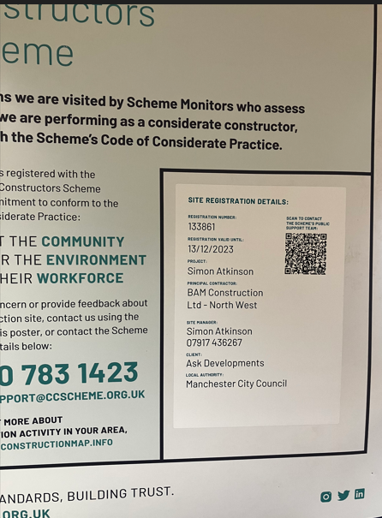 Emergency contact details displayed around site.
2 | Task Specific Safety Measures  - To Control dust the site will have early tarmac haul roads in place at the north end of site.  - 8 wheel tippers to have sheeting (as image above)  - The staff car park will have a tarmac surface.  - The compound for storage containers will be on a concrete surface.  - The south exit is an existing concrete road, there is a water jetwash at the top end of site will ensure all vehicles leave site clean, stopping mud to rads and dust.  - This Station is also the feed for the IBCs to be filled. The 1000L IBS will then distribute water via the telehandler or excavator forks on dry days to ensure any on haul roads is kept to a minimum. The hosepipe will also be used to dampen down roads.  - All subcons provide their own fuel storage, spill kits. All subcons have their own coshh stores.  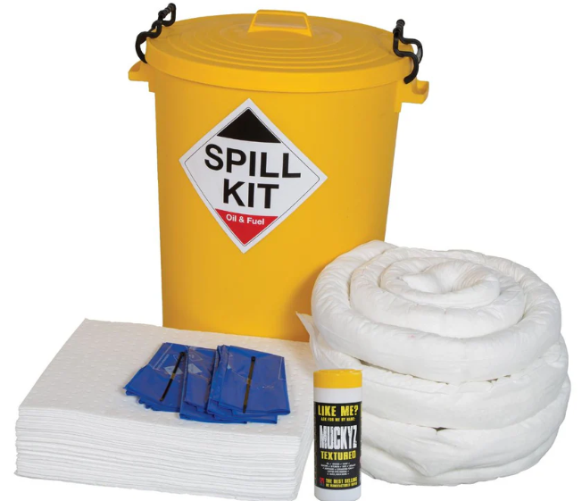 Example of Spill kit.  - For large concrete pours or muck away a road brush will also be visiting site to ensure all surrounding roads are clean and no material enters the storm drainage system near to the site on the boundary. In particular the drainage system on river street.  There are no storm drain gulleys on site until the buildings drainage is put in place. Any on site pumps will go via a Green Rhino oil and silt buster to the only foul outlet manhole on the north of site, orange sock shown below, high volumes of water not expected, but if required holding settlement tanks will be used.  - Piling is by CFA rig rather than driven piles to reduce vibration and noise levels.    - All concrete washout will be returned to the batching plant in the delivery vehicles, chute washout only on site is allowed into Kelly tanks (shown below) or lined skips for large pours. The waste water will be taken off site by licensed carrier. No washing into the ground on site.  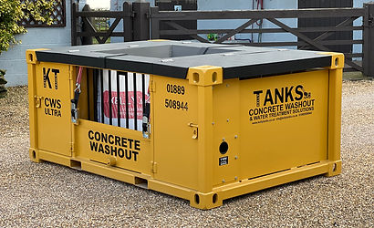  - Waste is taken off site on skips for early stages of project then by daily mobile compactor by Kenny Waste. This reduces storage of waste externally and reduces risk of spills onto the ground.
3 | Personal Protective Measures  - Safety Boots (BS EN 20345, Personal protective equipment, safety footwear) Must have midsole protection – NOT SB, S1,or S2)  - Safety Glasses (BS EN ISO 16321, Personal Eye Protection Class 1 F)  - Hi visibility vest (BS EN 20471, High visibility warning clothing)  - Safety Helmet (BS EN 397 / EN50365 Class 0, Industrial Safety Helmets)  - Gloves (BS EN 388, Protective gloves against mechanical risks min cut class 1)

 | 4 | Access Into Site  - Access into, around and out of the construction site via designated access points and routes, adhering to site rules in relation to speed limits, banks man control & reversing. All Vehicles will be controllled as per the logisitics plan appendix 1. All deliveries enter via a gate on river street to the north of the main works.  - Vehicle access to site for delivery and collection of materials and tools only.  - Access to work area to be via designated pedestrian walkways and routes at all times.  - Fire escape routes are not to be restricted by work activities at any time.  - Deliveries booked in by DMS – Delivery management system.
 | 5 | Work Area Set Up  Site logistics plan. Appendix 2.
 | 6 | At the end of each day  - Make the work areas safe, clean and tidy  - Close out any Permits with Site Manager  - Report any issues to the Site Manager  - Sign out of site
 | 7 | Vibration Monitoring  On site monitoring station during the pile works adjacent Cadent Gas main, undertaken by Cadent.  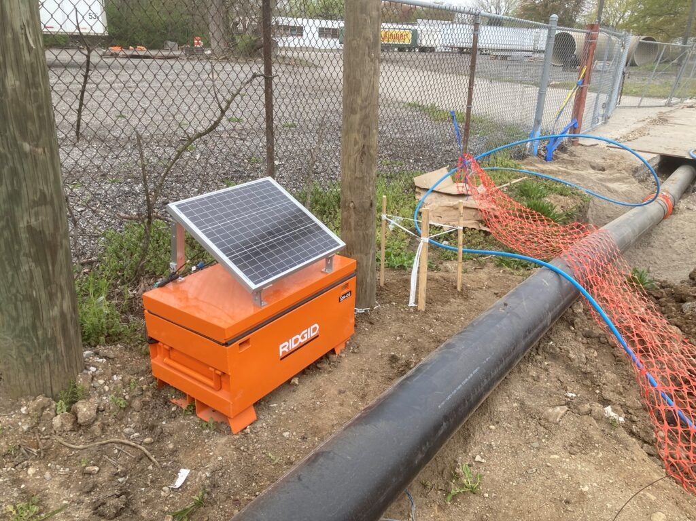
IF IN ANY DOUBT, STOP AND ASK FOR HELP OR ADVICE. IF ANY OF THE ABOVE CONTROL MEASURES CANNOT BE ACHIEVED, STOP AND REVIEW WITH SITE MANAGER / SUPERVISOR BEFORE PROCEEDING

Appendix 1: Site in relation to the River Medlock – nearest section of open river is over 130 meters from site.
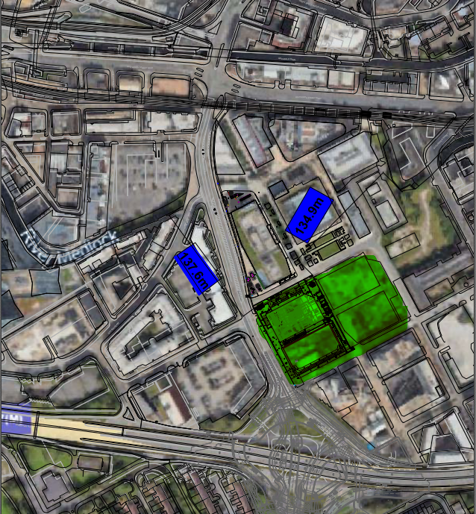
The Site is shaded in green for the first 12 months of the project
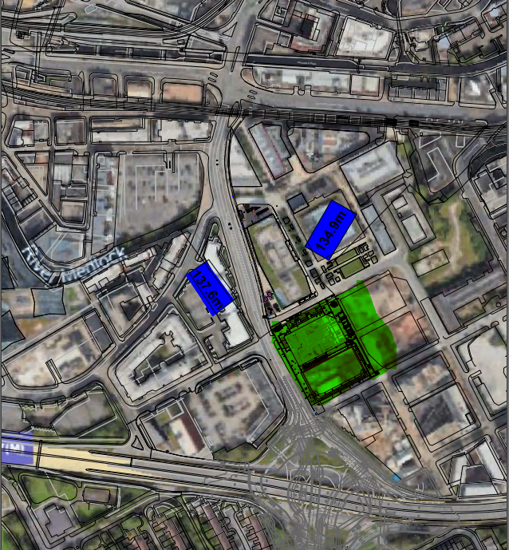

The Site is shaded in green for the last 12 months of the project
Appendix 2: Logistics plan – showing location of wheel wash, contractor parking, skip area,
Fuel storage (away from River) and one way system through site.
