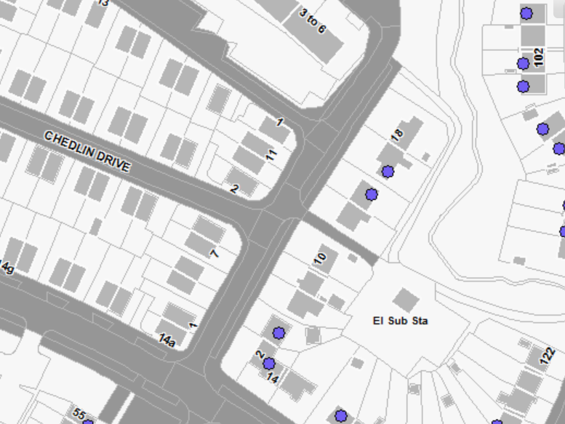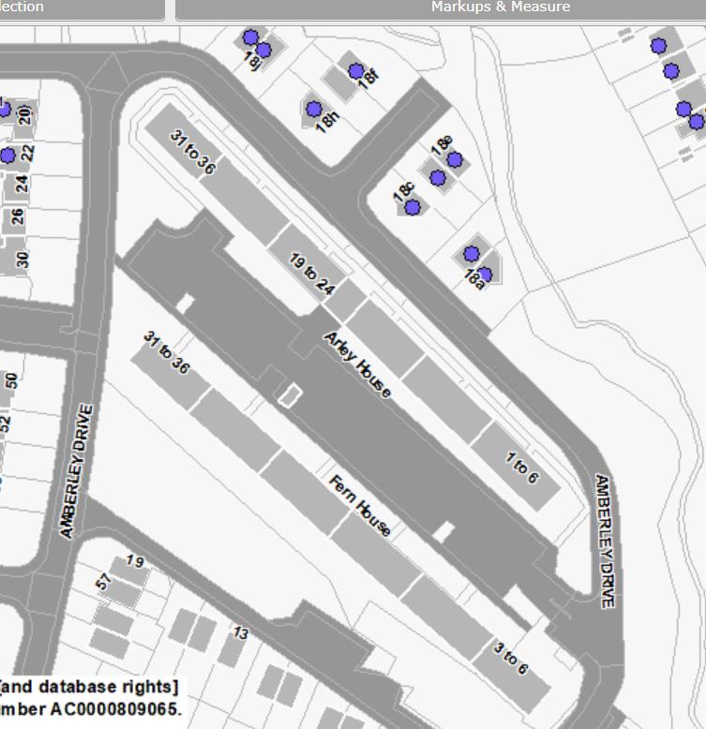
1-36 Fern House
1-36 Arley House
18A – 18N Amberley Drive – note no 18I or 18L
1-11 & 2-18 Amberley Drive
1 & 2 Chedlin Dr
1 Boncarn Dr
Amberley Drive Consultation Plan

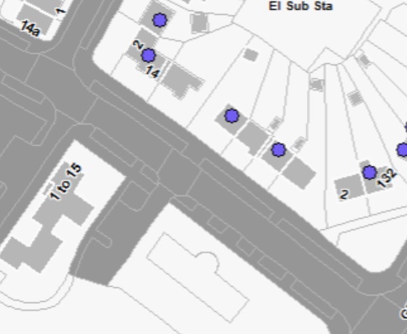
2-14 Wastdale Road
1-11 Wastdale Road

