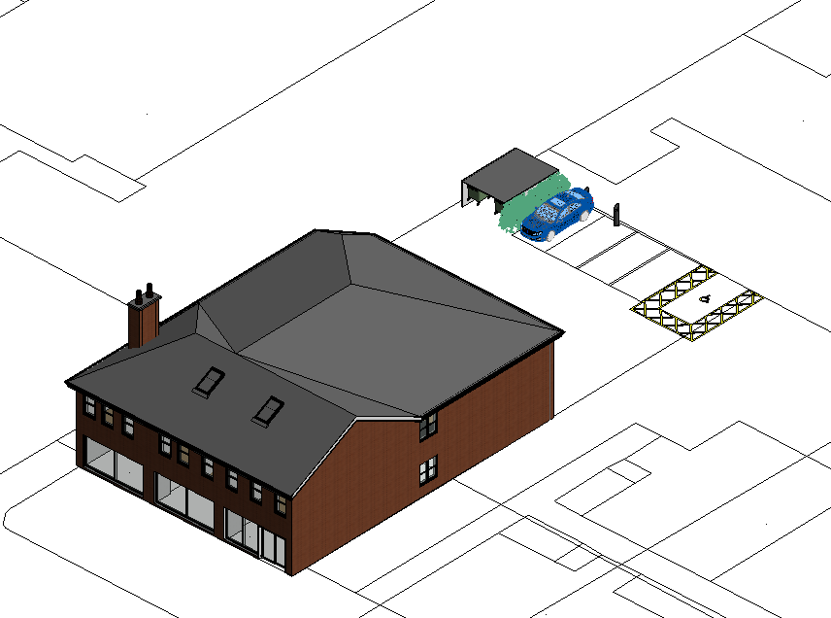
General Sustainability Statement.

In support of the full planning application for:
197-201 Mount Road, Gorton, Manchester M18 7GG

APPLICATION REFRENCE: PP-10308528

Proposed Double Storey Rear Extension to Accommodate 7 Self-contained Apartments.

1.0 Introduction
This design & access statement has been prepared in support of a planning application seeking permission for residential development above an existing property currently housing commercial on the ground floor and 3 self−contained apartments on the first floor on Mount Road Gorton. The statement focuses on the sustainable characteristics of the development which are also referred to in the Design & Access planning statement submitted with the application.
The statement comprises the following sections:

    - Description of the application site and surrounding area
    - Description of the proposed development
    - Reference to the panning policy framework
    - Demonstrating the sustainable qualities of the development
    - Conclusion

2.0 The application site and surrounding area

A predominately residential area surrounds the application site, characterised by older two storey terraced dwellings within which pockets of more recent housing infill apartment development has occurred.

3.0 Proposed development

The application seeks permission for 7 self-contained apartments including a double storey rear extension above an existing commercial property. Approval is sought for amount of development, siting and means of access, with design and appearance and landscaping to be reserved matters.
The proposed units will be laid out alongside the site frontage onto Mount Road, reflecting the prevailing street scene characteristic of buildings onto the back edge of pavement. The development will be two storeys in scale, in keeping with the surrounding locality.
The self−contained apartments will vary in size. The variation in size and the availability of a mix use class opportunities will add to and enhance the retail commercial offer within the locality. The provision of self−contained apartments above the existing commercial unit will deliver residential accommodation within a highly sustainable location and maximise use of a Brownfield site. The provision of access to the apartments onto the primary site frontage will enhance the street scene. This design detail will be subject to reserved matters consent.
Service access to the apartments will be via an existing vehicular entrance to the site from Mint Road. The entrance will be gated to provide security to the development. The servicing area will have sufficient manoeuvring space to enter and leave in forward gear. The security of the site will also be enhanced by the provision fencing to the boundary with adjoining car park.

4.0 Planning policy framework

Government guidance is set out in the National Planning Policy Framework. The NPPF expresses a presumption in favour of sustainable development which is perceived as a golden thread within the planning system. As such sustainable development is viewed as performing economic, social and environmental roles.
The Adopted Core Strategy and Saved Unitary Development Plan Polices comprise the local plan framework for Manchester City Council. Specific NPPF guidance and local plan polices relevant to the proposed development are set out on the Design & Access Statement.

5.0 Contribution to achievement of sustainable development

The application site occupies a highly sustainable location within the locality. The proposed scheme will achieve the following benefits in terms of sustainable development.

Environmental role

The development will have the following benefits:

    - The development will return Brownfield land into beneficial use.
    - The site provides excellent access to public transport in the form of regular bus services. This factor and the highly accessible location of the site will reduce the reliance on private motor vehicles.
    - The location of the site and associated movements will be positive n terms of a low carbon economy
    - The development will have no impact on wildlife or habitats of significant importance.

Social role

The development will secure the following benefits:

    - The development will provide residential accommodation to meet the needs of present and future generations with this side of Manchester in accordance with Core Strategy Policy.
    - Detailed design of the apartments will be subject to reserved matters approval. However, it is envisaged the accommodation will be designed to sustainable homes level 3 standard.

Economic role

The development will have the following benefits to the economy:

    - Occupiers of the residential development will support local services, particularly within the district centre.

    - The development will provide employment opportunities for the nearby local community.
    - The development will contribute towards the regeneration and renewal of the area and enhance the vitality and viability of the centre.
    - Detailed design of the proposal will be subject to reserved matters approval. However, it is envisaged the development will achieve a BREEAM good rating.

9.0 CONCLUSION

The statement demonstrated the development will be sustainable and will be of benefit environmentally, socially and economically for he reasons set out previous.

