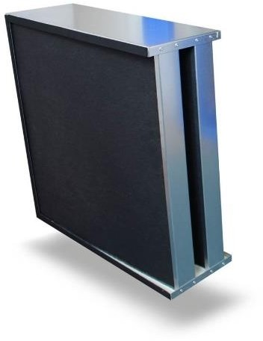

Applications | Structure and Operation
For purification of supply air, exhaust air and circulating air streams from harmful gases, steams and bad smells in:  - Canteen kitchens, museums, waste recycling centres  - Hospitals, laboratories, computer areas  - Chemical industry, paintshops, airports, petrol stations, parking garages | - Solid carbon  - Strong robust galvanized frame  - Humidity resistant up to 70% r. h.  - Temperature resistant up to max. 40°C

Versions | Contact time (Dwell Time)
- V-Formation  - Standard Duty  - Heavy Duty  - Removes hydrogen sulphide, ammonia, DMS etc. | - 0.1 Second – 0.4 Second  - Please ask for recommendations on dwell time

Tri-carb Safe Fit | 24x8x24 | Tri-carb Safe Fit | 3 x 24x8x24
Dimensions | 595x198x595 | Dimensions | 595x595x595
Gross Weight | 22.00KG | Gross Weight | 66.00Kg
Carbon Weight | 17.00KG | Carbon Weight | 51KG
Rated Velocity | 1266 M3/h | Rated Velocity | 3800 M3/h
Pressure Drop SD | 185Pa | Pressure Drop SD | 185Pa

Tri-Carb Dimensions

 |  |  |  |   ( | 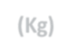  ( | 
TSF180912 | 2 | 18x18x12 | 451x220x295 | 6.5 | 9.85 | 473
TSF240612 | 2 | 24x12x12 | 595x146x295 | 6.5 | 8.80 | 469
TSF240812 | 3 | 24x24x12 | 595x198x295 | 8.68 | 11.00 | 625
TSF180918 | 2 | 18x18x18 | 451x220x451 | 10.08 | 13.85 | 725
TSF240618 | 2 | 24x12x18 | 595x146x451 | 9.98 | 13.22 | 719
TSF240818 | 3 | 24x24x18 | 595x198x451 | 13.31 | 16.55 | 958
TSF180924 | 2 | 18x18x24 | 451x220x595 | 13.31 | 16.55 | 958
TSF240624 | 2 | 24x12x24 | 595x146x595 | 13.18 | 16.68 | 950
TSF240824 | 3 | 24x24x24 | 595x198x595 | 17.58 | 22.00 | 1266

The above capacities are based on a 0.1 second dwell time. Please refer to the table below for the recommended minimum dwell times required for different applications and scale up accordingly. It should be noted that filtration performance will be improved by increasing the dwell times applied. The appropriate suffix should be added to the part number to specify the required grade e.g.
TRI240824CU50

 | 
General Cooking | 0.1 – 0.2 | COL-A50 | OLA-50
Spicy – Indian | 0.2 – 0.4 | COL-A50 | OLA-50
Reduction of Kerosene | 0.1 – 0.2 | COL-A50 | OLA-50
Reduction of Ozone | 0.1 – 0.2 | COC-A50 | OCA-50
Diesel Fumes | 0.2 | SORB17 | SORB17
Museum | 0.2 | Museum Grade | CU-50
Mortuary | 0.4 | Mortuary Grade | FORM
Ammonia | 0.3 | Ammonia Grade | AMM

Other Applications
We can formulate gas phase filters for most applications, simply contact us with your enquiry.

