 | Our Town Hall  Works Technical Submission


Technical Submission for external works

OTH-SWL-EX-ZZ-TSB-X-0002
Status: S3
Rev: P01
Document Type: Technical submission
Date: 14/11/2024

Issue History:
Revision Nr | Details | Date | Created By | Check by
P01 | First issue | 14/11/2024 | ST

Works Package Name: | Lot1 Phase B | Task/Activity: | External Works
Works Package Number: | 41111.04 | Location: | Townhall Extension , Mount Street.

Date: |  | 14.11.2024 | Start Date of Activity: | TBC
Scope/Overview:

Works will consist of removing up to 9 no. large paving slabs to facilitate Adana to install a steel bollard.

This technical submission covers the following tasks.
- Flag removal.

Prior to works commencing, a Daily Activity Briefing (Dabs, smart start), shall be communicated to the work party together. These forms will be signed by all operatives and records shall be maintained and kept on site. All methodology of works will be briefed to the site supervisor/foreman, who will then brief the mason operatives carrying out the works. At the end of the shift all work areas shall be tidied up and any unwanted or waste materials will be removed and placed in the appropriate site waste bins or skips. If any major changes to the agreed method of work need to be implemented, the proposed change(s) need to be approved by a member of the Lendlease Project Management team. Once the change(s) have been approved the relevant RAMS need to be amended by appending handwritten details of any new tasks that are identified and the control methods to be put in place. For minor changes the RAMS can be amended by the Stonewest site Manager or site Supervisor in charge of the works. The amended RAMS will need to be briefed to the relevant staff and signed to acknowledge the brief has been undertaken and most of all understood.

Deconstruction works
Preparation

5” and 9” Grinder with water bottle dust suppression.
Monoflex and Correx (Complete with signage.)
¼ “and ½” Sharp chisel to I.D paving slabs.
PPE: Hi-Vis, Hard Hat, Safety Glasses, Ear-defenders, Safety Boots, Cut resistant Gloves and FFP3 Dust Masks.
Lever Bar/Slab lifter.
A Gantry Frame (With a layer of Plywood under to protect the existing pavement.)
Block and Tackle with L/2 Ton lifting strap.
Brushes and shovels.
Sponges.
Refuse bags for construction waste/slurry.
Pallets for storage.
Barriers for material storage in the onsite laydown area.
Steintec high strength bedding mortar, primer and jointing system.

Existing Flag Removal

Once a commencement date has been agreed, contact will be made with the MCC FM team to arrange the temporary closure of the external right-hand side sliding doors. (see photo 1)
To create an outer perimeter, we will be using Heras fencing which will be covered with Monoflex and Correx where required, safety signage including contact details will also be displayed on the Monoflex/Correx. (Where Correx is used, additional kentledge will be placed on the fencing rubber feet to increase stability and security of the Heras Fencing in accordance with OTH – Temporary Heras Fencing construction standards, this will be observed during the works by our operatives.) (see photo 2)

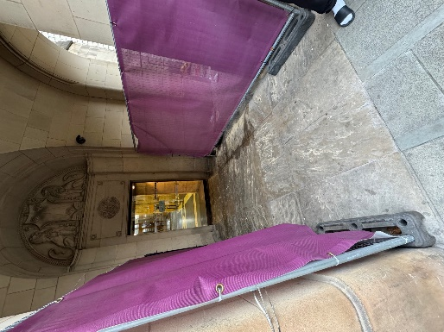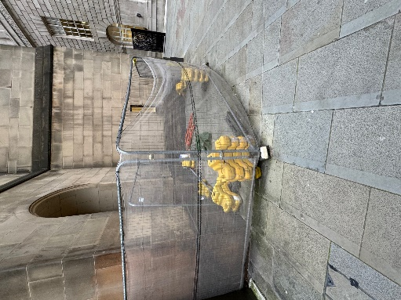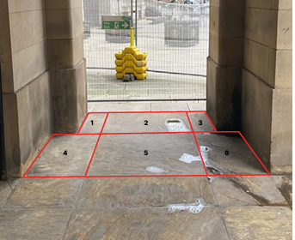
(photo 1) (photo 2) (photo 3)

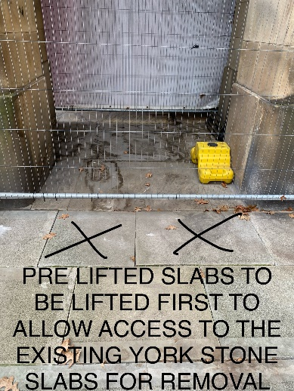
(photo 4)
A pre-start survey including photos will be carried out before work commences. This will determine the order that we remove the slabs, the condition of the slabs which will be recorded, any slabs that may be damaged will be recorded and reported to LL and MCC. Chalk will be used to mark the slabs that are to be removed/replaced. During this survey we will also be attempting to take a test sample of mortar by using hand raking out tool, if obtaining a sample isn’t possible, we will raise an RFI to LL/MCC for further information.

As a result of our pre-start survey, we have determined that we will start the slab removal process by removing Stone 2 first (see photo 3) this was decided due to the two existing stones adjacent to Stone 2 have previously been lifted by others (see photo 4) this will give us access to the underside of slab 2 for removal. Once slab 2 has been removed, recorded and put into storage, this will allow us the space required to commence lifting the remaining slabs (proposed order: Slab: 2, 1, 3, 5, 4 and 6.) Using the variable speed 5” grinder starting on the slowest speed with the water bottle, we will cut through the stone joints on a 90-degree angle to separate the paving slabs from each other whilst reducing the risk of damage to the adjacent slabs, this will allow us to lift and remove the paving slabs, whilst cutting we will ascertain the depth of the paving slab if possible. If necessary, we will use a 9” grinder to cut deeper. Whilst cutting we will be using a water bottle; to keep the wastewater to a minimum, our operatives will be managing the wastewater/slurry with brushes and a sponge to be collected and disposed of correctly once the cutting is completed. The fencing, complete with Monoflex/Correx, will also act as an additional barrier to minimise the water spray entering the public realm and protecting The Townhall Extension and its external entrances.
We will be using a lever bar to lift the paving slab until free starting at each corner to minimize the stress on one particular point, we will also be using a raking out hand tool to remove the excess mortar allowing more space for the lever bar to be used. Once free we will be lifting the stone using a slab lifter attached to a block and tackle on a gantry frame and placing it on a pallet (3 slabs per pallet with a rubber mat between each slab) once secured onto the pallet we will be using the sharp chisel to mark the stone with its I.D and original location. The paving slab will be cleaned of any residual mortar from the slab joints. Once all of the paving slabs have been removed, they will be stored on the pallets along with all of our materials and equipment in our current storage area within the OTH site laydown area on Lloyd Street. This will allow Lendlease/MCC to inspect the paving slabs if desired. The pallets will then be covered with Correx, and an exclusion zone will be created with barriers and signage to minimize the risk of damage or use by others. Photos of the stored materials will be taken. We will then hand the work area over to Lendlease to manage the works by others.

Existing Flag Reinstatement.

Once the bollard and plate have been installed, the existing 6no. paving slabs will be reinstated using the block and tackle on a gantry frame method as used at the removal stage. The paving will be bedded using Steintec high strength bedding mortar, primer and jointing system. The area between the concrete slab and the underside of the paving slab is approximately 120mm, which allows for the 60mm plate depth. The existing paving slabs will then be reinstated over the top of the plate to match the existing configuration and levels. (see photo 3). Once all of the paving slabs have been reinstated and jointed the area will be cleaned and all materials and waste will be correctly removed, the area will then be handed back to Lendlease to manage the installation of the bollard sleeve.

Heritage Considerations: | Controls:
Materials: (New, existing and waste streams) | Any construction waste will be disposed of in appropriate site waste bins or skips. All redundant pallets will be taken to the appropriate location to be reused/recycled.  All waste generated from removing the slabs will be cleaned up to ensure a clean and tidy work environment. All collected rubble will be carefully placed in heavy duty rubble sacks where at the end of the shift all work areas shall be completely tidied up and rubble/waste materials will be removed and placed in the appropriate site waste bins or skips.
Tools/Equipment: (Type, use and calibration) | Our stonemasons will be using hand tools in the form of chisels and lever bars. We will also be using Bock and Tackle, A Gantry frame. We will be using a 5” and a 9” Grinder complete with water dust suppression.
Storage: (During works for reinstatement, long term off site) | Once all of the paving slabs have been removed, they will be stored along with all of our materials and equipment in our current storage area within the OTH site laydown area on Lloyd Street.
Discovery: (Type to be expected and visual signs) | - Existing services.  - Damage to additional slabs.  - Displacement/dislodgement, of adjacent paving slabs.
Workforce Awareness: (Tool box talks and briefing by design consultants prior to works) | The site supervisor will also be carrying out the Lendlease Team Briefing – Smart Start Form before any site works will commence. This will cover all aspects of site activities including understanding the RAMS, through the list to a team discussion’s that are in relation to daily site activities. Toolbox Talks will also be executed on a weekly basis covering all aspects of site topics to ensure that site safety is adhered to at all times whilst working on the OTH project with copies returned to Lendlease in the weekly’s.

Project Team Approval to Commence Works
Organisation | Name | Signature | Date
MCC
Purcell
ARUP
Ramboll
Planit
Lendlease
Works Contractor

