Refuse Access Strategy.

In support of the full planning application for:
197-201 Mount Road, Gorton, Manchester M18 7GG

APPLICATION REFRENCE: PP-10308528

Proposed Double Storey Rear Extension to Accommodate 7 Self-contained Apartments.
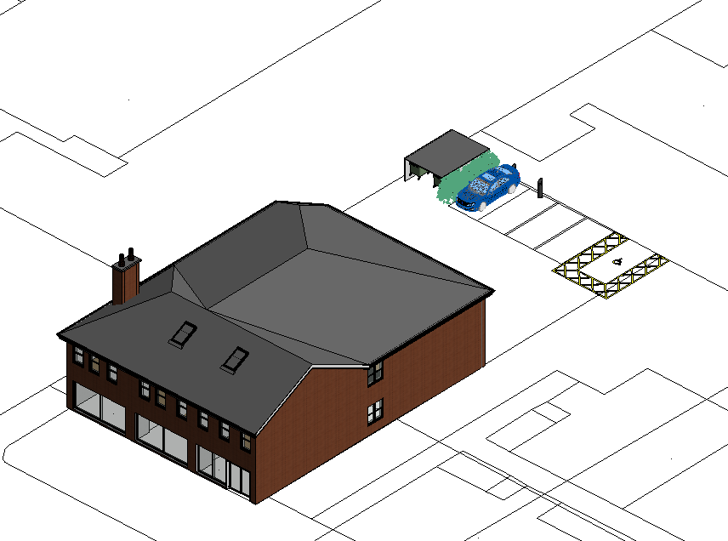

On behalf of Mr. Teja Sahotta

The following refuse strategy has been developed in line with current Manchester
City Councils waste management strategy.
Provision:

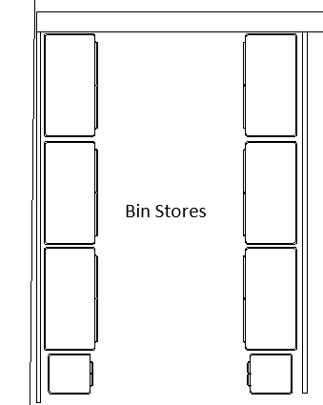
General Waste (twice weekly collection)
500 litres commingled waste (domestic)
500 litres landfill waste (domestic)
500 litres commingled waste(domestic)

500 litres commingled waste(commercial)

500 litres commingled waste (commercial)
500 litres landfill waste (commercial)

Recycling (2 commodities on 2 weekly schedule)
500 litres landfill waste(commercial)

500 litres landfill waste(domestic)

500 litre paper waste (domestic)
500 litre paper waste (commercial)
500 litres paper waste(commercial)

Bio waste (food) (collected weekly)
500 litres paper waste(domestic)

2 green wheeled bins (domestic)

Bio Waste (commercial)

Bio waste (domestic)

All bins will be removed to kerbside for collection weekly by the landlord.

Dimension:

All container sizes on plan. Typical layout

