Prospere Learning Trust.
Bio Diversity Survey
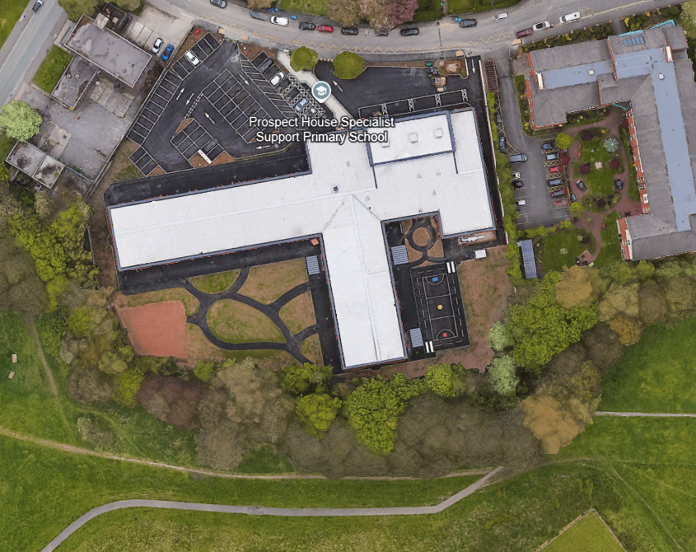

- Green Zoned area – location of play equipment installed 18- 24 months or so ago, for which the school moved and increased the size of its onsite wild flower area. This area is remaining unchanged.
- Purple Zoned – location of school MUGA and play area that is remaining unchanged.
- Yellow Zoned area – area used by schools’ animals including pigs
- Blue Zoned area – schools wildflower area referred to in Green Zone above.
- Red Zoned area – area where the school are looking to install play equipment. As you will see this area contains two areas of grass marked with a X. These are real grass areas that will be changed to ‘astro-turf (artificial grass) . The areas not marked with a X in the red zone will remain as grass but will have play equipment installed within them.

