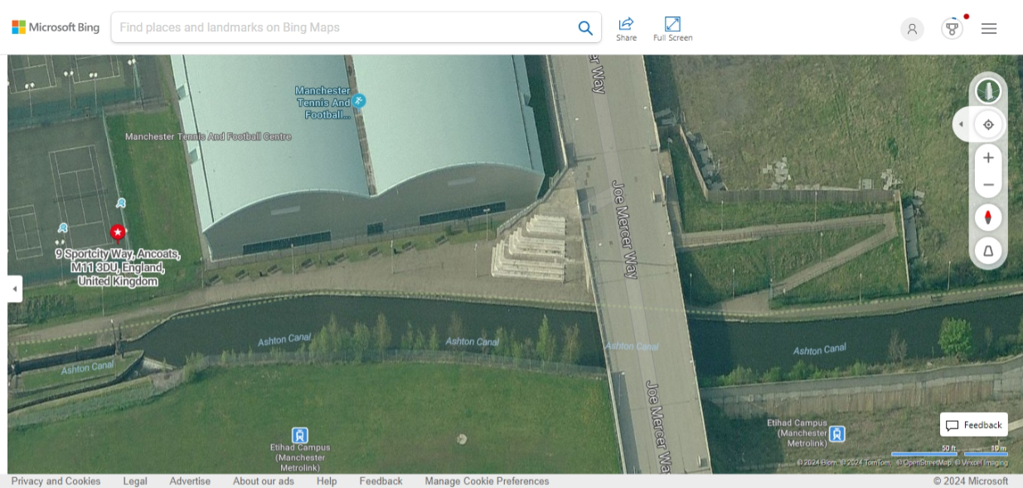
Location of boat 60 feet long, 6.6ft wide

