Revision: 3 10.03.2022
Written By: Sophie Nolan

Asbestos Management Plan & Register

Site Plan

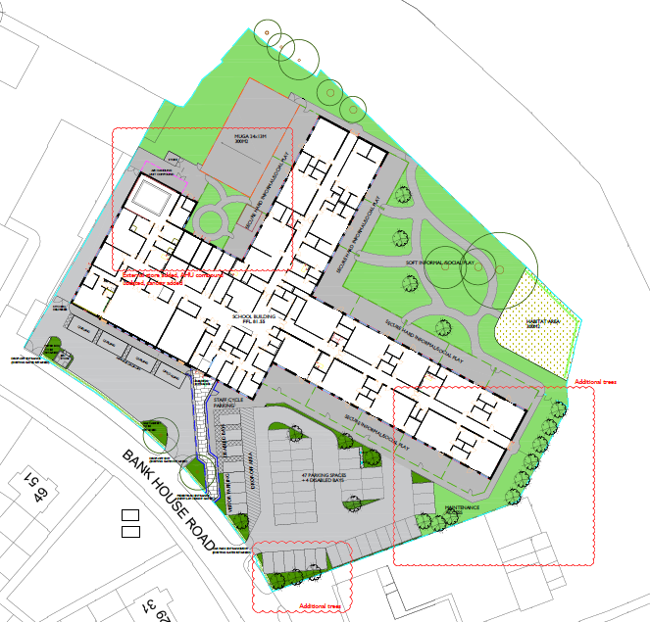

Surveys

Location | Product | Quantity | Surface Coating | Condition | Ease of Access | Type | Comment | Material Score | Priority Score
Under Ground below orange Teram barrier layer circa 500mm below ground level | Crysoltile within ground build up | Unknown – see report J180234 | N/A | Within ground make up | Below orange teram barrier layer – visual demarcation in place | Crysoltile |  | 2 | 5 - Low
Below Ground – Existing disused Pitch fibre drainage circa 3m below ground level | Crysoltile within ground make up circa 3m depth | Unknown – see report  J180234 | Bitumen pipe | Sections of pipe in tact with potential for pieces to be broken off | Difficult – below layer of orange tarmam barrier layer – visual demarcation and circa 3m in depth | Crysoltile |  | 2 | 5 - Low

Asbestos Action Plan

Where | Product | Action | By When | By Whom
External Ground | Crysotile | Do not disturb – below orange teram bariier layer – visual demarcation | N/A | N/A

Responsible person: S. Nolan Date: 10 March 2022 Monitoring date March 2023

Emergency Procedures Plan (Asbestos)

In the case of an uncontrolled release of asbestos fibers / presumed asbestos being discovered into the workplace the Control of Asbestos Regulations 2012 (CAR2012) requires that all persons are kept away from the affected area. An adequate assessment is required, and an emergency action plan should be followed.

What to do if Asbestos is Discovered or Accidently Damaged
In the event that potential ACM’s are discovered or disturbed the following steps must be carried out:
- Step 1 Stop work immediately and clear the area of all personnel and isolate the area, such as a single room, by closing all the windows and doors. Any persons within the area must be fitted with a FFP3 mask and removed from the area.
- Step 2 Retrieve emergency asbestos kit which is located within the site office.
- Step 3 Any personnel that may have come into contact with the material, must remove their outer layers of clothing and put into the sealable bag provided and wear a protective coverall suit, face mask and overshoes until the specialist asbestos removals company can safely de-contaminate. Note that operatives that have been removed from the area must be kept in a controlled area away from all other personnel, nominally site office storeroom.
- Step 4 Prohibit access to the area by where possible locking doors, placing signage on doors and sealing over the access area where possible with the polythene and tape provided.
- Step 5 Inform the named specialist asbestos removal contractor in this case Inglenorth
- Step 6 Inform all operatives and teams of the current situation and Relay information of potential exposure to all persons who may have been affected by the uncontrolled release
- Step 7 Inform Project Lead, associated personnel and the H&S team.
- Step 8 Collate information of the operatives that have potentially been involved in the disturbance / discovery of the ACM’s
- Step 9 The nominated specialist will survey the area, take samples where necessary and if urgent clean-up is required do so at this point.
- Step 10 Where samples have been taken, a lab survey will be required this may take 48 hours, during this time the area must remain sealed / prohibited access.
- Step 11 Following lab test results being analyzed where asbestos has been deemed to be present, specialists will remove / or encapsulate the ACM’s and clean up accordingly.
- Step 12 Following assessment the HSE may need to be notified of a RIDDOR event, where asbestos is present.
- Step 13 air test monitoring will be carried out, until the air is deemed to be clean and issue a clean air certificate.
- Step 14 All operatives, teams and member of the SHEQ team to be notified of the actions taken and if any further precautions / actions are required.
- Step 15 area re-opened

